Spark :

- Apache Spark is a lightning-fast cluster computing designed for fast computation. It was built on top of Hadoop MapReduce and extends the MapReduce model to efficiently use more types of computations, including Interactive Queries and Stream Processing.
- Spark uses Hadoop in two ways – one is storage and the second is Query and stream processing. Since Spark has its own cluster management computation, it only uses Hadoop for storage.

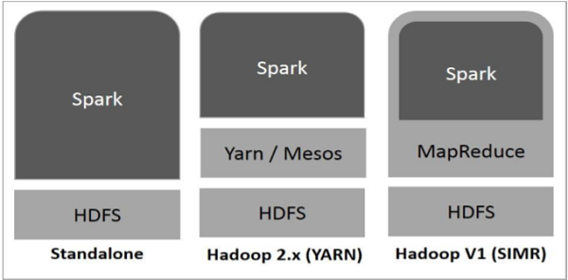

- Prerequisite - To Know Hadoop, HDFS, Map Reduce, Hive, Python, SQL

Components of Spark :

Apache Spark Core
Spark Core is the underlying general execution engine for spark platform that all other functionality is built upon. It provides In-Memory computing and referencing datasets in external storage systems.

Spark SQL
Spark SQL is a component on top of Spark Core that introduces a new data abstraction called SchemaRDD, which provides support for structured and semi-structured data.

Spark Streaming
Spark Streaming leverages Spark Core's fast scheduling capability to perform streaming analytics. It ingests data in mini-batches and performs RDD (Resilient Distributed Datasets) transformations on those mini-batches of data.

MLlib (Machine Learning Library)
MLlib is a distributed machine learning framework above Spark because of the distributed memory-based Spark architecture. It is, according to benchmarks, done by the MLlib developers against the Alternating Least Squares (ALS) implementations. Spark MLlib is nine times as fast as the Hadoop disk-based version of Apache Mahout (before Mahout gained a Spark interface).

GraphX
GraphX is a distributed graph-processing framework on top of Spark. It provides an API for expressing graph computation that can model the user-defined graphs by using Pregel abstraction API. It also provides an optimized runtime for this abstraction.

Batch Processing :
- Get information on top of having a file
- Hadoop only supports batch processing.
Stream Processing:
- On the live data processing.
- Spark allows both of them.

Hadoop Frame Work:
Data store -> HBase( NoSQL ), HDFS( Distributed RDBMS )
Data process -> Hive, Pig
Data Pipeline -> sqoop, Flume
Data visualization ->
Data Scheduling -> Oozie, Airflow

Spark :
Data process -> Spark ( Having this only )
( It uses the Hadoop framework )
- Spark is replaced for MapReduce.

Standalone - 10 Machine having only Spark
YARN - Cluster Management( Resource Allocator )
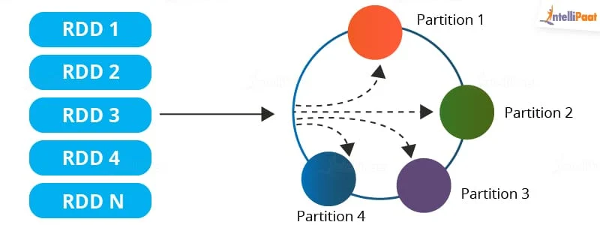

Spark important API:
- RDD - Main data Logic unit in spark. Distributed collection of objects which are stored in different clusters.
- Data frame -
- Dataset -

Basis | RDD | Datasets | DataFrame
Inception Year | RDD came into existence in the year 2011. | Datasets entered the market in the year 2013. | DataFrame came into existence in the year 2015.
Meaning | RDD is a collection of data where the data elements are distributed without any schema | Datasets are distributed collections where the data elements are organized into named columns. | Datasets are basically the extension of DataFrames with added features
Optimization | In the case of RDDs, the developers need to manually write the optimization codes. | Datasets use catalyst optimizers for optimization. | Even in the case of DataFrames, catalyst optimizers are used for optimization.
Defining the Schema | In RDDs, the schema needs to be defined manually. | The schema is automatically defined in the case of Datasets | The schema is automatically defined in DataFrame

Transformation and Action:
- Transformation - e.g.: group, sort, filter, Map, Flat Map
- Action - e.g. collect, save, Show
- Transformation works only after action calling it called Lazy Evaluation.
- Narrow transformation - No shuffle
- Wide Transformation - having shuffle

Spark with Apache Hive:
- Need installation -> Spark, Hadoop, Hive, Java
- Pip install pyspark

.

