**"“Online Reservation System for Celebrity Styles Hair Salon - Bauan Batangas Branch’’**

**A Capstone Project Presented to the Faculty of the**

**College of Computer Studies**

**AMA Computer College - Batangas**

**In Partial Fulfillment of the Requirements for the Degree of**

**Bachelor of Science in Information Technology (BSIT)**

**By**

**De Torres, Jersey**

**Flores, Isaac Vince**

**Ramos, Johnlery**

**January 20**

APPROVAL SHEET

This capstone project entitled, **“Online Reservation System for Celebrity Styles Hair Salon - Bauan Batangas Branch”,** prepared submitted by **De Torres, Jersey Flores, Isaac Vince Ramos, Johnlery** in partial fulfillment of the course requirements for the degree of Bachelor of Science in Information Technology, has been examined and recommended for acceptance and approval for Oral Examination.

MARIFE P. NORIEGA

Adviser

Approved by the Committee of Oral Examination on ______________ with a grade of _________.

___________________________ __________________________

Member Member

**_______________________**

Chairman

Accepted as partial fulfillment of the course requirements for the degree in Bachelor of Science in Information Technology.

Dr. Maria Lourdes A. Delariarte

Dean, College of Engineering

Date: _________

ACKNOWLEDGEMENT

First and foremost, we give thanks to Jehovah God, the Source of all wisdom and knowledge, for providing me with the strength, clarity, and endurance needed to complete this capstone project. Through prayer and reliance on His guidance, we were able to stay focused and motivated despite the challenges along the way.

We also extend my heartfelt appreciation to our family and friends, who have supported me with encouragement, patience, and understanding during the development of this study. Their emotional and moral support meant a lot, especially during difficult moments.

We would like to thank our adviser and instructors for their invaluable guidance, insights, and dedication throughout the entire process. Their constructive feedback helped shape this project into what it has become.

To our fellow group members and collaborators, thank you for your cooperation, efforts, and teamwork. Your contributions were essential to the success of this research.

Above all, we express our gratitude to Jehovah for blessing this endeavor and allowing it to reach completion.

ABSTRACT

This capstone project presents the design and development of a web-based salon management system tailored specifically for Celebrity Styles Hair Salon. The system addresses key operational challenges such as manual appointment booking, inefficient employee scheduling, and unorganized inventory tracking. Through a centralized platform, the system allows clients to conveniently book services online, while salon administrators can manage appointments, employee shifts, and monitor product inventory in real time.

The study was guided by the goal of improving business efficiency and customer satisfaction. A user-friendly interface was developed using modern web technologies to ensure smooth access for both clients and administrators. The project also incorporates features such as automatic appointment confirmations, low-stock alerts, and a scheduling tool to reduce double-booking and long wait times.

Survey data and feedback from users confirmed that the system significantly improved workflow, minimized human errors, and enhanced the overall service experience. This project highlights how digital solutions can support the evolving needs of small service businesses by providing streamlined operations, better customer engagement, and improved management capabilities.

Table of Contents

CHAPTER I 1

PROJECT AND ITS BACKGROUND 1

Introduction 1

Project Context 2

Purpose and Description 4

Significance of The Study 7

Scope and Limitations 8

CHAPTER II 10

REVIEW OF RELATED LITERATURE 10

Foreign Literature 10

Local Literature 11

Foreign Studies 13

Local Studies 15

Synthesis 16

CHAPTER III 18

METHODOLOGY RESULT AND DISCUSSION 18

Software Design, Products and/ or Processes 18

Conceptual Design 24

Cost benefit Analysis 26

Develop And Testing 32

Description Of Prototype 33

Implementation Plan 35

System Evalocation Results of Respondents 37

CHAPTER IV 39

SUMMARY OF FINDING , CONCLUSION AND RECOMMENDATIONS 39

Summary of findings 39

Conclusion 39

Recommendation 40

REFERENCES 41

LIST OF FIGURES

Figure 1. Software Product Process of Management System 18

Figure 2. System Architecture of Management System. 23

Figure 3. Hierarchical Input Process Output 24

Figure 4. Client Flow chart 29

Figure 5. Admin Flowchart 30

Figure 6. System Architecture Block Diagram 32

Figure 7. Dashboard 34

Figure 8. Booking Page 35

LIST OF TABLES

Table 1. Research Paradigm of Management System 25

Table 2. Cost and Benefits of Web app for Celebrity Salon. 26

Table 3. Software Requirements 27

Table 4. Hardware Requirements 28

Table 5. Deployment Timeline 35

Table 6. Risk Assessment & Mitigation 36

Table 7. Overall Mean Scheduling 37

Table 8. Overall Mean of Inventory Management 37

Table 9. Overall Mean of System Satisfaction 38

# CHAPTER I

# PROJECT AND ITS BACKGROUND

## Introduction

The beauty and salon industry is shifting toward digital solutions to provide faster and more convenient services. Celebrity Styles Hair Salon in Bauan, Batangas still relies on manual booking, which often causes scheduling errors, long wait times, and lower customer satisfaction.

This study proposes an online reservation system that allows clients to book salon services anytime, choose preferred dates and stylists, and receive email notifications confirming their reservations. The goal is to streamline the booking process, avoid double bookings, and enhance the overall customer experience.

## Project Context

## As the demand for convenience continues to grow, service-based businesses like salons need to adapt by offering digital solutions that simplify customer interactions. Celebrity Styles Hair Salon in Bauan, Batangas currently uses a manual reservation process, which can lead to scheduling conflicts, longer wait times, and reduced customer satisfaction.

## This project aims to develop an online reservation system that allows clients to easily book salon services, choose preferred dates and stylists, and receive email notifications to confirm their appointments. By automating these processes, the salon can provide faster service, minimize booking errors, and deliver a more reliable and professional experience to its customers.

## Purpose and Description

The purpose of this project is to develop an online reservation system for Celebrity Styles Hair Salon in Bauan, Batangas, aimed at providing customers with a simple and accessible way to book salon services anytime. The system will feature a responsive booking interface where users can select their desired services, choose preferred dates, and pick their stylist.

To ensure customers are informed, the platform will automatically send email notifications confirming their reservations. By replacing the current manual process, this system seeks to make booking faster, reduce scheduling errors, and improve overall client satisfaction.

**Objectives of the Study**

This project aims to develop an online reservation system designed to improve the booking process for Celebrity Styles Hair Salon in Bauan, Batangas. Celebrity Styles Hair Salon.

**General Objective**

To design and implement an online reservation platform that simplifies appointment scheduling and **easier, faster, and more convenient** for customers.

**Specific Objectives**

1. To develop an online reservation platform that allows customers to book salon services anytime.
2. To create a responsive booking interface where users can select services, preferred dates, and stylists.
3. To integrate an email notification feature that automatically confirms customer reservations.

## Significance of The Study

## This study focuses on developing an online reservation system for Celebrity Styles Hair Salon – Bauan Batangas Branch, aiming to improve appointment booking and communication with clients.

## For the Salon Owner The system provides an organized platform for managing customer bookings and reduces errors from manual scheduling. Automated email confirmations ensure that every reservation is properly recorded, helping maintain a more efficient daily operation.

## For the Employees By automating the booking process, staff can easily view upcoming appointments, avoid scheduling conflicts, and prepare for each client in advance, resulting in smoother service delivery.

## For the Customers Clients benefit from a convenient way to schedule appointments anytime, select their preferred stylist, and receive email confirmations, giving them assurance that their reservation was successfully recorded.

## For the Future Researchers This study can serve as a reference for those who aim to develop similar online booking systems, particularly for small businesses looking to transition from manual to digital operations.

## Scope and Limitations

This project focuses on the development of an online reservation system for Celebrity Styles Hair Salon – Bauan Batangas Branch. The system is designed to allow customers to book salon services anytime, choose their preferred stylist, select the desired date, and receive email notifications confirming their reservations. It will be accessible through both desktop and mobile browsers and will include an interface where clients can make bookings while salon staff can view, manage, and approve reservations.

The system is limited to one salon branch and does not support multiple locations. It will not include payroll processing, financial reports, marketing tools, or offline functionality, as internet access is required to operate. Furthermore, the platform focuses solely on appointment scheduling and does not cover product sales or inventory tracking.

# CHAPTER II

# REVIEW OF RELATED LITERATURE

## Foreign Literature

De Bruyn et al. (2020) emphasized the growing reliance of businesses on advanced digital tools to manage complex tasks that were previously difficult to handle efficiently. These tools have become essential in improving operational workflows and decision-making. Similarly, Vlacic et al. (2021) noted that the integration of intelligent systems into marketing operations has enhanced the ability of businesses to streamline tasks, offer personalized services, and increase overall engagement with customers.

Hua et al. (2022) described an appointment management system as a form of Management Information System (MIS) that supports service-based businesses in organizing, scheduling, and overseeing client appointments. By optimizing resource allocation, these systems contribute to better productivity, improved service delivery, and enhanced customer satisfaction.

In a study conducted by Li et al. (2023), the focus was on how automated service systems influence employee performance and customer interaction in the customer service industry.

Chen, Liu, and Zhang (2021) examined the influence of digital systems on business leadership and organizational structure. Their research showed that technology-driven platforms play a vital role in enhancing communication, streamlining feedback loops, improving performance monitoring, and supporting data-driven decision-making across different departments.

## Local Literature

Daniel Maligat, et al (2020) discussed the development of a Knowledge Management System (KMS) specifically designed for Camarines Norte State College. This web-based system allows users to create, share, and store academic knowledge and resources efficiently. The system was tailored to the specific needs of an academic institution and aimed to improve internal communication, collaboration, and information dissemination. A usability test was conducted to assess how well the platform provided consistent information and supported user engagement across the campus community.

According to Luisa Cabato (2023), the growth of online appointment scheduling and trip planning services is accelerating in the Philippines as part of the country’s expanding digital economy. Based on the e-Conomy SEA report titled “Reaching New Heights: Navigating the Path to Profitable Growth,” this industry is one of the fastest-growing sectors in the digital space. The increased internet usage beyond Metro Manila continues to drive this trend, opening up new opportunities for service-based businesses to implement efficient online booking systems. Such systems help avoid overbooking issues, reduce customer wait times, and streamline business operations, especially in high-demand service environments.

Judan-Jiao (2024) emphasized the increasing integration of digital tools in business strategies across the country. Organizations are now exploring more efficient customer support methods through web-based platforms that allow inquiries to be processed faster. These systems ensure consistent availability of service across digital channels like websites and mobile apps. As businesses focus on improving customer engagement, the adoption of structured and responsive digital systems has helped handle inquiries, track client concerns, and provide faster turnaround for service requests.

Salesforce (2024) reports that many Filipino organizations are turning to technological innovations to improve customer service and meet the growing demand for faster, more personalized communication. The report noted that organizations in various sectors have implemented digital customer service tools to streamline responses, improve agent workflows, and provide more consistent client support across various platforms. These systems help reduce delays, improve satisfaction rates, and maintain service quality even during high-volume periods.

Rest of World (2024) presented findings on the use of performance-monitoring tools in call centers throughout the Philippines. These tools assist management in overseeing daily operations, evaluating service quality, and tracking employee performance. The study concluded that the structured use of web-based platforms and internal support tools has enhanced productivity and helped maintain the efficiency of customer service workflows in the country’s business process outsourcing (BPO) sector.

## Foreign Studies

The study titled "Web-Based Student Result Management System" by Mohammad Gulam Lorgat (2020) focuses on the technological advancements brought by computers and the internet, especially in the education sector. Lorgat notes that computers have become essential in managing tasks efficiently, and one key business advantage today is the ability to gather and utilize information swiftly. At the Catholic University of Mozambique, student results were previously managed manually through spreadsheets, printed copies, and physical postings. This outdated process demanded significant human effort and was prone to inefficiencies. To address this, Lorgat proposed a web-based system designed to improve data security, reduce manual workload, and streamline the result declaration process. The system was built using Java, MySQL, Apache Tomcat Server, and followed the MVC architectural pattern.

Taufik and Fiqa Luthfia (2020) proposed the development of a Web-Based Thesis and Defense Management System for the Faculty of Computing. The traditional thesis process, which involves tracking topics, scheduling defenses, and document validation, was found to be inefficient and often led to miscommunication between students and faculty. Their proposed system aimed to provide a centralized platform that could help students, professors, and administrative staff collaborate and manage the entire thesis workflow more effectively. By allowing real-time updates and easier coordination, the system aimed to reduce delays and confusion often associated with thesis defenses.

In a separate study, Hasley (2021) discussed the numerous advantages of online scheduling systems within the healthcare sector. According to the study, patients benefit from time and cost savings by avoiding multiple in-person visits just to set appointments. The convenience of being able to book online increases patient satisfaction and encourages new client engagement. Healthcare providers, on the other hand, are able to manage schedules more effectively, which reduces administrative burdens and improves service delivery. The study emphasizes that digital scheduling is becoming an essential tool in modern healthcare.

Another study titled "Project Clinik," conducted by Mendoza, Cruz, and Santos (2023) from an international university, focused on the need for cross-platform scheduling systems in the healthcare industry. The researchers observed that while many appointment systems existed, few offered compatibility across multiple devices such as smartphones, tablets, and laptops. The study aimed to fill this gap by designing a scheduling platform that improves accessibility and convenience for both patients and service providers. The goal was to reduce waiting times and enhance the overall user experience by allowing easier access to appointment booking features across different devices.

Finally, the study "Design and Development of a Web-Based Student Result Management System" by Fernandez, Lim, and Takahashi (2024) introduced an academic portal for managing grades, attendance, and academic performance in schools and universities. The platform featured tools such as grade entry, profile management, report generation, and internal communication. It aimed to improve administrative accuracy and streamline communication between teachers, students, and administrators. The implementation of this system was found to enhance the efficiency of academic operations and support better decision-making through reliable data access.

## Local Studies

Salon Chami, located in Panadura, Sir Lanka, was facing operational challenges due to the use of manual systems. As the business grew, managing appointment details, customer transactions, and scheduling became increasingly difficult. This led to inefficiencies and hindered the establishment of long-term customer relationships. To address these issues, the study by Fernando and Silva (2021) proposed the development of a web-based system that would automate and efficiently handle daily salon tasks. The system was designed to manage appointments, transactions, promotions, and customer details. By automating these tasks, the salon could improve efficiency, reduce resource wastage, and enhance customer experience. The system was developed using object-oriented analysis and an iterative waterfall model. It was built using Hypertext Preprocessor (PHP), with MySQL for database management, and the Model-View-Controller (MVC) architecture to organize the system. The focus was on providing a user-friendly interface for both the salon staff and customers, ensuring smoother operations and better communication.

An Information System for Company-Owned Salons in NCR (2024), conducted by Reyes, Tolentino, and Dela Cruz, proposed "Beautify," an information system designed for company-owned salons with multiple branches in the National Capital Region (NCR). The system aimed to analyze sales figures and recommend strategies to enhance branch profitability, providing centralized management and operational insights for salon owners.

A Personalized Android-Based Salon Appointment Booking System (2024), a study by Marquez, Gutierrez, and Alcaraz, introduced ALMA, a personalized Android-based salon appointment booking system designed to streamline the booking process for salons in the Philippines. The system aimed to address common issues in traditional booking methods, such as overbooking and long waiting times, by offering an easy-to-use platform for customers to search for nearby salons, view services, and book appointments. ALMA was developed using modern technologies like Flutter, Firebase, Spring Boot, and MySQL to ensure a responsive design, secure data management, and efficient appointment handling. This system enhanced the customer experience and enabled salon owners to better manage appointments, track customer data, and optimize their operations.

## Synthesis

The reviewed foreign and local literature 5+and studies demonstrate the growing need for digital transformation in various service-based industries, particularly in appointment and records management. A common theme across the studies is the use of web-based systems to enhance efficiency, user accessibility, and overall service quality. However, there are notable differences between the foreign and local perspectives in terms of focus, scope, and implementation strategies.

Foreign studies mainly emphasize system development for academic and healthcare institutions, such as web-based student result management systems and appointment platforms for clinics. These studies, like those by Mohammad Gulam Lorgat (2020) and Taufik & Luthfia (2020), focus on improving administrative processes, record accuracy, and scheduling convenience in non-commercial settings. Their systems are usually designed to address institutional needs such as thesis monitoring, report generation, and patient scheduling, and tend to focus more on secure access, data handling, and multi-platform accessibility.

In contrast, local studies such as those by Reyes, Tolentino, and Dela Cruz (2024) and Marquez, Gutierrez, and Alcaraz (2024) highlight the operational challenges and digital needs of commercial businesses, particularly salons. These systems focus more on improving profitability, customer satisfaction, and day-to-day business operations such as sales tracking, customer data handling, and appointment bookings. Additionally, local systems are more tailored to the Philippine context, addressing common issues like long waiting times and inefficient manual bookings in micro to medium-sized enterprises. While both foreign and local studies recognize the importance of streamlined systems for service-based operations, foreign literature tends to explore broader institutional applications and cross-platform.

# CHAPTER III

# METHODOLOGY RESULT AND DISCUSSION

## Software Design, Products and/ or Processes

The proponents used a cycle diagram to illustrates the process of the software product they used in management system. The proponents discuss the stage to develop a software product.

#### 

**Figure 1 Software Product Process of Management System**

Agile methodology is a modern approach to software development that emphasizes adaptability, collaboration, and incremental progress. Unlike traditional models, which follow a strict sequence of planning, design, development, and delivery, Agile divides the project into smaller, manageable segments known as iterations or sprints. Each iteration produces a functional component of the system that can be reviewed, tested, and improved before moving to the next phase.

A key principle of Agile is continuous collaboration between developers and stakeholders. Instead of finalizing all requirements at the start, Agile encourages ongoing feedback from the client to ensure that the system being developed aligns with their actual needs. This reduces the risk of producing a product that fails to meet user expectations.

Agile also focuses on delivering value early. Rather than waiting for the entire system to be completed, basic features—such as the core booking functionality—are developed first and made usable. Additional features, like stylist selection and email notifications, are added in subsequent iterations.

Furthermore, Agile encourages flexibility in planning. If requirements change or new ideas emerge, the development team can adjust priorities without disrupting the entire project. Regular evaluations, called “reviews” or “retrospectives,” allow the team to identify what worked well, what needs improvement, and how to refine future cycles.

By applying Agile methodology to the development of the online reservation system, the project ensures a user-centered design, faster delivery of essential features, and the ability to continuously improve the platform based on feedback from the salon and its customers.

**SYSTEM ARCHITECTURE**

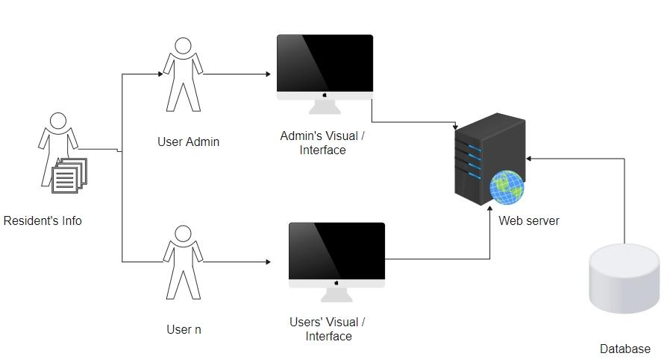The organizational diagram represents the general design and organization of the system, including its components.

**Figure 2. System Architecture of Management System.**

The organizational diagram represents the general design of made organization of the system, including its components, and demonstrates that the proponents have an Understanding of the System.

The following presentation illustrates how the information of the Client/ Customer and the administration is stored in the system's database and how they need it to access their accounts to be directed into the system's interface, which the system could access online or through the web. This allows clients/ customer and administrator to securely access their respective accounts and perform important system activities. Their data is not only kept in the system's database, but it also allows for proper data management and retrieval, which improves the system general functionality.

## Conceptual Design

This section represents the application as a conceptual entity -relationship model. Verification of the conceptual designs required to ensure that all needed data has been acquired and that is supports all processes identified in the requirement specifications

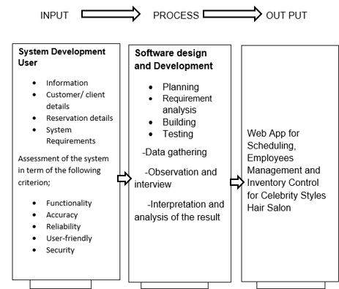**Figure3. Research Paradigm of Management System**

system for Celebrity Styles Hair Salon by transforming specific inputs into desirable outputs through a series of processes. The inputs (I) of the system include system development requirements, user information, customer/client details, and reservation system requirements. These inputs undergo a series of processes (P), consisting of planning, requirements analysis, building, and testing, to produce the desired outputs (O). The expected outputs of this system are a web application for scheduling appointments, an employee management system, and an inventory control system.

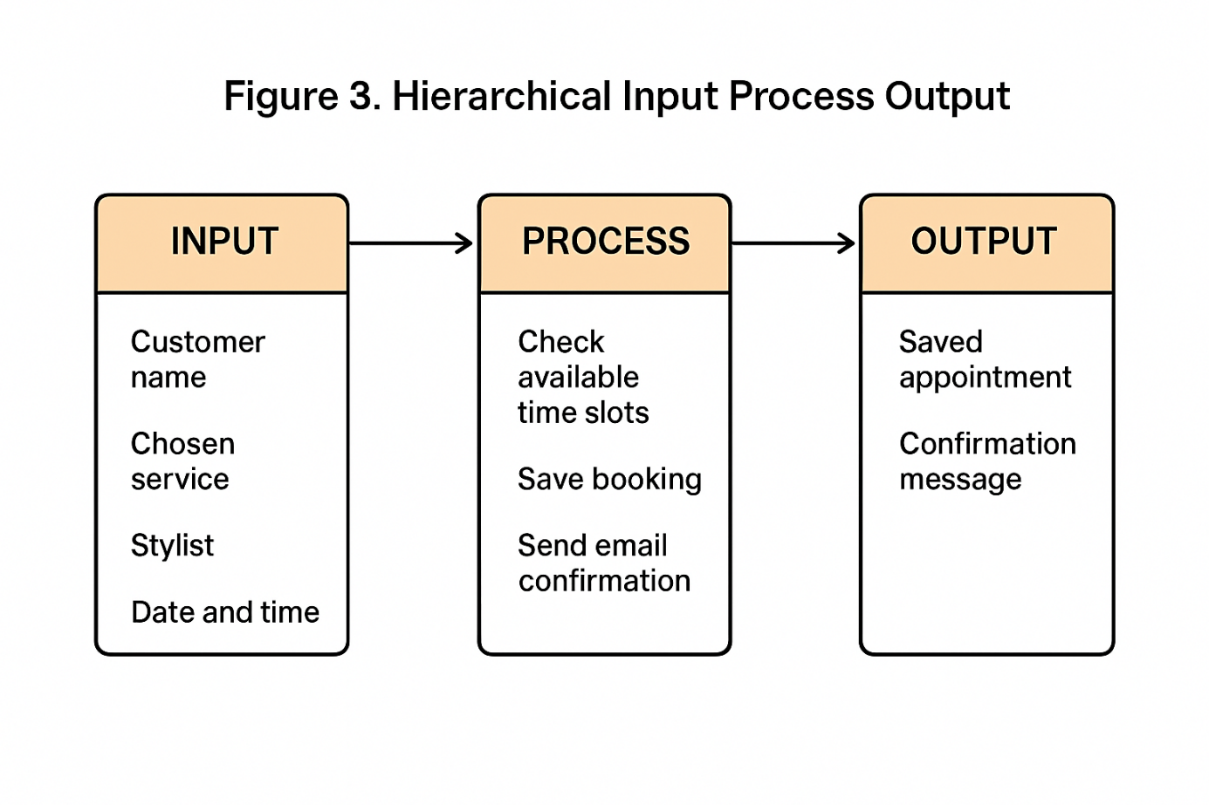

**Figure 4. Hierarchical Input Process Output**

The HIPO (Hierarchical Input Process Output) diagram seamlessly integrates two systematic methodologies for system analysis, providing a structured documentation mechanism. Analysis leverage HIPO diagrams to gain is comprehensive overview of the system functions employee, a hierarchical decomposition of function into sub – functions. The diagram effectively elucidates the system's operational workflow, offering high level-picture of its inner workings. facilitating diagrams serve as an invaluable for documentation purposes, offering clear and intuitive graphical representations. Such visual aids greatly enhance understanding for both designers and managers, facilitating smoother communication and decision making

## Cost benefit Analysis

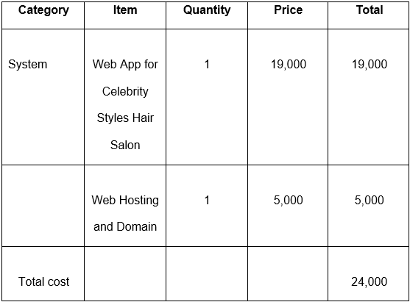

**Table 1. Cost and Benefits of Web app for Celebrity Salon.**

The table represents the planned projects development cost as reported by the proponents. It includes the system, web hosting and domain name of the project for a total of 24,000. With an estimated yearly revenue increase of 10,000, the salon was able to break even on the investment in about 2.4 years and eventually yield a positive return on investment. This is because the total investment of 24,000, which includes 19,000 for the web app development and 5,000 for web hosting and domain registration, is expected to yield significant benefits, such as increased online presence, improved customer engagement, increased revenue, and a competitive advantage.

**Software**

The following software we used and required by the project developers. The specification and description are listed below, along with a specific request. 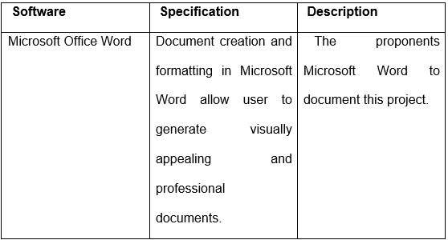

**Table 2. Software Requirements**

**Hardware**

The hardware used and requirements by the developers to build the project is described in the following section. Hardware refers to the physical components of a computer, as opposed to the data it stores or acts on. The developers decided that

it would be used to justify the project.

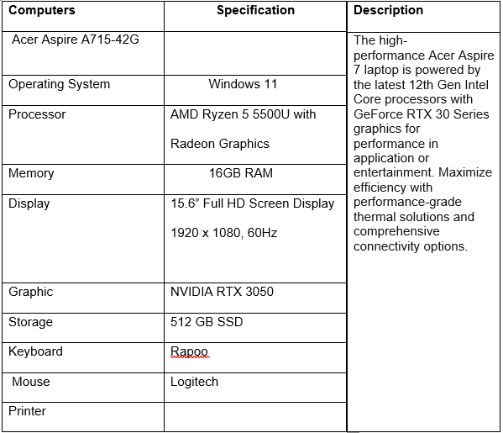

**Table 3. Hardware Requirements**

**Requirements Analysis**

During this stage, the proponents present a list of both functional and nonfunctional requirements for the system. The features of a system that satisfy the needs of the customer are known as its functional requirements. A system's technical needs are its non-functional requirements. The use case in this diagram explain what the system is capable of and how the user use it, and this is how the proponents plan to identify how the system interacts with the user.

**SYSTEM ARCHITECTURE/SYSTEM FLOW**

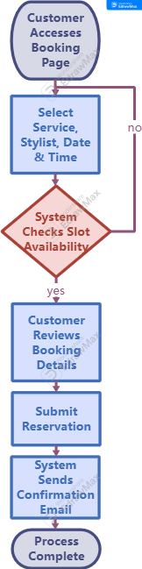

**Figure 5. Client Flow chart**

The client flow chart illustrates the step-by-step process a customer follows when making an online reservation. It begins with the customer accessing the salon’s booking page, where they are able to select a service, preferred stylist, and desired date and time. The system then checks the availability of the chosen slot to ensure there are no scheduling conflicts.

Once the availability is confirmed, the customer reviews the booking details. If the information is correct, they submit the reservation. Immediately after submission, the system generates an automated email notification to confirm that the appointment has been successfully recorded.

This structured flow ensures that the process is simple, quick, and reliable, reducing the chances of errors or missed bookings while giving customers confidence that their appointment is secured

. 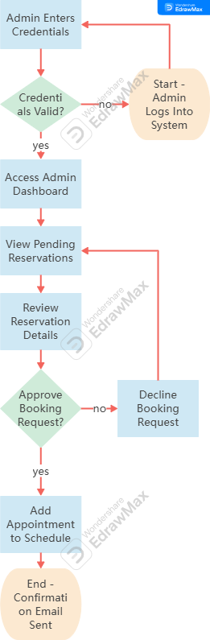

**Figure 6. Admin Flowchart**

The admin flow chart shows the sequence of actions taken by the salon administrator to manage customer reservations. The process starts when the administrator logs into the system and enters their credentials. The system verifies the login information, and if correct, grants access to the admin dashboard.

From the dashboard, the administrator can view all pending reservations. Each reservation is reviewed to ensure accuracy and validity. The administrator then decides whether to approve or decline each booking request. Once approved, the appointment is added to the salon’s schedule, and the customer receives a confirmation email.

This structured flow helps maintain an organized booking process, prevents scheduling conflicts, and ensures that only valid appointments are added to the salon’s calendar.

**Block Diagram**

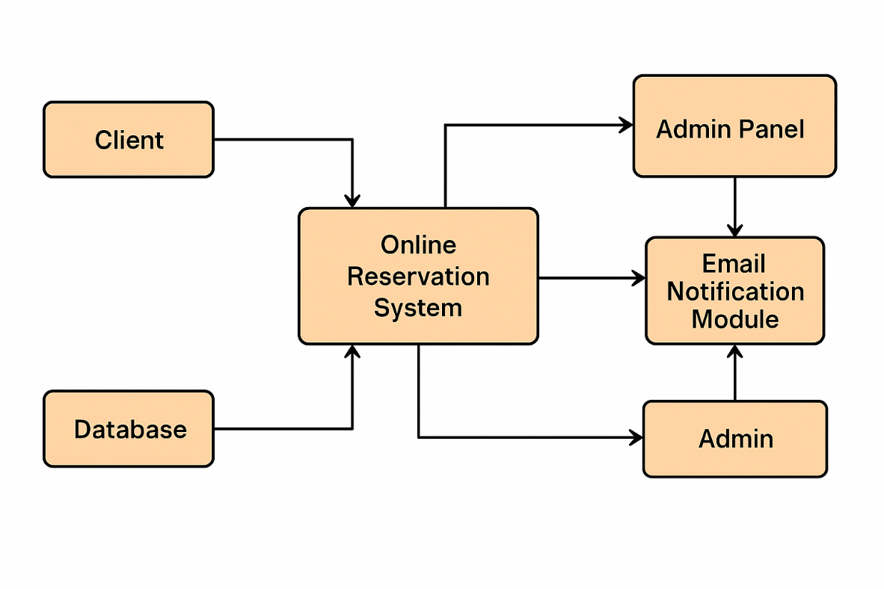

**Figure 7.. System Architecture Block Diagram**

The block diagram illustrates the key components and data flow of the online reservation system for Celebrity Styles Hair Salon – Bauan Batangas Branch. The process starts with the Client, who accesses the web-based platform to make a reservation by selecting the service, stylist, and preferred date and time.

The booking request is sent to the Online Reservation System, which manages the interaction between users and the system’s backend. This module communicates with the Database to store customer details, selected services, and appointment schedules.

Once the reservation is successfully recorded, the Email Notification Module automatically sends a confirmation message to the client, providing assurance that their booking has been received.

Simultaneously, the system updates the Admin Panel, where salon staff can view and manage pending reservations. The Admin then reviews the bookings, approves or declines them, and finalizes the schedule.

This structured process ensures accurate data handling, efficient communication, and a seamless experience for both customers and administrators.

## Develop And Testing

## The online reservation system was created step by step using the Agile method. First, the team built the basic parts, such as the booking page where customers can choose a service, date, and stylist. Then, they added features like checking if a time slot is available, sending email confirmations, and making an admin page where staff can see and approve bookings.

## After each part was made, it was tested right away. The team checked if the booking form worked, if the system saved the information correctly, and if the email notifications were sent without problems. They also asked a few people to try using the system to see if it was easy to understand.

## When issues came up—like a wrong time showing or a late email—the team fixed them before moving to the next step. Doing it this way helped make sure the system was simple, reliable, and ready for real customers to use.

## Description Of Prototype

The prototype is the first working version of the online reservation system for Celebrity Styles Hair Salon. It shows how customers can book a service, choose a stylist, and pick a date and time through a simple web page. After they submit their booking, the system saves the information and sends an email to confirm that the reservation was received.

For the admin side, the prototype includes a dashboard where salon staff can view all reservations. From there, they can approve or decline bookings to make sure the schedule is organized.

This early version already shows the main features: easy booking for clients, email confirmations, and a simple way for the salon to manage appointments.

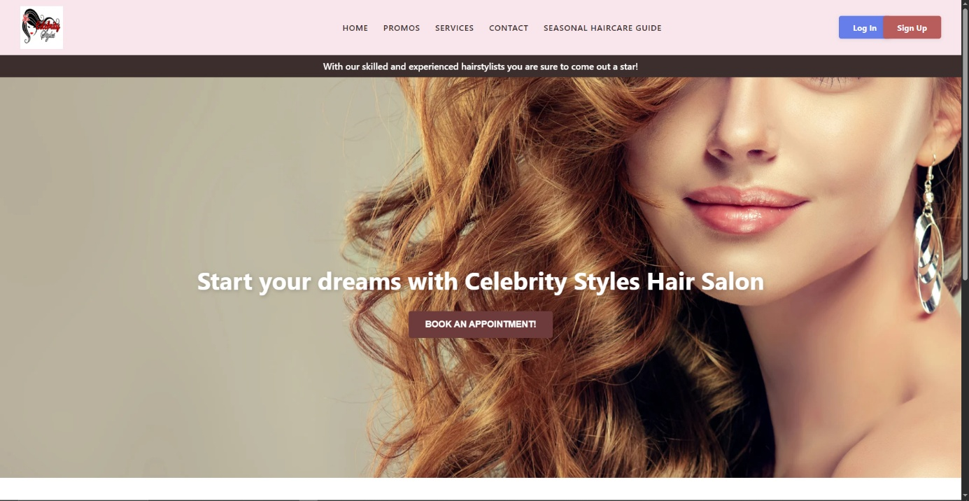

**Figure 8. Dashboard**

The homepage of the online reservation system. It welcomes users with a clean design and a featured message: “Start your dreams with Celebrity Styles Hair Salon.”

The page also includes a clear “Book an Appointment” button that leads customers to the reservation form. Navigation links like Home, Promos, Services, Contact, and Seasonal Haircare Guide are placed at the top, making it easy for users to explore. Log In and Sign Up buttons are also visible for account access.

This layout helps clients feel confident and makes it simple to start their booking journey.

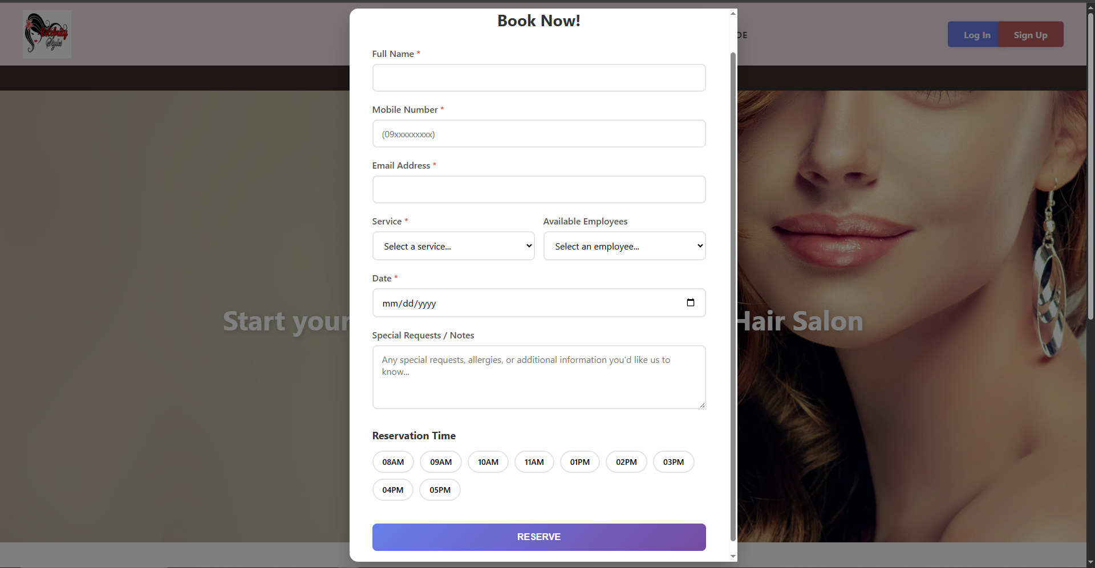

**Figure 9. Booking Page**

## the Booking Page where customers can schedule their salon appointments. The form includes fields such as full name, mobile number, and email address to identify the client and send a confirmation. Customers can select a service from a dropdown list and choose an available employee or stylist. They also pick a preferred date using the calendar input and select a time slot from the available options ranging from 8:00 AM to 5:00 PM. There is also a special requests or notes section where customers can include any allergies, preferences, or additional information. Once all the details are filled out, clicking the "RESERVE" button submits the appointment. The system then processes the request and sends a confirmation email to the customer.

## Implementation Plan

**1. Deployment Timeline**

The implementation of the AI-Powered Web-Based Management System for Celebrity Styles Hair Salon follow a phased approach to ensure smooth adoption and minimal disruptions.

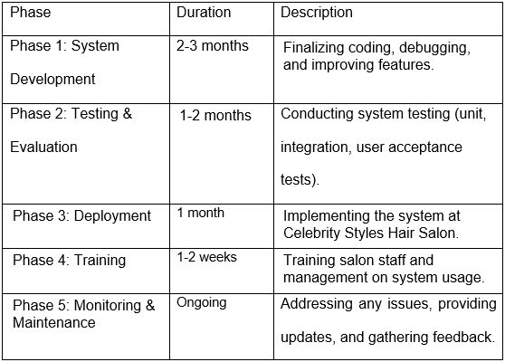

**Table 4. Deployment Timeline**

The table represents the implementation plan for the celebrity hair style salon's web application development project consists of five phases: System Development (2-3 months), Testing and Evaluation (1-2 months), Deployment (1 month), Training (1-2 weeks), and ongoing Monitoring and Maintenance. This phased approach ensured that the project was completed efficiently and effectively, meeting the requirements and expectations of the salon.

**2. Training Plan**

To ensure effective use of the system, training was provided for:

**Salon Staff** (employees) – How to manage appointments, view schedules, and update records.

**Admin/Owner** – How to manage inventory, monitor appointments, and oversee staff schedules.

**Customers (Optional)** – A guide on how to use the online booking system.

Training was conducted through:

**Hands-on Demonstrations** – In-person walkthroughs for salon employees.

**User Manual & Video Tutorials** – Step-by-step guides for future reference.

**Support Assistance** – A designated contact for troubleshooting issues.

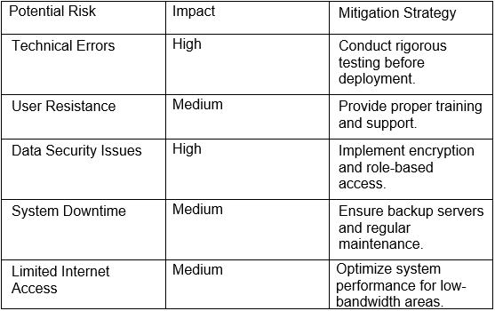

**Table 5. Risk Assessment & Mitigation**

|  |  |  |  |  |
| --- | --- | --- | --- | --- |
| **Items related to Scheduling** | **Mean** | **SD** | **Interpretation** | **Rank** |
| The current scheduling system is efficient. | 4.33 | 1.06 | Strongly Agree | 1 |
| An automated system would improve scheduling. | 4.30 | 1.18 | Strongly Agree | 2.5 |
| A system with automated reminders would help reduce missed appointments. | 4.30 | 0.99 | Strongly Agree | 2.5 |
| Too much time is spent managing schedules manually. | 4.17 | 1.05 | Agree | 4 |
| It is easy to reschedule appointments under the current system. | 4.07 | 1.05 | Agree | 5 |
| **Overall Mean Scheduling** | **4.23** | **0.43** | **Strongly Agree** |  |

## System Evalocation Results of Respondents

**Table 6. Overall Mean Scheduling**

*Scale: 1.00 – 1.80 (Strongly Disagree), 1.81 – 2.60 (Disagree), 2.61 – 3.40 (Neutral), 3.41 – 4.20 (Agree), 4.21 – 50 (Strongly Agree)*

The overall mean score for the scheduling items was 4.23, with a standard deviation of 0.43, indicating that respondents strongly agree that the scheduling features (both existing and proposed) are effective and beneficial. The relatively low standard deviation suggests a strong consensus among respondents.

|  |  |  |  |  |
| --- | --- | --- | --- | --- |
| **Items related to Overall System Satisfaction** | **Mean** | **SD** | **Interpretation** | **Rank** |
| A centralized management system would improve operations. | 4.40 | 0.97 | Strongly Agree | 1 |
| The current salon management approach meets business needs. | 4.17 | 1.02 | Agree | 2 |
| I would recommend upgrading to a modern salon management system. | 4.10 | 1.30 | Agree | 3.5 |
| The current system is easy to use and user-friendly. | 4.10 | 1.16 | Agree | 3.5 |
| I would support investment in a new system if it increases efficiency. | 3.93 | 1.34 | Agree | 5 |
| **Overall Mean of System Satisfaction** | **4.14** | **0.54** | **Agree** |  |

**Table 7. Overall Mean of System Satisfaction**

*Scale: 1.00 – 1.80 (Strongly Disagree), 1.81 – 2.60 (Disagree), 2.61 – 3.40 (Neutral), 3.41 – 4.20 (Agree), 4.21 – 50 (Strongly Agree)*

The overall mean for system satisfaction is 4.14, which falls within the “Agree” range. The standard deviation of 0.54 suggests a consistent trend among respondents with minor variation in opinion. This indicates that participants have a generally positive perception of the current system, while showing openness to enhancements.

# CHAPTER IV

# SUMMARY OF FINDING , CONCLUSION AND RECOMMENDATIONS

## Based on the development and testing of the online reservation system for Celebrity Styles Hair Salon – Bauan Batangas Branch, the system successfully addressed the main problems of the manual booking process. It provided customers with an easy way to schedule appointments anytime and allowed the salon staff to manage reservations efficiently. Email notifications worked as expected, ensuring that clients received confirmation messages after booking. Both admin and customer users found the interface easy to understand during testing.

## Summary of findings

## The online reservation system developed for Celebrity Styles Hair Salon – Bauan Batangas Branch successfully improved the booking process. Customers were able to book appointments easily by selecting services, preferred stylists, and available time slots. The system also sent email notifications to confirm each booking, which helped build trust and avoid confusion.

## During testing, users found the platform user-friendly and responsive. Admins were able to view and manage reservations through a dashboard, which made it easier to organize appointments and avoid double bookings. Overall, the system met the expected features and worked well during its trial phase.

## Conclusion

## The development of the online reservation system for Celebrity Styles Hair Salon – Bauan Batangas Branch achieved its main goal of improving the salon’s appointment process. The system made it easier for customers to book services anytime, choose their preferred stylist, and receive confirmation through email. This helped reduce scheduling errors and saved time for both clients and salon staff.

## The admin panel allowed salon employees to manage bookings more efficiently, ensuring that all appointments were organized and updated in real time. Based on testing and feedback, the system was found to be reliable, easy to use, and effective in addressing the problems of the previous manual setup.

## Overall, the project met its objectives and proved to be a helpful tool for improving customer service and internal operations.

## Recommendation

## To make the system even more useful, it is recommended to add an SMS notification feature in the future so that clients can receive reminders through text messages in addition to email.

## Adding a loyalty program to the system is also suggested. This feature can reward repeat customers with points, discounts, or special offers. Doing so may increase customer satisfaction and encourage clients to keep coming back to the salon.REFERENCES

[**https://www.academia.edu/81693770/Implicit_Theories_and_Creativity**](https://www.academia.edu/81693770/Implicit_Theories_and_Creativity)

Cabato (2023). Growth of appointment and travel planning using the internet in the Philippines. Inquirer. Retrieved from <https://newsinfo.inquirer.net/1863573/online-travel-booking-highest-contribution-to-ph-digital-economy-report>

Chen, Liu, and Zhang (2021). AI's influence on corporate leadership. SCIRP. Retrieved from <https://www.scirp.org/reference/referencespapers?referenceid=3708084>

De Bruyn et al. (2020). Artificial intelligence and marketing: Pitfalls and opportunities. Journal of Interactive Marketing, 51, 91-105. Retrieved from [**https://www.sciencedirect.com/science/article/abs/pii/S109499682030088**](https://www.sciencedirect.com/science/article/abs/pii/S109499682030088)

Hasley (2021). Benefits of online scheduling in healthcare. HHM Global. Retrieved from **Hasley (2021). Benefits of online scheduling in healthcare. HHM Global. Retrieved from**

Hua et al. (2022). Appointment management systems. BMC Health Services Research. Retrieved from <https://bmchealthservres.biomedcentral.com/articles/10.1186/s12913-022-08635-6>

Judan-Jiao (2024). Integration of generative in businesses. PhilStar. Retrieved from<https://www.philstar.com/the-freeman/cebu-business/2024/11/20/2401535/ibm-philippines-piie-collab-boost-ai-manufacturing>

Li et al. (2023). Generative AI's impact on productivity in the customer service sector. NBER Working Paper. Retrieved from <https://www.nber.org/system/files/working_papers/w31161/w31161.pdf>

Lorgat (2019). Web-based student result management system. ResearchGate. Retrieved from <https://www.researchgate.net/publication/318215858_Web-Based_Student_Result_Management_System>

Maligat et al. (2020). Web-based knowledge management system for Camarines Norte State College. ResearchGate. Retrieved from <https://www.researchgate.net/publication/341712328_Web-based_Knowledge_Management_System_for_Camarines_Norte_State_College>

Project Clinik (2023). Cross-platform scheduling and appointment reservation system. ResearchGate. Retrieved from <https://www.researchgate.net/profile/Cris-Norman-Olipas/publication/370755576_Project_Clinik_A_Cross-Platform_Scheduling_and_Appointment_Reservation_System/links/64604d944353ba3b3b632979/Project-Clinik-A-Cross-Platform-Scheduling-and-Appointment-Reservation-System.pdf>

Salesforce (2024). A adoption in the Philippines. BusinessWorld. Retrieved from <https://www.bworldonline.com/bw-launchpad/2025/03/05/657193/ai-agents-to-streamline-philippine-businesses-workload-salesforce/>

Taufik and Luthfia (2020). Web-based application for thesis and defense management. President University Repository. Retrieved from <http://repository.president.ac.id/handle/123456789/3295>

Vlacic et al. (2021). The trajectory of marketing and research fields. Journal of Business Research, 128, 187-203. Retrieved from <https://ideas.repec.org/a/eee/jbrese/v128y2021icp187-203.html.>

Adapted and modified from: *Online Reservation and Ordering System Survey Questionnaire*, Academia.edu (Retrieved 2023, <https://www.academia.edu>)

### APPENDIX A

**SAMPLE QUESTIONNAIRE**

Questionnaire on Celebrity Styles Hair Salon

Name:(Optional)______________________ Age: _______ Gender: _______

OBJECTIVES : We are 3rd year at AMA Computer College , we are currently undertaking our Capstone Research project titled “Celebrity Styles Hair Salon Management for Scheduling , Employee Management and Inventory Control.”This projects aims to develop a web based system for Celebrity Styles Hair Salon.

DIRECTION:

For each statement below , please indicate how much you agree or disagree with the statement by selecting the response that best represent your opinion . Use the following scale to guide your responses:

5 - Strong Agree

4- Agree

3-Neutral

2 -Disagree

1. Strongly Disagree

|  |  |  |  |  |  |
| --- | --- | --- | --- | --- | --- |
| Statement | 5 | 4 | 3 | 2 | 1 |
| **SCHEDULING** |  |  |  |  |  |
| 1. The current scheduling system is efficient. |  |  |  |  |  |
| 1. It is easy to reschedule appointments under the current system. |  |  |  |  |  |
| 1. An automated system would improve scheduling. |  |  |  |  |  |
| 1. Too much time is spent managing schedules manually. |  |  |  |  |  |
| 1. A system with automated reminders would help reduce missed appointments. |  |  |  |  |  |
| **OVERALL SYSTEM SATISFACTION** |  |  |  |  |  |
| 1. The current salon management approach meets business needs. |  |  |  |  |  |
| 1. A centralized management system would improve operations. |  |  |  |  |  |
| 1. I would recommend upgrading to a modern salon management system. |  |  |  |  |  |
| 1. The current system is easy to use and user-friendly. |  |  |  |  |  |
| 1. I would support investment in a new system if it increases efficiency. |  |  |  |  |  |

**APPENDIX B**

**Beneficiary Approval Form**



Date 7/29/2025

We , are the students AMA COMPUTER COLLEGE , taking Bachelor of Science in Information Technology (BSIT) would like yo ask your permission to allow the undersigned proponents to interview your prominent institution.

We are humbly request for your service to serve as our beneficiary for our soon to make system, which are titled " Celebrity Styles Hair Salon for Scheduling, Employee Management and Inventory Control " as a partial requirements for our IT Capstone Project 1. In line with this project the proponenst wouuld to gather accurate and helpful information through an interview method , which will guide analysis and create an Official Website that will help your consumers.

The proponents will be very grateful to you and ll ghe members of this school . If you accept this project proposal , rest assured that any gathered information will be used strictly for education purposes only and remain confidental.

Hoping your kind consideration

Respectfully yours

Received by:

__________________________________

_______________________________________

Signature over printed Name

Proponent 1

__________________________________

Signature over printed name

Proponent 2

_____________________________________

Signature over printed name

Proponent 3

**APPENDIX C**

|  |  |  |
| --- | --- | --- |
| **National Road, Bolbok, Batangas City** | Doc. No. | FR-RES-RTP |
| Issue No. | 00 |
| Revision No. | 00 |
| College/Department: BSIT | Date of Effectivity | July 2025 |
| **RESEARCH TOPIC PROPOSAL FORM** | | Page 1 of 2 |
|  | |  |

**Research Topic Proposal Form**

|  |  |  |  |
| --- | --- | --- | --- |
| Name of Student | De Torres, Jersey  Flores, Isaac Vince  Ramos, Johnlery | | |
| USN | 21007064810  2001800100  19003436600 | Program | Bachelor of Science in Information Technology (BSIT) |

|  |  |
| --- | --- |
| Proposed Title | Celebrity Styles Hair Salon Management: For Scheduling,  Employee Management, and Inventory Control |
| Area of Investigation | Web-based system, Salon management, Appointment scheduling, Operational efficiency, Manual process, Automation, Customer satisfaction, Batangas salon |
| Reasons for Choice of Project | Because the study focus to have an better customer satisfaction and fast and more accurate transaction |
| Importance of the Study | Digital transformation, Customer experience, Online booking, Inventory management, Employee scheduling, Error reduction, Business efficiency, Strategic growth, Data management, IT research |
| Target Users/Beneficiary | salon , client , and employee |
| Similarity with any Previous Study/Project | ALMA system, Salon Chami system, Beautify system, Appointment automation |



|  |  |  |
| --- | --- | --- |
| **National Road, Bolbok, Batangas City** | Doc. No. | FR-RES-RTP |
| Issue No. | 00 |
| Revision No. | 00 |
| College/Department: BSIT | Date of Effectivity | July 2025 |
| **RESEARCH TOPIC PROPOSAL FORM** | | Page 2 of 2 |
|  | |  |

|  |  |
| --- | --- |
| Similarity with any Previous Study/Project | ALMA system, Salon Chami system, Beautify system, Appointment automation |
| Project Time Table (Gantt Chart) |  |

|  |  |  |
| --- | --- | --- |
| Recommending Approval | Signature | Approved by |
| Research Adviser |  | Research Director |
| Technical Adviser |  |
| Research Coordinator |  |
| Dean |  |



APPENDICEX D

Certification of grammarian  
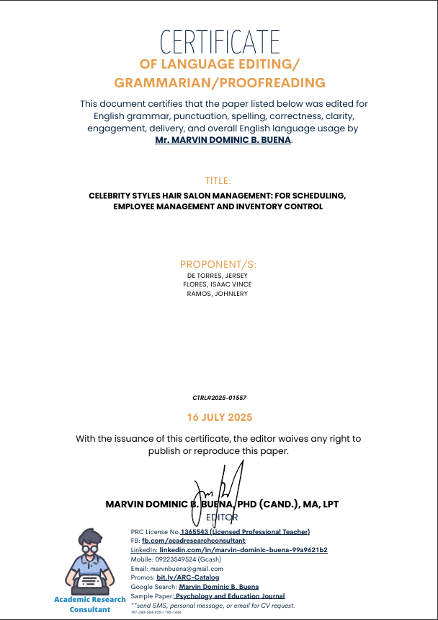

APPENDICEX E

Certification of Statistian



Descriptive Statistics: Scheduling

Statistics

|  |  |  |  |  |  |  |  |  |
| --- | --- | --- | --- | --- | --- | --- | --- | --- |
| Variable | Mean |  | SE Mean | StDev | Q1 | Median | Q3 | IQR |
| Scheduling Q1 | 4.333 |  | 0.194 | 1.061 | 4.000 | 5.000 | 5.000 | 1.000 |
| Scheduling Q2 | 4.067 |  | 0.191 | 1.048 | 4.000 | 4.000 | 5.000 | 1.000 |
| Scheduling Q3 | 4.300 |  | 0.215 | 1.179 | 4.000 | 5.000 | 5.000 | 1.000 |
| Scheduling Q4 | 4.167 |  | 0.192 | 1.053 | 4.000 | 4.000 | 5.000 | 1.000 |
| Scheduling Q5 | 4.300 |  | 0.180 | 0.988 | 4.000 | 5.000 | 5.000 | 1.000 |
| Scheduling | 4.2333 |  | 0.0785 | 0.4302 | 3.9500 | 4.4000 | 4.6000 | 0.6500 |

Descriptive Statistics: Overall System Satisfaction

Statistics

|  |  |  |  |  |  |  |  |
| --- | --- | --- | --- | --- | --- | --- | --- |
| Variable | Mean | SE Mean | StDev | Q1 | Median | Q3 | IQR |
| SatisfactionQ1 | 4.167 | 0.186 | 1.020 | 4.000 | 4.000 | 5.000 | 1.000 |
| SatisfactionQ2 | 4.400 | 0.177 | 0.968 | 4.000 | 5.000 | 5.000 | 1.000 |
| SatisfactionQ3 | 4.100 | 0.237 | 1.296 | 4.000 | 5.000 | 5.000 | 1.000 |
| SatisfactionQ4 | 4.100 | 0.211 | 1.155 | 4.000 | 4.000 | 5.000 | 1.000 |
| SatisfactionQ5 | 3.933 | 0.244 | 1.337 | 3.000 | 4.000 | 5.000 | 2.000 |
| Satisfaction | 4.1400 | 0.0983 | 0.5386 | 3.8000 | 4.2000 | 4.6000 | 0.8000 |

APPENDICEX F

System Manual