FRA231: Robotics Sensors & Actuators: Modelling & Experimentation  
Homework Assignment 3: Modelling of DC-motor

You and your partner are tasked to model a specific permanent magnet brush DC motor and synthesize signal converter for the practical use. A high-level system architecture diagram is shown below.

Figure 1: System Architecture Diagram

**Task 1**: You must model ENA-020Q3000 PMDC brush motor from Allied Motion. The datasheet of the motor can be found here.

<https://www.alliedmotion.com/wp-content/uploads/documents/Endurance_20_Datasheet_R2ascrn.pdf>

For this specific assignment, you ***MUST*** parameterize the model by stall torque & no-load speed in the Simscape’s DC Motor block although the stall torque is not given in the datasheet.

Assume that the internal inductance $L$ is $0.01$ $\left[H\right]$ and the mechanical inertia is $0.1 \left[g⋅cm^{2}\right]$

**Task 2**: You must implement a subsystem that represent a signal converter. The signal converter must do the following.

* The converter saturates the input $u$ to the value 100. This implies that even though the input $u$ varies beyond 100 and -100, the resulting signal will be bounded between 100 and -100 (anything above 100 will convert to 100).

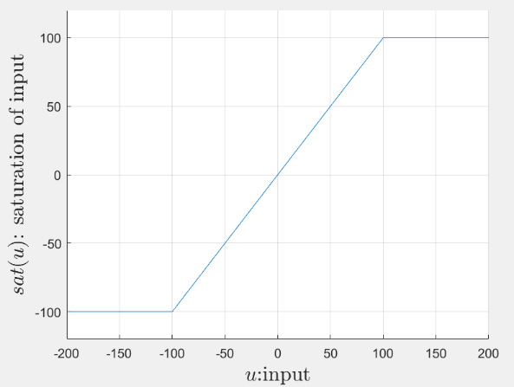

Figure 2: graph of saturation

* The saturated signal must be converted to the duty cycle of PWM $d$ and the direction of rotation $r$.
* The direction signal $r$ is a digital signal that depends on the sign of the input $u$.
$$r=\left\{\begin{aligned}0, &u≥0 \\ 1, &u<0\end{aligned}\right.$$

* The duty cycle of the output PWM $d$ is bounded between 0 and 100 (%), which linearly corresponds to the magnitude of $u$.

$$d∈\left\{x∈R:x∈\left[0,100\right]\right\}$$