Program Structure

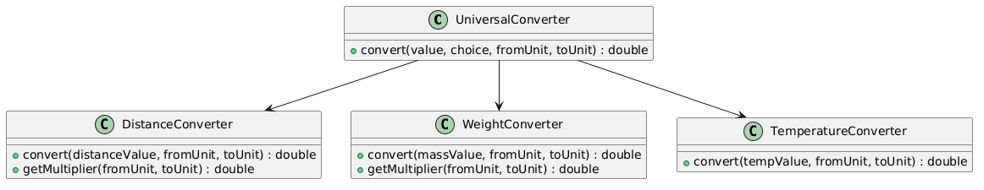

Top-down Integration
Unit under test | List of Stubs/Drivers | result | Stub’s return value | Expected results | Actual results | Pass/Fail/No run
UniversalConverter | DistanceConverterStub | 1.0 | 1.0 | 1.0 | 1.0 | Pass
UniversalConverter | WeightConverterStub | 1000.0 | 1000.0 | 1000.0 | 1000.0 | Pass
UniversalConverter | TemperatureConverterStub | 32 | 32.0 | 32.0 | 32.0 | Pass

Bottom-up Integration
Unit under test | List of Stubs/Drivers | result | Stub’s return value | Expected results | Actual results | Pass/Fail/No run
DistanceConverter | DistanceConverterDriver | 1.0 | - | 1.0 | 1.0 | Pass
WeightConverter | WeightConverterDriver | 1000.0 | - | 1000.0 | 1000.0 | Pass
TemperatureConverter | TemperatureConverterDriver | 32.0 | - | 32.0 | 32.0 | Pass

