



**DEPARTMENT OF “BACHELOR OF COMPUTER APPLICATION”**

**NESS WADIA COLLEGE OF COMMERCE, PUNE**

**ACADEMIC YEAR 2023-24**

**SEMESTER – V**

A

PROJECT REPORT

ON

***ONLINE BUS TICKET BOOKING SERVICES***

SUBMITTED TO

SAVITRIBAI PHULE PUNE UNIVERSITY

SUBMITTED BY

Prajval Haged

&

Ritik Kadechur

UNDER THE GUIDANCE OF

Prof. Leena Thorat

Prof. Ashwini Waghmare

**ACKNOWLEDGEMENT**

I would wish to thank all the people who have helped to make this project possible. A project for a student is an experience, in the course of which he/she realizes the realworld problems that one has to undergo during the development of any project. Hence without the help and guidance of our teachers, this project wouldn't have been successful. We are grateful to them for supporting us throughout the Design, Implementation and Evaluation phase of the project.



I'm thankful to Prof. SEEMA PURANDARE and Prof. ASHWINI WAGHMARE for giving us their valuable time and also for guiding through the stages of the project and also being such a supportive project guide.

I also acknowledge with sense of reverence my gratitude towards the Prof. SEEMA PURANDARE and Prof. ASHWINI WAGHMARE for providing us an opportunity to work in project.

I also sincerely acknowledge the help of the entire staff of the Bachelors in Computers Application Department and our classmates whose cooperation has made our project a success.

Your Sincerely,

Prajval Haged

&

Ritik Kadechur

**INDEX**

|  |  |  |  |
| --- | --- | --- | --- |
| **No.** |  | **Title** | **Page No.** |
| **1.** | 1.1  1.2  1.3 | **Introduction**  Problem Definition  Need for the New System  Project Scope |  |
| **2.** | 2.1  2.2 | **Analysis**  Feasibility Study   * Technical Feasibility * Economical Feasibility * Operational Feasibility   Hardware and Software Requirements |  |
| **3.** | 3.1  3.2  3.3 | **Design**  DFD diagram  ER diagram  Data dictionaries |  |
| **4.** |  | **Screenshots** |  |
| **5.** |  | **Limitations** |  |
| **6.** |  | **Future Enhancement** |  |
| **7.** |  | **References and Bibliography** |  |

**1. Introduction**

1.1 Problem Definition

In today's fast-paced and financially complex world, individuals and businesses face a common challenge - effectively managing their financial resources.

The problem lies in the difficulty of keeping track of income and expenses, which can lead to financial disarray, overspending, and an inability to make informed financial decisions.

Without a structured system, people often struggle to understand where their money is going and how to allocate funds optimally. The problem is compounded when individuals and businesses are unable to generate clear, concise reports that provide insights into their financial habits, making it challenging to set and achieve financial goals.

The Expense Tracker aims to address this problem by providing a solution that simplifies the recording, categorization, and reporting of income and expenses, empowering users to take control of their finances, make informed decisions, and work toward financial stability and success.

1.2 Need for New System

1. Financial Management: As individuals and businesses juggle complex income streams and expenses, there's a growing need for a centralized system to track, record, and manage these financial transactions. A new Expense Tracker system provides a more organized approach to financial management.

2.Budgeting and Planning: Creating and adhering to a budget is crucial for financial stability. An Expense Tracker system offers the tools to set and monitor budgets, ensuring that users can plan their spending effectively and avoid overspending.

3. Improved User Experience: User interface design and user experience (UX) play a crucial role in the success of expense tracker software. A new system may be developed to offer a more intuitive and user-friendly interface, making it more accessible to a broader audience.

4. Customization and Reporting: Users often have unique financial needs and preferences. A new system can offer customization options and generate detailed reports, including graphical representations, to cater to diverse user requirements.

1.3 Project Scope

The project scope of a expense tracker outlines the specific objectives, deliverables, features, and limitations of the project. It defines the boundaries of what the project will encompass and is essential for project management, budgeting, and communication.

Here's a basic outline of the project scope for a expense tracker:

**Project Title**: Expense tracker system

**Project Description:**

The Expense Tracker is a user-friendly digital tool that simplifies financial management. It allows easy recording and categorization of income and expenses, providing insightful reports. With user profiles and data visualization, it's a valuable resource for informed financial decision-making and goal achievement, catering to both personal and business finances.

**Project Objectives:**

1. Develop a user-friendly and intuitive expense tracker system.

2.Enable users to record income and expenses with ease and accuracy.

3.Categorize expenses to provide a structured overview of spending habits.

**Project Deliverables:**

1. User-friendly expense tracker application.
2. Comprehensive user documentation for efficient usage.
3. A secure system with user profiles and authentication.
4. Income and expense recording and categorization features.

**Technical Requirements:**

1. Compatibility with Windows7, Windows 10, macOS 11, and modern web browsers.

2. Support for multi-core processors and GPUs for improved performance.

**Testing and Quality Assurance:**

1. Comprehensive testing of all features and functions.

2. Timely updates and bug fixes.

**Project Timeline:**

1. Planning and requirements gathering: 3 Weeks

2. Development: 2 week

**2. Analysis**

2.1 Feasibility Study

A feasibility study for a expense tracker project is essential to assess whether the project is viable and worth pursuing. It helps in evaluating the technical, economic, operational, and scheduling aspects of the project. Here are the key components of a feasibility study for a photo editor project:

**Technical feasibility**: The technical requirements for this projects are very suitable

**Hardware Requirements**:

Processor - Any Updated or Latest Processor

Speed-1.13 GHz or above

RAM- 4GB (Min)

Any basic machine would be able to run and use this tracker very easily without giving much load to there system.

**2. Economic Feasibility:**:function of this project is to track the spendings and categorize them accordingly to give you your monthly expense and the giving ways to potentially cut cost.so there will be no requirements for extra funding

**3. Operational Feasibility:**As the system is going to be very user friendly there is no need to have any kind of extra knowledge to use this software

This system can be used by school student and an working class man

2.2 Hardware and Software Requirement

The software and hardware requirements for a expense tracker project depend on the project's goals, the complexity of the software, and the target platforms. Here is a general outline of the software and hardware requirements for a expense tracker project:

**Software Requirements**: Chrome and Vs Code for Development

**Hardware Requirements**: Laptop or Computer, Stable Internet Connection

**3. Design**

3.1 DFD Diagram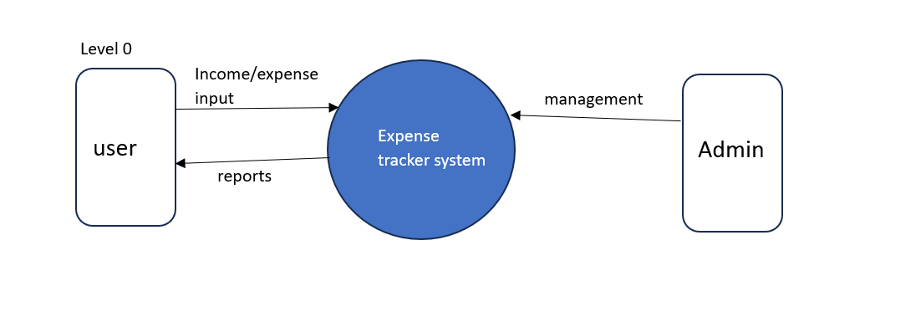

**First Level DFD**

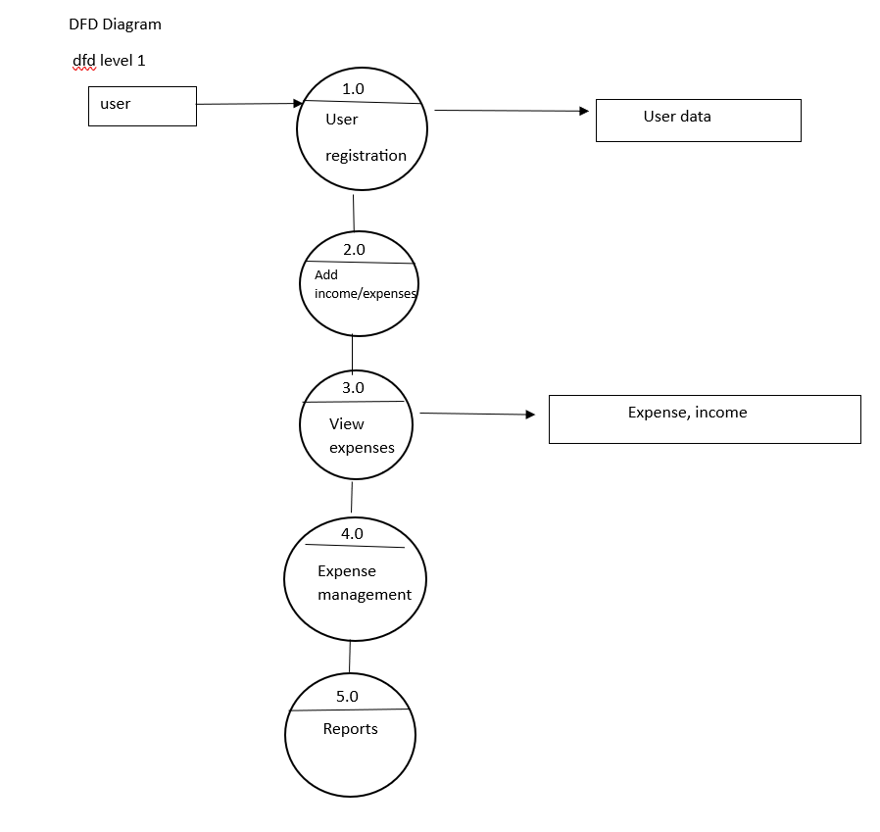

**3.2 ER DIAGRAM**

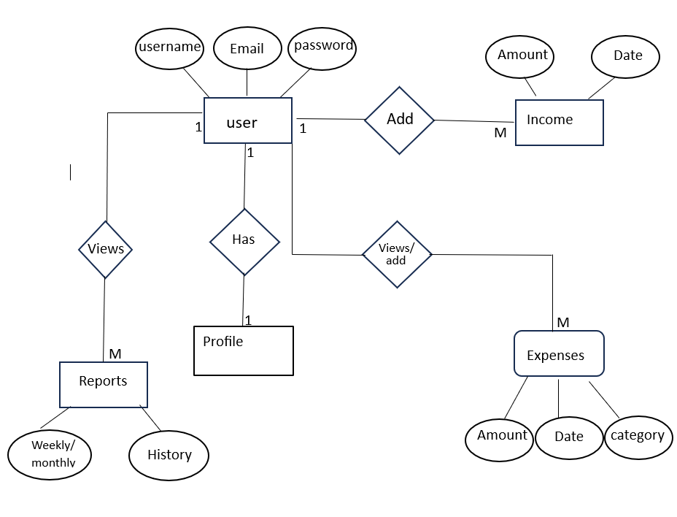

1. **Screenshots**

Home Page

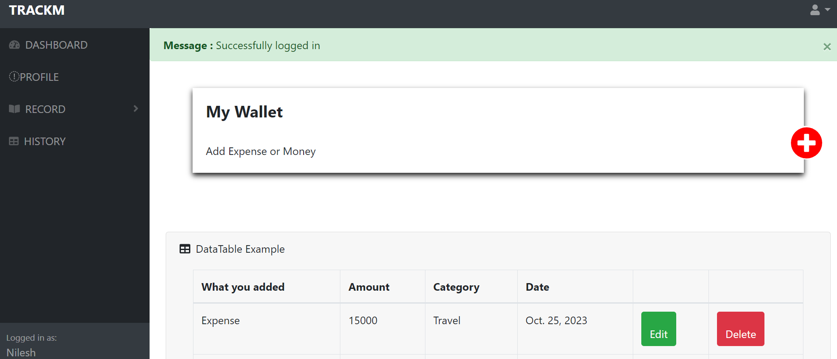

Report Page

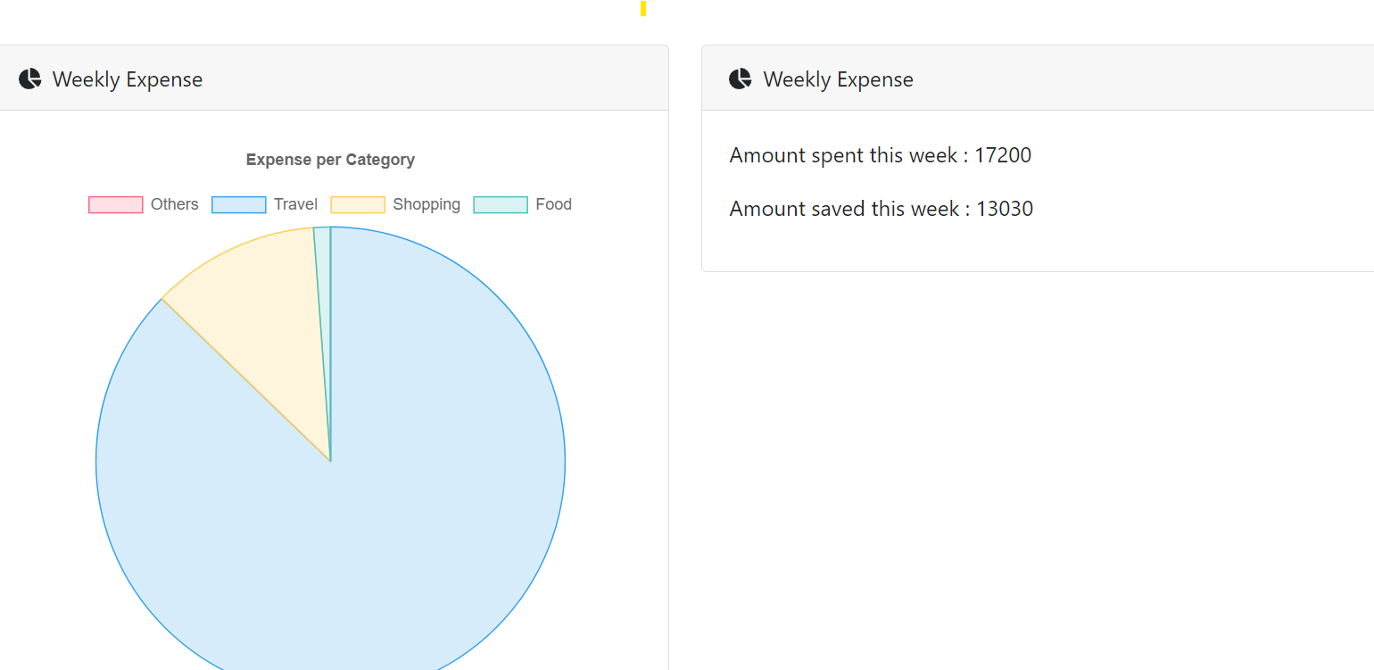Histort page

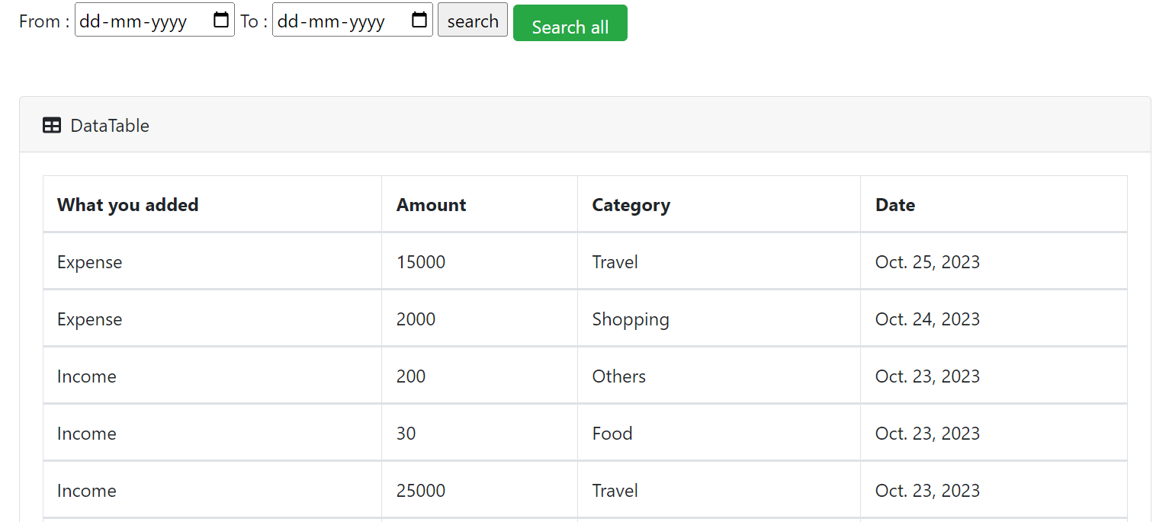

Wallet page



3.3 Data dictionaries

**5. Limitations**

Like any software project, a expense tracker project has limitations and constraints that developers and users should be aware of. Understanding these limitations is crucial for managing expectations, planning, and making informed decisions.

Here are some common limitations of a expense tracker project:

**1. Dependency on User Discipline**: The effectiveness of an expense tracker depends on users consistently recording transactions. Inconsistent usage can lead to incomplete and unreliable financial data.

**2. Compatibility:** Ensuring compatibility with a wide range of devices, operating systems, and web browsers can be challenging. The expense tracker may not perform consistently or support all features on every platform.

**3. Development Resources:** Constraints on development resources, including time and budget, may limit the speed of development and the extent to which features can be implemented.

**4. Cross-Platform Limitations:** Developing a consistent and feature-rich experience across multiple platforms (web, desktop, mobile) can be complex, and certain features may not be available on all platforms.

**6. Future enhancement**

Enhancing a expense tracker project can be an ongoing process to meet evolving user demands, technological advancements, and market trends.

**1. AI-Powered Tools:** Implement artificial intelligence (AI) algorithms to provide with suggestions based in user expense habits.

**2. Application**: Making this system to work as an app on both android and IOS devices.

**3. PDF:** Providing an feature of downloading reports of the users expenses.

**7. References and Biliography**

**Reference:** 1) expenditure-tracker.com

2)moneylover.me

**Biliography:**