***THANANI S***

***1JT18IS060***

**Program-4: Develop and demonstrate a HTML5 file that includes JavaScript script that uses functions for the following problems:**

**a. Parameter: A string**

**b. Output: The position in the string of the left-most vowel**

**c. Parameter: A number**

**d. Output: The number with its digits in the reverse order<html>**

CODE:

<body>

<script type="text/javascript">

var str = prompt("Enter the Input","");

if(isNaN(str))

{

str = str.toUpperCase();

const count = str.match(/[aeiou]/gi).length;

if(count ==0)

alert("No vowel found in the entered string '"+str+"'.");

else

alert("The number of vowels in the string '"+str+"' is "+count);

}

else

{

var num,rev=0,remainder;

num = parseInt(str);

while(num!=0) {

remainder = num%10;

num = parseInt(num/10);

rev = rev * 10 + remainder;

}

alert("Reverse of "+str+" is "+rev+" and thier product is " +(str*rev));

}

</script>

</body>

</html>

|  |  |  |  |
| --- | --- | --- | --- |
| **TEST NO** | **TEST CASE** | **EXPECTED OUTPUT** | **OUTPUT OBTAINED** |
| 1. | Integer Value: 234 | Reverse of 234 is 432 and their product is 101088 | Reverse of 234 is 432 and their product is 101088 |
| 2. | Negative Integer value: -234 | Reverse of -234 is -432 and their product is 101088 | Reverse of -234 is -432 and their product is 101088 |
| 3. | Alpha numerical value: QWER123 | The number of vowels in the string 'QWER123' is 1 | The number of vowels in the string 'QWER123' is 1 |
| 4. | Non vowel string: QWR | No vowel found in the entered string | No vowel found in the entered string |
| 5. | Test case of choice: I HAD MY BREAKFAST | The number of vowels in the string : I HAD MY BREAKFAST ' is 5 | The number of vowels in the string : I HAD MY BREAKFAST ' is 5 |

**SNAPSHOTS:**

**1.**

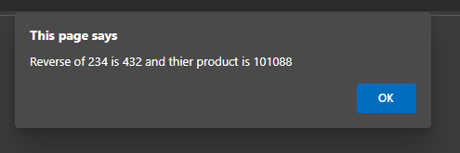

**2.**

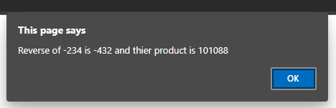

**3.**

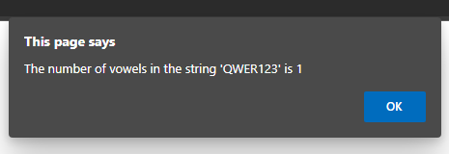

**4.**

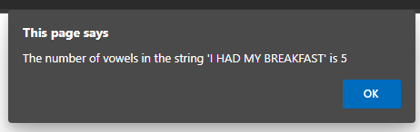

**5.**

