**An Emerging Sustainable Approach to Indian E-commerce by using German Pfand System- Closed-Loop Packaging and Delivery Optimization**

Rose Mol Peter [rose.peter@bca.christuniversity.in](mailto:rose.peter@bca.christuniversity.in) Department of Computer Science, Christ University, Bengaluru

Thanatip Singpee [thanatip.singpee@bca.christuniversity.in](mailto:thanatip.singpee@bca.christuniversity.in) Department of Computer Science, Christ University, Bengaluru

Hemant Tripathi [Hemant.tripathi@bca.christuniversity.in](mailto:Hemant.tripathi@bca.christuniversity.in) Department of Computer Science, Christ University, Bengaluru

Dr. Vineetha KR [vineetha.kr@christuniversity.in](mailto:vineetha.kr@christuniversity.in) Department of Computer Science, Christ University, Bengaluru

**ABSTRACT**

The research paper explores the revolutionary potential of introducing Pfand System, Closed-Loop System and Delivery Optimization (through Image-based Location Mapping) in the realm of Indian e-commerce, with an emphasis on efficiency and sustainability. By focusing the implementation of these innovative techniques in the context of RePack, an e-commerce platform committed to environmental sustainability, the study aims to address pressing ecological challenges simultaneously enhancing overall customer experiences. Through a review of existing literature and case studies, the research explains the significance of sustainable practices in controlling packaging waste and optimizing certain operations in online retail. This study also highlights the relevance of theses initiatives in the Indian e-commerce, fostering long-term economic sustainability and underscoring opportunities for revolutionizing industry practices. Despite the inevitable constraints such as contextual variations and data unavailability, the results and findings gained from this research offer invaluable insights into the numerous prospects and obstacles associated with promoting sustainability in e-commerce, thus charting a promising path for future inquiry and real-world application within the field. The implementation of this project involved using PHP along with MYSQL to develop and integrate the above features into the RePack e-commerce platform. This allowed seamless functionality and data management, ensuring making sure efficient execution within the platform.

**Keywords**: Pfand System, Closed-Loop Packaging, Delivery Optimization, Image-based Location Mapping, e-commerce, PHP implementation with mysql

1. **INTRODUCTION:**

Electronic commerce, or "e-commerce," is the purchasing and selling of products and services using the internet. It consists the transaction of data and funds between sellers and buyers, typically using technologies and digital platforms such as mobile apps, websites, online marketplaces, and electronic payment systems. RePack is an e-commerce website that revolutionizes e-commerce by seamlessly integrating three keen features that differentiates it from any other e-commerce platform: Pfand System, Closed-Loop Packaging and Delivery Optimization. The integration of these features brings about a substantial change in the arena of e-commerce. As the world struggles with rising ecological challenges, the necessity for innovative remedies to control waste generation and encourage resource conservation has grown increasingly urgent. This research addresses this increasing issue by studying the efficiency of Pfand System, Closed-Loop Packaging and Delivery Optimization.

* Pfand System: A Pfand system is a deposit-refund system where customers pay a deposit fee when purchasing certain items, which is refunded upon returning the empty container, which incentivizes recycling and waste reduction.
* Closed-Loop Packaging: A system where packaging materials are returned and then reused for packing the next product after undergoing certain treatments and thus promoting sustainability by minimizing the need for new resources.
* Delivery Optimization through Image based Location Mapping: During the delivery of the first product to a new user, the delivery personnel click an image which indicates the exact location (like of a doorstep) to be delivered and uploads it to a database. This process improves efficiency and accuracy during the next delivery, thus reducing delivery time.

The introduction of Pfand System in India and other features would positively contribute to revolutionize Indian e-commerce, mainly to the efficiency and sustainability. The incentive in the pfand system encourages the customer to return the packaging material, thereby promoting reducing and reusing them. Delivery optimization through image-based location mapping would be a great step especially in India’s densely populated areas. The problem would be how could these be included into the current e-commerce in India.

1. **LITERATURE REVIEW**

‘A closed-loop packaging network design model to foster infinitely reusable and recyclable containers in food industry’ authored by R. Accorsi, G. Baruffaldi and R. Manzizni, mentions the importance of efficient management of packaging waste in the food industry by proposing a deliberate model for designing closed-loop packaging networks focused one infinitely reusable and recyclable containers. They implement closed-loop packaging keeping in mind, different factors like container lifespan and varying demand [1]. The study aims to guide towards sustainable, at the same time, profitable practices in e-commerce packaging.

E. Kostikov, P. Jílkova and P. S. Kotatkova, in the article ‘Optimization of e-commerce distribution centre location’ explores how to choose the best location for a central warehouse in Europe to minimize shipping costs for e-commerce companies. It explains the impact of the COVID-19 pandemic on international shipping and the subsequent rise in demand for online consumption and fast home delivery [2]. It focuses on finding optimal solutions while minimizing distribution cost.

R. Accorsi, R. Manzini, C. Pini and S. Penazzi, in the article, ‘On the design of closed-loop networks for product life cycle management: Economic, environmental and geography’ introduces a tool to design sustainable closed-loop networks for managing products throughout their life cycle [3]. The study, focusing on the furniture industry in Italy, offers insights into environmental, geographical, and economical aspects.

‘The Future of E-Commerce Systems: 2030 and Beyond’ authored by A. Mohdhar and K. Shaalan, explores the e-commerce evolution in the technology age, concentrating at its influence on society. It examines the current level and the challenges faced by the e-commerce system. It also mentions the application of omnichannel systems in communication, transactions, and composition, aiming to provide insights for governments, consumers and supply chain organizations into the future of commerce in the fourth industrial revolution [4].

R. Wiltheford in the article ‘Germany’s simple solution to complex waste challenges’, analyses Germany’s effective beverage container system, pfand system, which combines refillable bottles and compulsory deposits on one-way containers. By implementing these features, Germany has reduced waste, improved recycling, and created more jobs. This system, set up in the 1970s, focuses on the importance of preserving refillable bottle infrastructure to prevent a complete switch to one-way containers and emphasizes the environmental benefits of returning refillable bottles for washing and refilling [5].

1. **METHODOLOGY**

RePack is driven by a commitment to make online shopping more sustainable and environment friendly. Our primary goal is to reduce packaging waste by encouraging customers to return the packaging through a rewards system. In doing so, we contribute to minimize reliance on virgin materials, a circular economy and promote responsible consumption. Beyond that, RePack aims to align with some of the Sustainable Development Goals adopted by all the United Nation Members in 2015:

* SDG 9: By harnessing innovative technologies like delivery optimization and closed-loop packaging which enhances efficiency and sustainability in the e-commerce sector, RePack contributes to the goal ‘Industry, Innovation and Infrastructure’.
* SDG 12: By innovating in sustainable packaging and logistics, it contributes to the goal ‘Responsible Consumption and Production’.
* SDG 13: By addressing climate change through waste reduction, resource preservation, and the optimization of delivery processes, it contributes to the goal ‘Climate Action’.

RePack is a website where we redefine the landscape of e-commerce through innovative sustainable solutions. The Pfand System, originating from the German word ‘Pfand’ meaning deposit is a deposit refund system. According to this, a customer pays a small additional fee along with the value of the product while purchasing the packaged product. After the consumption of the product, the customer can return the packaging to designated locations to collect their deposit which they had paid earlier during the purchase. In RePack, the customer not only gets back the deposit, but also some Royalty points that could be used later while purchasing products on the platform. This incentive acts as a thank you gift to the customer for contributing more to the environment sustainability, which intact encourages the customers to opt RePack rather than other available e-commerce platforms.

In a closed-loop system incorporating the Pfand system and package returning, the returned containers and other packaging materials is sent to specialized units for cleaning, sterilizing and then used again for the packaging of new products. This closed loop approach makes sure that the materials are continuously cycled within the system, reducing the necessity for virgin materials, thus promoting resource conservation.

Delivery Optimization is achieved through Imaged-based location mapping. Suppose the delivery is to be made to a neighbourhood with lots of similar-looking houses. Finding the right place to be delivered might be tough for the delivery personnel. With image-based mapping, photos of the doorstep or landmarks or any unique features is taken and stored into a database during the first delivery to a new customer. This would be later referred by other delivery personnel during future deliveries, thus saving time and efficiency.

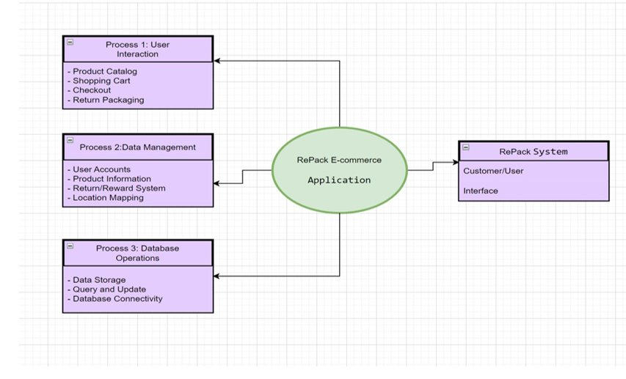

Figure 1: Flow diagram of Recycling Closed-Loop Packaging

RePack’s unique mode of focus on sustainability is well integrated with distinct modules. Here is a breakdown of the key components:

* Home: This is the landing page of the website. It welcomes users with a vibrant interface containing easy-to-navigate menus showing eco-friendly practices. A user can explore and navigate the site to go through RePack’s efficient initiatives according to their choice.
* Login: The RePack login page consists of an easy interface for users to access their accounts. The new users who haven’t logged in have an option to sign up to the platform. Once logged in, users achieve access to personalized features like my orders, user page etc.
* About Us: It offers insights on the how RePack was born. It provides information detailing its commitment to eco-friendly and sustainable practices in e-commerce. Visitors can learn about the team members, RePack’s journey and their innovative practices.
* Shop: This module consists of a few sub-modules namely, Pfand products, Non Pfand products, cart my orders, and checkout.
* Packaging and more: This module includes the detailed information on different packaging types, materials and techniques. This is to make the user more informative on how they are contributing to sustainability. Sub-modules include Our Delivery Personnel Training, FAQs, and Contact Us.
* Blog: This contains different blogs on how RePack started and Delivery Personnel Training. It also gives a detailed information on the Sustainable Development Goals kept in mind by the RePack team. Sub-modules include blog and SDG blog.
* User Page: RePack’s User Page provides essential options like log out and account settings of the user. With just few clicks, a user can easily manage their preferences.

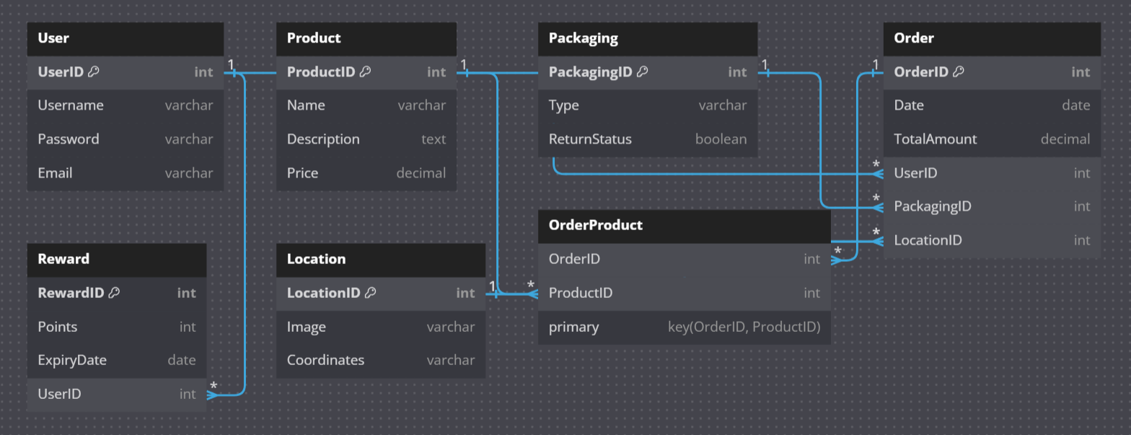

Figure 2: Class Diagram of RePack

Allows the user to login to the website which would allow them to proceed with the purchase

Takes the user to the products available in the RePack platform

Leads to information on RePack Team

Provides detailed information on packaging pf the products

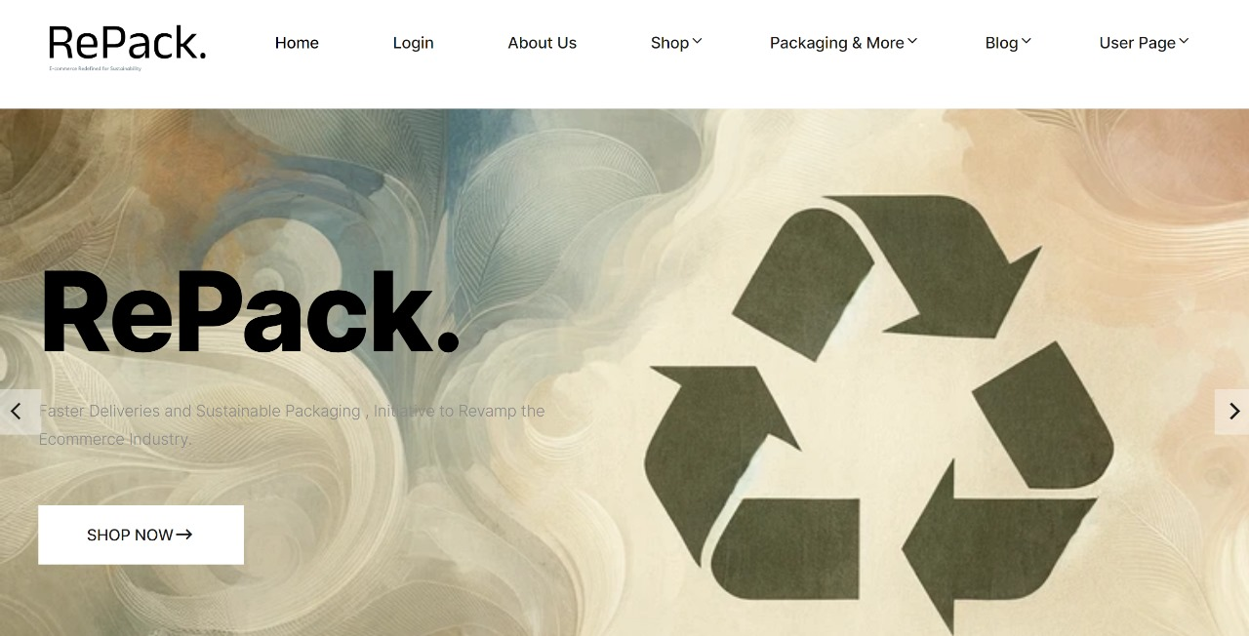

Takes the user to the products available in the RePack platform

Figure 3: Home Page of RePack

1. **CONCLUSION**

This study on the subject is relevant for many reasons. The implementation and usage of practices such as Closed-loop Packaging, introduction of Pfand System in India, and delivery optimization can significantly improve the environment condition as it promotes less dependency on virgin materials and optimization of resources. It promotes economic efficiency by responsible consumption practices and improving the efficiency of delivery processes. This would help in long-term economic sustainability. Promoting sustainable practices would result in fostering loyalty and trust among customers. This study addresses the pressing issues such as carbon emissions and packaging wastes in the e-commerce industry. If the features in the study come to practice, especially the introduction of Pfand System in India, it would result in a revolutionary change in the Indian e-commerce.

Although the study sheds light on the potential integration of sustainable practices in e-commerce system, it is important to acknowledge certain limitations that may arise. Firstly, the study is based on the implementation of the sustainable features in Indian e-commerce. Additionally, the unavailability of data pertaining to Pfand System in English may have constrained the accuracy and depth of our research as it is a German concept and most of the researches available is in the German language. Additionally, the contextual factors inherent in different regions including varying regulations, consumer behaviours, and infrastructure capabilities may limit the applicability of our conclusions to broader contexts. Despite these limitations, our research offers valuable insights into the opportunities and challenges of promoting sustainable practices in online retail, laying a groundwork for future studies to build upon.

1. **REFERENCES**

|  |  |
| --- | --- |
| [1] | R. Accorsi, G. Baruffaldi and R. Manzizni, “A closed-loop packaging network design model to foster infinitely reusable and recyclable containers in food industry,” *Sustainable Production and Consumption,* pp. 48-61, 2020. |
| [2] | E. Kostikov, P. Jílkova and P. S. Kotatkova, “Optimization of e-commerce distribution center,” *Marketing and Management of Innovations,* no. 2, 2021. |
| [3] | R. Accorsi, R. Manzini, C. Pini and S. Penazzi, “On the design of closed-loop networks for product life cycle management: Economic, environmental and geography considerations,” *Journal of Transport Geography,* vol. 48, pp. 121-134, 2015. |
| [4] | A. Mohdhar and K. Shaalan, “The Future of E-Commerce Systems: 2030 and Beyond,” in *Recent Advances in Technology Acceptance Models and Theories* , 2021, pp. 311-330. |
| [5] | R. Wiltheford, “Germany’s simple solution to complex waste challenges,” in *Sustainable Innovation and Impact*, 2018, p. 4. |
|  |  |