**CHAPTER 4**

**DESIGN AND HAEDWARE IMPLEMENTATION**

**4.1. Hardware Implementation**

The elevator is developed around the Arduino Mega microcontroller. The Arduino Mega microcontroller was chosen because of its versatility and ease of availability. The main function of microcontroller is to control the other components in this thesis. This system was designed elevator control system.

For elevator control system, Arduino Mega microcontroller is used with stepper motor, push-buttons, keypad, seven-segment display and inductive sensors. Stepper motor is used for moving up and down the cabin. The stepper motor is connected to the cabin through a belt mechanism to ensure up and down movement. The elevator control system has three push-buttons which is first floor, second, third floor. The push-buttons are used to select the desired location for elevator. Keypad is used to get the desired floor so that the user can choose the desired floor within the cabin. It also has three inductive sensors for detecting elevator cabin current reaching floor. Moreover, it consists of seven-segment display which is used for displaying the desired floor and current floor.

In an elevator, the automatic doors are absolutely essential. For door closing and opening system, two DC motors, motor driver and ultrasonic sensor are used. The doors on the cabin are operated by DC motors. To control speed of two DC motors, motor driver is used. The controller turns the motors to open the doors when the cabin arrived at a floor and closed the doors before the cabin starts moving again. When the cabin reaches to the desired floor, the doors open and close automatically. When an object is detected by an ultrasonic sensor, the DC motors are activated and the doors open. An ultrasonic sensor keeps on checking if the detected object is within its range. On the other hand, if the object is out of range, the DC motors are activated again, this time for closing of the doors else the doors remain opened.

**4.2. The Elevator Skeleton**

The skeleton was constructed using aluminum bars that were welded to form the skeleton shown in figure 4.1. The dimensions are:

* The heigth is 2 feet.
* The width is 1 foot.

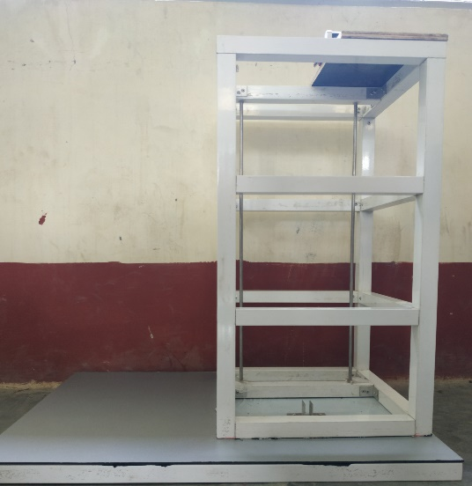

Figure 4.1. Elevator Skeleton

**4.3. The Elevator Cabin Design**

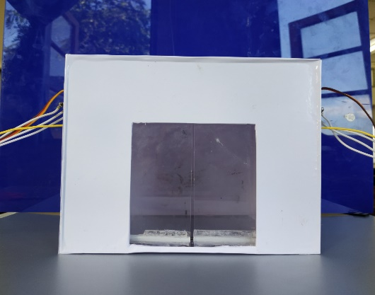

Figure 4.2. Elevator Cabin Design

The elevator cabin was constructed using fiber and the fiber flats were joined by using glue to form the elevator cabin. The dimensions are:

* The height is 6 inches.
* The length is 7 inches.
* The width is 6 inches.

The doors are also designed by using fiber. The elevator has the two slide doors.

The dimension of one slide door is 1.75 inches. To open and close the doors, the DC motor and gear pinions were used. The ultrasonic sensors were also used to detect an object within its range.

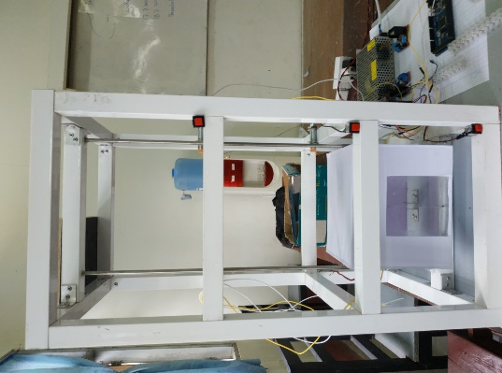

Figure 4.3. Overall Design

**4.4. Pin Connections of Ultrasonic Sensor to Arduino MEGA**

The HC-SR04 Ultrasonic module has 4 pin, ground, VCC, Trigger and Echo. The ground and VCC pins of the module needs to be connected to the ground and the 5Volts pins on the Arduino Board respectively and the trigger is connected to pin 40 and the echo pin is connected to pin 41on the Arduino Board.

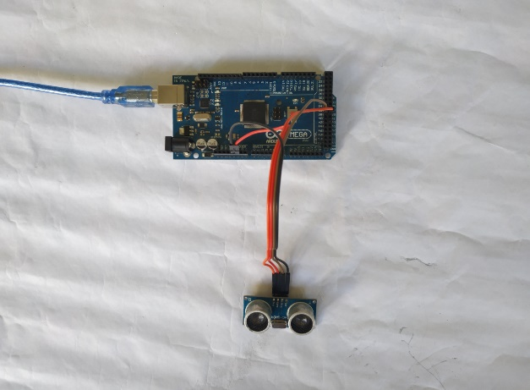

Figure 4.4. Pin Connections of Ultrasonic Sensor to Arduino

**4.5. Pin Connections of DC motor and motor driver to Arduino**

To control two DC motors, motor driver is used. Pins EnA and EnB of motor driver are connected to Arduino pins 12 and 13. IN1, IN2, IN3 and IN4 of motor driver are connected Arduino pins 30,31,32 and 33. OUT1 and OUT2 are connected to one motor and OUT3 and OUT4 are connected to another motor.

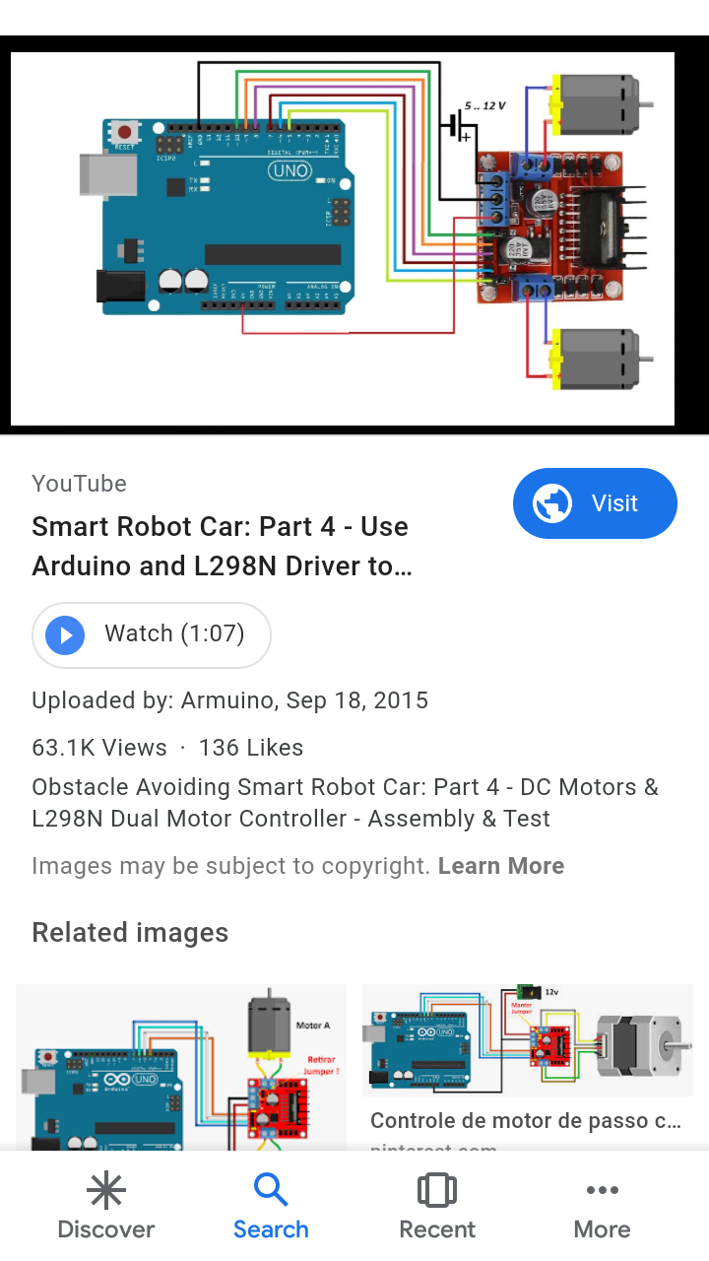

Figure 4.5. Pin Connections of DC Motor and Arduino

**4.6. Pin connections of 4×3 matrix to Arduino**

There is a switch connecting each row and column. The first four pins are connected to column as input and the other three pins are connected to the row as output. For keypad No.1, the first row and the first column of the keypad are connected to Arduino 5 pin. For keypad No.2, the first row and the second column of the keypad are connected to Arduino 6 pin. For keypad No.3, the first row and the third column of the keypad are connected to Arduino 7 pin. In this project, keypad numbers 1,2 and 3 are only used for three floors.

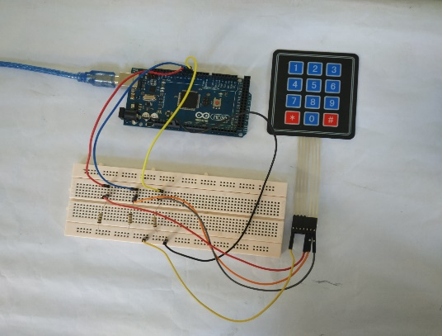

Figure 4.6. Pin connections of 4×3 matrix to Arduino

**4.7. Pin connections of buzzer to Arduino**

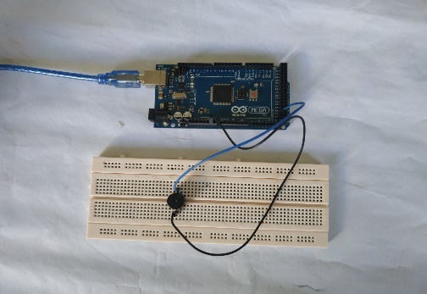

Figure 4.7. Pin connections of buzzer to Arduino

Signal pin of buzzer is connected to pin 50 of Arduino and one Gnd pin is connected to Gnd pin of Arduino.

**4.8. Pin Connections of Inductive Sensor to Arduino**

The metal proximity sensor will have three color wires. The blue should be in the ground, brown is on +VCC which should be given to Arduino + 5V VCC and black is trigger pin. Three inductive sensors are used in this elevator project. These sensors are connected to pin 2,3 and 4 of the Arduino.

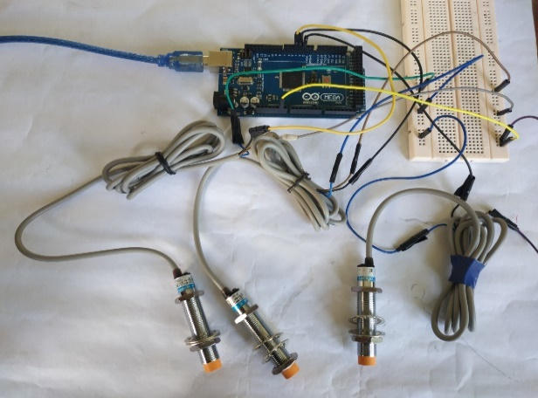

Figure 4.8. Pin Connections of Inductive Sensor to Arduino

**4.9. Pin Connections of Seven-segment Display to Arduino**

The pins of seven-segment display are connected to Arduino pins 22-28. Common pins (pin 3 and pin 8) of seven-segment display are connected to GND and dp is unconnected, because it is not used in this experiment.

Table 4.1. Seven-segment pin connections

|  |  |
| --- | --- |
| Seven segment pins | Arduino pins |
| a | 22 |
| b | 24 |
| c | 26 |
| d | 28 |
| e | 30 |
| f | 32 |
| g | 34 |
| 3,8 (com) | GND |
| dp | - |

**4.10. Pin Connections of Stepper Motor and Motor Driver to Arduino**

The motor driver can be supplied 5V or 12V. In this project, the motor driver must be supplied 12V because of using stepper motor. The input pins IN1, IN2, IN3 and IN4 of the motor driver are connected to Arduino pins 8,9,10 and 11. The output pins OUT1, OUT2, OUT3 and OUT4 of the motor driver are connected to 4 pins of stepper motor. The ground pin of motor driver must be connected to the ground pin of Arduino.

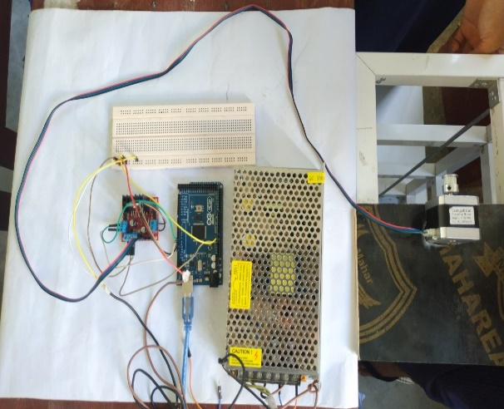

Figure 4.9. Pin Connections of Stepper Motor and Motor Driver to Arduino

**4.11. Comparison of Prototype and Commercial Elevator Control System**

The following table 4.2 is comparison of prototype and commercial elevator control system.

Table 4.2. Comparison of Prototype and Commercial Elevator Control System

|  |  |  |
| --- | --- | --- |
| Item | Prototype | Real |
| Controller | Arduino | Programmable Logic Controller |
| Open and close door | Servo motor SG90 | Dc Motor |
| Elevator cabin area | Fiber plate | Steel |
| Slot option | Keypad | Touch screen LCD |
| Position display | Seven-segment display | LED board |
| Up and down movement | Stepper motor | Electric motor |
| Elevator design | Aluminum bar | Concrete |
| Hoisting rope | Belt | Steel rope |



Figure 4.10. Flow Chart