**CHAPTER 5**

**TEST AND RESULT**

The elevator control system is meant for actual applications in real world. Therefore, the project in this thesis carries out some demonstrating using manual system to evaluate its dependability. In this chapter, there may include six different sections divided; ultrasonic sensor testing, buzzer testing, seven segment testing, door open and close testing and up and down movement testing. There may sometimes be some errors while testing for the sensitive conditions of the components according to the environment it is put. But if more upgraded system such as PLC are used, the whole system is more reliable and durable. In real life, PLC system is applied, therefore, there are hardly occurred unconditional errors according to the components.

**5.1. Testing Inductive Sensor**

Inductive sensor is used to detect the current reaching floor because it is enough for the requirement of the proposed design. During along the testing, it is a good condition-no error. It operates exactly as it was programmed in the code.

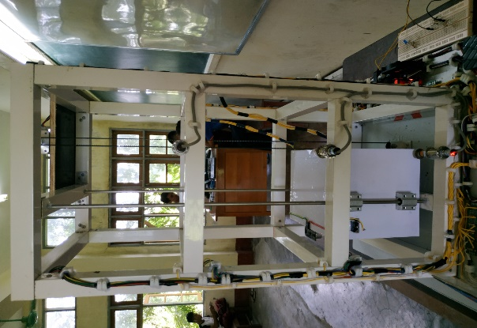

Figure.5.1. Testing Inductive Sensor

**5.2. Testing Seven-Segment Display**

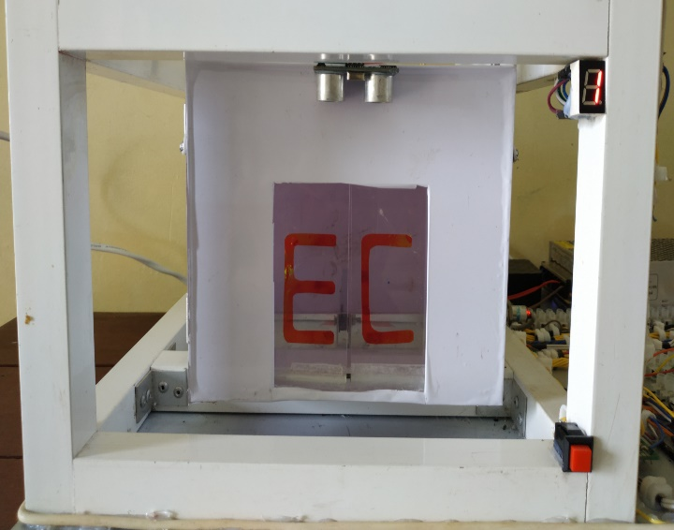

Figure.5.2. Testing Seven-Segment Display at First Floor

hguyyt

Iii8ytyttt

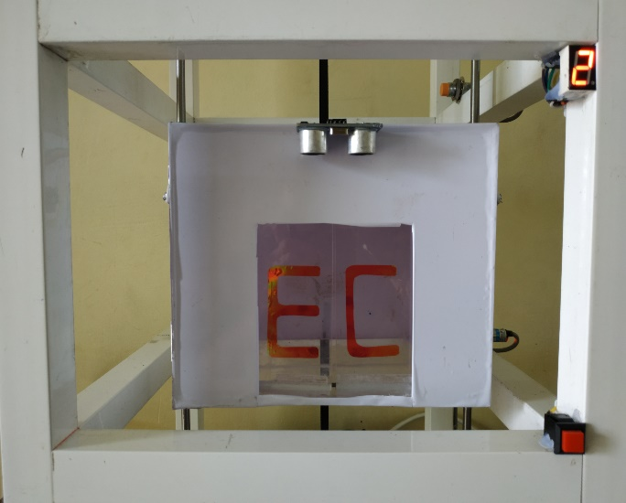

Figure.5.3. Testing Seven-Segment Display at Second Floor

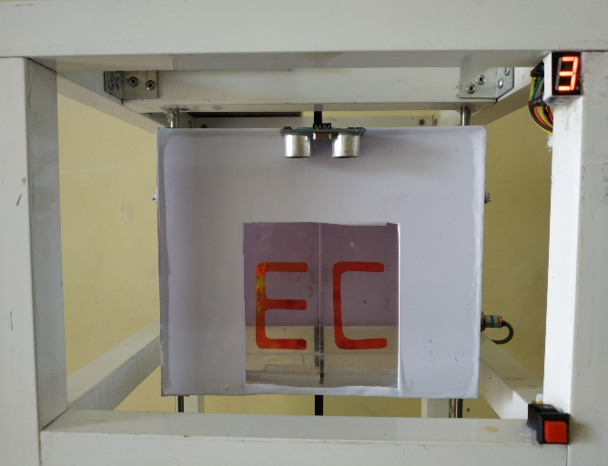

Figure.5.4. Testing Seven-Segment Display at Third Floor

Seven-Segment Display is used to show the desired floor and current floor of elevator. During the elevator cabin reached the first floor, seven-segment display showed one floor. During the elevator cabin reached the second floor, seven-segment display showed two floor. During the elevator cabin reached the third floor, seven-segment display showed three floor.

**5.3. Testing Ultrasonic Sensor**

The Ultrasonic sensor is set up at the front side of the elevator car to sense the obstacles from 4cm to the sensor. If there are obstacles on the elevator car and the sensor send the information to the Arduino and then the Arduino comment the motor to stop the elevator car.

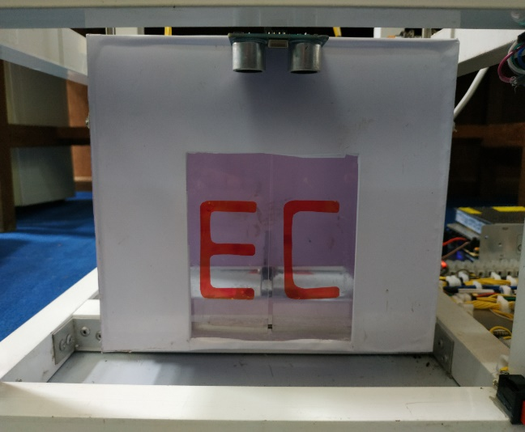

Figure.5.5. Testing Ultrasonic Sensor

**5.4. Testing Buzzer**

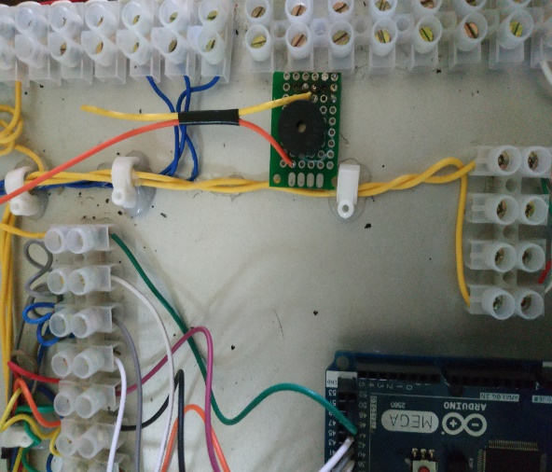

Figure.5.6. Testing Buzzer

Buzzer is used to give bit-horn when the elevator cabin reached to the desired floor. The buzzer is also give alarm when the elevator cabin reached to the desired floor. This testing also gets very well for the thesis. Figure shows the operation of buzzer testing.

**5.5. Testing Door Opening and Closing System**

The doors on the cabin are operated by DC motors. When the elevator cabin reaches to the desired floor, the door opens automatically and after 4.5 seconds delay, the door closes automatically. During the door is closing, the ultrasonic sensor detects whether the object is or not within its range. If the ultrasonic sensor senses an object, the door opens automatically.

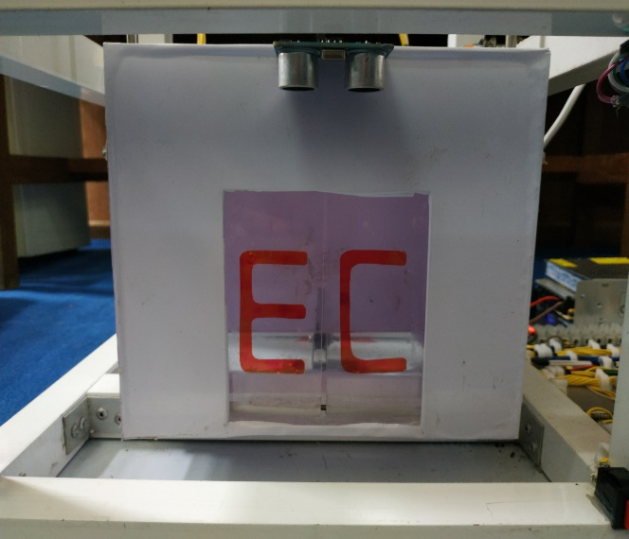

Figure.5.7. Door Closed Condition

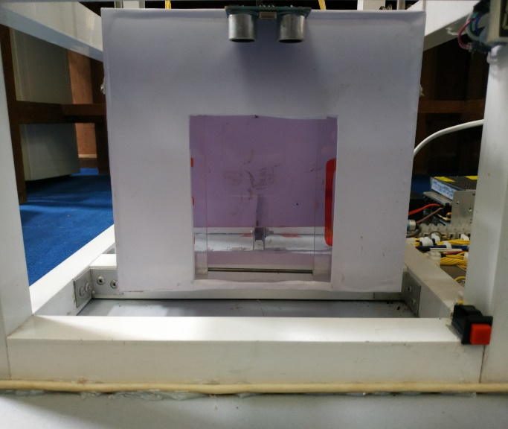

Figure.5.8. Door Opened Condition

**5.6. Testing up and down movement system**

The up and down movement of the elevator cabin is operated by stepper motor. Stepper motor is connected to the elevator cabin through a belt mechanism to ensure up and down movement. Arduino gives the command to the motor driver and the motor driver operates the stepper motor in forward direction and reverse direction. Based on this operation, elevator moves up and down.

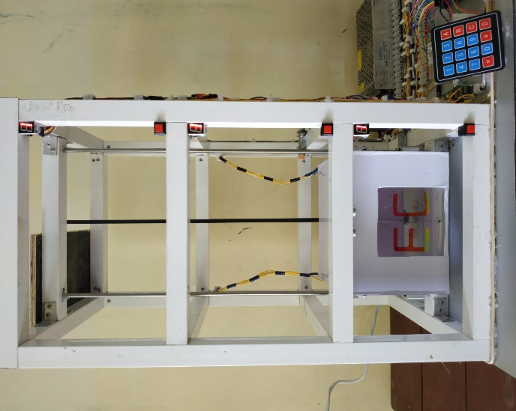

Figure.5.9. Testing Up and Down Movement system

**5.7. Test and result of elevator in first floor**

First, the elevator is located at the first floor and it is waiting for a call.

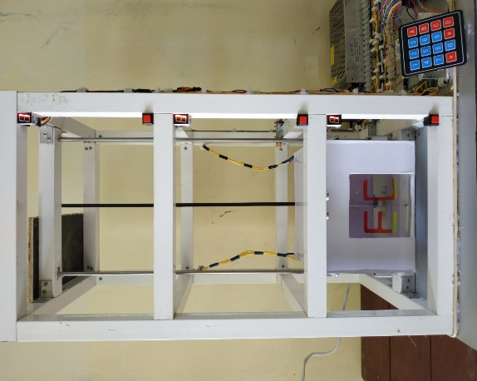

Figure 5.10. Test and Result of Elevator in First Floor

**5.8. Test and result of elevator in second floor**

Firstly, if there is a call from a user who is located on the second floor. The Arduino determines the up and down condition. Then the current position is compared with the user request. When the push-button is greater than the sensor value, the elevator motor drives upward direction, if not, it goes downward.

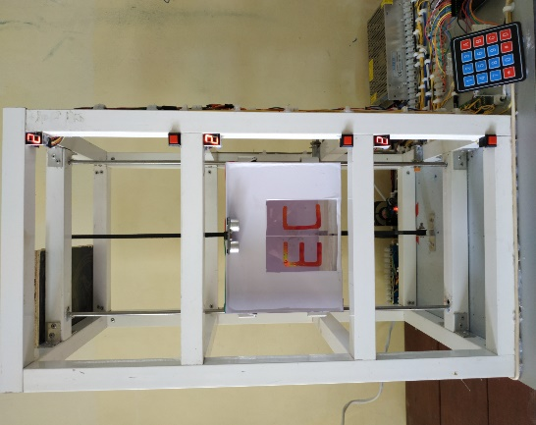

Figure 5.11. Test and Result of Elevator in Second floor

**5.9. Test and result of elevator in third floor**

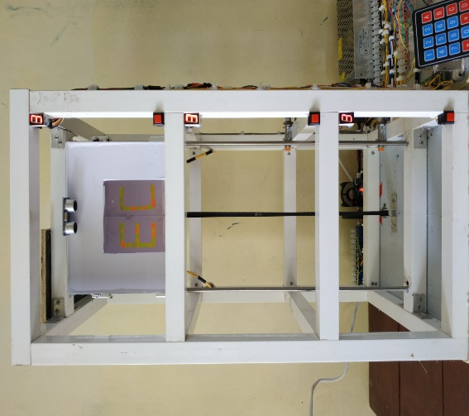

Figure 5.12. Test and Result of Elevator in Third Floor

If there is also a call from a user who is located on the third floor. The Arduino determines the up and down connection of the elevator cabin. Then, the current elevator position is compared with the user request. When the push-button is greater than the sensor value, the elevator motor drives upward direction. If not, it can drive downward direction. By the time, the destination floor is equal to the desired floor, the elevator motor stops and the door motor operates. Finally, the Arduino checks that there is a next call or not and then the operation is stopped.

**5.10. Testing Overall Circuit Condition**

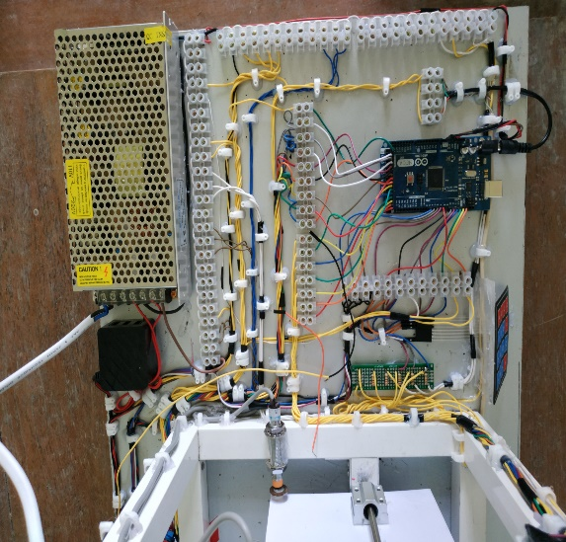

Figure 5.13. Testing Overall Circuit Condition