---2
SELECT DISTINCT City
FROM `workspace`.`default`.`employeezzz`;
---3
SELECT * FROM `workspace`.`default`.`employeezzz`
Order BY Salary DESC;
---4
SELECT * FROM `workspace`.`default`.`employeezzz`
Order BY Salary DESC
Limit 5;
---5
SELECT * FROM `workspace`.`default`.`employeezzz`
WHERE City = 'New York';

--7
SELECT *
FROM `workspace`.`default`.`employeezzz`
WHERE `Department ` = 'HR'
OR `Department ` = 'MARKETING';

---8
SELECT *
FROM `workspace`.`default`.`employeezzz`
WHERE NOT `Department ` ='IT';

---9
SELECT *
FROM `workspace`.`default`.`employeezzz`
WHERE `Department ` IN ('HR', 'IT','Finance');

---10
SELECT *
FROM `workspace`.`default`.`employeezzz`
WHERE `Department ` = 'IT'
AND salary > 50
AND City = 'New York';

---11
SELECT First-name, Last-name
FROM `workspace`.`default`.`employeezzz`
WHERE `Department`= ('MARKETING', 'Finance')
AND Salary >52
ORDER BY Salary DESC;

---12
SELECT DISTINCT City
FROM `workspace`.`default`.`employeezzz`
WHERE `Department ` NOT IN ('IT', 'HR');
---13
SELECT *
FROM `workspace`.`default`.`employeezzz`
WHERE NOT `Department ` = 'Finance'
AND Salary > 50
ORDER BY `Hire-Date `ASC;
---14
SELECT *
FROM `workspace`.`default`.`employeezzz`
WHERE City = 'Los Angels'OR 'Chicago'
AND `Department `IN ('MARKETING', 'IT')
LIMIT 3;

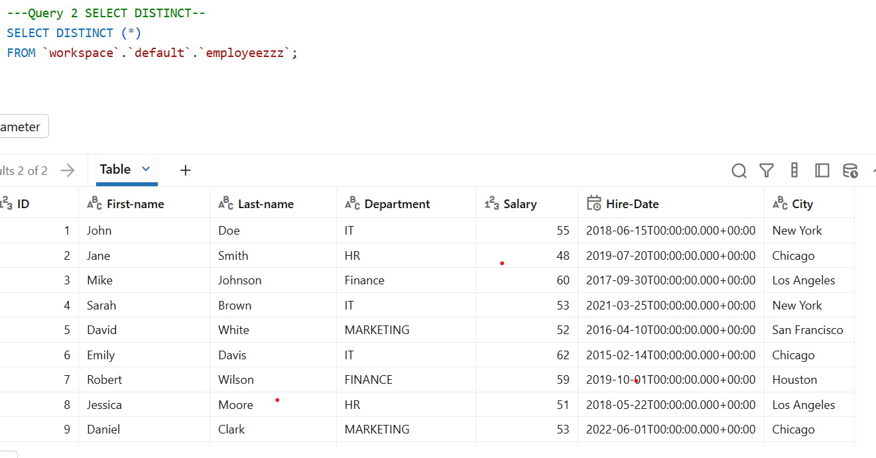
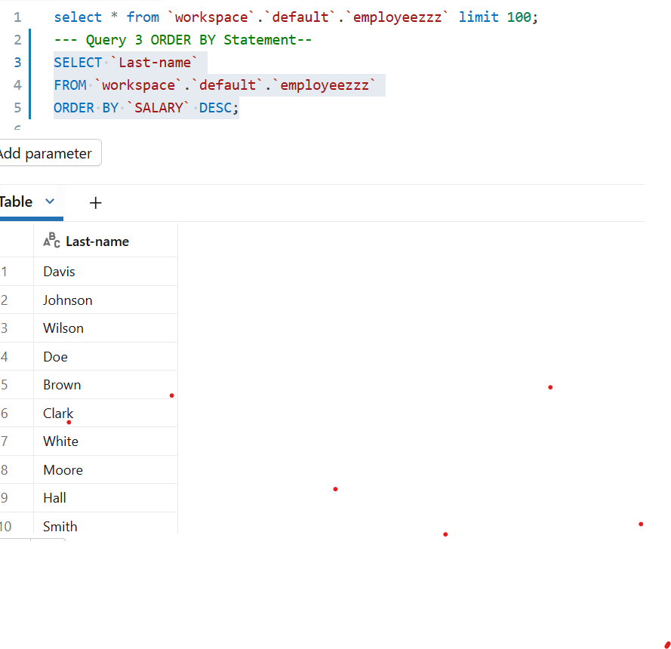
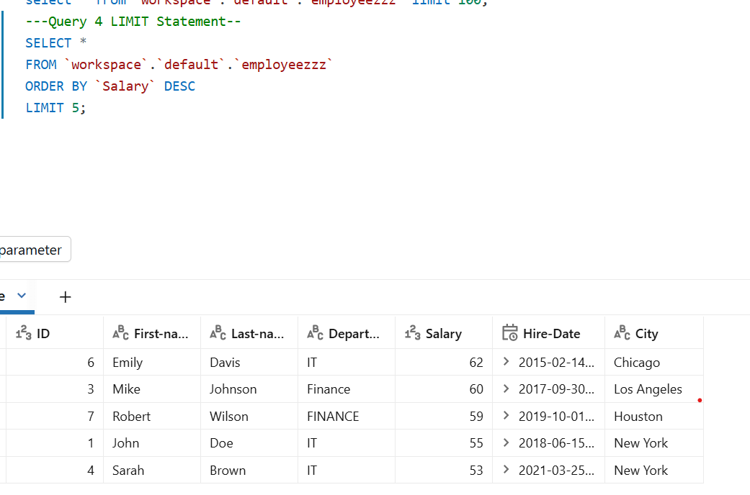
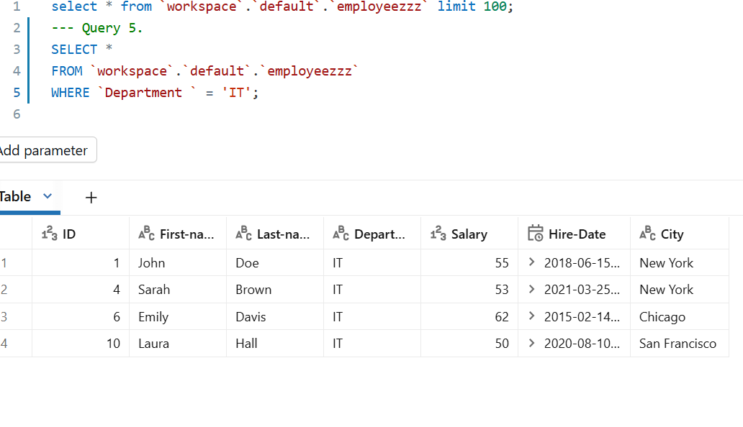
12.
`work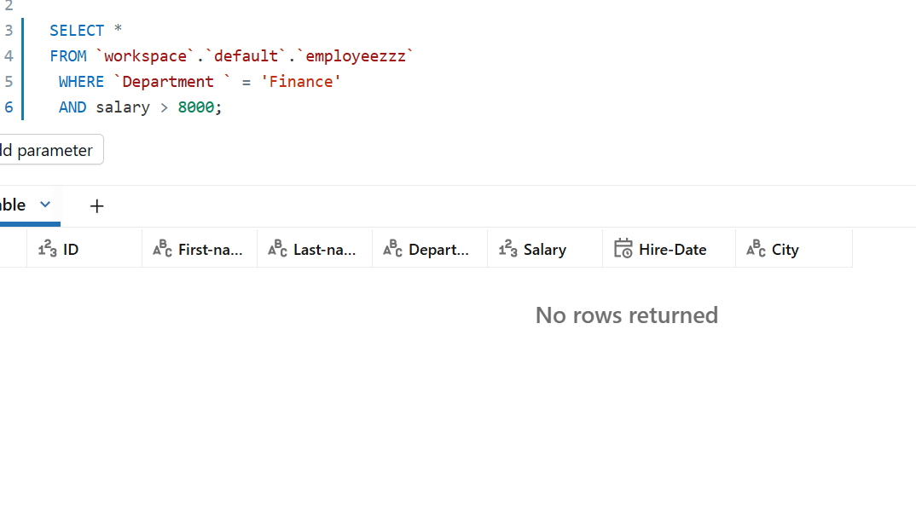space`.`default`.`employeezzz`

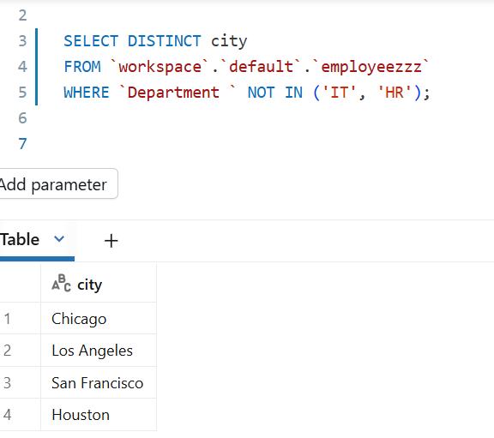

Q.13
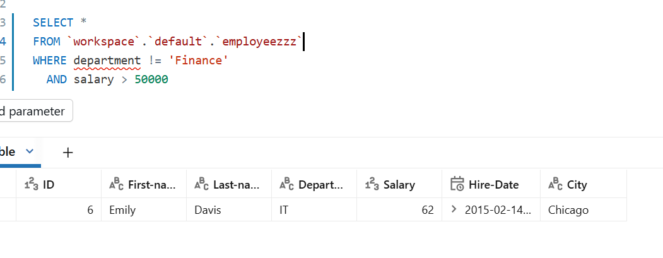
14.
