ECEn 631 3D Trajectory Estimation – HW 4
Seth Nielsen

Task 1

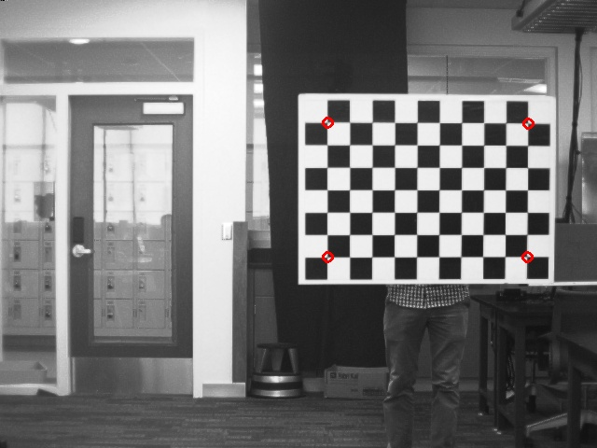
Left:

Left pts:
[38.5474, 5.67971, 277.41]
[3.51612, 5.91889, 277.296]
[38.3723, -17.5588, 275.304]
[3.37155, -17.3091, 274.585]

Right:
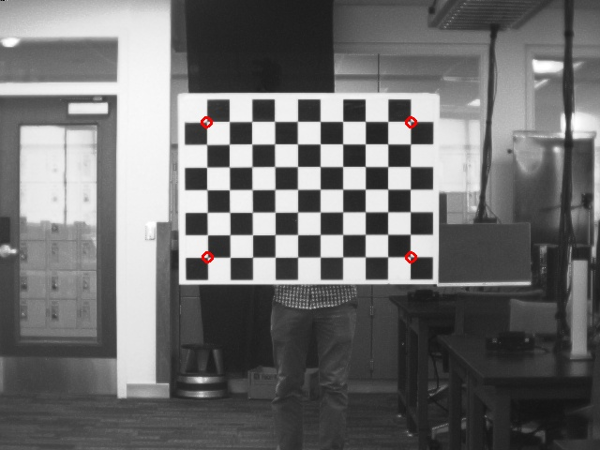

Right pts:
[18.2687, 5.5991, 277.41]
[-16.7626, 5.8765, 277.296]
[18.0936, -17.6365, 275.304]
[-16.9072, -17.3983, 274.585]

The points are quite consistent in their x and y positions, and the x positions of the right camera are 20 less than the left, which is the distance between the two cameras.
Task 2

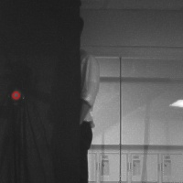



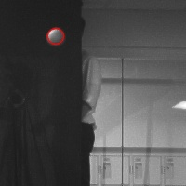
Left:
Right:

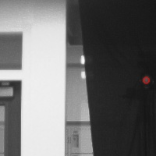
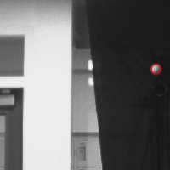
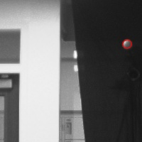
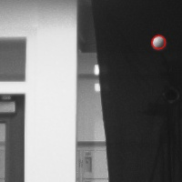
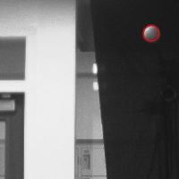
Task 3
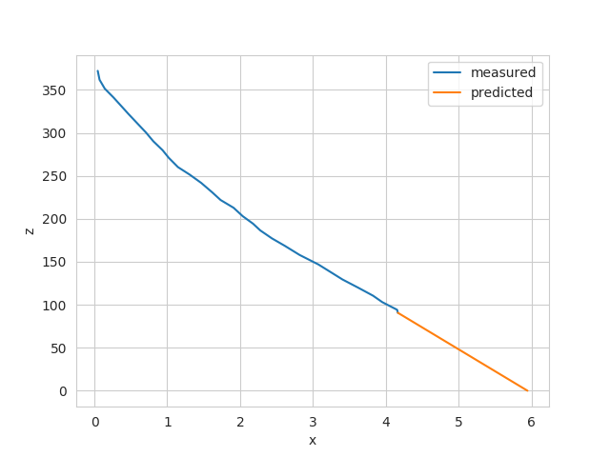
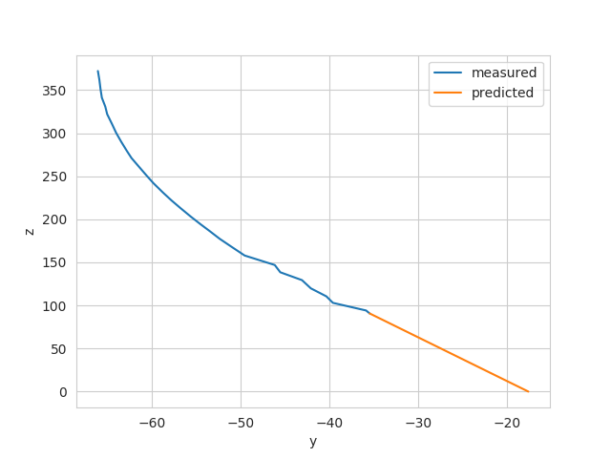

The method I used to predict the x and y positions when z = 0 was a simple linear extrapolation. I took the average velocity of the last 5 frames in z in inches/sec, as well as the average x and y velocities of the last 5 frames. The time t needed for the ball to reach z = 0 was used to extrapolate the the x and y position at time t.

