## Tech Saksham

## Case Study Report

## Data Analysis With Power BI

**‘’Real-Time Analysis of Bank of Customer‘’**

**‘’Government Arts & Science College Sivakasi’’**

|  |  |
| --- | --- |
| **NM ID** | **Name** |
| **18C0D7B51171D4D8CF5466F968154522** | **Thanesh kumar.P** |

**Trainer name : Umamageshwari.R**

**Master Name :Umamageshwari.R**

**ABSTRACT**

IN the digital age ,data has become an invaluable asset for businesses ,particularly in the banking sector . The proposed project , “REAL TIME ANALYSIS OF BANK CUSTOMER” Aims to leverage Power BI , a leading business intelligences tool ,to analyze and visualize real-time customer data.This project will enable banks to gain deep insights into customer behavior, preferences, and trends, thereby facilitating data-driven decision- making and enhancing customer satisfaction. The real-time analysis will allow banks to respond promptly to changes in customer behavior or preferences, identify opportunities for cross-selling and up-selling, and tailor their products and services to meet customer needs. The project will also contribute to the broader goal of digital transformation in the banking sector, promoting efficiency, innovation, and customer- centricity.

**INDEX**

|  |  |  |
| --- | --- | --- |
| **SI. No** | **Table of Contents** | **Page.No** |
| 1 | Chapter 1 : Introduction |  |
| 2 | **Chapter 2:Services And Tools Required** |  |
| 3 | **Chapter 3:Project Architecture** |  |
| 4 | **Chapter 4:Modeling and Result** |  |
| 5 | **Conclusion** |  |
| 6 | **Future scope** |  |
| 7 | **References** |  |
| 8 | **Links** |  |

**Chapter 1**

**Indroduction**

1.1 Problem Statement

In today's competitive banking landscape, understanding customer behavio preferences is crucial for customer retention and revenue generation. However, banks often face challenges in analyzing customer data due to the sheer volume and velocity of data generated. Traditional data analysis methods are time-consuming and often fail to provide real-time insights. This lack of real-time analysis can lead to missed opportunities for customer engagement, cross-selling, and up-selling, impacting the bank's revenue generation and customer satisfaction. Furthermore, the complexity and diversity of customer data, which includes transaction history, customer feedback, and demographic data, pose additional challenges for data analysis.

**1:2 Features**

* Real-Time Analysis: The dashboard will providereal-time analysis of customer data.
* Customer Segmentation: It will segment customers based on various parameters like age, income, transaction behavior, etc.
* Trend Analysis: The dashboard will identify and display trends in customer behavior. Predictive Analysis: It will use historical data to predict future customer behavior.

1.3 Advantages

* Data-Driven Decisions. Banks can make informed decisions based on real-time dataanalysis
* Improved Customer Engagement: Understanding customer behavior and trends can help banks engage with their customers more effectively.
* Increased Revenue. By identifying opportunities for cross-selling and up-selling, bariks can increase their revenue.

**1.4 Scope**

The scope of this project extends to all banking institutions that aim to leverage data for decision-making and customer engagement. The project can be further extended to incorporate more data sources and advanced analytics techniques, such as machine learning and artificial intelligence, to provide more sophisticated insights into customer behavior. The project also has the potential to be adapted for other sectors, such as retail, healthcare, and telecommunications, where understanding customer behavior is crucial. Furthermore, the project contributes to the broader goal of digital transformation in the banking sector, promoting efficiency, innovation, and customer- centricity.

**SERVICE AND TOOLS REQUIRED**

2.1 Services Used

* Data Collection and Storage Services: Banks need to collect and store customer data in real-time. This could be achieved through services like Azure Data Factory, Azure Event Hubs, or AWS Kinesis for real-time data collection, and Azure SQL Database or AWS RDS for data storage.
* Data Processing Services: Services like Azure Stream Analytics or AWS Kinesis Data Analytics can be used to process the real-time data.
* Machine Learning Services: Azure Machine Learning or AWS SageMaker can be used to build predictive models based on historical data.

2.2 Tools and Software used

Tools:

* PowerBI: The main tool for this project is PowerBI, which will be used to create interactive dashboards for real-time data visualization.
* Power Query: This is a data connection technology that enables you to discover, connect, combine, and refine data across a wide variety of sources

Software Requirements:

* PowerBI Desktop: This is a Windows application that you can use to create reports and publish them to PowerBl
* PowerBI Service: This is an online SaaS (Software Service) service to you use to publish reports, create new dashboards, and share insights.
* PowerBI Mobile: This is a mobile application that you can use to access your reports and dashboards on the go.

**Chapter 3**

PROJECT ARCHITECTURE

3:1Architecture

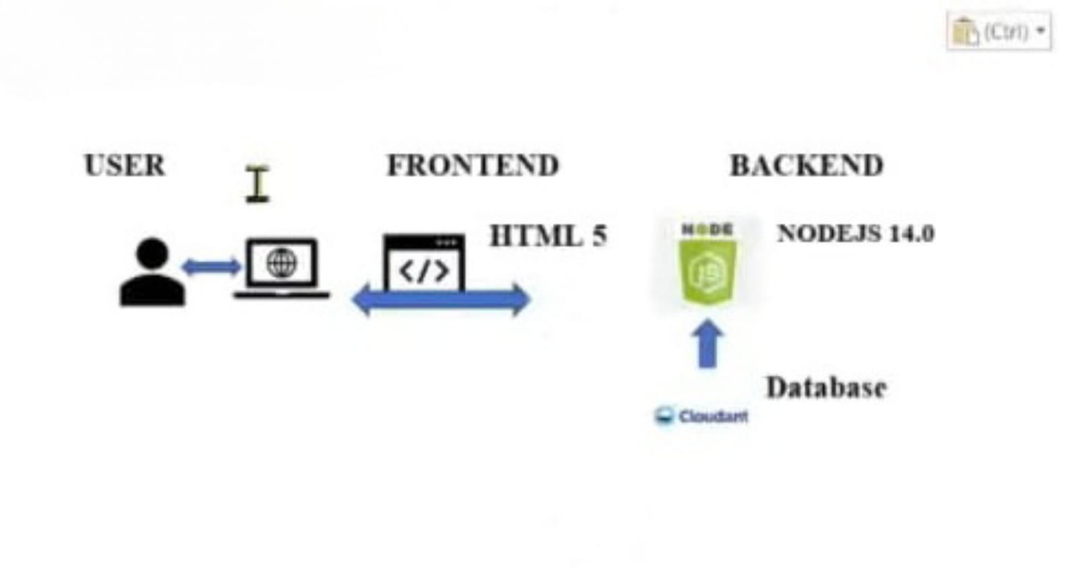

Here is a high level architecture for the project:

1. Data Collection: Real-time customer data is collected from various sources like bank transactions, customer interactions, etc. This could be achieved using services like Azure Event Hubs or AWS Kinesis.

2. Data Storage: The collected data is stored in a database for processing. Azure SQL Database or AWS RDS can be used for this purpose.

3. Data Processing: The stored data is processed in real-time using services like Azure Stream Analytics or AWS Kinesis Data Analytics.

4. Machine Learning: Predictive models are built based on processed data using Azure Machine Learning or AWS SageMaker. These models can help in predicting customer behavior, detecting fraud, etc.

5. Data Visualization: The processed data and the results from the predictive models are visualized in real-time using PowerBI. Powerß! allows you to create interactive dashboards that can provide valuable insights into the data.

6. Data Access: The dashboards created in PowerBi can be accessed through PowerBI Desktop, PowerBI Service (online), and PowerBI Mobile.

This architecture provides a comprehensive solution for real-time analysis of bank customers. However, it's important to note that the specific architecture may vary depending on the bank's existing infrastructure, specific requirements, and budget. It's also important to ensure that all tools and services comply with relevant data privacy and security regulations

CHAPTER 4

MODELING AND RESULT

Manage relationship

The "disp" file will be used as the main connector as it contains most key identifier (account id, client id and disp id) which can be use to relates the 8 data (C) together. The "district file is use to link the client profile geographically with "district id

Manage Relationships

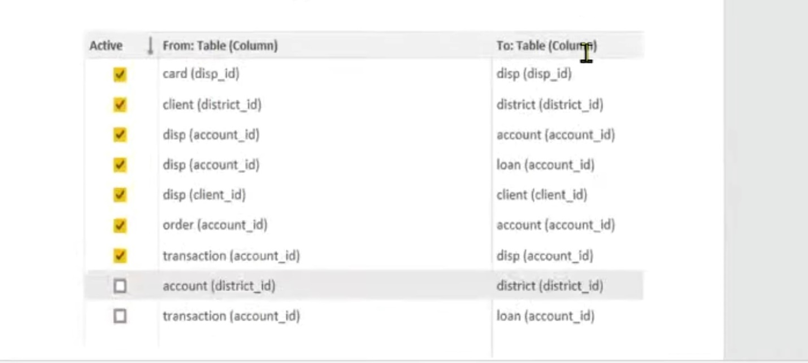

Edit Relationship

Select tables and coloumns that are related

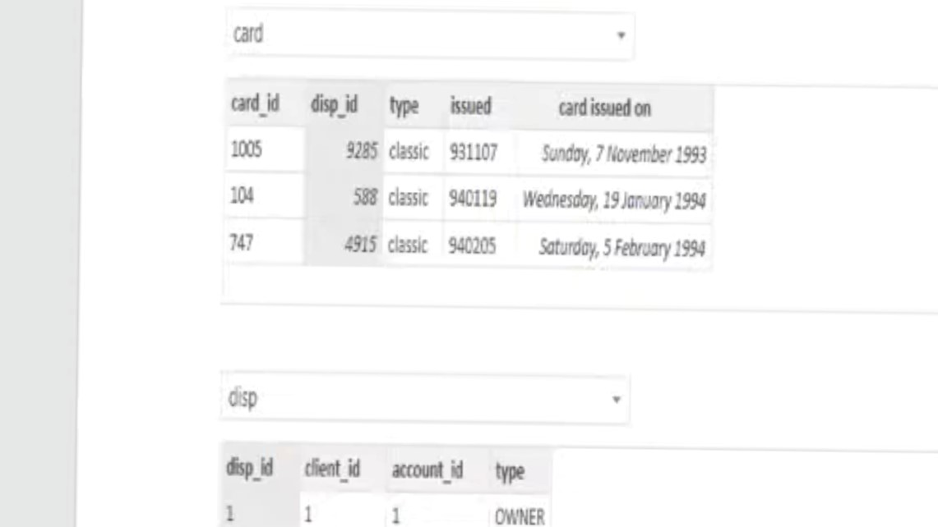

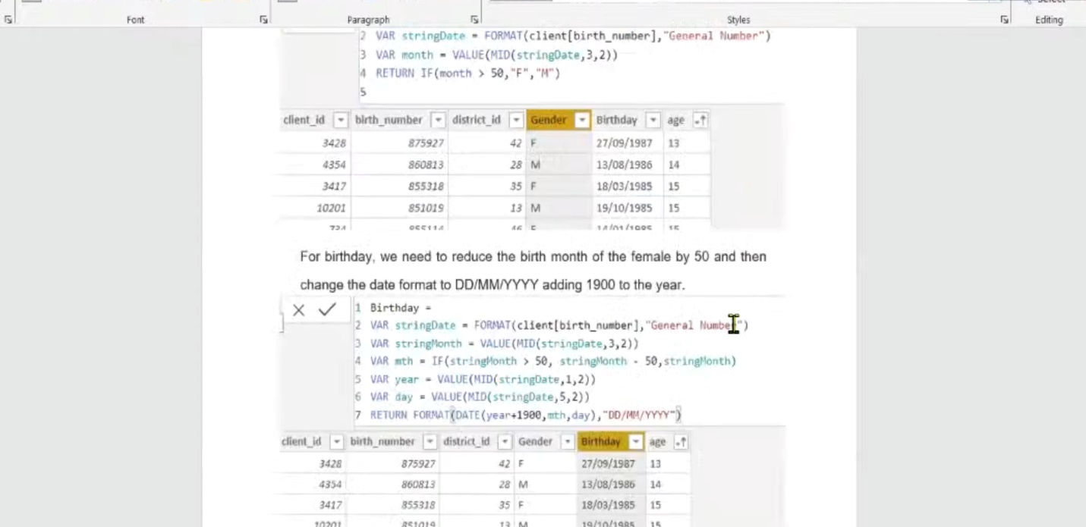

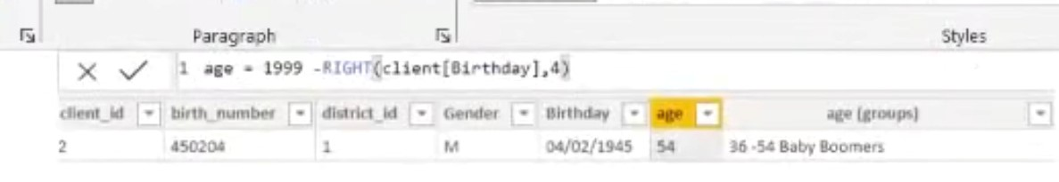

Replacing values

Set some fields to English for easy understanding, we replace values to English with the power query editor

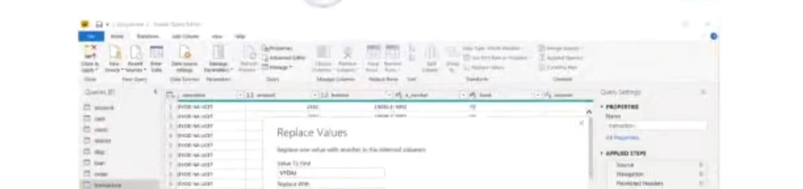

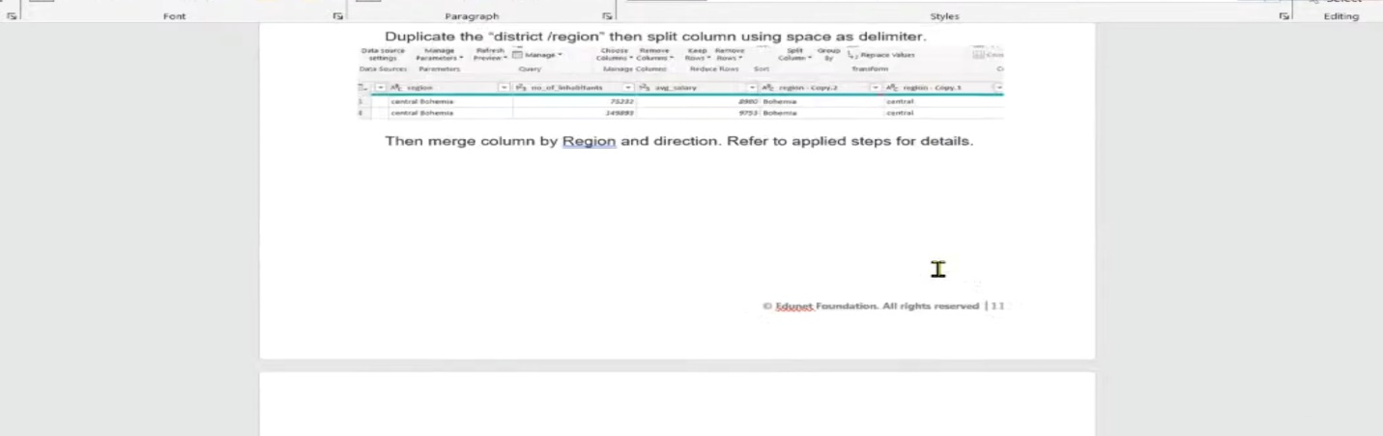

Then merge coloumn by region and direction .refer to applied steps for details

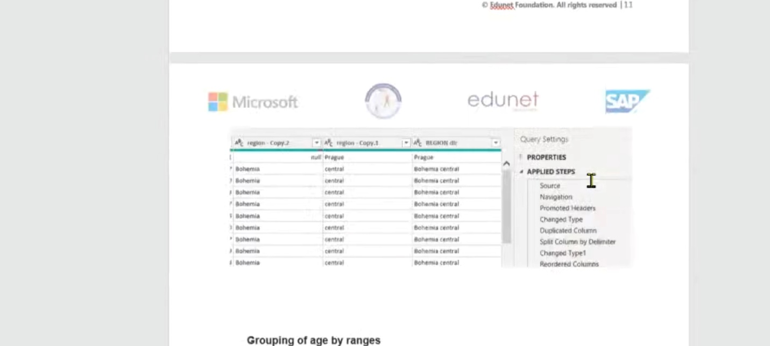

Baby boomer areworking adults with families .

The silent generation some are working and retired ,living on pensions

The greatest generation retired elderly living on pensions

GROUPS

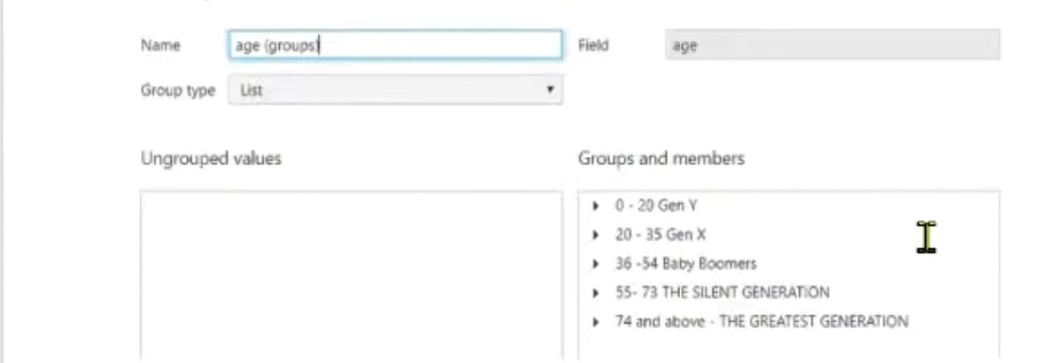

Credit rating and loan status

Dashboard

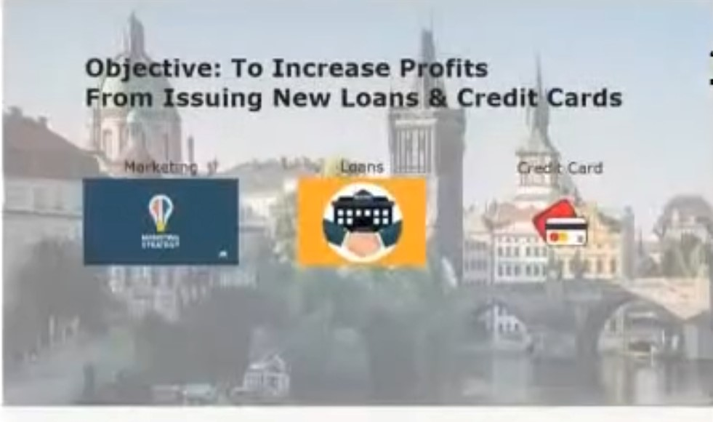

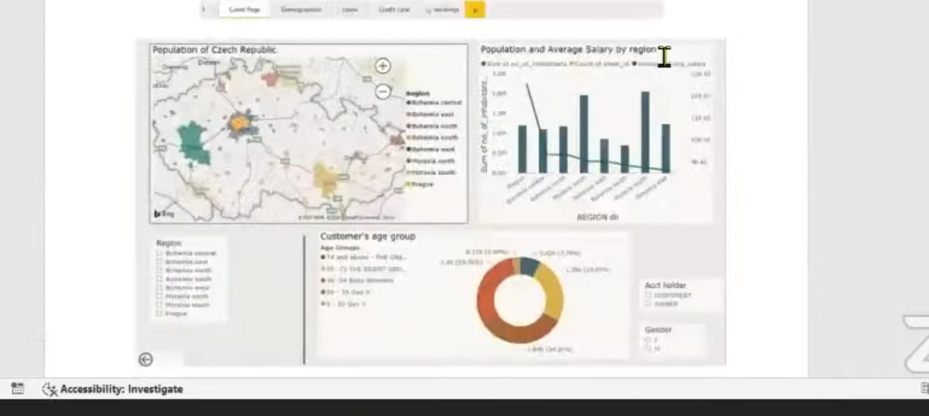

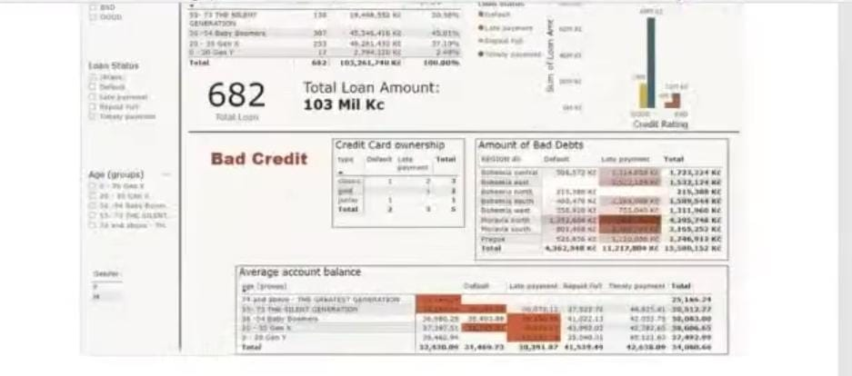

FUTURE SCOPE

The future soope of this project is vast. With the advent of advanced analytics and machine learning Cowabi can be leveraged to predict future trends based on historical data Integrating these predictive analytics into the project could enable the barkt anticipate customer needs and proactively offer solutions. Furthermore, Powertis capability to integrate with various data sources opens up the possibility of encorporating more diverse datasets for a more holistic view of customers. As data pricecy and secunty become increasingly important, future iterations of this project should focus on implementing rubunt data governance strategies. This would ensure the secure handling of sensitive customer data while complying with data protection redtion Additionally, the project could explore the integration of realtime data streams to provide even more smely and relevantes. The could potentially transform the way banka interact with their customers, leading to improved customer satisfaction and lovaite.

REFERENCE

<https://wso2.com/whitepapers/real-time-analytics-in-banking-and-finance-use-cases/>

<https://www.verifiedmarketresearch.com/product/global-big-data-analytics-in-banking-market-size-and-forecast/>

**LINK**