**MEN'S RING WITH GREEN AGATE, DIAMETER 23 MM**

Men's ring with green agate stone 23 mm diameters with luxurious and sophisticated design gives you a meaningful and delicate valuable accessory. The product possesses an enchanting radiant beauty, like hot flames spreading throughout the Agate River, a symbol of passion, fire and enthusiasm. 10 years ago, Green Agate used to storm the feng shui market, is considered one of the seven treasures of the Buddha. With its great uses for health and feng shui, Green Agate confidently beat the hearts of those who love beauty and believe in spirituality. Men's green onyx ring promises to bring great experiences to you when you bring it with you.

**Product features: Uses and meanings of GREEN AGATE stone**

**In terms of feng shui:**

Green Agate symbolizes health, wealth and longevity, loved by the ancient nobility to affirm their status and class.

- Stone brings you wonderful experiences in love, giving you strength and confidence to fulfill your ideals.

The wearer will always feel optimistic, love life and be helped by the positive energy that Green Agate brings.

**In terms of health:**

- Green Agate enhances memory, concentration, and clarity. It also helps to clear anger so you can make the right decisions.

- Stone supports blood circulation, improves physical fitness and solves some problems in women.

**Destiny:**

Green Agate is suitable for people with Wood par (according to compatibility) and par Fire (according to mutual birth).

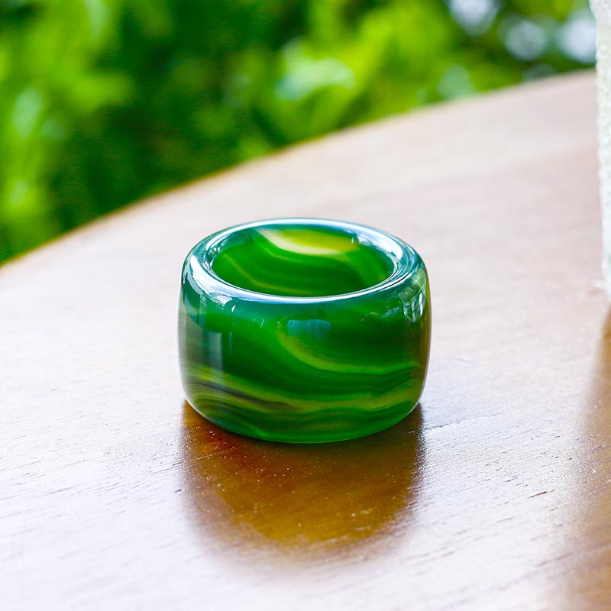

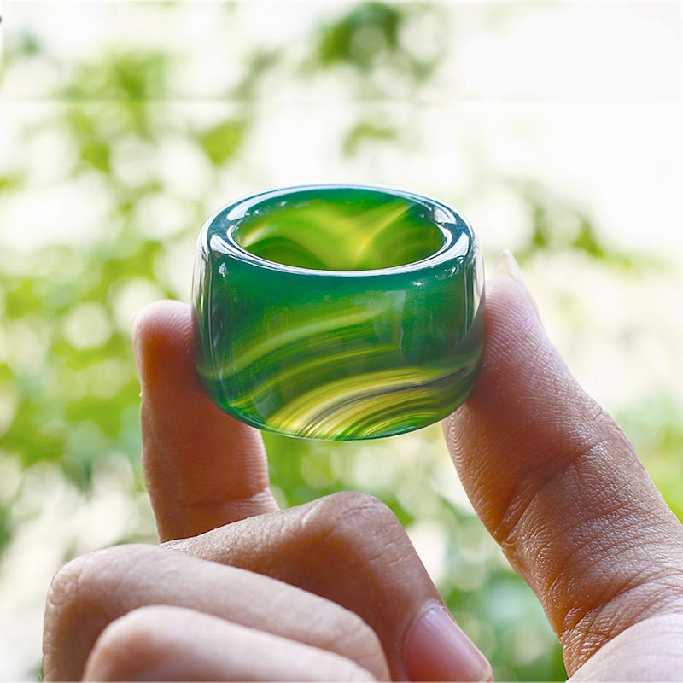

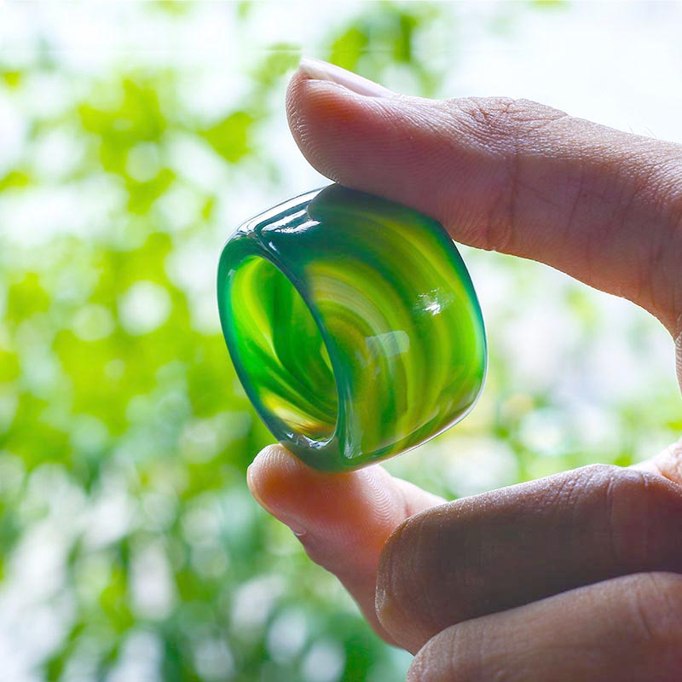

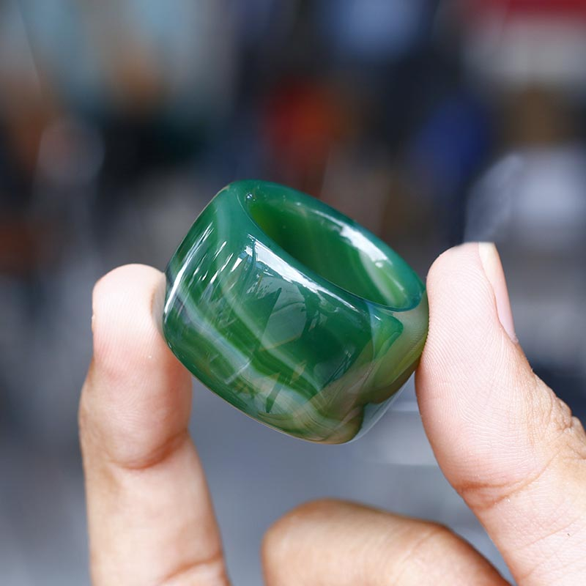

**Product warranty:**

- 24 months warranty for all feng shui jewelry products.

- Warranty service includes: Warranty for stone color, knitting rope (for rings), necklace (for necklaces, necklaces).

**INSTRUCTIONS FOR STORAGE OF US PRODUCTS:**

1. Avoid contact with chemicals

When wearing should avoid contact with chemicals in daily activities such as:

- Cosmetics: lotion, perfume, makeup powder, makeup remover...

- Daily activities: dishwashing liquid, laundry soap, hand sanitizer...

- Other: sea water, swimming pool water...

2. Avoid strong impact

- As a product made from natural stone with a certain hardness, but will also break, scratch when hit hard, should avoid the following cases:

- Do not wear rings when playing sports and other vigorous activities.

- Avoid hitting the ring, dropping the ring.

- Avoid wearing rings in activities that are easily bumped and entangled such as housework, changing clothes...

3. Proper use and storage of rings

- It is advisable to remove the ring when taking a shower and when going to bed.

- Store rings separately from other jewelry.

- Store in a box lined with soft cloth to avoid scratches.

4. Cleaning the ring

- Clean the ring regularly with a soft cloth.

- Bring to the store to clean the ring with specialized cleaning water.