**LALIZ BRACELET WITH BLUE AGATE**

Laliz blue agate bracelet is made from natural gemstones, not only an ordinary jewelry but the bracelet also has many effects for health as well as spirit. Wearing a bracelet will enhance health; blood circulation helps the wearer reduce stress, fatigue, and disease very well. In terms of spirituality, the wearer can attract prosperity and fortune, helping the owner to have many good opportunities in business, improves family relationships, friends, colleagues, and advance at work.

**The effect of stone:**

- Agate has the effect of reducing stress and anxiety, helps you calm down, brings mental strength to help you overcome difficulties and move forward.

- Use agate jewelry for a while and you will realize the possibilities are endless. And help you be able to follow the most suitable path. Be it a business path, career advancement…

In addition, in love Agate (Agate) also symbolizes emotional endurance. This stone will encourage you to weather the storm together and believe in the promise you made to each other. Besides, the energy in the stone can also release resentment, jealousy, insecurity and bitterness.

- Material: Natural stone.

- 1 year warranty.

- Storage: Store jewelry in its original packaging or a soft bag to prevent scratches. Avoid direct contact with perfumes, hairsprays, soaps, lotions, chlorine, chemicals, or salt water... as this can be harmful; reduce shelf life as well as cause discoloration and loss of color of jewelry.

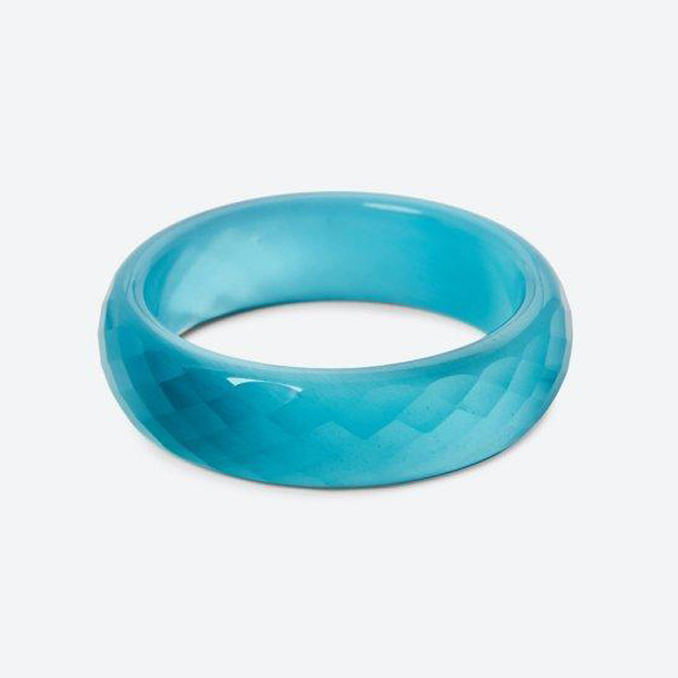

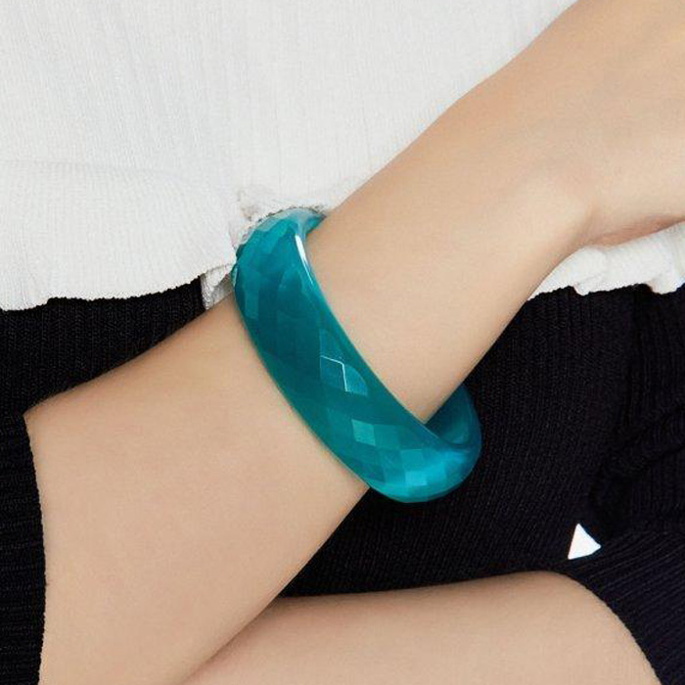

**Guide to choosing feng shui stones according to destiny:**

The choice of colors in accordance with your preferences and personality is also consistent with the principle of the five elements of mutual birth and contrast. Knowing the rules below, you will choose the right colors according to your destiny when choosing Laliz jewelry.

Color in feng shui is mainly geared towards balancing yin and yang energies to achieve ideal harmony. Yin is a quiet dark hue that absorbs color and yang is a moving light that reflects color. Therefore, color is used to enhance the favorable factors and limit the adverse effects from the environment on the wearer.

**The Law of Mutual Coexistence and Contrast in the Five Elements:**

According to the principle of five elements, the environment consists of 5 elements Metal (metal), Wood (plants), Thuy (water), Fire (fire), Earth (earth) and each element has its own color. Metallic includes bright colors and iridescent shades; Wood is blue, green; Mercury includes dark blue, black; Fire is red, purple; Earth includes brown, yellow, orange…

The mutuality of the five elements includes Wood gives birth to Fire, Fire gives birth to Earth, Earth gives birth to Kim, Kim gives birth to Water, and Thuy gives birth to Wood. The contrast of the five elements is that Metal meets Wood, Wood meets Earth, Earth meets Water, Water meets Fire, Fire meets Metal. Mutual coexistence, harmonious and reasonable contrast will bring balance in feng shui as well as in our common sense according to feng shui.

**Instructions for preserving Laliz feng shui jewelry products:**

- Store jewelry in its original packaging or a soft bag to prevent scratches.

- Avoid direct contact with perfumes, hair sprays, soaps, lotions, chlorine, chemicals, or salt water... as this can be harmful; reduce shelf life as well as cause discoloration and loss jewelry shine.