**MEN'S BRACELET RED AGATE**

**The red agate men's bracelet** possesses enchanting radiant beauty, like hot flames spreading throughout the Agate River, is a symbol of passion, fire and enthusiasm. 10 years ago, Red Agate used to storm the feng shui market, is considered one of the 7 treasures of the Buddha. With its great uses for health and feng shui, Red Agate confidently beat the hearts of those who love beauty and believe in spirituality.

**Details:**

- Made in Viet Nam

- Material: Red Agate

- Color: Red

- Dimensions: 18mm

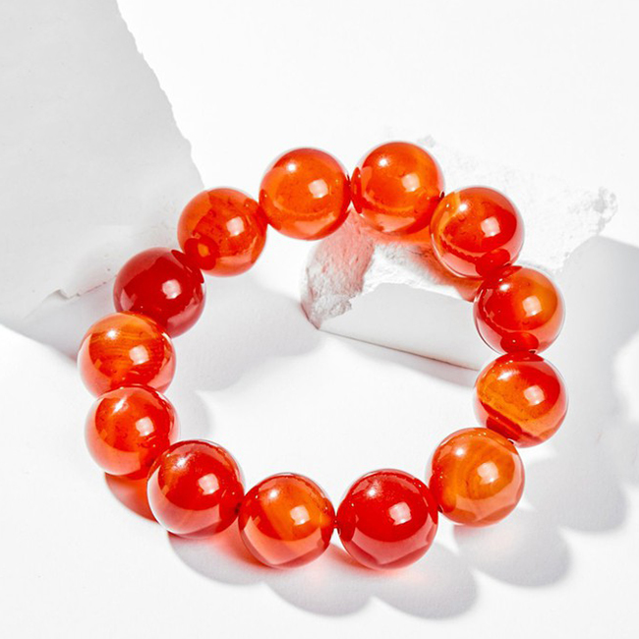

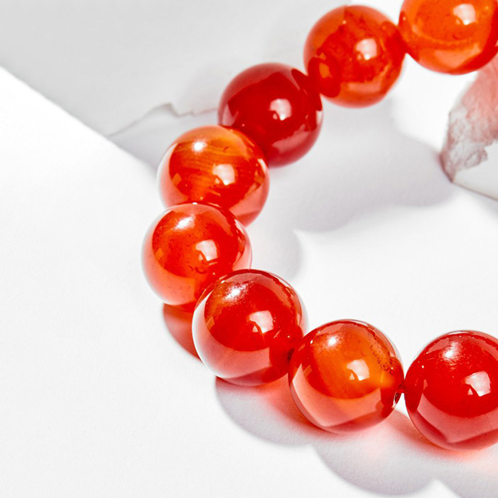

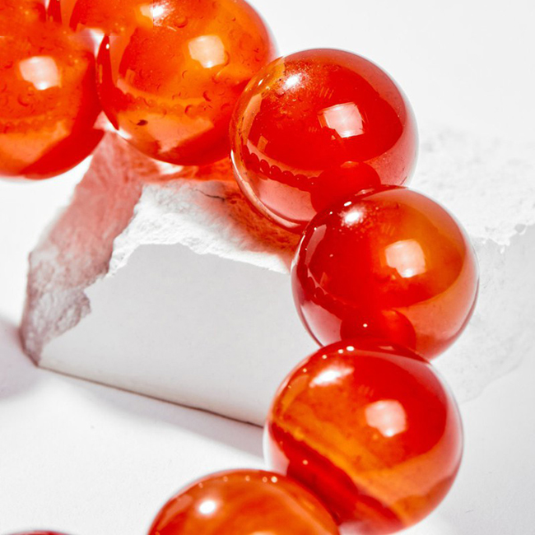

**USES AND MEANINGS OF RED BEAUTIFUL STONE:**

**In terms of feng shui:**

Red Agate symbolizes health, wealth and longevity, was loved by the ancient nobility to affirm their status and class.

- Stone brings you wonderful experiences in love, giving you strength and confidence to fulfill your ideals.

- The wearer will always feel optimistic, love life and be helped by the positive energy that Red Agate brings.

**In terms of health:**

- Red Agate enhances memory, concentration, clarity and clears anger so you can make the right decisions.

- Stone supports blood circulation, improves physical fitness and solves some problems in women.

**Destiny:**

The Red Code is suitable for people with Fire par (according to compatibility) and par Earth (under mutual birth).

**WARRANTY OF OUR PRODUCTS**

- 24 months warranty for all feng shui jewelry products.

- Warranty service includes: Warranty for stone color, knitting rope (for rings), necklace (for pendants, necklaces).

**INSTRUCTIONS FOR STORAGE OF US PRODUCTS**

1. Avoid contact with chemicals.

When wearing should avoid contact with chemicals in daily activities such as:

- Cosmetics: lotion, perfume, makeup powder, makeup remover...

- Daily activities: dishwashing liquid, laundry soap, hand sanitizer..

- Other: sea water, swimming pool water...

2. Avoid strong impact.

As a product made from natural stone with a certain hardness, but will also break and scratch when hit hard, the following cases should be avoided:

- Do not wear bracelets when playing sports and other vigorous activities.

- Avoid banging the bracelet, dropping the bracelet.

- Avoid wearing bracelets during activities that are easily bumped and entangled such as housework, changing clothes...

3. Use and store the bracelet properly.

- Should remove the bracelet when bathing and when going to bed.

- Store the bracelet separately from other jewelry. Store in a soft cloth-lined box to prevent scratches.

4. Sanitize the bracelet

- Clean the bracelet regularly with a soft cloth.

- Bring to the store to clean the bracelet with specialized toilet water.