**TIGER'S EYE QUARTZ STONE BRACELET & BLACK AGATE WITH BUDDHA CHARM**

**Tiger's eye quartz & black quartz with Buddha charm** is a feng shui item that is believed by many people, representing strength and fortune with strong beauty and hidden positive energy. Tiger's Eye, scientifically known as Tiger Eye, is a type of metamorphic crystal with colors ranging from yellow, red-brown to blue-black, the stone surface has a particularly eye-catching parallel light effect.

**Details:**

- Made in Viet Nam

Stone Material: Tiger's Eye Quartz, Black Agate

- Color: Black and Sepia

- Dimensions: 0.8x16(cm)

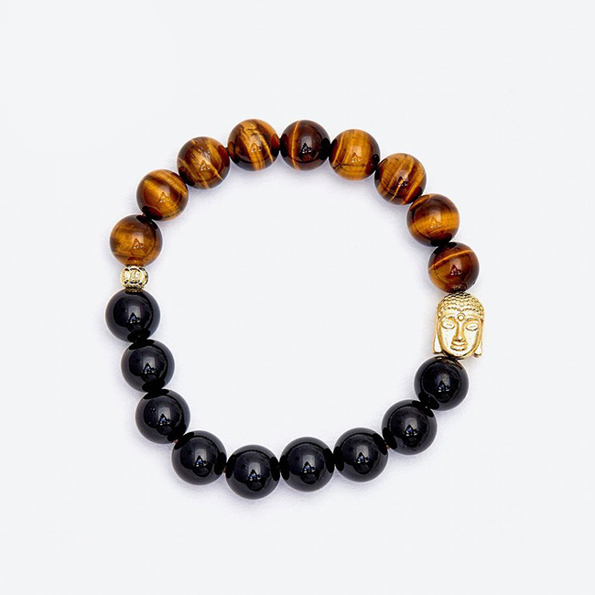

**USES AND MEANINGS OF TIGER'S EYES:**

**In terms of feng shui:**

Tiger's Eye is a stone symbolizing the power of the Lord of the Green Forest, showing courage, perseverance and representing people with status, power and success in society.

The stone brings the owner good things and luck in life.

The stone has feng shui value in terms of fortune, prosperity, banishing bad energies and exorcism, while improving the owner's ability to communicate and social relationships.

**In terms of health:**

Tiger's Eye is used in folk medicine to treat a number of problems with the nervous system, stomach and intestines.

In addition, the stone also has the effect of improving the physical and mental strength of the owner thanks to its abundant yang energy.

**Destiny:**

Tiger's Eye Stone is suitable for people with Earth destiny (according to compatibility) and par Metal (according to mutual birth).

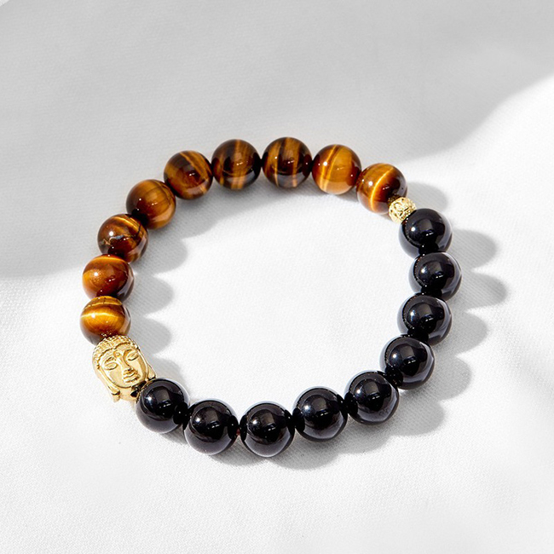

**USES AND MEANINGS OF BLACK AGATE:**

**In terms of feng shui:**

Black Agate symbolizes health, wealth and longevity, was loved by the ancient nobility to affirm their status and class.

- Stone brings you wonderful experiences in love, giving you strength and confidence to fulfill your ideals.

- The wearer will always feel optimistic, love life and be helped by the positive energy that Black Agate brings.

**In terms of health:**

- Black Agate enhances memory, concentration, clarity and clears away anger so you can make the right decisions.

- Stone supports blood circulation, improves physical fitness and solves some problems in women.

**Destiny:**

Black Agate is suitable for people with Water (according to compatibility) and Wood (according to mutual birth).

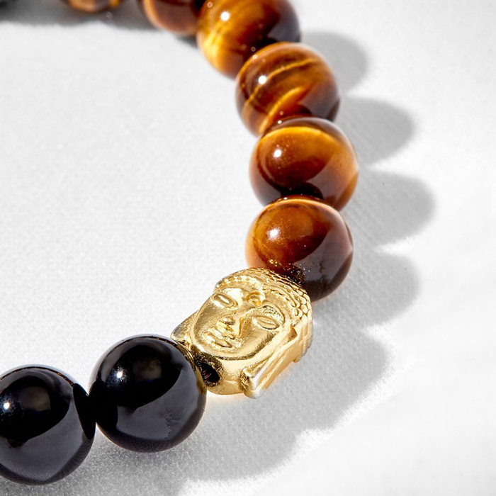

**WARRANTY OF OUR PRODUCTS**

- 24 months warranty for all feng shui jewelry products.

- Warranty service includes: Warranty for stone color, knitting rope (for rings), necklace (for pendants, necklaces).

**INSTRUCTIONS FOR STORAGE OF US PRODUCTS**

1. Avoid contact with chemicals.

When wearing should avoid contact with chemicals in daily activities such as:

- Cosmetics: lotion, perfume, makeup powder, makeup remover...

- Daily activities: dishwashing liquid, laundry soap, hand sanitizer..

- Other: sea water, swimming pool water...

2. Avoid strong impact.

As a product made from natural stone with a certain hardness, but will also break and scratch when hit hard, the following cases should be avoided:

- Do not wear bracelets when playing sports and other vigorous activities.

- Avoid banging the bracelet, dropping the bracelet.

- Avoid wearing bracelets during activities that are easily bumped and entangled such as housework, changing clothes...

3. Use and store the bracelet properly.

- Should remove the bracelet when bathing and when going to bed.

- Store the bracelet separately from other jewelry. Store in a soft cloth-lined box to prevent scratches.

4. Sanitize the bracelet

- Clean the bracelet regularly with a soft cloth.

- Bring to the store to clean the bracelet with specialized toilet water.