# 14K CZK White Gold Diamond Ring

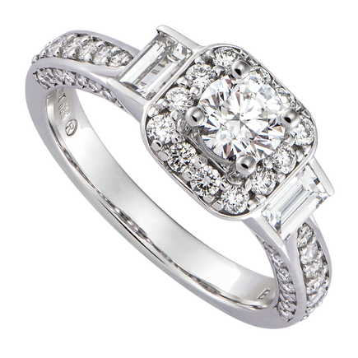

73.960.000 đ

Possessing a beautiful, sparkling and luxurious beauty, diamond jewelry helps to honor class, express power as well as luck to the owner. In particular, diamonds are not only for women, but men can also wear diamond rings to show their elegance and elegance.

The gold ring created by the combination of 14K white gold material with diamond accents will be an indispensable "helper" for every girl. Besides, she can also mix & match with other accessories such as earrings, necklace or a small diamond bracelet, PNJ is sure that she will become the focus of every meeting.

Diamond – Jewelry honoring class đẳng

Possessing a beautiful, sparkling and luxurious beauty, diamond jewelry helps to honor class, express power as well as luck to the owner. In particular, diamonds are not only for women, but men can also wear diamond rings to show their elegance and elegance.