14K CZK White Gold Diamond Bracelet

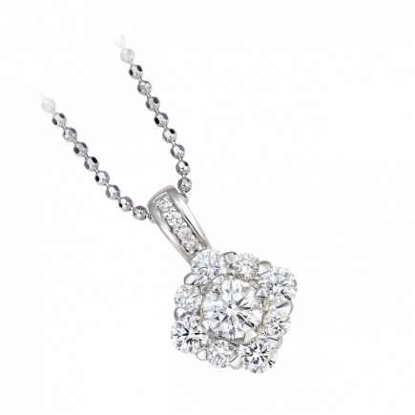

167.521.000 đ

Beyond all the material values of precious metals, diamond's eternal light always has unlimited attraction and lasts forever. PNJ Diamond Jewelery masterpieces not only honor beauty but also affirm style, class, passion and bring success to the owner.

PNJ Diamond Jewelry always chooses Round Brilliant Cut diamonds with 57 cuts, which is also the most perfect and standard criterion for diamond jewelry.

14K WHITE GOLD DIAMOND Bracelet

Set of 14K white gold material, set with Diamonds.

14K WHITE GOLD DIAMOND Bracelet

Bracelet, 14K . white gold

The process of choosing the perfect diamond jewelry for yourself is no different from finding a lover. The 4Cs were born to make sure your choices don't go wrong. This international rule covers the basic parameters that have a decisive influence on the value of top gems.

Therefore, before "falling in love" with a diamond, make sure you understand these quality standards!

A personalized design diamond jewelry will help you shine at any angle and in any fashion.

Discover the design for you!