White Gold Diamond Pendant

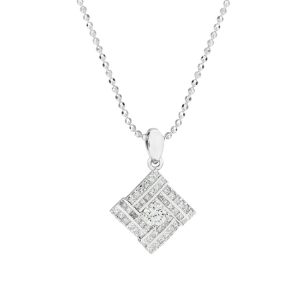

34.054.000

In this day and age, diamonds are no longer strange and diamond-studded jewelry has been one of the accessories that women choose to add to their jewelry collection. With the sweet and harmonious combination of 14K gold and diamonds and the integrated heart-shaped design, the PNJ pendant is youthful and luxurious.

Not only impressing with the sweet appearance, but the pendant also exudes the elegance of the diamond set inside the heart shape. And it will become more perfect when combined with necklaces, earrings, rings, etc. This combination will definitely honor the beauty and class of the ladies.

Diamond – Jewelry that shows class

The allure of diamond jewelry comes from its purity, which reflects many colors, creating a magical glittering beauty that no other jewelry can match. Wearing luxury diamond jewelry is like putting on pride and nobility, making ladies confidently present themselves in front of the crowd, attracting admiring glances at the outstanding luxury class.