18K CZK Italian White Gold Pendant

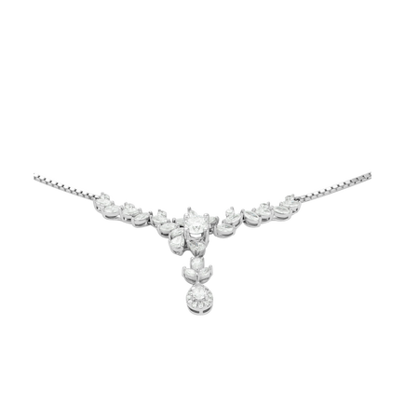

1.040.000

18K CZK white gold PNJ pendant

Jewelry is always a necessary accessory and an endless passion of women because of its usefulness and high aesthetic value. In particular, this 18K white gold pendant not only enhances the feminine beauty of the women's neck but also creates a highlight for the outfit.

The 18K white gold PNJ pendant is the perfect choice to enhance the style of modern women. With a feminine design, finely crafted to bring a radiant, shimmering beauty full of attraction. Expressing youth, gentleness but no less charming and luxurious. An easy accessory for girls that can be mixed with many different outfits.

PNJ pendant is a meaningful gift

A youthful and charming accessory, 18K white gold PNJ pendant with 5 petals of apricot blossom, symbolizing the five blessings: The first is joy, the second is good luck, the third is longevity, the fourth is happiness , the fifth is peace. That is also the symbolic meaning of this flower. At the same time, PNJ pendants can also be used as meaningful and loving gifts that you want to send to your loved ones.