**Drone Tracking and Pilot Tracking system**

The "Drone Tracking and Pilot Tracking System" is a console-based application designed to manage drone operations and ensure compliance with maintenance, safety, and licensing standards. This system allows administrators to manage drones, pilots, and their activities efficiently. Through tracking, recording, and reporting functionalities, the system maintains comprehensive records of drone information (such as serial numbers, models, and maintenance history), pilot details (such as licenses, experience, and certifications), and flight logs. By storing this information in a structured database, the system generates insights on drone utilization, pilot activity, and maintenance schedules, which help optimize operational efficiency and safety protocols.

**OBJECTIVE:**

The primary objectives of this system are:

To provide a centralized solution for managing drone and pilot information, including maintenance histories and certifications.

To accurately record and track flight logs for each operation, linking drones to pilots and tracking flight details.

To streamline report generation, helping stakeholders understand drone utilization, pilot working hours, and upcoming maintenance schedules.

To store data securely in a database, ensuring data integrity and ease of retrieval for future audits, compliance checks, or operational assessments.

To enhance data accuracy and reliability through input validation and error handling, making the system robust and user-friendly.

**PLATFORM SPECIFICATION:**

Programming Language: Java (for its robustness, portability, and extensive library support)

Database: MySQL (for structured data storage, relational integrity, and SQL support)

Development Environment: Console-based application; IDE such as IntelliJ IDEA, Eclipse, or NetBeans is recommended

Database Connectivity: JDBC (Java Database Connectivity) for connecting the Java application to the MySQL database

Operating System Compatibility: Cross-platform support (Windows, macOS, Linux) due to Java’s platform independence

**FUNCTIONAL REQUIREMENTS:**

The functional requirements define the core functionalities the system should perform to meet the needs outlined in the problem statement.

**Database Design**

Tables:

Drones: Stores details like serial number, model, manufacturer, and maintenance history.

Pilots: Records pilot information, including license numbers, experience, and certifications.

FlightLogs: Logs individual flight details, including drone, pilot, flight times, and location.

MaintenanceRecords: Maintains a history of maintenance events for each drone.

Relationships:

FlightLogs table has foreign keys referencing the Drones and Pilots tables.

MaintenanceRecords table has a foreign key referencing the Drones table.

**Drone Management**

Add New Drone: Administrators can add new drone records with required fields (serial number, model, manufacturer, last maintenance).

Update Drone Details: Allows modification of drone information, including updates to the maintenance history.

Delete Drone: Administrators can remove drones from the database.

View Drone List: A function to display all drones along with their details, useful for quick overviews.

**Pilot Management**

Add New Pilot: Administrators can add a new pilot with license details, experience, and certifications.

Update Pilot Details: Enables updating pilot information, such as adding certifications or updating experience.

Delete Pilot: Administrators can remove a pilot’s record if necessary.

View Pilot List: A function to display all registered pilots along with their details.

**Flight Log Entry**

Log New Flight: Authorized users can record flight details, including the drone used, the pilot, flight duration (start and end times), and location.

Edit Flight Log: Modify flight log entries if there were errors or changes in details.

Delete Flight Log: Remove entries if a flight record is incorrect or obsolete.

**Report Generation**

Drone Utilization Report: Summarizes each drone's usage, showing how frequently each drone is used over a selected period.

Pilot Hours Report: Tracks the number of hours each pilot has flown, useful for monitoring workload and compliance with licensing requirements.

Maintenance Schedule Report: Lists upcoming and overdue maintenance for each drone, assisting in proactive maintenance planning.

Output Format: Reports will be console-displayed, with options to save in CSV or text format if required.

**Error Handling and Validation**

Error Handling:

Database Connectivity Errors: Checks for connection issues and notifies users.

Data Insertion/Update Errors: Handles exceptions if data fails to insert or update, displaying appropriate error messages.

Validation:

User Input Validation: Ensures inputs for serial numbers, license numbers, and dates are formatted correctly.

Duplicate Entries: Prevents duplicate records, especially for unique identifiers like serial numbers and license numbers.

Date Validation: Ensures dates for flights and maintenance entries are within logical ranges

**SCHEMA DIAGRAM:**

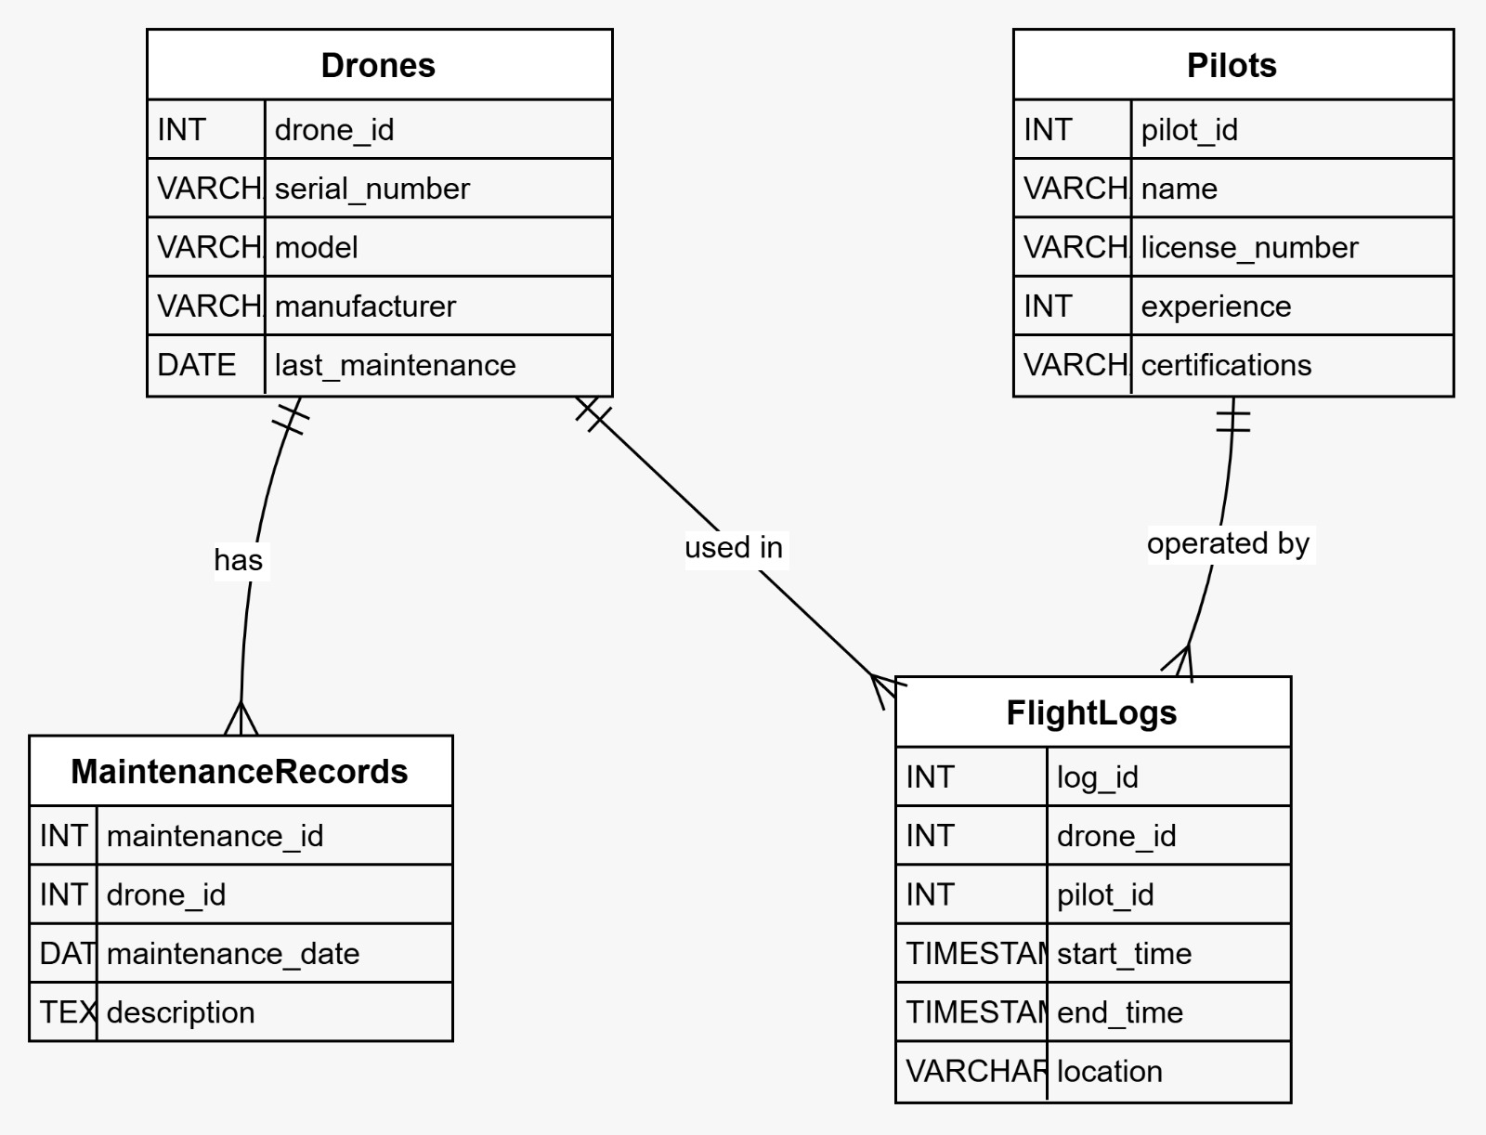

**ENTITY-RELATIONSHIP DIAGRAM**

