**COMPONENTS :**

* Resistors
* Capacitors
* Inductor
* Transformers
* Transistors
* Relay
* Switch
* Batteries
* Integrated Circuits
* Fuse
* Optional Amplifier
* Connectors
* Tunnel diode
* Zener diode
* Light emitting diode-LED
* Potentiometer
* Multimeter
* Vacuum tubes
* Electronic power
* Microcontroller
* Microprocessor
* Analog to digital converter
* Digital to analog converter

**Classification of components:**

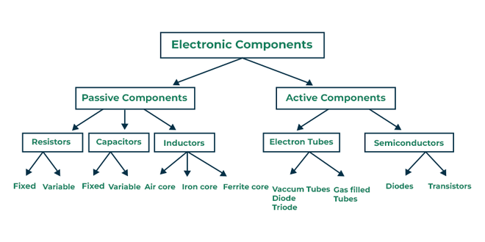

**Passive components:**

Passive components are electronic components that do not require an external power source to function. They control, store, or filter electrical signals without amplification.

**Active components:**

Active components are electronic components that **require an external power source** to operate and can **control, amplify, or generate electrical signals**.

**RESISTORS:**

* Resistors are passive electronic components that **limit current flow** and **divide voltage** in a circuit.
* They are measured in **ohms (Ω)** and follow **Ohm’s Law (V = IR)**.

**SI Unit:**

**ohms (Ω)**

**Types of Resistor:**

* Linear Resistor
* Non linear Resistor

**Linear Resistor:**

* **Definition:** Resistors whose resistance remains constant regardless of applied voltage or current.
* **Follows Ohm’s Law:** V=IRV = IRV=IR (Voltage and current have a linear relationship).

**Non-Linear Resistor:**

* **Definition:** Resistors whose resistance changes with applied voltage, temperature, or other factors.
* Does NOT follow Ohm’s Law.

**Classification of Resistor:**

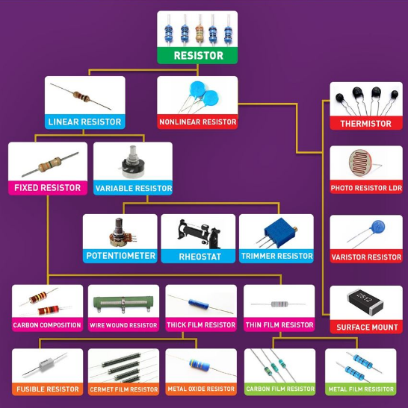

**1.Fixed Resistors:**

These resistors have a set resistance and cannot be adjusted.

**Types of Fixed Resistor:**

1. Carbon composition Resistor
2. Wire wound Resistor
3. Thick film Resistor
4. Thin film Resistor
5. **Carbon composition Resistor:**

A **carbon composition resistor** is a type of fixed resistor made from a mixture of carbon powder and a binder, which is molded into a cylindrical shape and coated with an insulating material.

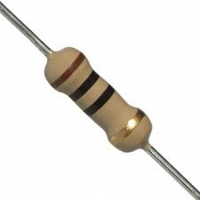 

1. **Wire wound Resistor**

A **wire wound resistor** is a type of fixed or variable resistor made by winding a resistive wire (usually **Nichrome**) around an insulating core, such as ceramic or fiberglass.

  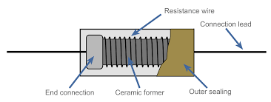

1. **Thick film Resistor:**

A **thick film resistor** is a type of fixed resistor made by applying a thick layer of resistive paste (typically a mixture of **ceramic and metal oxides**) onto an insulating ceramic substrate.

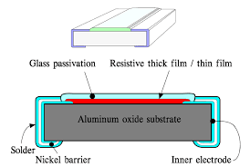

**Types of Thick film resistor:**

1. Fusible resistor
2. Cermet resistor
3. Metal-oxide resistor

**Fusible resistor:**

A **fusible resistor** is a special type of resistor that functions both as a **resistor** and a **fuse**. It limits current under normal operation and **opens the circuit (blows like a fuse) when excessive current flows**, protecting other components from damage.

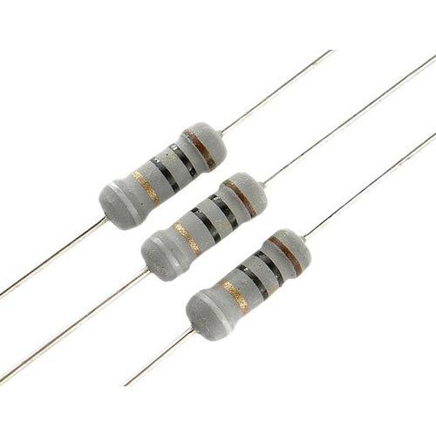 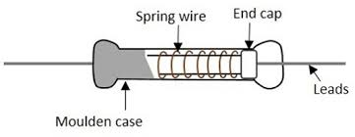

**Cermet resistor:**

A **cermet resistor** is a type of fixed or variable resistor made from a mixture of **ceramic (cer) and metallic (met) materials**, forming a stable resistive element.

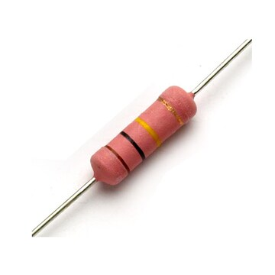 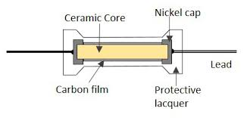

**Metal-oxide resistor:**

A **metal-oxide resistor** is a type of fixed resistor made using a **metal-oxide film (such as tin oxide) deposited on a ceramic core**. It offers better stability and durability than carbon-based resistors.

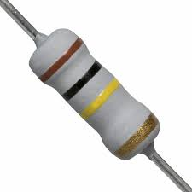 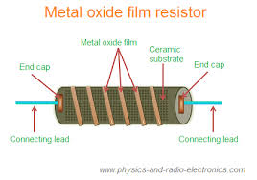

1. **Thin film Resistor:**

A **thin film resistor** is a high-precision resistor made by depositing a **thin layer of resistive material (such as nickel-chromium) onto a ceramic substrate**. It offers better accuracy and stability than thick film resistors.

**Types of Thin film resistor:**

1. Carbon film resistor
2. Metal film resistor

**Carbon film resistor:**

A **carbon film resistor** is a type of fixed resistor made by depositing a thin layer of **carbon film** onto a ceramic substrate. The resistance is adjusted by cutting a **helix-shaped groove** into the film.

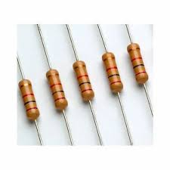 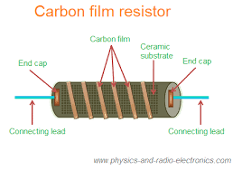

**Metal film resistor:**

A **metal film resistor** is a type of fixed resistor made by depositing a thin layer of **metal alloy (such as nickel-chromium) onto a ceramic substrate**. It provides higher precision and stability than carbon film resistors.

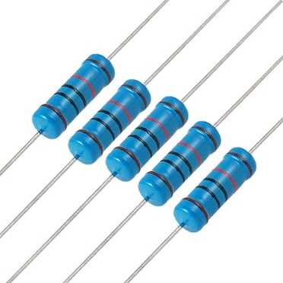 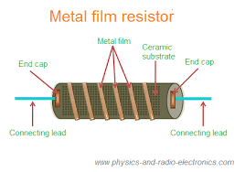

**2.Variable Resistor:**

These resistors allow manual or automatic adjustment of resistance.

**Types of Variable resistor:**

1. Potentiometer
2. Rheostat
3. Trimmer resistor

**Potentiometer:**

A **potentiometer (pot)** is a **variable resistor** with three terminals, used to adjust voltage levels by sliding or rotating a contact over a resistive element.

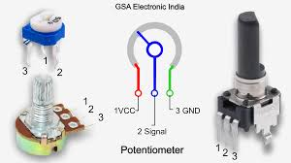

**Rheostat:**

A **rheostat** is a **variable resistor** used to control **current flow** in a circuit by manually adjusting resistance. It typically has **two terminals** (one fixed and one adjustable).

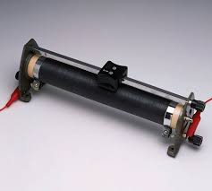 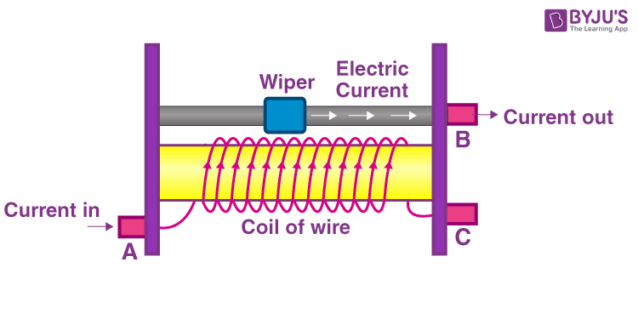

**Trimmer Resistor:(Trimpot)**

A **trimmer resistor (trimpot)** is a small, adjustable **variable resistor** used for fine-tuning and calibration in electronic circuits. It is typically set during circuit assembly and rarely adjusted afterward.

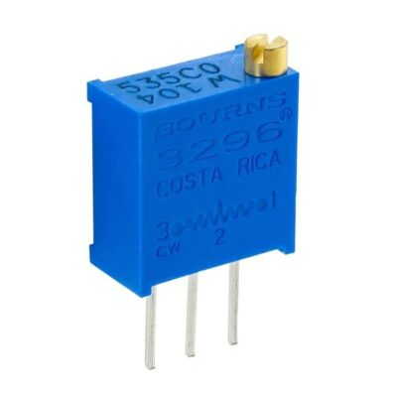

**Types of Non-linear resistor:**

1. Thermistor
2. Photoresistor(LDR)
3. Varistor(VDR)

**Thermistor:**

A **thermistor** is a **temperature-sensitive resistor** whose resistance changes significantly with temperature. It is widely used for **temperature sensing and control** applications.

**NTC (Negative Temperature Coefficient) Thermistor**

* **Resistance decreases** as temperature increases.
* Used in **temperature sensors and inrush current limiters**.

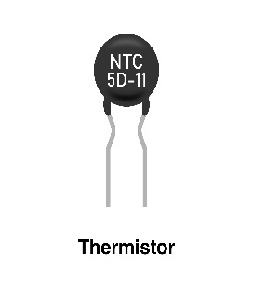

**PTC (Positive Temperature Coefficient) Thermistor**

* **Resistance increases** as temperature increases.
* Used in **overcurrent protection and self-resetting fuses**.

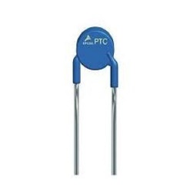

**Photoresistor(LDR-Light Dependent Resistor):**

A **photoresistor (LDR)** is a **light-sensitive resistor** whose resistance **decreases** as light intensity **increases**. It is used in **light detection and automatic control systems**.

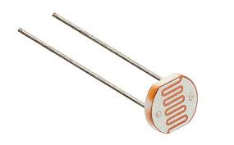

**Varistor(VDR- Voltage Dependent Resistor):**

A **varistor (VDR)** is a **non-linear resistor** whose resistance **changes with applied voltage**. It is primarily used for **surge protection** in electrical circuits.

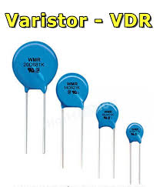

**Colour Coding of Resistor:**

Resistor color coding is a **standardized system** used to indicate the resistance value, tolerance, and sometimes reliability of a resistor. It consists of **colored bands** printed on the resistor body.

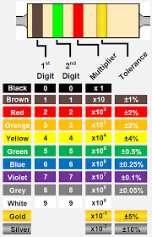 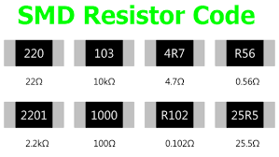

**Resistor in Series:**

When resistors are connected **end-to-end** in a single path, they are said to be in **series**. In this configuration, the total resistance is the **sum of individual resistances**.

**Formula:**

**Rtotal​=R1​+R2​+R3​+⋯+Rn​**

where:

* Rtotal​ = Total resistance
* R1​,R2​,R3​,… = Individual resistor values

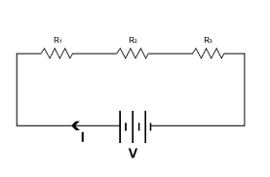

**Resistor in Parallel:**

When resistors are connected **side by side**, with their terminals joined at both ends, they are said to be in **parallel**. In this configuration, the total resistance is **less than the smallest individual resistor** because multiple paths allow more current to flow.

**Formula:**

The total resistance for **n** resistors in parallel is given by:

**1/Rtotal=1/R1+1/R2+1/R3+⋯+1/Rn**

For **two resistors**, the formula simplifies to:

**Rtotal=R1×R2/R1+R2**

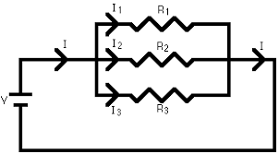

**CAPACITORS:**

A **capacitor** is a **passive electronic component** that **stores electrical energy** in an **electric field**. It consists of **two conductive plates** separated by an **insulating material** called a **dielectric**.

**Unit of Capacitance:**

* Measured in **Farads (F)**.
* Common values: **Microfarads (µF), Nanofarads (nF), Picofarads (pF)**.

### **Capacitor Formulas:**

1. **Charge Stored**:

Q=C×V

where **Q** = Charge (Coulombs), **C** = Capacitance (Farads), **V** = Voltage (Volts).

1. **Capacitors in Series**:

1/Ctotal=1/C1+1/C2+1/C3+…

(Opposite to resistors in series; total capacitance **decreases**).

1. **Capacitors in Parallel**:

Ctotal=C1+C2+C3+…

**Classification of capacitors:**

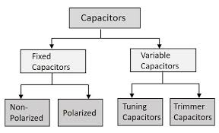

**1.Fixed Capacitors:**

A **fixed capacitor** is a type of capacitor with a **predefined and constant capacitance value** that does not change during circuit operation. These capacitors are widely used in electronic circuits for **filtering, energy storage, timing, and coupling applications**.

Types of Fixed Capacitors:

1. Polarized Capacitor
2. Non-Polarized Capacitors

**Polarized Capacitor:**

A **polarized capacitor** is a type of capacitor that **has a fixed polarity**, meaning it must be connected with the correct positive (+) and negative (-) terminals. If reversed, it can **fail or even explode**.

**Types of Polarized capacitors:**

* Electrolytic Capacitors
* Tantalum Capacitors

**Electrolytic Capacitors**

Electrolytic capacitors are a type of **polarized capacitor** that use an **electrolyte** as one of their plates to achieve **high capacitance values**. They are widely used in **power supply filtering, energy storage, and coupling applications** in electronic circuits.

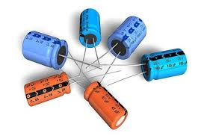 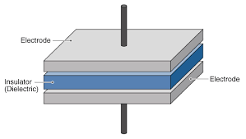

**Tantalum Capacitors:**

A **tantalum capacitor** is a type of **electrolytic capacitor** that uses **tantalum metal** as the anode. It offers **higher stability, reliability, and lower leakage current** compared to aluminum electrolytic capacitors.

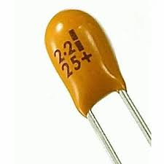 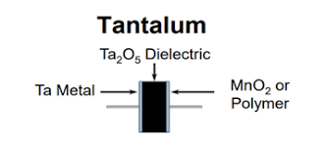

**Non-Polarized Capacitors:**

A **non-polarized capacitor** is a capacitor that **does not have a fixed polarity**, meaning it can be connected in any direction in a circuit. Unlike **electrolytic capacitors**, these capacitors can be used in **both AC and DC circuits**.

**Types of Non-Polarized Capacitors:**

* Ceramic Capacitor
* Film Capacitor
* Mica Capacitor

**Ceramic Capacitor:**

A **ceramic capacitor** is a type of **non-polarized capacitor** that uses a **ceramic dielectric material** to store electrical charge. It is widely used due to its **compact size, low cost, and excellent high-frequency performance**.

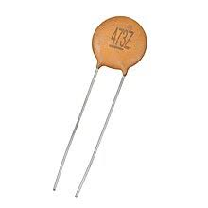 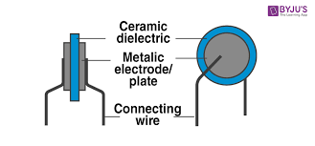

**Film Capacitor:**

A **film capacitor** is a type of **non-polarized capacitor** that uses a **thin plastic film** as a dielectric. It is known for its **high stability, low loss, and long lifespan**, making it ideal for **AC and high-voltage applications**.

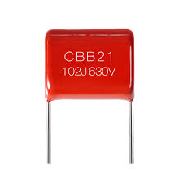 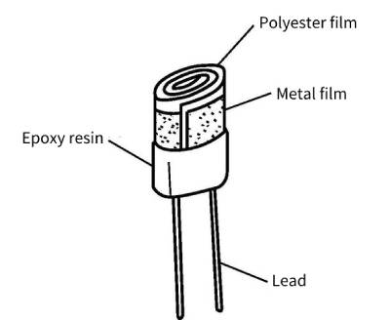

**Mica Capacitor:**

A **mica capacitor** is a type of **non-polarized capacitor** that uses **mica as the dielectric material**. It is known for its **high precision, stability, and reliability**, making it ideal for **high-frequency and RF applications**

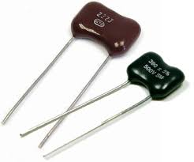 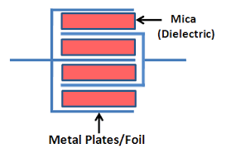

**2.Variable Capacitors:**

A **variable capacitor** is a capacitor whose **capacitance value can be adjusted** mechanically or electronically. These capacitors are commonly used in **radio tuning, frequency control, and impedance matching** applications.

Types of variable capacitors:

1. Tuning capacitors
2. Trimmer capacitors

**Tuning capacitors:**

A **tuning capacitor** is a type of **variable capacitor** specifically designed for **adjusting the resonance frequency** of circuits, especially in **radio receivers, transmitters, and oscillators**.

Types of Tuning Capacitors:

* Air-Gap Variable Capacitor
* Vacuum Variable Capacitor

**Air-Gap Variable Capacitor:**

An **air-gap variable capacitor** is a type of **mechanically adjustable capacitor** that uses **air as the dielectric material**. The capacitance is adjusted by varying the **overlapping area or distance between metal plates (rotor and stator)**.

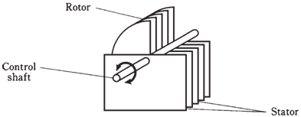

**Vacuum Variable Capacitor:**

A vacuum variable capacitor is a type of variable capacitor that uses a vacuum as the dielectric material instead of air or other insulating materials. It provides high voltage handling, low losses, and excellent stability, making it ideal for RF, high-power, and industrial applications.

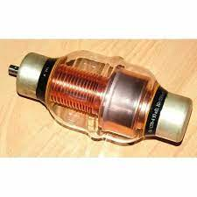

**Trimmer capacitors:**

A **trimmer capacitor** is a **small, adjustable capacitor** designed for **fine-tuning circuits**. It is typically used for **calibration, frequency adjustment, and impedance matching** in electronic circuits. Once adjusted, it is **not meant for frequent changes**.

