PENETRATION TESTING REPORT
FOOTPRINTING & NETWORK SCANNING PHASES
W2-PM-FINAL | CYBERSECURITY | NETWORKWALKS
Pentester Name (Cybersecurity Professional) | THANGAMANI M
Program/Batch | B083F - Networkwalks
Date | 18 September 2026
Modules Completed | W2-PM1 (Multiple Kali Tools) W2-PM5 (Nmap Network Scanning)
Client / Target | 1. Networkwalks.com (secured written permission already) 2. My own local LAN Network
Permission secured from client? | Yes
Phases Covered | Phase 1: Reconnaissance & Footprinting Phase 2: Scanning & Network Discovery Phase 3–5: In Progress

1. Liability Disclaimer
I have performed these activities only on the systems and devices where I had secured written permission, or the devices/systems that I own myself. All these materials are for education and research purposes only. Do not use anything from here to break the law. The instructor, the authors and Networkwalks are not responsible for what you do with this knowledge. Every action you take is your own responsibility. Misuse can lead to criminal charges, heavy fines, loss of your job and a permanent record. In most countries, unauthorised access is a crime even when nothing is damaged.

2. Introduction
This report covers footprinting the networkwalks.com domain using multiple Kali Linux tools (W2-PM1) and scanning my own local network using Nmap ping scan (W2-PM5). One module covers the footprinting phase and the other covers the scanning phase, so together they show how a penetration tester moves from gathering public information to mapping live hosts on a network. This is part of the Week 2 assignment of my ongoing cybersecurity internship at Networkwalks.
All commands were run in Kali Linux running inside Oracle VirtualBox. Every step below includes the exact command used, the result observed, a screenshot as evidence, and a short note on why the finding matters from a security perspective.

3. Tools Used
The table below lists each tool used in this report and its purpose.
Tool | Purpose
Kali Linux | Operating system used for reconnaissance activities
whatweb | Fingerprint web technologies (server, CMS, plugins, IP)
nslookup | Resolve the domain name to its IP address using DNS
curl -I | Read the HTTP response headers of the website
wafw00f | Detect whether a Web Application Firewall protects the site
dnsrecon | Enumerate all DNS records (NS, MX, SPF, TXT, SRV)
nmap (ping scan) | Scan the local subnet to find live hosts and IPs

4. Activities Performed

4.1 Footprinting & Reconnaissance (W2-PM1)
I performed reconnaissance against the networkwalks.com domain using five Kali Linux tools: WhatWeb, Nslookup, Curl, Wafw00f, and DNSRecon. Each tool was used to collect a different type of information about the target.
Step 1 – Network Configuration & WhatWeb
I first configured the DNS server by setting 8.8.8.8 in /etc/resolv.conf, then verified internet connectivity by pinging google.com (3 packets sent, 0% packet loss confirmed). I then ran whatweb against networkwalks.com to fingerprint the web technologies in use.
Result: WhatWeb identified WordPress 7.1.1, WP Download Manager 3.3.58, Apache web server, Bootstrap 7.1.1, jQuery 3.7.1, IP 192.232.216.135, and the site title 'Networkwalks Academy'.
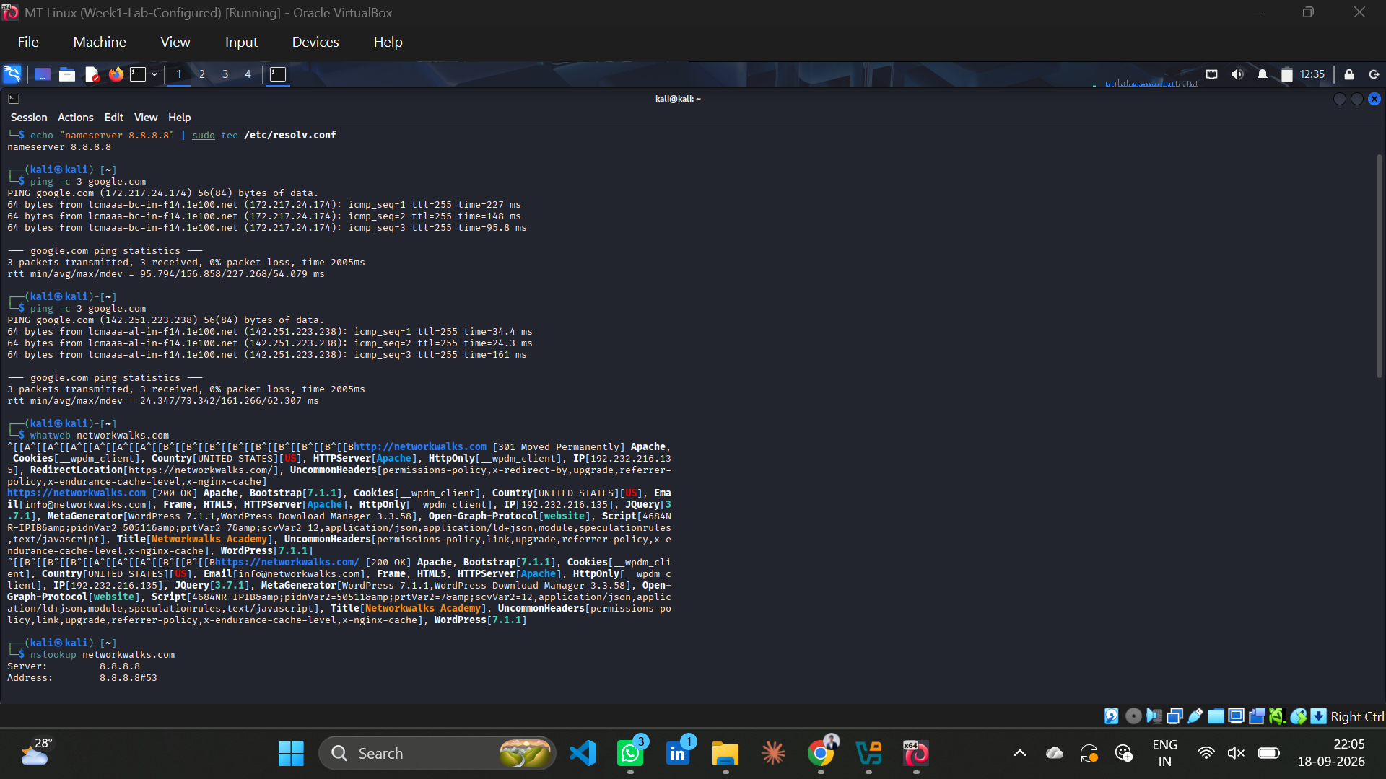
Screenshot 1: Network configuration and WhatWeb scan results
Step 2 – Nslookup & Curl
I used nslookup to resolve networkwalks.com to its IP address using Google's DNS (8.8.8.8). Result: networkwalks.com resolved to 192.232.216.135.
I then used curl -I to inspect the HTTP response headers. This returned HTTP/2 200, server: Apache, x-nginx-cache: WordPress, and exposed the /wp-json/ REST API endpoint in the Link header.
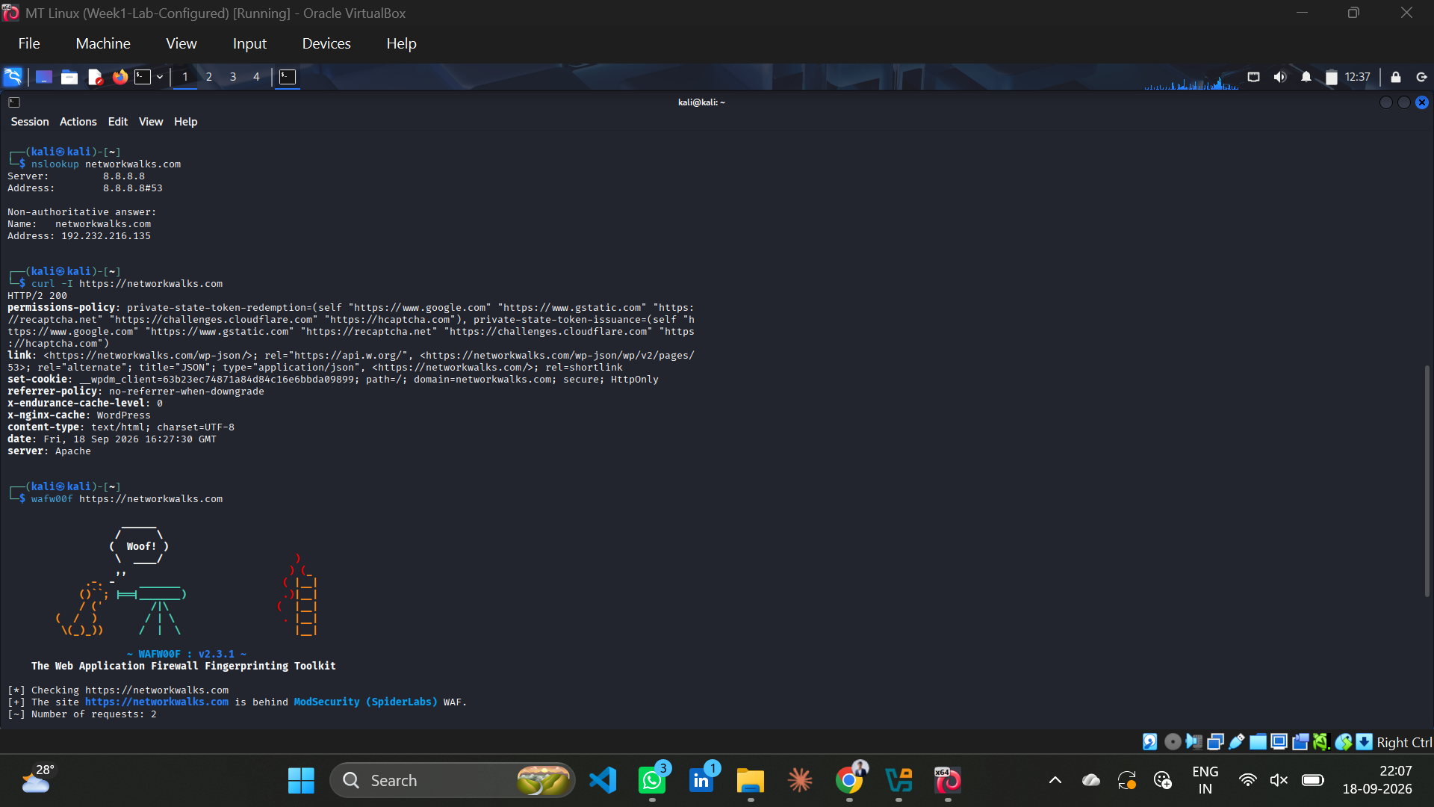
Screenshot 2: nslookup and curl -I results
Step 3 – Wafw00f & DNSRecon
I ran wafw00f to detect any Web Application Firewall protecting networkwalks.com. Result: The site is behind ModSecurity (SpiderLabs) WAF.
I then ran dnsrecon -d networkwalks.com to enumerate DNS records. Key results: NS records – ns6135.hostgator.com (50.87.144.87), ns6136.hostgator.com (192.232.216.131); MX record – mail.networkwalks.com (192.232.216.135); TXT records – Google site verification and SPF record (+a +mx +ip4:50.87.144.87 +include:websitewelcome.com ~all); SRV records – 8 autodiscover._tcp.networkwalks.com entries pointing to cpanelemaildiscovery.cpanel.net.
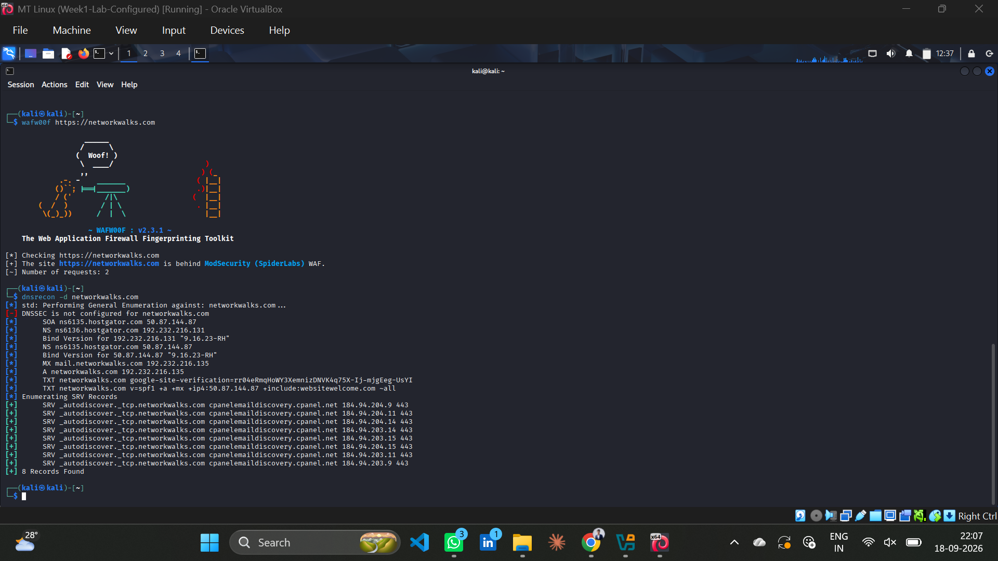
Screenshot 3: wafw00f and dnsrecon results

4.2 Network Scanning with Nmap (W2-PM5)
For the second activity, I performed a ping scan on my local network using Nmap to discover all live hosts on the 10.0.0.0/24 subnet.
Step 4 – Nmap Ping Scan (Start)
Command used: sudo nmap -sn 10.0.0.0/24 -oN nmap_result.txt
The scan began at 2026-09-18 13:12 EDT. The first screenshot shows the scan in progress, with hosts from 10.0.0.0 through 10.0.0.13 already confirmed as live.
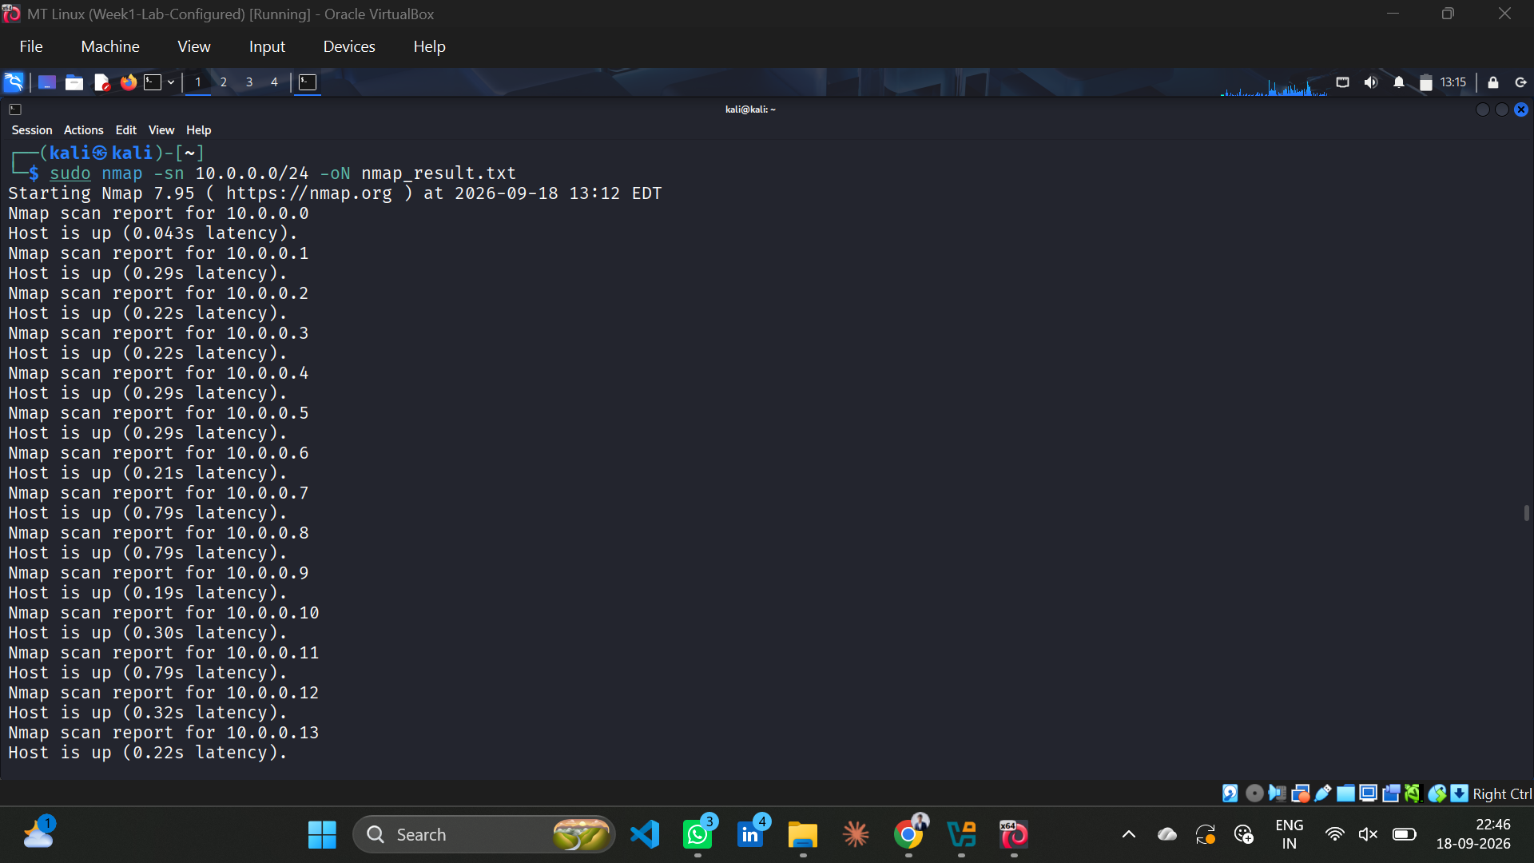
Screenshot 4: Nmap ping scan in progress
Step 5 – Nmap Ping Scan (Complete)
The scan completed at 13:16 EDT, taking 129.40 seconds. Final result: 256 IP addresses scanned, 256 hosts up on the 10.0.0.0/24 subnet (all hosts responded to the ping probe).
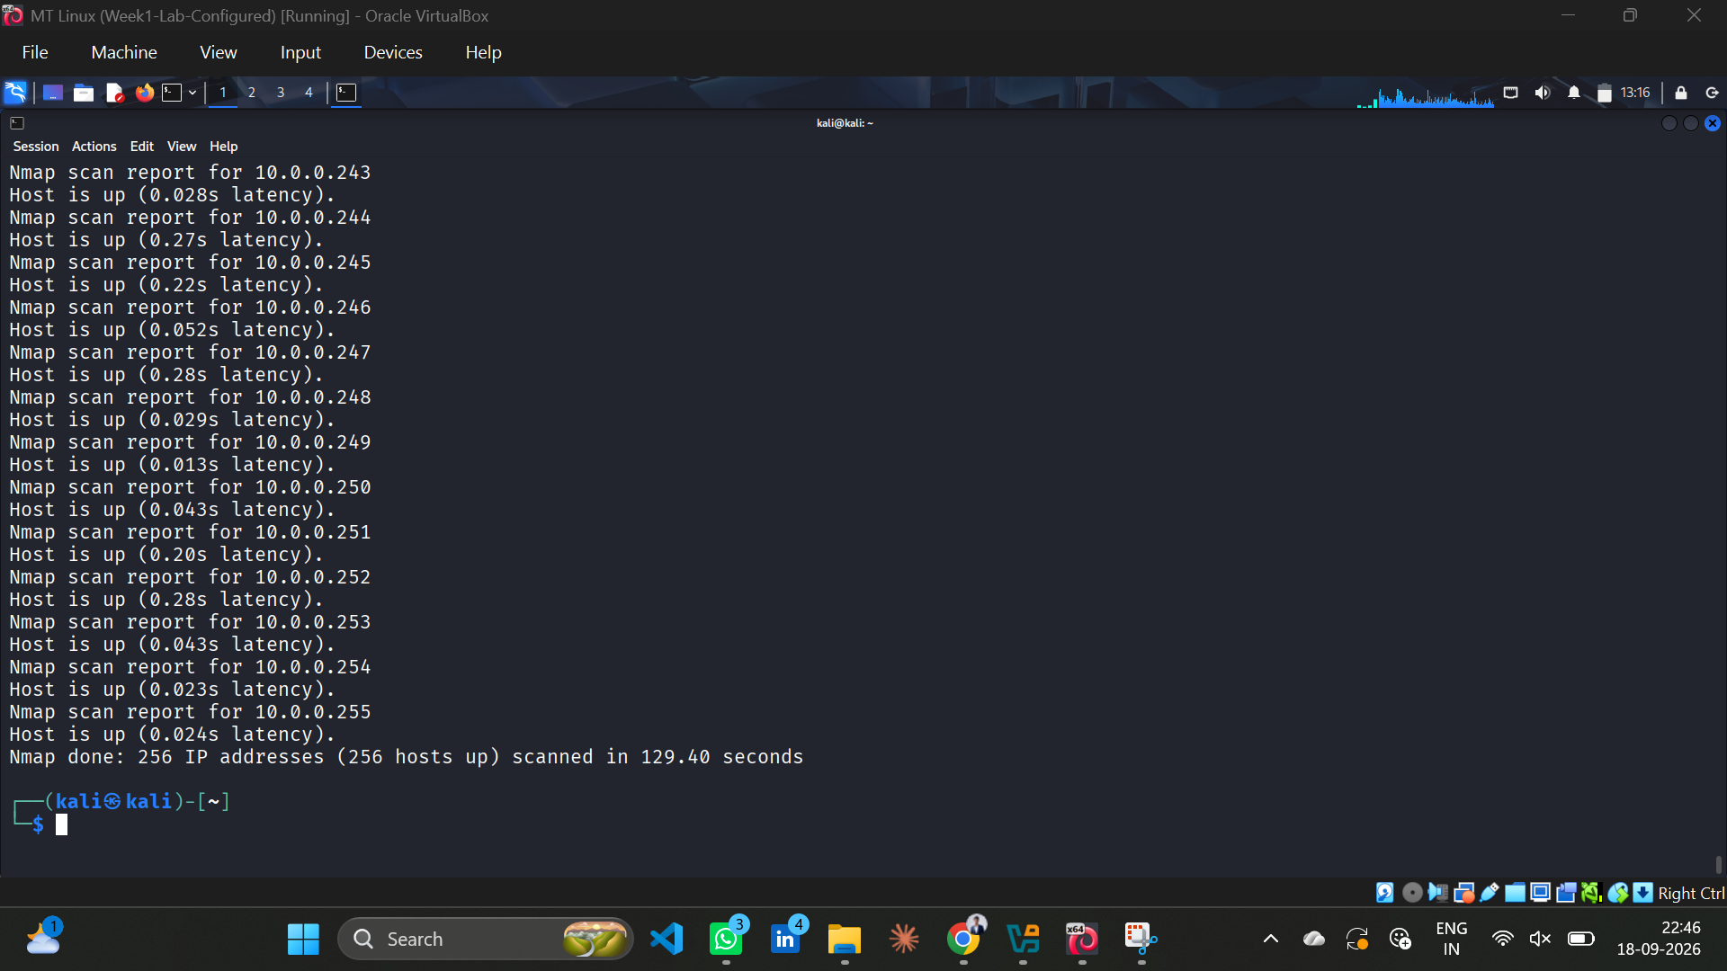
Screenshot 5: Nmap ping scan complete – 256 hosts found

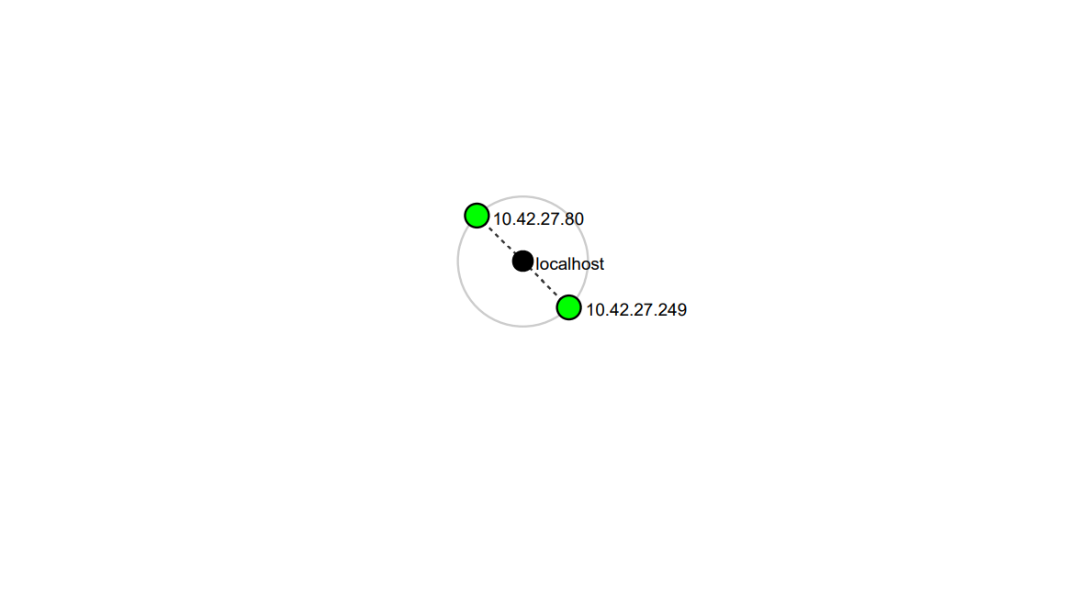

5. Risk Analysis / Impact
Based on the information collected during the footprinting and network scanning activities, the following potential risks were identified.

# | Risk / Finding | Evidence / Observation | Potential Impact | Risk Level
1 | Web technology information exposed | WhatWeb identified WordPress 7.1.1 and WP Download Manager 3.3.58 | Attackers may use exposed technology/version info to identify known vulnerabilities | ● Medium
2 | Server IP address identifiable | nslookup resolved networkwalks.com to 192.232.216.135 | Provides information about the network location of the web service | ● Low
3 | HTTP technical information exposed | curl -I returned HTTP response headers including /wp-json/ REST API endpoint | May assist technology fingerprinting and further enumeration | ● Low
4 | WAF technology identifiable | wafw00f identified ModSecurity (SpiderLabs) | Reveals information about the web application's security architecture | ● Low
5 | DNS infrastructure information exposed | dnsrecon identified NS, MX, SPF/TXT, SRV records | DNS info can help build a broader infrastructure profile | ● Medium
6 | All 256 hosts visible on local network | Nmap ping scan found 256 live hosts on 10.0.0.0/24 | Unknown or unauthorized devices may be present on the network | ● Medium

Risk level key: ● Critical ● Medium (Orange) ● Low (Green)

6. Recommendations
Based on the findings, the following security measures are recommended:
- Review publicly exposed technology information – Organizations should regularly audit what CMS version, plugin names, and server details are publicly visible via WhatWeb or similar tools.
- Keep software updated – WordPress, plugins, and other web technologies should be patched regularly and reviewed against current security advisories.
- Review HTTP response headers – Unnecessary headers such as x-nginx-cache and exposed API endpoints (/wp-json/) should be suppressed or restricted.
- Review DNS records regularly – DNS records should be checked periodically to ensure only required information is publicly exposed.
- Properly configure and monitor the WAF – ModSecurity is in place; its rule sets should be kept updated and actively monitored.
- Perform regular internal network discovery – Internal network scans should be run periodically to maintain an accurate inventory of connected devices.
- Investigate unknown devices – Any unexpected device discovered during network scanning should be identified, verified, and documented.
- Maintain network documentation – Network topology and device inventory should be kept updated as a baseline for anomaly detection.
- Perform security testing only with authorization – All reconnaissance and scanning should be performed strictly within an authorized scope.

7. Conclusion
During Week 2 of my Cybersecurity & Ethical Hacking internship at Networkwalks, I completed practical activities covering footprinting, reconnaissance, and network scanning.
In the footprinting activity (W2-PM1), I used five Kali Linux tools to collect information about the networkwalks.com domain. I learned how WhatWeb can fingerprint web technologies, nslookup can resolve domain names, curl -I can expose HTTP headers and API endpoints, wafw00f can identify WAF solutions, and dnsrecon can enumerate DNS infrastructure records.
In the network scanning activity (W2-PM5), I used Nmap's ping scan to discover all 256 live hosts on my local 10.0.0.0/24 network. The results confirmed that every IP in the subnet was active.
These exercises demonstrated that information gathering is a critical first phase in any penetration test. Even before attempting to exploit a system, a security professional can learn a significant amount about an environment by carefully analyzing publicly available information and network responses.
I also learned that technical findings must be clearly documented. A good cybersecurity report explains what was performed, what was discovered, what the observation means, what risk it may create, and what remediation steps are recommended.
Finally, I reinforced the importance of ethics in cybersecurity: all reconnaissance and scanning must be performed only within an authorized and agreed scope.

— End of Report —
👤 Author
THANGAMANI M
Cybersecurity Intern | Batch B083F | Networkwalks
📌 Program: Cybersecurity at Networkwalks | Week: 02

