Assignment 1:

1. **git init** : It is Initialization and used to start new repository
2. **git status** : It lists all the files that have to be committed.

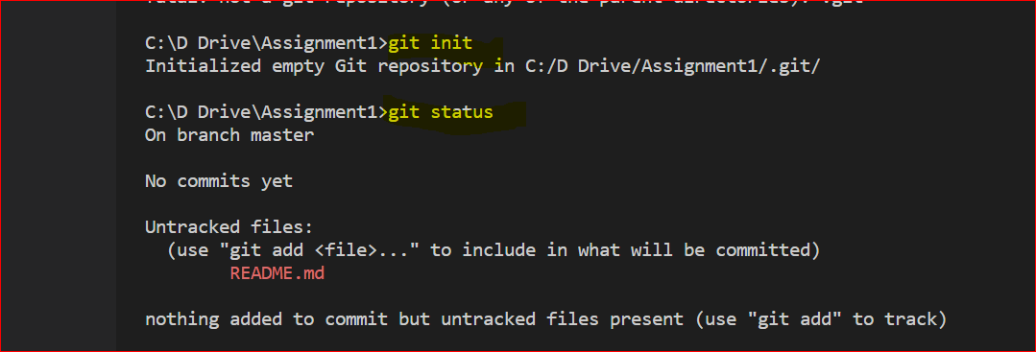

3.**git config --global user.name** : It gives the user name

4**. git config --global user.email** : It gives the user email address

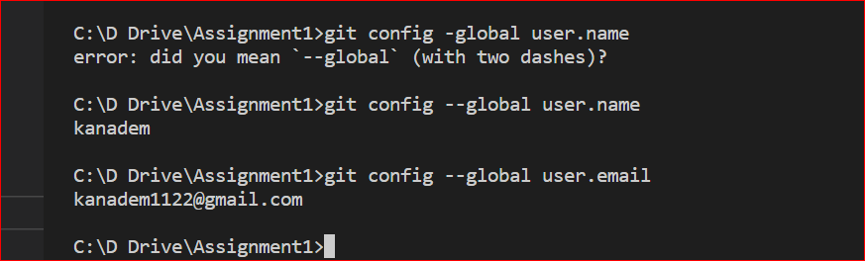

5.**git clone :** This command is used to obtain a repository from an existing URL

6**.git add :** This command adds a file to the staging area.

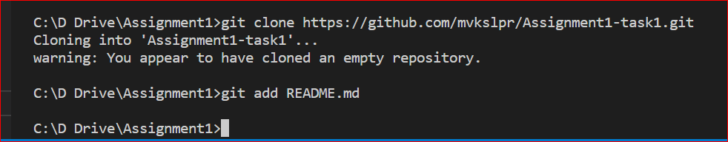

7**.git commit -m “message”** : This command records or snapshots the file permanently in the version history.

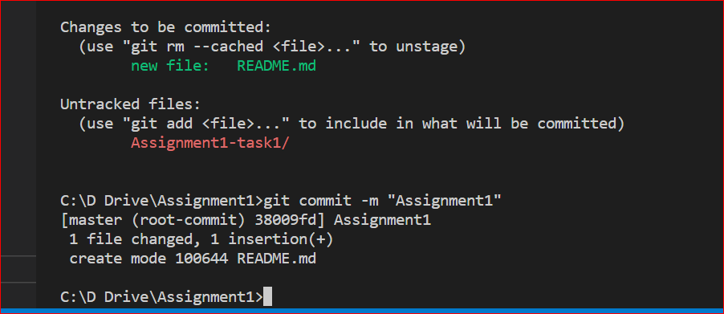

8.**git add * :** This command adds one or more to the staging area.



9.**git commit -a:** This command commits any files you’ve added with the git add command and also commits any files you’ve changed since then.

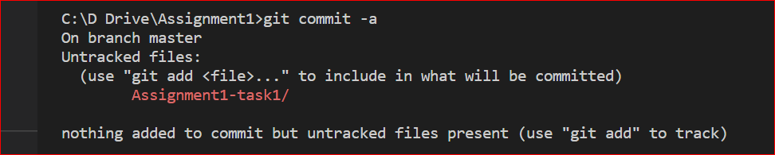

10.**git diff** : This command shows the file differences which are not yet staged

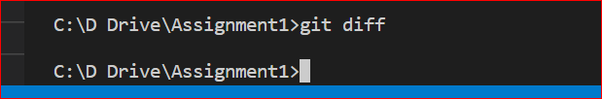

11**.git diff --staged:** This command shows the differences between the files in the staging area and the latest version present.

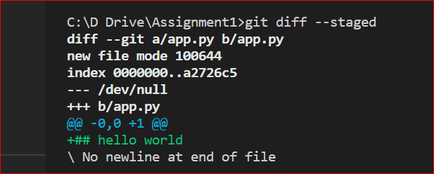

12**.git branch :** It shows the branch name

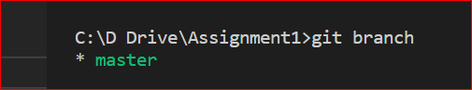

13. **git branch -M main** : It changes the branch from master to main

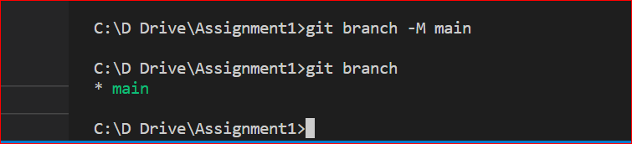

14.**git log :** This command is used to list the version history for the current branch.

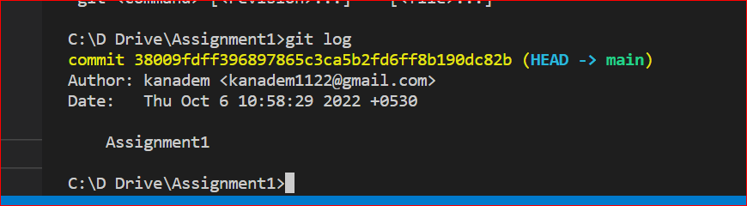

15.**git show :** This command shows the metadata

