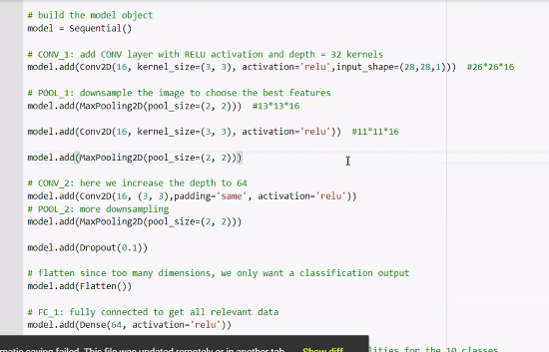

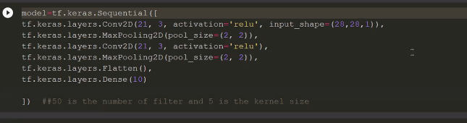

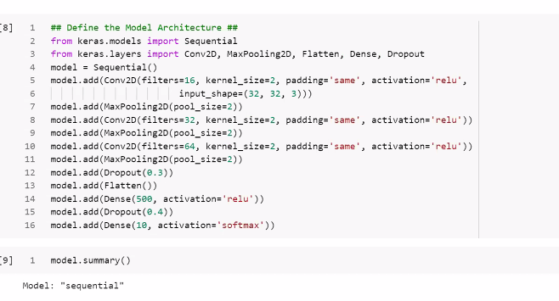

**sabinachellan@gmail.com**

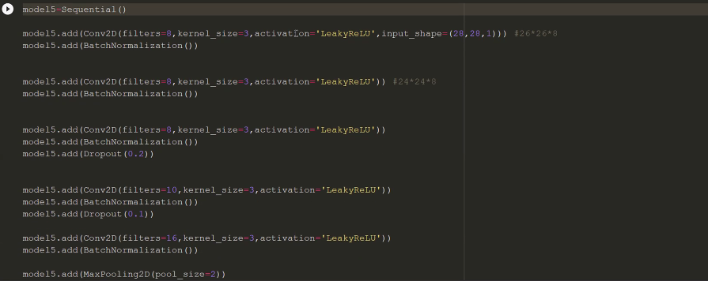

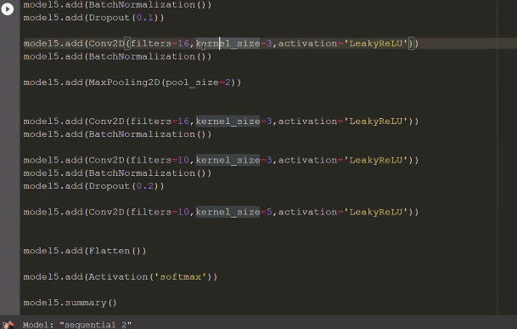

She did not used Dense

https://colab.research.google.com/drive/1h3pOTVc-ne7k9SS7D0qy-EYX83D0uEGI?usp=sharing

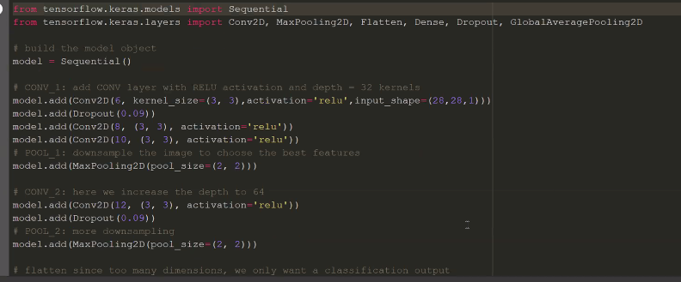

Paul Solution:

Batch size 16

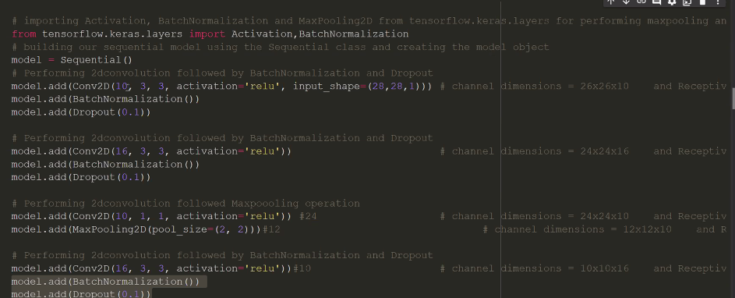

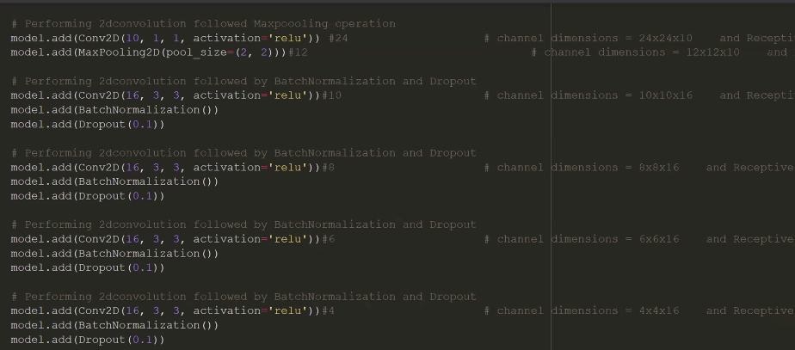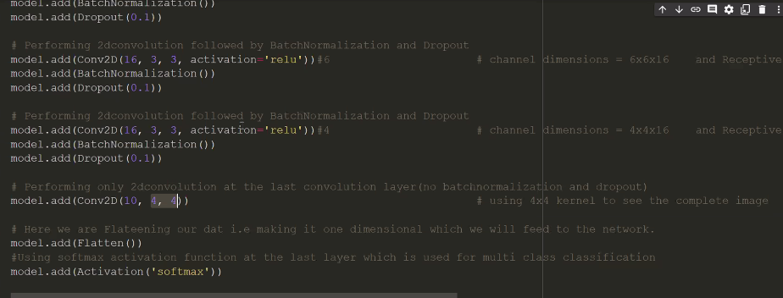

Mobile Number: 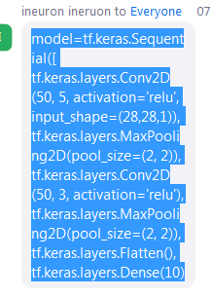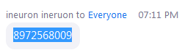



Less Than 8k param:

<https://www.kaggle.com/noelmat/mnist-99-5-acc-with-less-than-8000-parameters>

<https://github.com/sourangshupal/Cat_Dog>

<https://www.kaggle.com/gauravsharma99/mnist-8k-parameters>

less than 8K param:

15/01/2022:

Forked Repo:

<https://github.com/thangarajdeivasikamani/Cat_Dog>

without code pipeline:

<https://drive.google.com/u/0/uc?id=1mwk7gG0-xVRp92dS8C2hRwnYzXorJf_w&export=download>

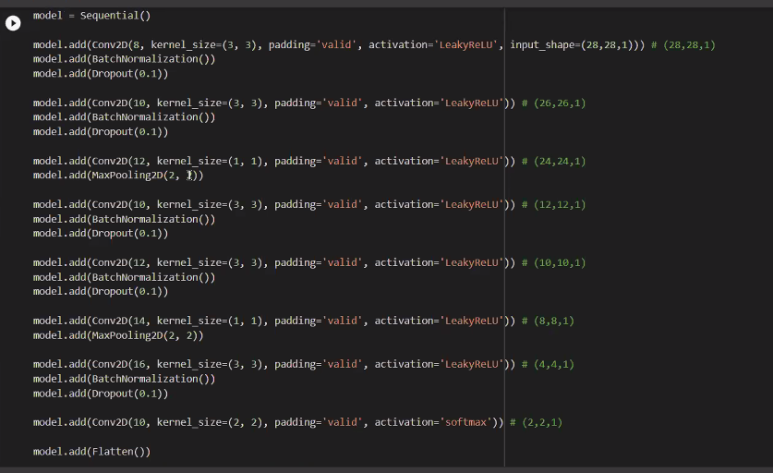

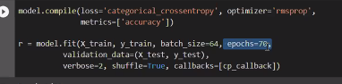

Mohan:

16/01/2022

<https://drive.google.com/file/d/1HKdvmIzF6VrjL4dAp59iOXYTTsE7ie7l/view>

<https://dl.google.com/dl/cloudsdk/channels/rapid/GoogleCloudSDKInstaller.exe>

app.yaml example & creation

<https://github.com/GoogleCloudPlatform/python-docs-samples/tree/main/appengine>