Why statistics required?

Collet the data- organize the data- Present the data –analysis/interpret the data using some lib.

Using data we can take decisions.

Statistics is a branch of applied mathematics that involves the collection, description, analysis, and inference of conclusions from quantitative data.

Reference: wikipidea , <https://www.investopedia.com/terms/s/statistics.asp>

Example:

Person English – 88 and Maths -98 for looking into data I have done very well in maths.

I have collected all person marks & take avg

Will get mean of English – 80

Mean of maths -98

& Now tell who perform well,

Now the interspersion will vary. Because English avg mark is 80, But I took 88 so I performed well in English.

So data won’t tell everything we need to interpret.

Two types:

(1)Descriptive – Huge amount data – from the data we will get the conclusion/ statistics quantative.

Method Collet the data- organize the data- Present the data informative way.(EDA)

(2)Inferential - Method to which determine to understand the population from sample.

Descriptive statistics mostly focus on the **central tendency, variability(spread), and distribution** of sample data. Central tendency means the estimate of the characteristics, a typical element of a sample or population, and includes descriptive statistics such as [mean](https://www.investopedia.com/terms/m/mean.asp), [median](https://www.investopedia.com/terms/m/median.asp), and [mode](https://www.investopedia.com/terms/m/mode.asp).

[Variability](https://www.investopedia.com/terms/v/variability.asp) refers to a set of statistics that show how much difference there is among the elements of a sample or population along the characteristics measured, and includes metrics such as [range](https://www.investopedia.com/terms/r/range.asp), [variance](https://www.investopedia.com/terms/v/variance.asp), and [standard deviation](https://www.investopedia.com/terms/s/standarddeviation.asp).

The [distribution](https://www.investopedia.com/terms/p/probabilitydistribution.asp) refers to the overall "shape" of the data, which can be depicted on a chart such as a histogram or dot plot, and includes properties such as the **probability distribution function,** **skewness, and kurtosis**. Descriptive statistics can also describe differences between observed characteristics of the elements of a data set. Descriptive statistics help us understand the collective properties of the elements of a data sample and form the basis for testing hypotheses and making predictions using inferential statistics.

## Inferential Statistics

Inferential statistics are tools that statisticians use to draw conclusions about the characteristics of a population from the characteristics of a sample and to decide how certain they can be of the reliability of those conclusions. Based on the sample size and distribution of the sample data statisticians can calculate the probability that statistics, which measure the central tendency, variability, distribution, and relationships between characteristics within a data sample, provide an accurate picture of the corresponding parameters of the whole population from which the sample is drawn.

Inferential statistics are used to make generalizations about large groups, such as estimating average demand for a product by surveying a sample of consumers' buying habits, or to attempt to predict future events, such as projecting the future return of a security or asset class based on returns in a sample period.

Example: we are collecting marks from different college. But impossible to collect all data.

Based on section of data ( sample) we will take decision . so we are conclude population from characteristic from sample.

Another example: Decide the below poverty line – city to city the income will vary COB may be < 1000 consider BPL or BAN may be >1500. Entire people belong to BAN is population, So it’s not possible collect all data.so we need to take decision based on fractional ( sample) data.

[Regression](https://www.investopedia.com/terms/r/regression.asp) analysis is a common method of statistical inference that attempts to determine the strength and character of the relationship (or [correlation](https://www.investopedia.com/terms/c/correlationcoefficient.asp)) between one dependent variable (usually denoted by Y) and a series of other variables (known as independent variables). The output of a regression model can be analyzed for [statistical significance](https://www.investopedia.com/terms/s/statistical-significance.asp), which refers to the claim that a result from findings generated by testing or experimentation is not likely to have occurred randomly or by chance but are instead likely to be attributable to a specific cause elucidated by the data. Having statistical significance is important for academic disciplines or practitioners that rely heavily on analyzing data and research.

### What is the difference between descriptive and inferential statistics?

Descriptive statistics are used to describe or summarize the characteristics of a sample or data set, such as a variable's mean, standard deviation, or frequency. Inferential statistics, in contrast, employes any number of techniques to relate variables in a data set to one another, for example using correlation or regression analysis. These can then be used to estimate forecasts or infer causality.

1.Descriptive – Describe the data

Example: Age feature – from this we can conclude few characteristics like mean,median,mode,etc..

Population: Exit poll, 100K Emp – We need to buy T-shirt, The entire 100K is population, from that we will select some set is called sample.

Two term Population and sample

Population mean formula : 1/N

Sample mean formula: 1/n

Data type in statics  
==================

1 . Categorical – Group or some categorical – Every time we are dividing the data

Yes/No

Rating: 1,2,3,4,5 - Even numeric its cat

Theater ticket A,B,C,D - Even string also cat.

2. Numerical – Descriptive - whole number - Range

Continues - with floating number

Label of measurements: ( Inferential statstics)

=====================

1. Qualitative – Variable that categories or describe the quality of population/sample elements.

Nominal : Not in order example Brand of car

Ordinal : Put into order – Example review rating

1. Quantitative: Variable that describe the magnitude of the population

Interval :

Ratio:

1. **Measure of Center Tendency:**
2. Mean
3. Media
4. Mode

**Mean:** 50,40,,30,40,10 Avg/Mean = ( 50+40+30+40+10)/5 = 34

Suppose the late element is 100. Then Mean: 50,40,,30,40,10 Avg/Mean = ( 50+40+30+40+100)/5 = 52

Huge difference due to outliers.

We will remove outlier & cal correct?

May be huge data – huge outlier or the outlier has some info. So we will go median

**Median :** reduce the impact of outlier

Sort the value & take middle value.

Suppose we have even number – we need to consider middle of two numbers

**Mode:** Most frequency value.

All are unique we will get error.

**Skeness:**

Here positive skewness – Right side is outlier

Mean is > median.

Normalize formula. X- axis data , Y –axis is frequency of data.

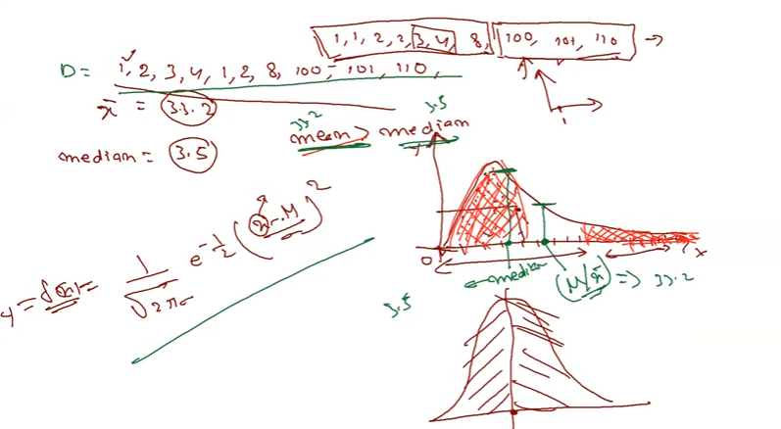

Left sknewness: ( Negative) – Some time will not impact much – so we can take not an issue.

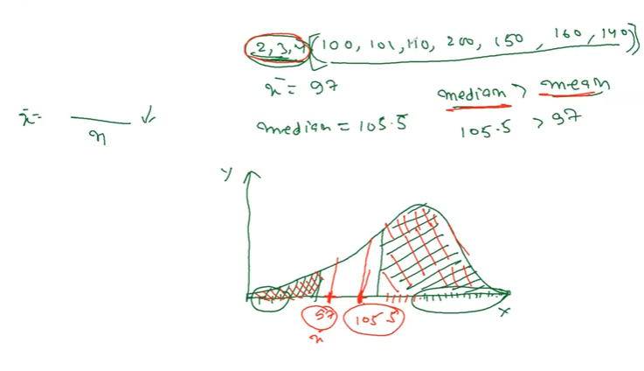

Sknewness will be find based on comparison of mean & median

Measure of dispersion:

Each data we will get the symmetric curve, why different curve ? because the vraince.

**If we send raw data to ML algo – my data is not evenly distributed – ML algo will not learn relationship.**

**What is the range of data ? 1 to 110**

**Variance will help to understand how my data vary with respect to my mean?**

**If the variance is high we can say my data is too far from mean.**

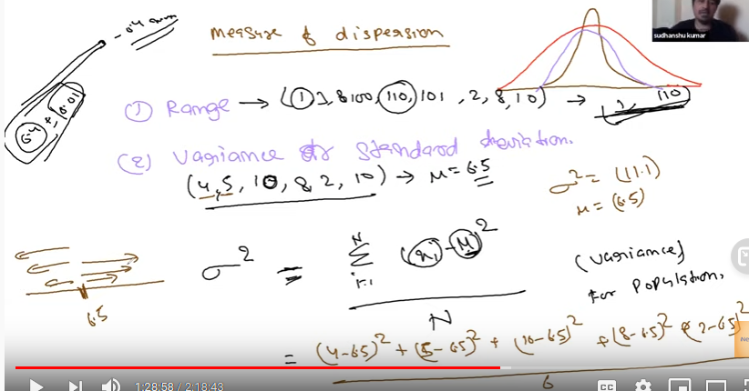

1. **Dispersion: Variance(spread), Std**

Variance : How far my point from mean

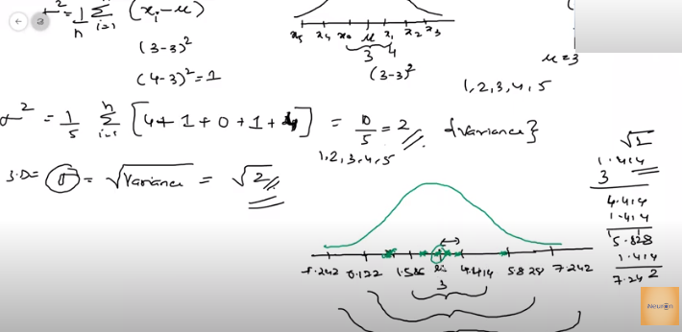

Mean + std = right value

Mean –std = left values

Most of the data b/w with two standard deviation - Gaussian distribution

Variance is used to measure the spread, Standard deviation will help to identify whether element will be located from mean?

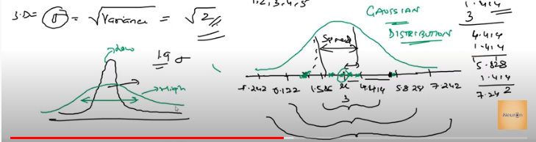

Above green one have higer standard deviation, so higher spread.

All the data will come under bell curve? No.

**III.Random variables:**

Rol the dice = {1,2,3,4,5,6} - discrete ( whole number), Number of children, Number of eating plate

1000 members measure height = Continues. Weight , KM which I run.

Age is – both Continues( if we mention with Year,month, date) & discrete( whole number)

1. Gaussian/Normal distribution:

Laptop touching in touch pad.

Population : Number of touch - 80% data will be fall in to

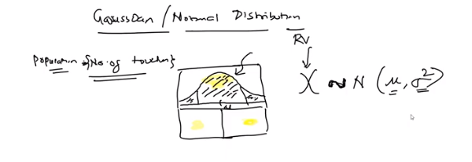

Whether all the data come under Gaussian or Normal? Depends on data

Height of the population : we need domain expertise to conclude whether data will come under Gaussian or not.

Random variable belong to Normal/Gaussian then it has mean & variance

For example, the [normal distribution](https://www.statisticshowto.com/probability-and-statistics/normal-distributions/) is a [symmetric distribution](https://www.statisticshowto.com/symmetric-distribution-2/)with no skew. The tails are exactly the same.

1. **Skewness**

**Right skewness: -**Measure the wealth of the population . Whether the data is Normal distribute? No.

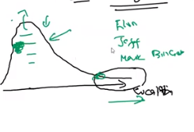

Left skewness example : Retirement Age

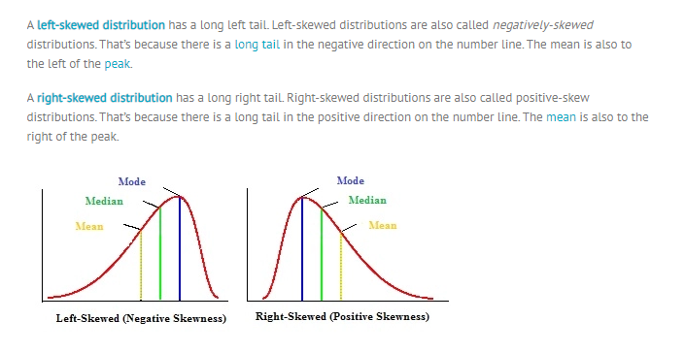

**Another is Left skeness:**

1. **Empirical formula – How much data distributed – based on that we will say 68.27 % fall in two standard deviation**

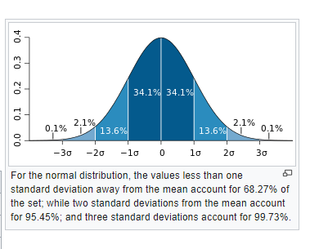

1. **unbiased variance: (**[**https://www.khanacademy.org/math/ap-statistics/summarizing-quantitative-data-ap/more-standard-deviation/v/another-simulation-giving-evidence-that-n-1-gives-us-an-unbiased-estimate-of-variance**](https://www.khanacademy.org/math/ap-statistics/summarizing-quantitative-data-ap/more-standard-deviation/v/another-simulation-giving-evidence-that-n-1-gives-us-an-unbiased-estimate-of-variance) **)**

Use N-1 for formula ( when you use different different sample )

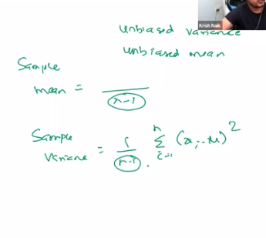

DAY2:

Standard Normal distribution or standard Normal Variate ( Z)

Normal distribution means any random X variable blongs (Mu, sigma squre)

Standard normal distribution means any random variable y blongs to ( zero mean, one standard deviation) e.g(0,1)

If we have mean & standard deviation we can form the curve.

Why we need Standard Normal distribution?

In machine learning we need common standard( scaling down the feature data) so that prediction will be more accuracy.

It’s also called standardization

How to convert Normal distribution to Standard normal distribution?

Use Z-score

Whether the standard deviation will reduce the outlier impact? It’s depends on algorithm

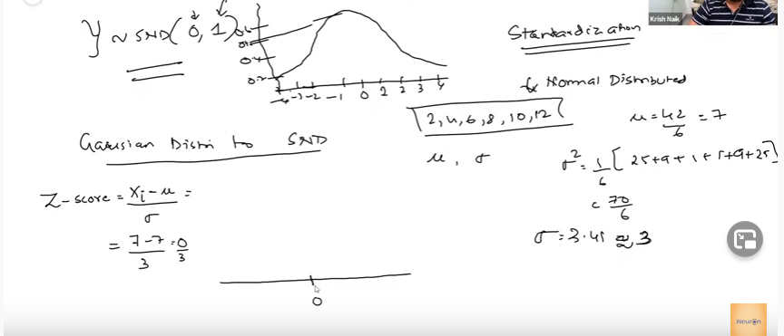

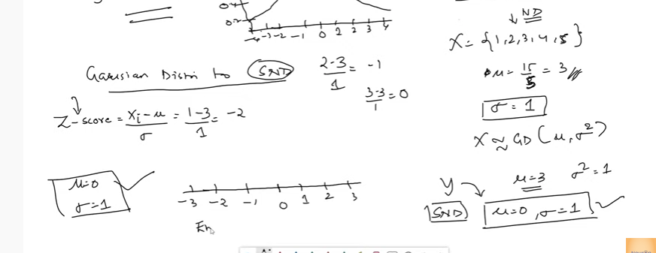

Example my X, Y large value & I will convert Standard Normal distribution so the more points are close

& easy to classify.

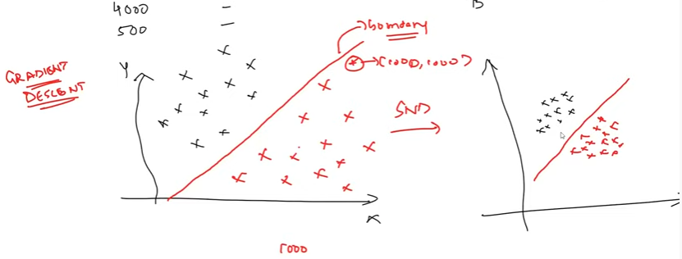

**After conversion whether empirical formula will hold or not? Still will hold Empirical formula .**

Why we need?

When we convert Normal data into Standard Normal distribution

Data will fall under -3 to 3

So the calculation will be easy when go for complex machine learning algorithms.

Some ML algorithm we will use equalization distance.

Can we change other distribution to Standard Normal distribution?

Yes, But we need to know the original data belong to which distribution ?

**Sample distribution:**

Consider random variable – it can be any distribution

Consider I have 1000 random variable out of 1000 we will take random of 30 sample

Here m = 1000 n= 30 or more

This we can call as S1, Similarly we can take another Sample S2, like wise we can take n number of sample.

Next we need to calculate the mean for each sample, sample mean we will call as X1 bar, X2 bars..

Here X bar is collection of {x1bar,x2bar,x3 bar,etc…)

If we try the plot using these means values we will get bell curve/Normal distribution/Gaussian distribution.

This curve mean (sample mean) is equal to 1000 variable mean or population mean.

The variance is equal to sigma squre/n

Here n is sample size.

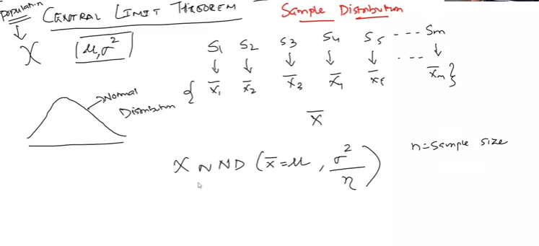

**Central Limit Theorem:**

Central limit theorem says my enter population I will take multiple sample & calculate the mean and create the distribution

(a)Then my sample means approximately equal to population mean.

(b)Variance is equal to sigma square/ number of sample

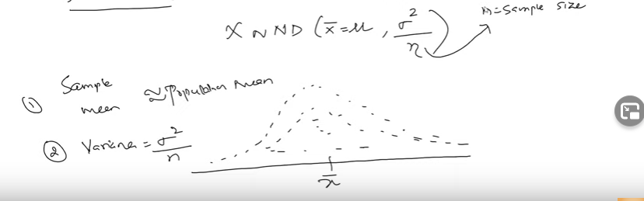

Various statistics say the sample size should be equal to 30 or more then only we will get the sample mean approximate population mean.

**Sample distribution of sample mean.**

X1, X2 bar are sample distribution

If we calculate mean of x bar collection { X1 bar,X2 bar,x3 bar ,etc..} it’s called sample distribution of sample mean.

If we take mean of the sample distribution we can call as sample distribution of sample mean.

sample distribution of sample mean will follow normal distribution if plot using collection values

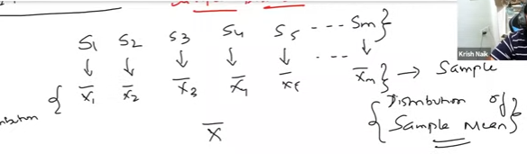

**Importance of CLT:**

**===============**

Even though we have sample distribution we can find the approximately population mean.

Using this we can assume lot of statistics

Why distribution are used?

To data analysis and get the information from data.

**Pdf: Probability density function**

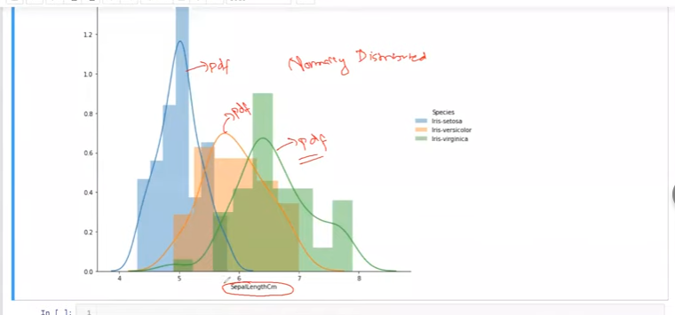

# Green on has more standard devation

**Pdf is smooth version on top of histogram.**

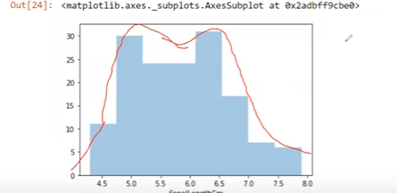

DAY3:

Topics

PDF,CDF, Percentile

PDF – Probability ,CDF - Cumulative

Uni varite , - Single plane, histogram , histogram with KDE, PDF,CDF graph

bi-variate - Scatter

multi varite –pair plot

Refer : Statistics EDA Note book

Variance of x is Var(x) is covariance(X,X)

Covariance:

Quantify the relationship b/w feature.

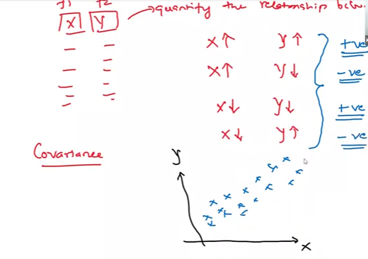

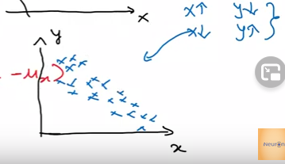

The above curve we can say linear relationship , x axis increase the y axis also increase.

And also we can say positive co-variance.

Formula ( Variance with respect to feature) ( Here mu is mean of feature)

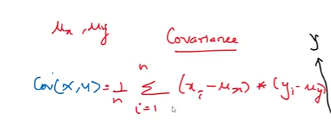

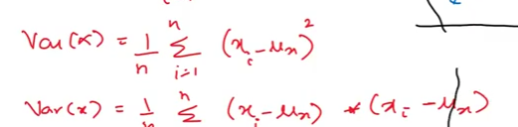

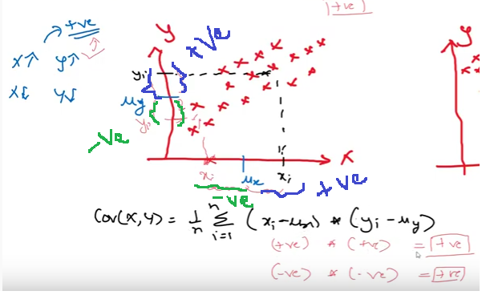

From the above graph if the new point is xi above the mean ( x increase Y increase) - both points are positive from mean – so positive covariance.

From the above graph if the new point is xi below the mean ( x increase Y increase) - both points are negative from mean ( Negative multiply by negative- psotive) – so positive covariance.

Next scenario:

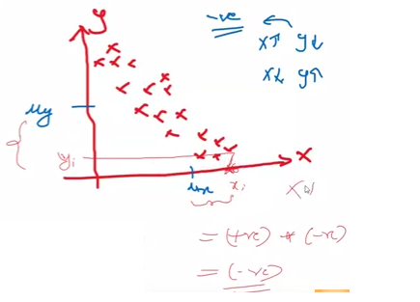

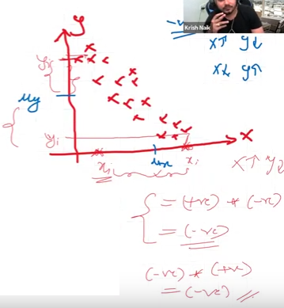

The data is scatted – Then no relationship – Zero co variance.

Day4

**(1)Covariance:**

==========

Find the relationship

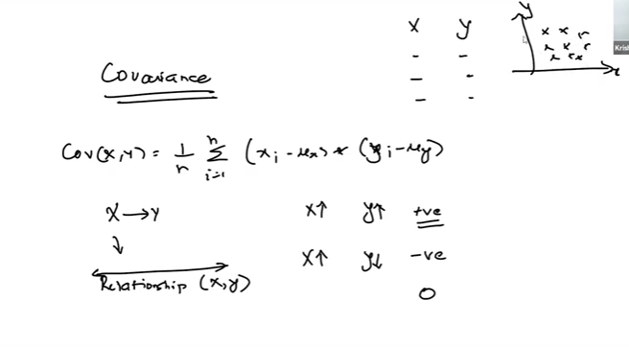

Zero means there is no much relationship.

Here we will know direction whether it’s positive or negative, we can’t find magnitude

Disadvantage of covariance:

We can’t find the how much positive and how much negative.

Means can’t find strength, here it will go positive infinite to negative infinite.

**(2)Pearson correlation:**

Using this we can find the type of relation & strength,

The range between {-1 to 1}

The value is near to 0.9 means highly positive co-relation.

The value is near to - 0.9 means highly negative co-relation.

Formula:

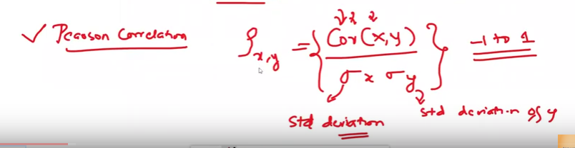

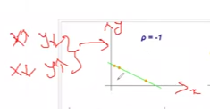

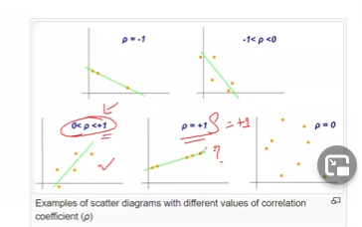

The above diagram first plot p = -1 means – best fitted line pass through all points so negatively co-related

The above diagram second plot -1<P<0 means – best fitted line pass through only few points and negatively co-related so the range will be -1 to 0

The above diagram third plot o< p + 1 means –– best fitted line pass through only few points and positively co-related so the range will be 0 to 1

The above diagram fourth plot p = +1 means – best fitted line pass through all points so positively co-related

P =0 means no co relation.

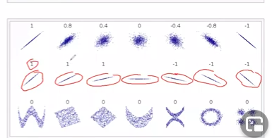

Pearson co-relation will work only with linear .The above diagram we can see even though the direction change ( second row) we can find the co-relation.

Second row third picture no – correlation because the line is horizontal. ( Constant)

**Disadvantage of Pearson co-relation:**

The above diagram in third row non linear pattern but we points are positively & negatively co-related.

But we can’t find.

**(3)Spearman Rank co-relation:**

Correlation

Magnitude

Non Linear property

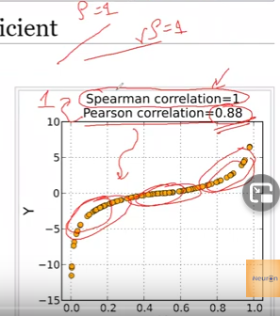

The above diagram

X is increase Y also increase so the spearman correlation is =1

But here not all the lines are pass thorough the straight best fitted line so person co-relation is 0.88

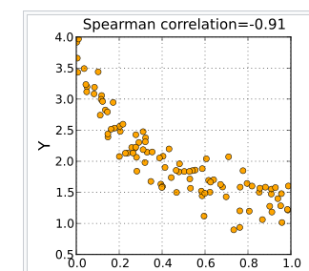

Example:

<https://statistics.laerd.com/statistical-guides/spearmans-rank-order-correlation-statistical-guide.php>

Formula:

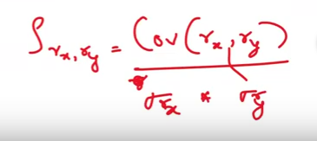

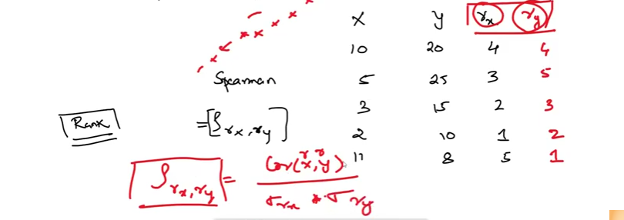

**Practical:**

Statistics EDA Note book.

**Why Correlation is important?**

**Case 1:**

Assume my X feature is Age, Y feature is Weight I need to predict feature Z( Height)

I machine learning algo or feature engineering we will find the correlation b/w each in-depended feature variable. ( Example Pair plot)

Example age also 90%(0.9) correlated with Height & weight also 90%(0.9) correlated with Height

We can drop one feature to predict the height.

So which variable gives highest correlation we will use those feature for predication.

Assume we are adding one more feature now the age correlation is 95% and weight correlation also 95% with height. Now also we can use either one feature to predict.

Case 2:

One more scenario:

Co-relation checking with O/P feature, which one we will use predict?

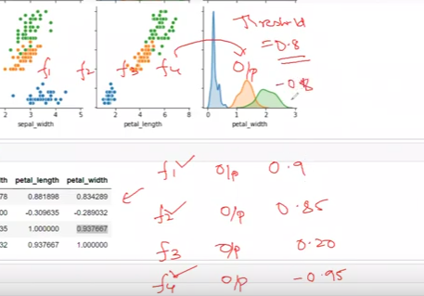

We can use f1,f2,f4 –may be here we will set threshold like choose if positive correlation is 0.8 &

negative correlation is 0.8 .

others co-relation value are dropped.

Here negative co-relation also important.

Threshold – will set by domain expert.

Correlation work with Numeric feature

Whenever the depend variable is classification based we will not use co-relation.

**Feature Engineering:**

Practical:

Feature Engineering – Folder Jupyter Notebook.

Data science life cycle:

1. Data Gathering

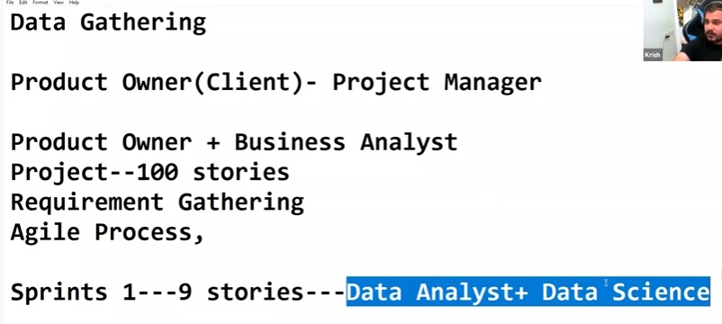

The data may be internal or external – ( may be cost involved)

1. The data may be different format.

The data may be missing values,

There is many scenarios to missing the data.

As Data eng we need to clean the data using EDA & feature engineering.

1. Missing data:

#### What are the different types of Missing Data?[¶](http://localhost:8888/notebooks/MachineLearning/iNeuron_ML/Week10/statistics_week1/Feature-Engineering-Live-sessions-master/Feature%20Engineering-%20MeanMedianDay%201.ipynb#What-are-the-different-types-of-Missing-Data?)

##### *Missing Completely at Random, MCAR:*

A variable is missing completely at random (MCAR) if the probability of being missing is the same for all the observations. When data is MCAR, there is absolutely no relationship between the data missing and any other values, observed or missing, within the dataset. In other words, those missing data points are a random subset of the data. There is nothing systematic going on that makes some data more likely to be missing than other.

Examples: The women to write the phone number – ( Generally will happen so relation ship is there – so this not MCAR)

But in Titanic data set Age & cabin info missing – Here there is no relationship. – This type of missing is MCAR

##### *Missing Data Not At Random(MNAR): Systematic missing Values*

There is absolutely some relationship between the data missing and any other values, observed or missing, within the dataset.

E.g More non survived more person cabin info missing – so relationship is there

1. *Missing at random.(MAR)*

e.g #Men---hide their salary

#Women---hide their age

**Missing value imputation:**

# 1. Mean/ Median/Mode replacement

# 2. Random Sample Imputation

# 3. Capturing NAN values with a new feature

# 4. End of Distribution imputation

# 5. Arbitrary imputation

# 6. Frequent categories imputation

DAY5:

--------------

Missing at completely random (MACR) – we will use random imputation – will give good prediction as per research.

50% missing. Please drop the feature.

Hypothesis:

Hypothesis will help analysis data

Based on the sample we will derive some conclusion.

For that we will assumption something.

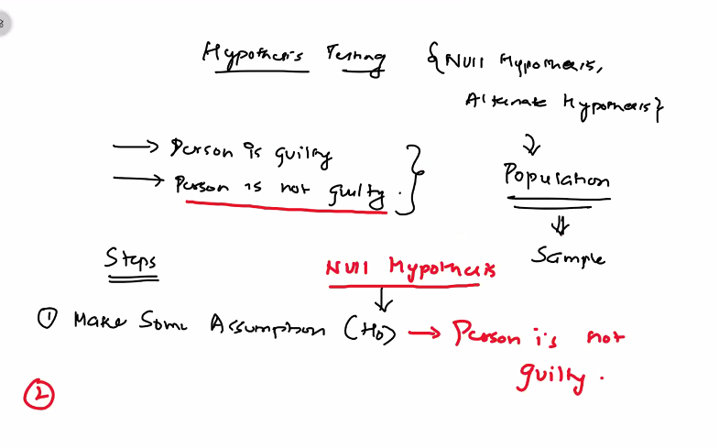

.

We will use data & test – if Test Pass we will say person is not guilty.

If test fail we will consider alternative hypothesis

**We can do assumption initially as person is guilty also. ( not an issue**)

What kind of data I will take?

We need more evidence to prove.

Confusion matrix

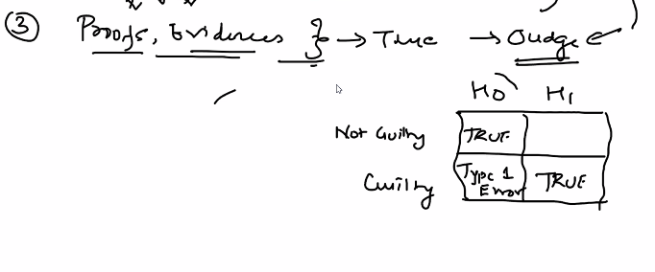

The person not done any crime, because of evidence he put as guilty.

Then it’s Type 1 Error.

The person is done crime, But does not have any evidence so it’s shows not guilty.

This is called Type 2 error.

We need to reduce Type1 & type2 error.

Another example:

Cancer example:

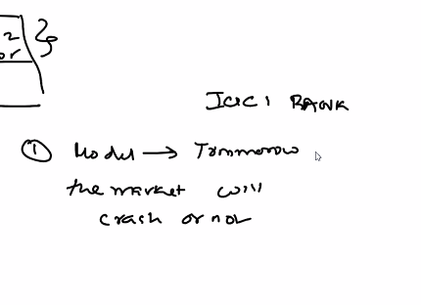

Example:

**Tomorrow market will crash or not**

Ho = Market will crash

Alternate: market will not crash

2 x 2 matrix

Diagonal will be True.

HO H1

|  |  |
| --- | --- |
| True | Type 2 error. |
| Type 1 error | True |

Model predict not crash – but actually crashed - People will lose money. This is danger. Type 1 is more important.

Model predict is crash – But not crashed - model predict the market will crash so people will fear & get out the money from bank.

From People perceptive Type 1 is danger, From bank perceptive Type 2 is danger.

Hope my understanding is correct?

Normally Assumption statement will be positive.

Tomorrow topics:

