

|  |
| --- |
|  |
| Deployment of Machine Learning Model to Google Cloud Platform |
| |  |  |  | | --- | --- | --- | | iNeuron.ai |  |  | |

Contents

**1.** **The Problem statement:** 3

**2.** **Application Design:** 3

**3.** **Pre-requisites:** 5

**4.** **Python Implementation:** 5

**5.** **Flask App:** 10

**6.** **Deployment to G-cloud:** 14

**Preface**

This book is intended to help all the data scientists out there. It is a step by step guide for creating a machine learning model right from scratch and then deploying it to the Google Cloud Platform. This book uses a dataset from Kaggle to predict the chances of the admission of a student into foreign universities based on different evaluation criteria. This book tries to explain the concepts simply, extensively, and thoroughly to approach the problem from scratch and then its deployment to a cloud environment.

Happy Learning!

**Machine Learning with Deployment to Google Cloud Platform**

1. **The Problem statement:**

The goal here is to find the chance of admission of a candidate based on his/her GRE Score (out of 340), TOEFL Score (out of 120), rating of the University (out of 5) in which he/she is trying to get admission, Strength of the SOP (out of 5), strength of the Letter Of Recommendation (out of 5), CGPA (out of 10) and the research experience (0 or 1).

1. **Application Design:**

Once we have the data source fixed, the machine learning approach majorly consists of two pipelines:

* **The Training Pipeline**

The training pipeline includes data pre-processing, selecting the right algorithm for creating the machine learning model, checking the accuracy of the created model and then saving the model file.

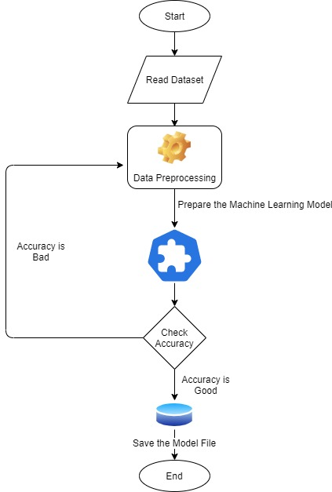

* **The Testing Pipeline**

Once the training is completed, we need to expose the trained model as an API for the user to consume it. For prediction, the saved model is loaded first and then the predictions are done using it. If the web app works fine, the same app is deployed to the cloud platform.

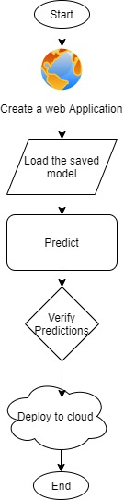

1. **Pre-requisites:**

* Basic knowledge of flask framework.
* Any Python IDE installed(we are using PyCharm).
* A Google Cloud Platform account.
* Basic understanding of HTML.

1. **Python Implementation:**
   1. **Importing the necessary Files**

We’ll first import all the required libraries to proceed with our machine learning model.

# necessary Imports  
import pandas as pd  
import matplotlib.pyplot as plt  
import pickle  
% matpllotlib inline

* 1. **Reading the Data File**

df= pd.read_csv('Admission_Prediction.csv') # reading the CSV file

* 1. **Data Pre-processing and Exploratory Data Analysis**
* First, we print a small sample from the data.

df.head() # checking the first five rows from the dataset

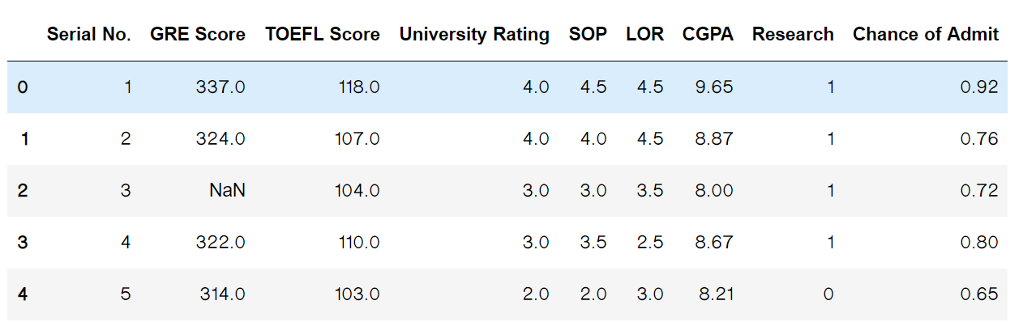

* We check for the datatypes and missing values in the dataset.

df.info() # printing the summary of the dataframe

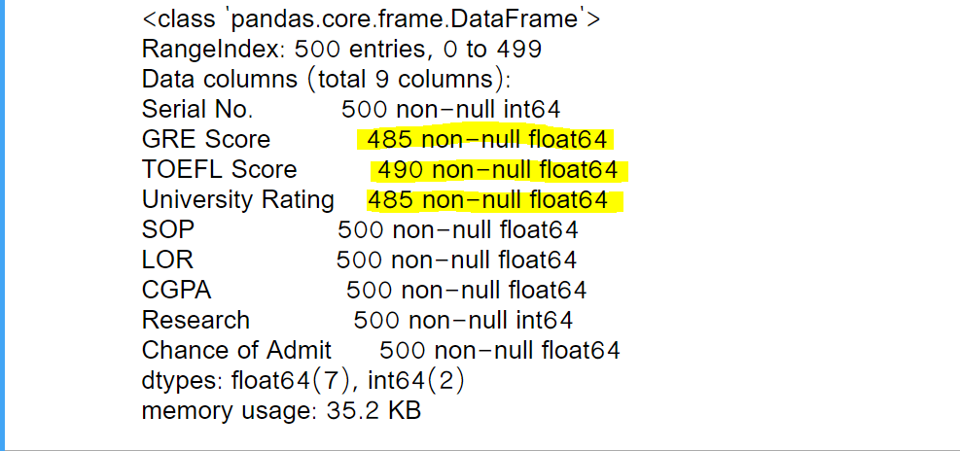

As shown in the screenshot above, the highlighted columns have some missing values. Those missing values need to be imputed.

* Imputing the missing values in the dataset.

df['GRE Score'].fillna(df['GRE Score'].mode()[0],inplace=True)  
# to replace the missing values in the 'GRE Score' column with the mode of the column  
# Mode has been used here to replace the scores with the most occurring scores so that data follows the general trend  
  
df['TOEFL Score'].fillna(df['TOEFL Score'].mode()[0],inplace=True)  
# to replace the missing values in the 'GRE Score' column with the mode of the column  
# Mode has been used here to replace the scores with the most occurring scores so that data follows the general trend  
  
df['University Rating'].fillna(df['University Rating'].mean(),inplace=True)  
# to replace the missing values in the 'University Rating' column with the mode of the column  
# Mean has been used here to replace the scores with the average score

* Now, we create separate training and test data sets.

# dropping the 'Chance of Admit' and 'serial number' as they are not going to be used as features for prediction  
x=df.drop(['Chance of Admit','Serial No.'],axis=1)  
# 'Chance of Admit' is the target column which shows the probability of admission for a candidate  
y=df['Chance of Admit']

The new data set looks like:

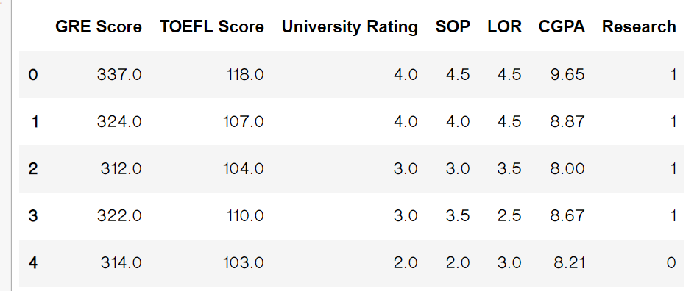

Generally, we’d use a scaler to transform data to the same scale. But as we are just at the beginning of the curriculum, we are skipping that. It’ll be discussed in the forthcoming reading materials.

* Once the feature columns have been separated, we’ll plot the graphs among the feature columns and the label column to see the relationship between them.

**Note:** *If the same code is being written in a python IDE, instead of a Jupyter Notebook, please use plt.show() for the showing the graphs.*

* A graph between GRE Score and Chance of Admission

plt.scatter(df['GRE Score'],y) # Relationship between GRE Score and Chance of Admission

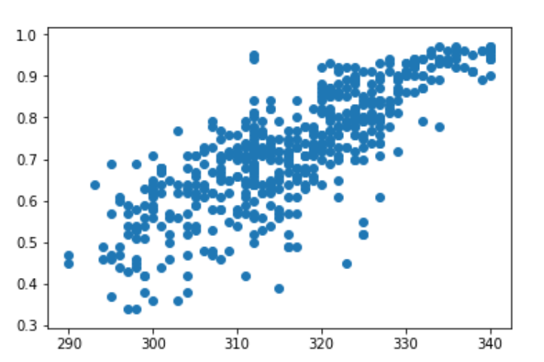

* A graph between TOEFL Score and Chance of Admission

plt.scatter(df['TOEFL Score'],y) # Relationship between TOEFL Score and Chance of Admission

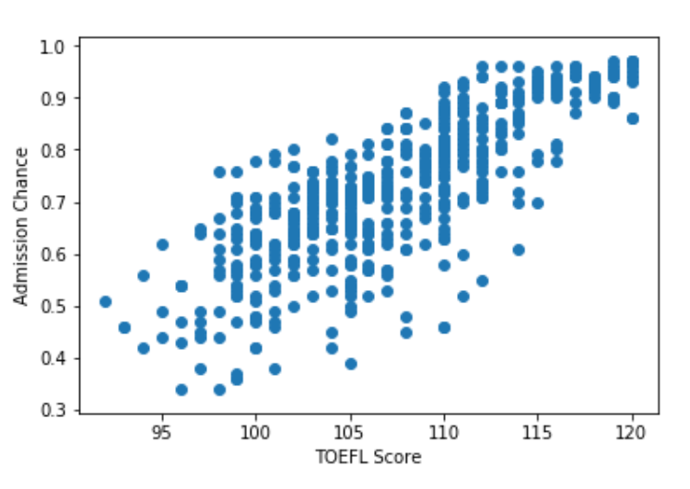

* A graph between CGPA and Chance of Admission

plt.scatter(df['CGPA'],y) # Relationship between CGPA and Chance of Admission

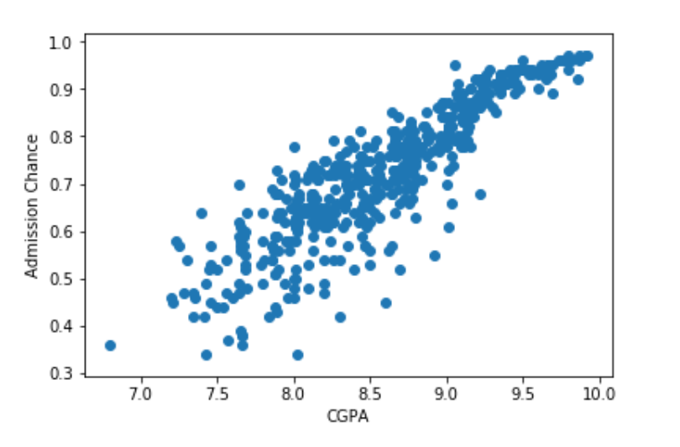

* From the above graphs between the continuous feature variables and the label column, it can be concluded that they exhibit a linear relationship amongst them. So, we’ll use Linear regression for prediction.
* Once we have determined the Machine Learning algorithm to use, we’ll split the datasets into train and test sets as shown below:

# splitting the data into training and testing sets  
from sklearn.model_selection import train_test_split  
train_x,test_x,train_y,test_y=train_test_split(x,y,test_size=0.33, random_state=100)

* Now, we’ll fit this data to the Linear Regression model.

# fitting the date to the Linear regression model  
from sklearn import linear_model  
reg = linear_model.LinearRegression()  
reg.fit(train_x, train_y)

* Let’s check the accuracy of our model now. Accuracy is calculated by comparing the results to the test data set.

# calculating the accuracy of the model  
from sklearn.metrics import r2_score  
score= r2_score(reg.predict(test_x),test_y)

* If we are content with the model accuracy, we can now save the model to a file.

# saving the model to the local file system  
filename = 'finalized_model.pickle'  
pickle.dump(reg, open(filename, 'wb'))

* Let’s predict using our model.

# prediction using the saved model.  
loaded_model = pickle.load(open(filename, 'rb'))  
prediction=loaded_model.predict(([[320,120,5,5,5,10,1]]))  
print(prediction[0])

With the given input, our model predicts that the chance of admission is 99.57 per cent.

Now, the model is ready for cloud deployment.

1. **Flask App:**

As we’ll expose the created model as a web API to be consumed by the client/client APIs, we’d do it using the flask framework.

The flow of our flask app will be:

* Create the project structure, as shown below:

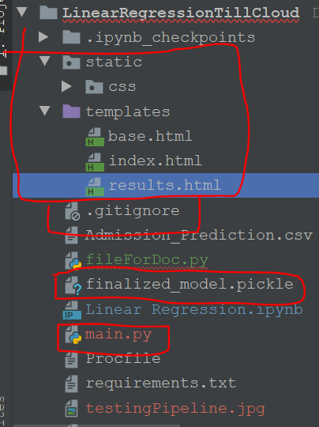

Only create the marked files and folders and put the saved model file in the same folder as your main.py file.

* Index.html:
* {% extends 'base.html' %}  
    
  {% block head %}  
    
  <title>Search Page</title>  
  <link rel="stylesheet" href="{{ url_for('static', filename='css/style.css') }}">  
  {% endblock %}  
    
  {% block body %}  
  <div class="content">  
   <h1 style="text-align: center">Predict Your chances for Admission</h1>  
    
   <div class="form">  
   <form action="/predict" method="POST">  
   <input type="number" name="gre_score" id="gre_score" placeholder="GRE Score">  
   <input type="number" name="toefl_score" id="toefl_score" placeholder="TOEFL Score">  
   <input type="number" name="university_rating" id="university_rating" placeholder="University Rating">  
   <input type="number" name="sop" id="sop" placeholder="SOP Score">  
   <input type="number" name="lor" id="lor" placeholder="LOR Score">  
   <input type="number" name="cgpa" id="cgpa"placeholder="CGPA" step="any">  
   <select name="research" id="research">  
   <option value="yes">Yes</option>  
   <option value="no">No</option>  
  </select>  
   <input type="submit" value="Predict">  
   </form>  
   </div>  
  </div>  
  {% endblock %}
* main.py:

# importing the necessary dependencies  
from flask import Flask, render_template, request,jsonify  
from flask_cors import CORS,cross_origin  
import pickle  
  
app = Flask(__name__) # initializing a flask app  
  
@app.route('/',methods=['GET']) # route to display the home page  
@cross_origin()  
def homePage():  
 return render_template("index.html")  
  
@app.route('/predict',methods=['POST','GET']) # route to show the predictions in a web UI  
@cross_origin()  
def index():  
 if request.method == 'POST':  
 try:  
 # reading the inputs given by the user  
 gre_score=float(request.form['gre_score'])  
 toefl_score = float(request.form['toefl_score'])  
 university_rating = float(request.form['university_rating'])  
 sop = float(request.form['sop'])  
 lor = float(request.form['lor'])  
 cgpa = float(request.form['cgpa'])  
 is_research = request.form['research']  
 if(is_research=='yes'):  
 research=1  
 else:  
 research=0  
 filename = 'finalized_model.pickle'  
 loaded_model = pickle.load(open(filename, 'rb')) # loading the model file from the storage  
 # predictions using the loaded model file  
 prediction=loaded_model.predict([[gre_score,toefl_score,university_rating,sop,lor,cgpa,research]])  
 print('prediction is', prediction)  
 # showing the prediction results in a UI  
 return render_template('results.html',prediction=round(100*prediction[0]))  
 except Exception as e:  
 print('The Exception message is: ',e)  
 return 'something is wrong.'  
 # return render_template('results.html')  
 else:  
 return render_template('index.html')  
  
  
  
if __name__ == "__main__":  
 #app.run(host='127.0.0.1', port=8001, debug=True)  
 app.run(debug=True) # running the app

* results.html:
* <!DOCTYPE html>  
  <html lang="en" >  
    
  <head>  
   <meta charset="UTF-8">  
   <title>Review Page</title>  
    
   <link rel="stylesheet" href="https://cdnjs.cloudflare.com/ajax/libs/normalize/5.0.0/normalize.min.css">  
    
    
   <link rel="stylesheet" href="./style.css">  
   <link rel="stylesheet" href="{{ url_for('static', filename='css/style.css') }}">  
    
    
  </head>  
    
  <body>  
    
   <div class="table-users">  
   <div class="header">Prediction</div>  
    
   <p>Your chance for admission is {{prediction}} percent</p>  
  </div>  
    
    
    
  </body>  
    
  </html>

1. **Deployment to G-cloud:**

* Go to <https://cloud.google.com/> and create an account if already haven’t created one. Then go to the console of your account.
* Go to *IAM and admin*(highlighted) and click *manage resources*.

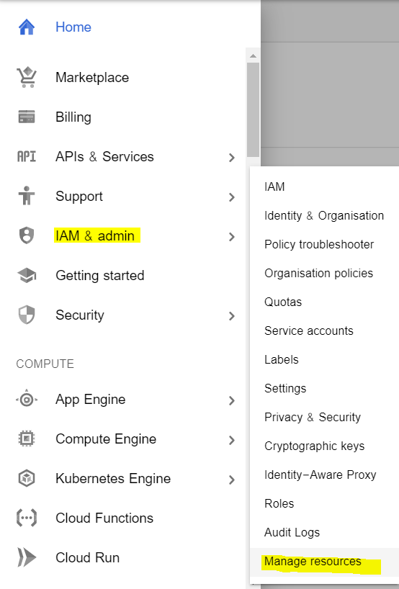

* Click *CREATE PROJECT* to create a new project for deployment.
* Once the project gets created, select *App Engine* and select *Dashboard.*

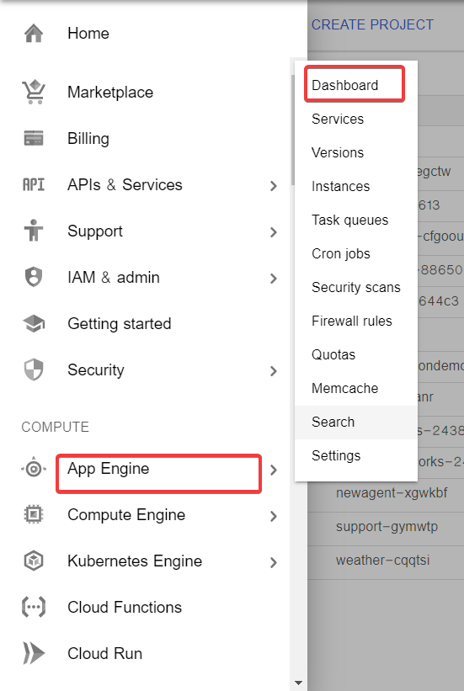

* Go to <https://dl.google.com/dl/cloudsdk/channels/rapid/GoogleCloudSDKInstaller.exe> to download the google cloud SDK to your machine.
* Click *Start Tutorial* on the screen and select Python app and click start.

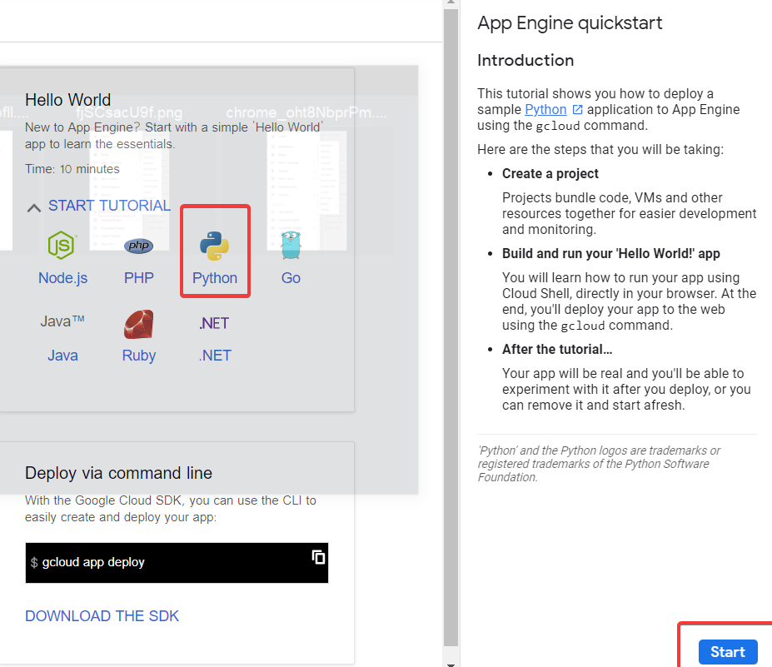

* Check whether the correct project name is displayed and then click next.

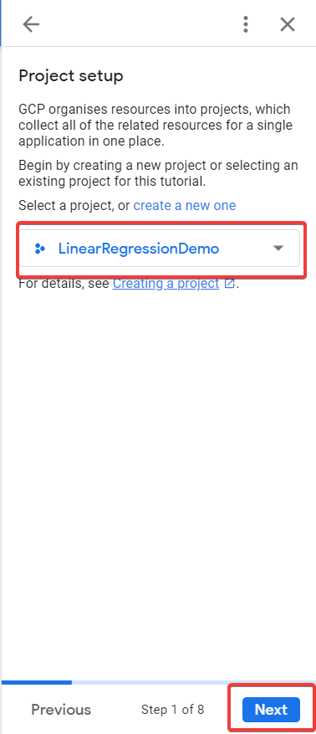

* Create a file ‘app.yaml’ and put ‘runtime: python37’ in that file.
* Create a ‘requirements.txt’ file by opening the command prompt/anaconda prompt, navigate to the project folder and enter the command ‘pip freeze > requirements.txt’.

It is recommended to use separate environments for different projects.

* Your python application file should be called ‘main.py’. It is a GCP specific requirement.
* Open command prompt window, navigate to the project folder and enter the command *gcloud init* to initialise the gcloud context.
* It asks you to select from the list of available projects.

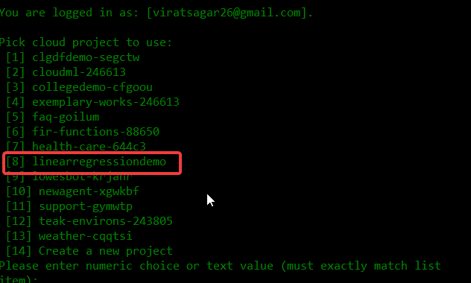

* Once the project name is selected, enter the command gcloud app deploy app.yaml --project <project name>.
* After executing the above command, GCP will ask you to enter the region for your application. Choose the appropriate one.

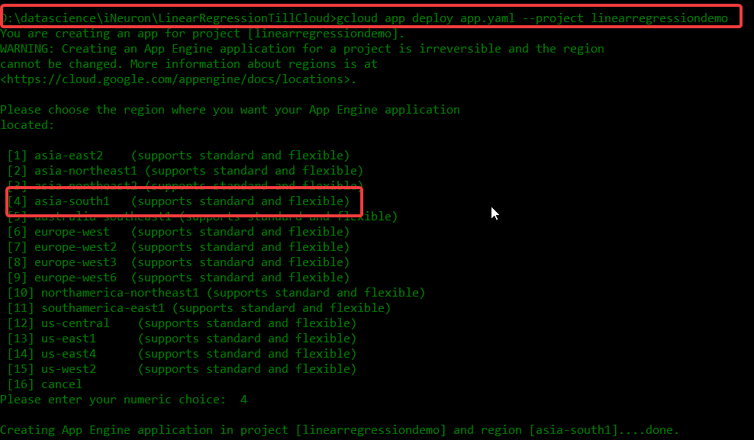

* GCP will ask for the services to be deployed. Enter ‘y’ to deploy the services.
* And then it will give you the link for your app, and the deployed app looks like:

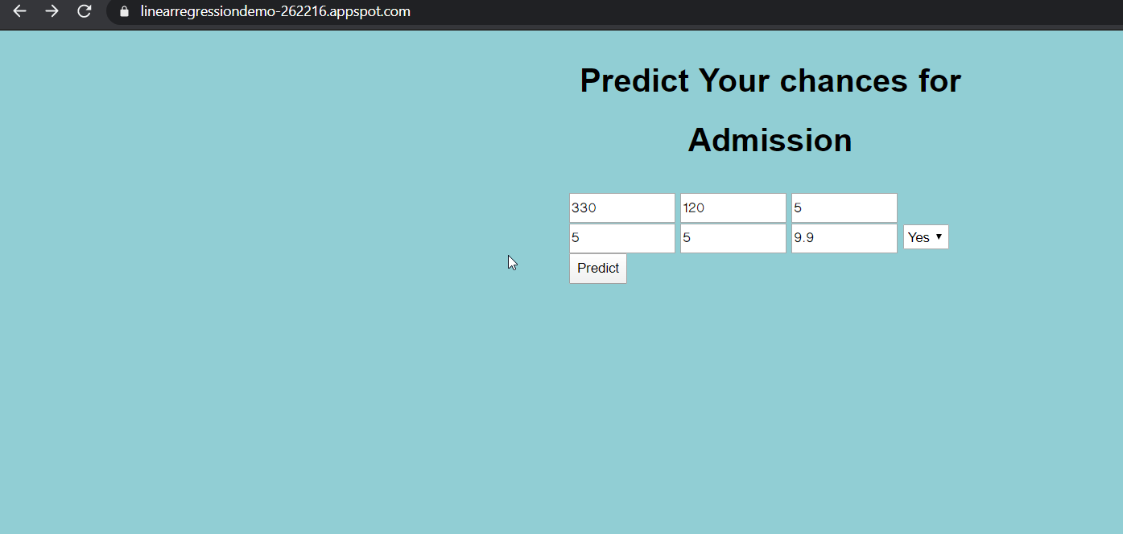

* To save money, go to settings and disable your app.

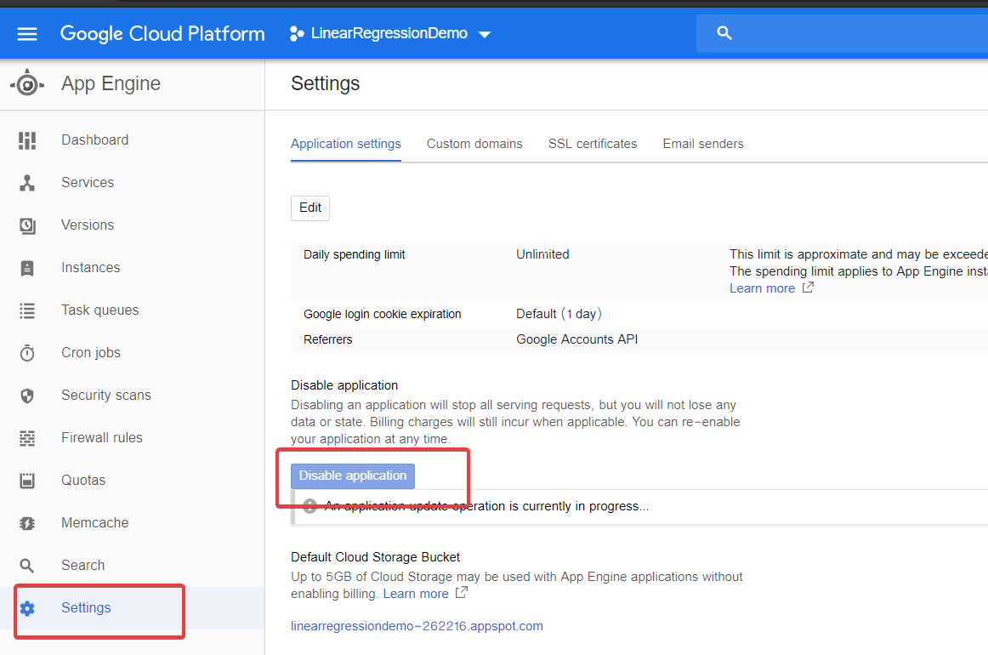

Thank You!