ML:

**Supervised Machine Learning**

Regression:

Classification:

Binary classification : Yes/No

Multi class : Pass/Fail/Topper

Multilevel Classification: Same problem will satisfy more than one condition

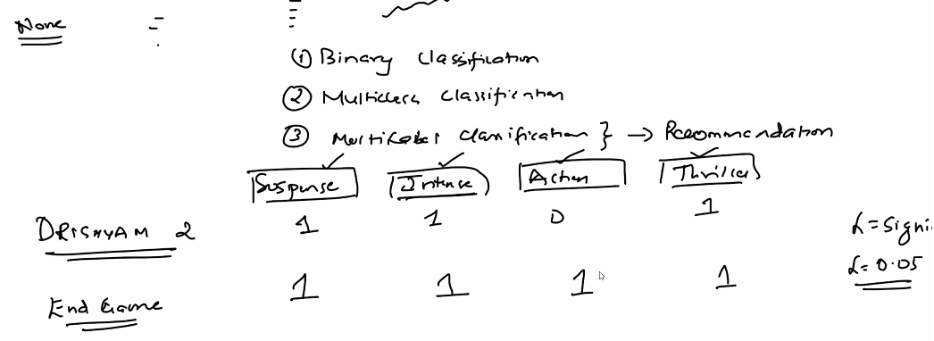

Regression: linear,lasso,Ridge

Classification : Logistic

Decision Tree

Adaboost Ensamble- Boosting, Bagging

XGBOOST

KNN

SVM

Random Forest

Nave Bayes

Time Series: ARIMA,SARIMA, SEASONAL ,ARIONA

**Unsupervised Machine learning:**

Clustering, PCA

Many feature ,All are independent, we need to identify similarity or group

Example:

I am planning to release premium product , I need to advertise for that I need to group/cluster the people based on salary, spending score

Customer segmentation:

Similar way we can cluster for loan given to specific group.

K-mean , DBScan, Hierarchical

PCA ( principal component analysis)

Reduce the features.

Semi Supervised:

Initially we have label data – later based on interaction model will learn automatically.

Netflix :

We will provide the user info, later based on watching pattern – It will recommend

May be Today I will watch comedy _ Will recommend

Later I will watch Action movie – based on that will recommend.

Re- inforcement is based semi supervised

Recommendation : It will be Supervised,Unsuperived

**Deep Learning:**

Subset of Machine learning;

Whenever we talk about neural network it will DL

How we learn ( mimic the brain) the machine also will learn.

Supervised: ( ANN – Tabular format) - Both Regression ,Classification

CNN – Image - Classification

RNN – Recurrent neural network, Text data, Time series data - Both Regression ,Classification

Advance RNN- LSTM,Bi Directional LSTM, Enocode,decoder,Transformer,BERT,GTP1,GPT2,GPT3

CNN Object detection: Label

RCNN,FAST RCN,Faster RCN, SSD, YOLO

**NLP**

Text convert to Vectors- we can later apply any algo

It will present both ML & DL

**Computer Vision**

also will present ML & DL

**Data Scientist:**

EDA, ML,DL,NLP, deployment,Any kind of work.

Usecases:

**1,Supervised Binary classifation**

Cancer or Not

Stock market will crash or not

Loan approve or not.

**Anomaly detection - Un supervised – detect outlier**

**Predict the Tea crop production:**

**Custom-Enable – Clustering – regression**

Because It will grow only in hill area so first we will cluster the Temp & we will do predict.

**Difference between Forecast /Predict ->**

Forecast= Time date

Predict – generic data

**Linear Regression:**

Two co-ordinate

I will train & predict

Best way predict – we need to find the best fit line. Y = mx+c

Slope will tell what is the change respective to x- axis,& Y- axis,

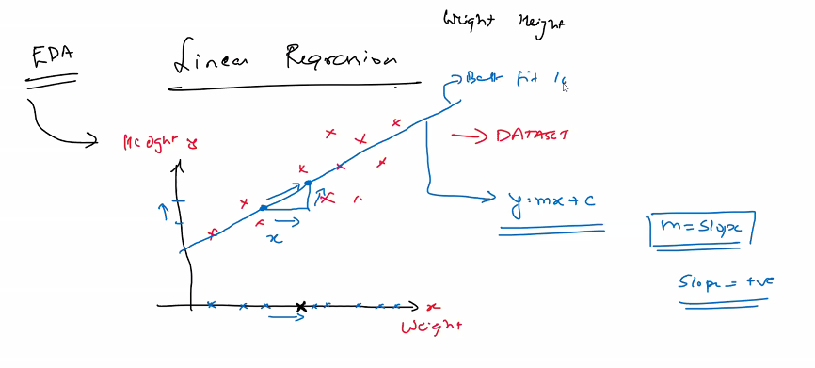

What is C? C is intercept or co-efficient when X =0 what is the value of Y.

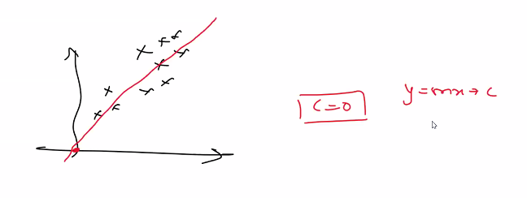

The above case X = 0 , So Y = 0 .

Another example : Predict the salary, Fresher will get default package – This is my intercept.

How do we say which one best fitted line. – How to come up best fitted line – using Gradient boost

Best fitted line – Error minimum.

Gradient boost – will try to fit best fit – in this condition the residual error will low.

