SIES GRADUATE SCHOOL OF TECHNOLOGY
DEPARTMENT OF COMPUTER ENGINEERING
DATA ANALYTICS & VISUALIZATION (DAV)
CEP 3: OPTIMAL ELECTRIC VEHICLE CHARGING STATION PLACEMENT
SDG 7 • SDG 9 • SDG 11
Project detail | Information
Group No. | [Enter group number]
Faculty Name | [Enter faculty name]
Submission Date | [Enter date]
Student 1 / Roll No. | [Enter name and roll number]
Student 2 / Roll No. | [Enter name and roll number]
Student 3 / Roll No. | [Enter name and roll number]
Student 4 / Roll No. | [Enter name and roll number]

Important data note
This is a complete report draft and planning prototype. No verified traffic counts, public-charger inventory, grid-capacity records, site quotations, or group details were supplied. Therefore, candidate ratings, cost units, coverage percentages, and utilization figures in this document are illustrative demonstration values, not measured or official Navi Mumbai results. Replace them with verified data and actual model outputs before final submission. Candidate areas require site-level verification.

1. Abstract
Public electric vehicle (EV) charging infrastructure must expand in a way that serves demand while respecting limited installation budgets and electrical-grid capacity. This project proposes a data-driven location-selection framework to identify underserved areas and compare alternative deployment plans. Candidate locations are assessed using traffic intensity, travel demand, existing charging coverage, grid feasibility, accessibility, and installation cost. A demand-weighted coverage objective is combined with budget and feasibility constraints, while equity measures help avoid concentrating chargers only in already well-served areas. The prototype uses a structured candidate dataset, weighted scoring, and budget-scenario analysis that can be implemented using Python, Pandas, and Power BI. Illustrative scenarios demonstrate the expected reporting process; final recommendations must be validated with local traffic, charger, demand, cost, and utility data.

2. Introduction and Problem Statement
EV adoption depends partly on the availability of reliable public charging. Poorly distributed stations can leave residential, transit, and employment areas underserved, while placing too many stations in a few popular areas may waste funds and worsen access inequality.
Problem statement: A transport authority wants to expand public EV charging facilities but has limited installation funds and electrical capacity. It must analyze traffic volume, existing charging points, travel demand, and grid capacity; identify underserved locations; develop a coverage- and demand-based location-selection model; compare plans under different budgets; and evaluate accessibility, expected utilization, and equitable geographic coverage.

2.1 Objectives
- Combine traffic, travel demand, existing charging coverage, grid feasibility, and installation cost in one candidate dataset.
- Identify high-demand areas with weak existing charging access.
- Select locations that maximize demand-weighted coverage within budget and grid constraints.
- Compare low-, medium-, and high-budget deployment scenarios.
- Evaluate accessibility, utilization, cost efficiency, and geographic equity.
- Develop a dashboard with a map, KPIs, scenario comparisons, and candidate-level details.

2.2 Scope, assumptions, and constraints
- Illustrative study area: candidate locations in Navi Mumbai; boundaries and coordinates must be verified.
- The system is a planning-support prototype, not an electrical engineering approval or live charger-status service.
- Costs and demand must be standardized and supported by documented sources.
- Sites failing a hard grid or land-feasibility check should not be selected.
- Constraints include limited funds, feeder/substation capacity, parking and land availability, data quality, and equitable access.
SDG | Project contribution
SDG 7 – Affordable and Clean Energy | Supports access to EV charging and clean-energy transport.
SDG 9 – Industry, Innovation and Infrastructure | Applies a reproducible data-driven method to infrastructure planning.
SDG 11 – Sustainable Cities and Communities | Measures geographic access gaps and more equitable service coverage.

3. Existing System / Literature Review
Existing charging-planning methods include nearest-station analysis, GIS mapping, weighted multi-criteria scoring, and facility-location optimization. GIS can combine roads, population, points of interest, and existing chargers. Weighted scoring is transparent, while maximum-coverage models explicitly optimize the demand served by a limited number of facilities. Grid-aware planning is essential because a high-demand site may be expensive or infeasible to connect.
Approach | Strength | Limitation / project response
Nearest-station analysis | Simple and easy to map | May ignore cost, demand concentration, and grid limits.
Weighted criteria | Transparent ranking | Weights are subjective; test sensitivity.
Maximum coverage model | Optimizes served demand under limits | Needs demand zones, distances, costs, and constraints.
Grid-aware planning | Reduces risk of infeasible installations | Requires utility capacity assessments.

Research gap: a student-scale solution should be explainable and compare multiple budgets rather than return an unexplained ranking. This project combines transparent scoring, budget-constrained selection, coverage analysis, and equity checks.

3.1 References
- International Energy Agency (IEA), Global EV Outlook 2024, https://www.iea.org/reports/global-ev-outlook-2024
- U.S. Department of Energy, Alternative Fuels Data Center, Electricity Infrastructure, https://afdc.energy.gov/fuels/electricity_infrastructure.html
- Church, R. and ReVelle, C. (1974). The maximal covering location problem. Papers of the Regional Science Association, 32, 101–118.
- OpenStreetMap contributors, copyright and licence, https://www.openstreetmap.org/copyright
- Government of India, Smart Cities Mission, https://smartcities.gov.in/

4. Dataset and Requirements

4.1 Dataset and sources
The model expects one row per candidate site, plus optional demand-zone and site-to-zone coverage tables. For a real study, use authority-approved traffic counts, verified public-charger registers, population or travel-demand data where permitted, GIS road networks, utility feasibility assessments, and current installation quotations. OpenStreetMap can support exploratory road-network mapping subject to attribution and licence terms. A map listing alone does not prove a station is operational.
Attribute | Meaning | Suggested source / treatment
candidate_id | Unique candidate identifier | Created by team
location / coordinates | Name and geographic position | Verified GIS or field survey
traffic_volume | Vehicles in a defined period | Transport authority counts
travel_demand | EV trips or demand proxy | Survey, travel model, or documented proxy
existing_coverage | Current charger access nearby | Official register plus verification
grid_capacity | Connection feasibility / capacity | Distribution utility
installation_cost | Equipment, civil work, connection, contingency | Current site quotation
accessibility | Parking, hours, safety, inclusive access | Site audit
demand_weight | Relative demand per zone | Derived and documented

The included CSV contains eight illustrative candidates with qualitative attributes and demonstration cost units. It is not an official dataset.
ID | Candidate area | Traffic | Existing coverage | Demand | Grid | Cost units | Note
L1 | Nerul Railway Station | High | Low | High | High | 18 | Priority candidate
L2 | Juinagar Station Area | High | Low | Medium | High | 16 | Priority candidate
L3 | CBD Belapur Transit Hub | High | Medium | Medium | High | 20 | Priority candidate
L4 | Seawoods Residential/Commercial | High | Medium | Medium | Medium | 17 | Review coverage overlap
L5 | Turbhe Industrial Area | Medium | Low | High | Medium | 14 | Check fleet demand
L6 | Kharghar Central Area | High | Medium | Medium | Medium | 19 | Review equity benefit
L7 | Vashi Market/Transit Area | High | High | Medium | Low | 21 | Defer pending grid review
L8 | Airoli Office/Residential Area | Medium | Medium | Medium | Medium | 15 | Reserve candidate

4.2 Functional requirements
- Import and validate site and demand data.
- Normalize criteria and calculate candidate priority scores.
- Filter sites that fail grid, land, or access checks.
- Select sites under configurable budgets.
- Calculate coverage, cost, utilization, and equity indicators.
- Display maps, KPIs, scenario charts, and a ranked table.
- Export selected locations and metrics to CSV.

4.3 Non-functional requirements
- Transparency of weights, assumptions, and constraints.
- Usable dashboard labels and filters.
- Validation and explicit reporting of missing data.
- Reproducible results for identical inputs.
- Privacy protection through aggregated or anonymized demand data.
- Scalable tables for additional candidate sites and zones.
Type | Requirement
Software | Python 3.x, Pandas, NumPy, Matplotlib, VS Code/Jupyter, Power BI Desktop, CSV/Excel.
Hardware | Standard laptop or desktop; 8 GB RAM recommended; no specialized hardware.
Inputs | Candidate sites, traffic, demand, existing chargers, grid feasibility, costs, budgets.
Outputs | Selected locations, coverage analysis, cost comparison, equity indicators, dashboard.

5. Proposed Methodology and System Design
Workflow: collect data → validate and clean → derive demand and underserved scores → check site feasibility → select sites under each budget → calculate coverage, cost, utilization, and equity → publish dashboard and export results.

5.1 Data preparation
- Check unique IDs, valid coordinates, consistent units, and missing values.
- Standardize traffic periods and convert all costs to a consistent currency and price year.
- Flag incomplete data; do not silently replace missing cost or grid values with zero.
- Normalize numerical criteria to 0–1 and reverse criteria where lower values mean greater priority.
- Build demand zones and mark which zones each candidate can serve within a selected distance or travel-time threshold.
- Record source, date, units, and limitations for every field.

5.2 Priority score
A transparent shortlist score can be calculated as: PriorityScoreᵢ = 0.20Tᵢ + 0.30Dᵢ + 0.20Uᵢ + 0.15Gᵢ + 0.15Aᵢ, where T is normalized traffic, D is demand, U is underserved need, G is grid feasibility, and A is accessibility. The weights are provisional and should be tested through sensitivity analysis. Grid feasibility can instead be treated as a hard constraint; infeasible sites must not be selected merely because their demand score is high.

5.3 Location-selection model
Let xᵢ = 1 if candidate i is selected, otherwise 0; yⱼ = 1 if demand zone j is covered; cᵢ is site cost; B is the budget; dⱼ is the demand weight of zone j; and aᵢⱼ = 1 when candidate i can serve zone j within the access threshold.
Objective: maximize Σⱼ dⱼyⱼ, subject to Σᵢcᵢxᵢ ≤ B; yⱼ ≤ Σᵢaᵢⱼxᵢ for each zone; xᵢ = 0 for sites failing hard feasibility; and xᵢ,yⱼ ∈ {0,1}. Optional constraints can require minimum coverage in underserved wards or limit the load added to a feeder.

5.4 Evaluation metrics
- Demand-weighted coverage = demand weight in covered zones ÷ total demand weight × 100.
- Utilization = occupied charger-hours or sessions ÷ available charger-hours × 100.
- Cost efficiency = newly covered demand weight ÷ installation cost.
- Equity gap = highest zone coverage rate minus lowest zone coverage rate.
- Accessibility = share of target population or demand within the selected travel distance/time.
- Grid feasibility = share of selected sites with utility-confirmed capacity.

5.5 Dashboard design
Recommended dashboard components are KPI cards for selected sites, planned cost, demand-weighted coverage, estimated utilization, and lowest-zone coverage; a map showing existing and selected stations; a budget-versus-coverage chart; a ranked candidate table; an equity chart by ward; and filters for budget, zone, and grid status.

6. Algorithm Design

6.1 Greedy marginal coverage-per-cost algorithm
- Input candidate sites, demand zones, site-zone coverage, costs, feasibility flags, and budget B.
- Initialize selected sites and covered zones as empty.
- For each feasible unselected site that fits the remaining budget, calculate new demand weight covered.
- Divide marginal demand coverage by site cost.
- Select the feasible site with the highest positive ratio; update covered zones and remaining budget.
- Repeat until no candidate can be added.
- Calculate total cost, weighted coverage, utilization, and equity measures.
- Repeat for low, medium, and high budgets.

6.2 Pseudocode
INPUT candidates, zones, coverage matrix, costs, feasibility, budget B
selected = {}; covered = {}; remaining = B
WHILE a feasible candidate can be added:
calculate each candidate's newly covered demand / cost
choose feasible candidate k with highest positive ratio
if none exists: BREAK
add k to selected; update covered zones
remaining = remaining - cost[k]
RETURN selected sites, total cost, weighted coverage, equity metrics

6.3 Complexity
For n candidate sites and m demand zones, a straightforward implementation that recalculates each site's marginal gain at every iteration has worst-case time complexity approximately O(n²m) and coverage-matrix space complexity O(nm). Precomputing site-to-zone coverage and updating gains incrementally can reduce repeated work. Greedy selection is explainable but does not guarantee a globally optimal solution for every dataset.

7. Implementation
Suggested tools: Python 3.x, Pandas and NumPy for data processing, Matplotlib for charts, CSV/Excel for data storage, and Power BI Desktop for dashboard creation.
Module | Purpose | Output
Import and validation | Load files, check schema, IDs, missing values, units | Validated dataset
Feature engineering | Normalize criteria and estimate underserved scores | Candidate feature table
Selection engine | Apply feasibility filters and greedy selection | Selected sites by budget
Scenario analysis | Calculate costs, coverage, utilization, equity | Comparison table
Visualization | Map, KPIs, filters, charts, ranked table | Planning dashboard
Export | Save metrics and site lists | CSV outputs

7.1 Setup and execution
- Install Python 3.x and create a project directory.
- Install libraries with: pip install pandas numpy matplotlib openpyxl.
- Put candidate, demand-zone, and coverage-matrix files in a data folder.
- Run preprocessing and selection for each budget scenario.
- Export selected sites and metrics to CSV, then import the outputs into Power BI.
- Replace the illustrative data, refresh the dashboard, and capture actual output screenshots.
GitHub repository: [Insert the team's repository URL]. Include complete code, data dictionary, setup instructions, assumptions, and output files in the repository.

8. Testing and Validation
The following are proposed test cases. Fill in actual results after executing the implementation; do not mark a test as passed before running it.
Test case / input | Expected result | Actual result | Status
Valid candidate CSV | Data loads and validation succeeds | To be filled | Pending
Missing site cost | Missing value is flagged; site is not silently selected | To be filled | Pending
Grid-infeasible candidate | Candidate is excluded | To be filled | Pending
Budget below all site costs | No site selected; budget is not exceeded | To be filled | Pending
Two sites cover same zone | Demand is not double-counted | To be filled | Pending
Repeat same input twice | Same selected sites and metrics | To be filled | Pending
Increase budget | Cost remains within budget; coverage does not decrease if previous plan remains feasible | To be filled | Pending
Unequal zone coverage | Dashboard reports lowest coverage and equity gap | To be filled | Pending

9. Results and Discussion
All figures in this section are illustrative examples for showing the analysis format. They are not outputs from verified local datasets or an executed optimization model.
Scenario | Sites selected | Illustrative cost units | Weighted coverage | Estimated utilization
Low budget | 2 | 34 | 38% | 72%
Medium budget | 4 | 65 | 67% | 68%
High budget | 6 | 104 | 84% | 61%

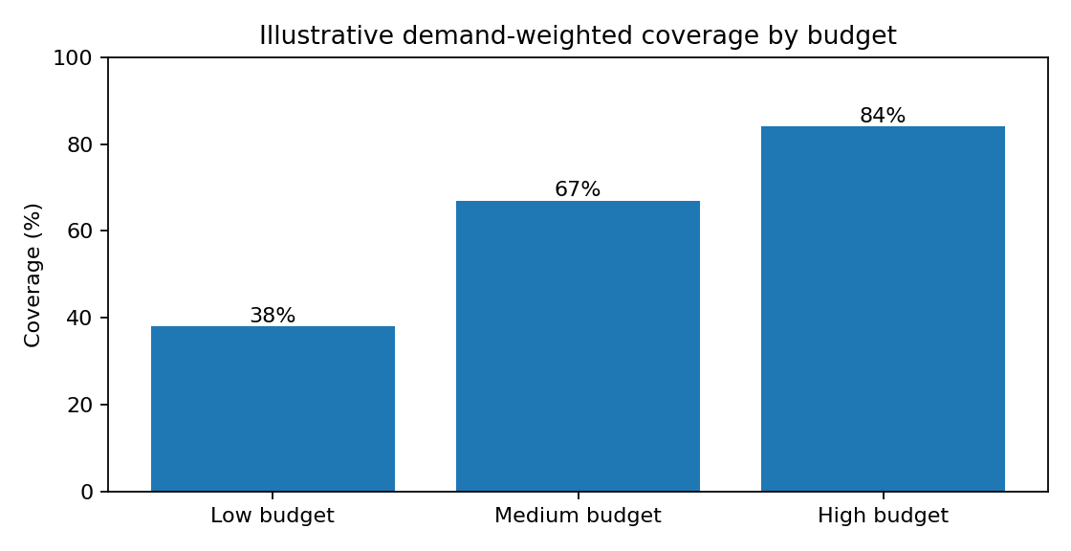
Figure 1. Illustrative demand-weighted coverage by budget scenario.
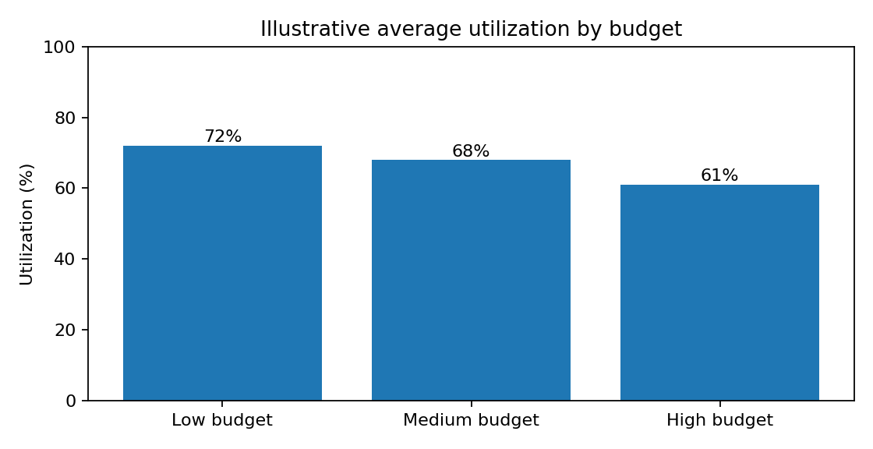
Figure 2. Illustrative average utilization by budget scenario.
Interpretation: in this demonstration, the high-budget scenario reaches 84% demand-weighted coverage compared with 38% in the low-budget scenario. Average utilization decreases as sites spread demand across more chargers. This is a possible planning pattern, not a forecast; actual results depend on local demand, charger power, session duration, and grid availability.

9.1 Candidate areas for investigation
Priority | Candidate area | Reason to investigate | Required validation
1 | Nerul Railway Station | Illustrative high demand and low existing coverage | Verify site access, nearby chargers, feeder capacity
2 | Juinagar Station Area | Potential transit demand and access gap | Traffic counts and charger-distance analysis
3 | CBD Belapur Transit Hub | Potential transit and employment demand | Site ownership, access, utility connection
4 | Seawoods Residential/Commercial | Potential mixed-use charging demand | Avoid duplicate coverage; survey dwell time
5 | Turbhe Industrial Area | Potential employee or fleet demand | Operating hours, fleet demand, grid check
6 | Kharghar Central Area | Potential residential/transit demand | Demand distribution and equity impact

Vashi is marked for deferral only in the illustrative table because its demonstration grid category is low. This is not a factual statement about the real electricity network. A utility assessment may change the decision.

9.2 Limitations
- Demonstration values must be replaced with official or field-verified data.
- Priority rankings depend on selected criteria and weights.
- Straight-line distance may not reflect road travel time or congestion.
- Utilization depends on EV adoption, charger power, session duration, and user behaviour.
- Grid feasibility requires utility assessment and engineering review.
- Land ownership, accessibility standards, safety, maintenance, and tariffs need further evaluation.

10. Team Contributions
Replace placeholders with actual names and roll numbers, and edit contributions to reflect the work genuinely completed. The template below includes ten rows as required by the report format.
Student name / roll no. | Assigned role | Contribution / module
1. [Name / Roll No.] | Coordination | Problem definition and report integration
2. [Name / Roll No.] | Data collection | Traffic, existing chargers, source documentation
3. [Name / Roll No.] | Preprocessing | Cleaning and data-quality checks
4. [Name / Roll No.] | Model design | Scoring formula and location-selection method
5. [Name / Roll No.] | Optimization | Budget constraints and scenarios
6. [Name / Roll No.] | GIS/accessibility | Mapping and distance-based coverage
7. [Name / Roll No.] | Equity analysis | Ward-level access gap measures
8. [Name / Roll No.] | Dashboard | KPIs, charts, filters
9. [Name / Roll No.] | Testing | Validation and test results
10. [Name / Roll No.] | Documentation | References, formatting, presentation

11. Conclusion and Future Scope
This project proposes a transparent framework for selecting public EV charging locations under limited funds and electrical capacity. It combines candidate scoring, demand-weighted coverage, feasibility constraints, budget-scenario comparison, and geographic equity measures. The illustrative scenarios show how the report can compare cost and coverage while tracking utilization. These results are not empirical findings; the main next step is to replace the demonstration values with verified local data, run the selection algorithm, and capture actual dashboard and test outputs.
Future scope includes road-network travel-time analysis, ward-level equity constraints, charger type and power-level selection, demand forecasting, uncertainty analysis, feeder-load optimization, multi-year EV adoption scenarios, current installation quotations, and integration with verified station-status data.

Appendix A: Planning dashboard layout
Component | Purpose
KPI cards | Selected sites, planned cost, weighted coverage, utilization, lowest zone coverage
Map | Existing chargers, candidate sites, selected sites, demand zones, access gaps
Scenario chart | Compare budget, number of sites, and weighted coverage
Candidate table | Score, demand, existing coverage, cost, grid status, selection
Equity chart | Coverage rates by ward or demand zone
Filters | Budget, ward/zone, grid feasibility, charger type, priority

Appendix B: Final submission checklist
- Replace illustrative data and clearly label any remaining simulated values.
- Add data sources, access dates, units, and licence/permission notes.
- Fill in group number, faculty, date, and all member details.
- Execute the model and replace pending test results with actual outputs.
- Add screenshots of the dashboard, map, and program execution.
- Add the GitHub URL and ensure complete code and setup instructions are available.
- Check budget limits and ensure overlapping demand is not double-counted.

