K-Nearest Neighbours

Description
- Supervised Learning Model
- Can be used for both Regression and Classification
- Fix & Hodges proposed K-nearest neighbor classifier algorithm in the year of 1951 for performing pattern classification task.
- KNN is very simple algorithm, using distance calculation
- Non Parametric, as it does not assumes the distribution of data
- KNN is lazy algorithm, Lazy means during training not much is done, fit function will run faster and predict will run slower
- Y value is identified with the majority of vote casted by the Neighbours (K), having K as constant
  - Classification:
    - Eg: If the neighbours are as below :
      - F, F, F, T, T, T, F
      - The result will also be F
  - Regression
    - If the values are continuous like 32, 34, 43, 54, 21
    - Below are some methods can be used to predit
      - Mode, Median, Mean
- Neighbours are identified by using distance, and using the closest distance
- So defining the K value is important, as based on K (either mode or median ) of the neighbours the Y value is predicted
- K value is kept as odd number, for clarity in classification of Y value
- Increasing the K value, refine the judgement of Y value
  - If only we take 2 neighbours and see them as :
    - T, T
    - Then we would come predict Y as T
  - But the real picture would be like this :
    - F, F, F, F, F, F, T, T
    - Here where the two T were outliers and actual prediction should be as F
- Always suggested to have the Data to be Scaled, else it might skew towards the high magnitude attributes.
  - Beautifully explained in the below link:
    - https://medium.com/analytics-vidhya/why-is-scaling-required-in-knn-and-k-means-8129e4d88ed7
    - Short summary:
      - Having 2 attributes, age and income
      - As age is much smaller than income, the distance becomes much biased to the income
      - After scaling, similar weightage is given to both the variables
- Suggested selection method for the prediction :
  - Classification : Mode
  - Regression : Mean or Median
- Steps :
  - Calculate distance from the given input
  - Sort the distance
  - Find K closest neighbours
  - Vote for Y
  - Eg:
    - Input:
      - age, income -> Vote/Not Vote
      - 33, 10K -> Vote
      - 34, 40L -> Not Vote
      - 29, 45K -> Vote
      - 45, 50L -> Note Vote
      - 31, 30K -> Vote
      - 28, 25K -> Note
    - Output:
      - 29, 35K
        - 1
        - 30
        - 2
        - 29
        - 3
      - 1, 2, 3, 29, 30
      - K = 3
        - 1 , 2 , 3
        - Vote, Vote, Vote
        - Vote

Formula
- Distance Formulas for Continuous X values, either one could be used
  - Euclidean: Remember “Pythagorean Theorem”, L2 Norm
  - Manhattan: Also known as Taxicab Geometry, City Block Distance etc., L1 Norm
  - Minkowshi: Lp Norm
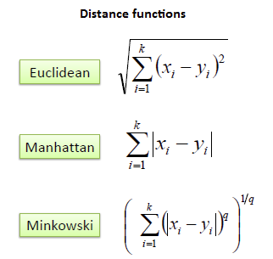

Fig2: Distance functions for continuous values

- Distance Formulas for Categorical X values
  - Hamming distance: Number of position of different bit. Eg:
    - 10100
    - 10111
  - At times Cosine Distance Metric is used,
Actually the distance is calculated by the Cos Theta, the angle between P1 and P2
Here,
    - cosine value 1: vectors are pointing to same direction, i.e there is similarities,
    - value 0: some similarities found though unrelated and
    - value -1: the vectors point opposite direction, hence no similarities found
Note: Researchers have shown for larger dimensions or when more values are with 0 Euclidean distance is not useful, Cosine similarity have less impact in such scenario. I assume that as the two points are zero there is possibility those values could be similar (i.e the angle distance between cos 0 will be 1).
Reference: https://www.youtube.com/watch?v=ieMjGVYw9ag

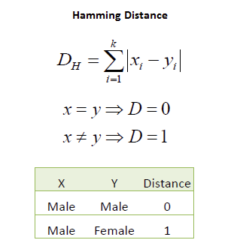
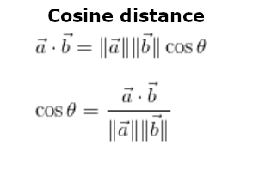

Fig3: Distance functions for discrete values

Assumption
- Scaling of the data is important
- Address missing values

Hyper Parameter Tuning
- Metric : Euclidean, Manhattan, Minkowski, Hamming, Cosine
  - The distance metric to use for the tree.
  - The default metric is minkowski, and with p=2, as p is 2 its is equivalent to the standard Euclidean metric (so by default its euclidean, even though in the default parameter it says minkowski)
- K : Starting for 3, Odd number
  - Elbow Curve: helps to select the optimal number of K
  - Eg: The optimal value of K is 20. The graph of the error rate increases after 20.
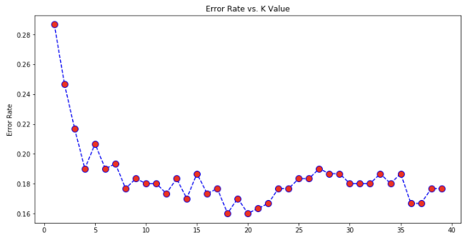
Fig4: Elbow curve
- Algorithm :
  - brute
    - Lazy, finds all the distance of the neighbours, also time costly (O(N^2) ) and inefficient with increase in number of points
  - kd_tree
    - binary tree – but holds K values
    - sort the points first
    - tree is split alternatively on the parameters
      - eg: if we have only 2 parameters, x1 and x2
      - the first split will happen in x1
      - the second spilt will happen in x2
      - sample image:
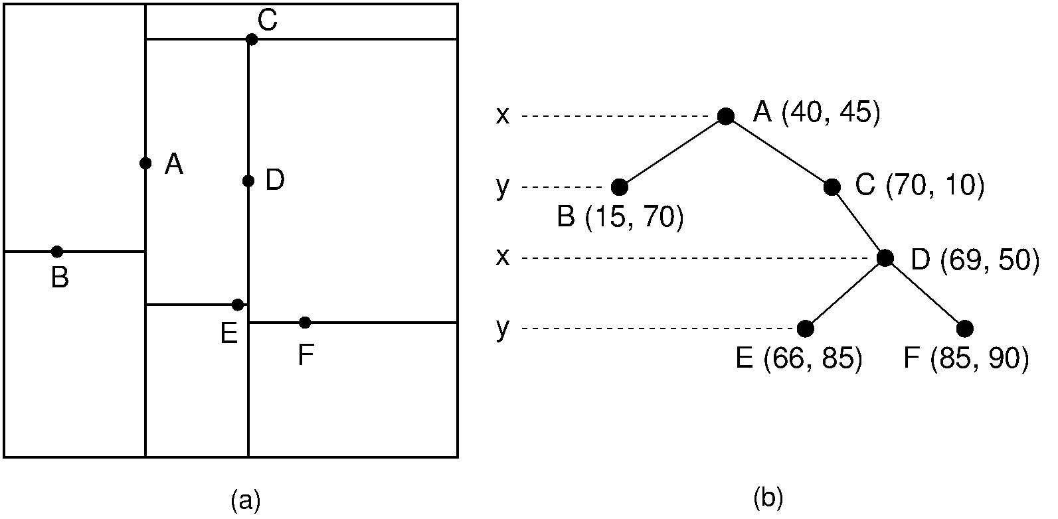
Fig5: kd_tree
Credit: https://opendsa-server.cs.vt.edu/ODSA/Books/CS3/html/KDtree.html
    - works well in low dimensions, but causes curse of dimensionality with high dimensions data
    - because higher the dimensions the near points and the far points are so close to each other in the vector, its difficult to calculate the distances between the values
  - ball_tree
    - binary tree – but holds K values
    - find the random point and find the farthest point, and farthest point from this point, hence the split will happen
    - Sample image
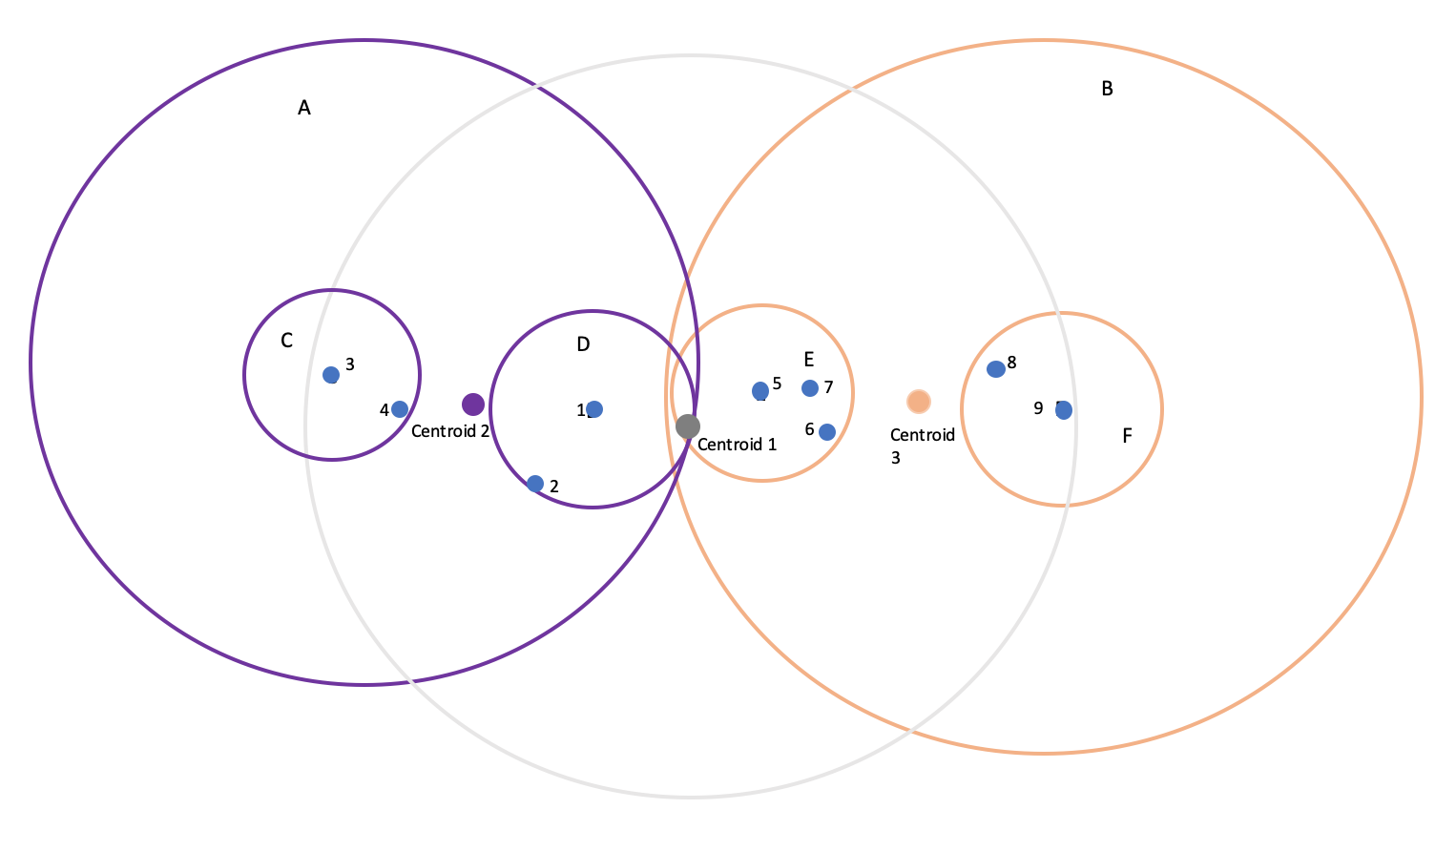
Fig6: ball_tree
    - works well in high dimensions, and it would take more time than kd_tree for low dimensions data
    - Very nice explanation:
      - https://www.youtube.com/watch?v=czC0j_oUb6g
  - auto
    - will attempt to decide most appropriate algorithm based on the values passed to the fit function
- Weights : uniform, distance
  - Weights function used while prediction
  - uniform: uniform weights, all the points in each neighbourhood are weighted equally
  - distance: closer neighbours will have greater influence in the predictions

Visualisation
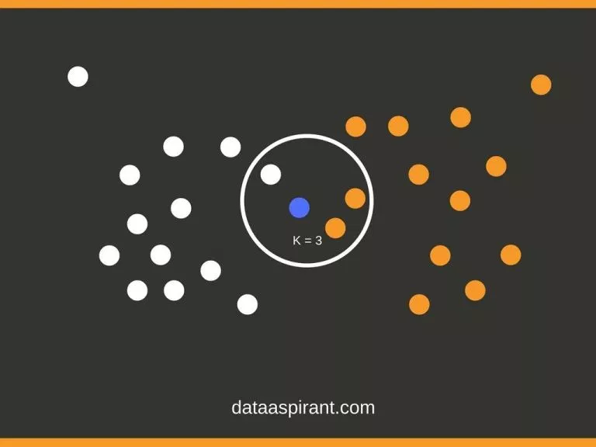
Fig7: KNN 2D visualisation
Credit: https://dataaspirant.com/k-nearest-neighbor-classifier-intro/

Evaluation
- For Regression :
  - R2
  - AdjR2
- For Classification
  - Classification Matrix
  - Confusion Matrix

Module
- Classification
>>> X = [[0], [1], [2], [3]]
>>> y = [0, 0, 1, 1]
>>> from sklearn.neighbors import KNeighborsClassifier
>>> neigh = KNeighborsClassifier(n_neighbors=3)
>>> neigh.fit(X, y)
KNeighborsClassifier(...)
>>> print(neigh.predict([[1.1]]))
[0]
>>> print(neigh.predict_proba([[0.9]]))
[[0.66666667 0.33333333]]

- Regression
>>> X = [[0], [1], [2], [3]]
>>> y = [0, 0, 1, 1]
>>> from sklearn.neighbors import KNeighborsRegressor
>>> neigh = KNeighborsRegressor(n_neighbors=2)
>>> neigh.fit(X, y)
KNeighborsRegressor(...)
>>> print(neigh.predict([[1.5]]))
[0.5]

Advantages
- Faster in Training Phase
- Useful when the data is Non Linear
- Not impacted by the outliers

Drawbacks
- Curse of Dimensionality, struggles when the input parameters are high, as more the features means overfitting of the model, and to control overfitting requires more the data.
- Testing phase is costlier in time and memory
- Scaling is important

References
https://scikit-learn.org/stable/modules/generated/sklearn.neighbors.NearestNeighbors.html
https://github.com/scikit-learn/scikit-learn/tree/054d156a1d4f2e74c15031db81c10a72c67cc2c5/sklearn/neighbors
https://people.revoledu.com/kardi/tutorial/KNN/HowTo_KNN.html
https://www.geeksforgeeks.org/k-nearest-neighbours/
https://www.datacamp.com/community/tutorials/k-nearest-neighbor-classification-scikit-learn
https://towardsdatascience.com/tree-algorithms-explained-ball-tree-algorithm-vs-kd-tree-vs-brute-force-9746debcd940
https://towardsdatascience.com/importance-of-distance-metrics-in-machine-learning-modelling-e51395ffe60d

