Thang Hoang Cao

Android Developer

**Phone:** 0933840682 | **Email:** caohoangthang93@gmail.com

**Address**: 77 Tran Ke Xuong – Phu Nhuan District – Ho Chi Minh City

|  |  |  |
| --- | --- | --- |
|  | Education |  |
|  |  |
|  | Diploma in Information Technology  University of Science, VietNam  2011 - 2014 |  |

|  |  |  |
| --- | --- | --- |
|  | Experience |  |
|  |  |
| Startup Upupme • Android Developer • Ho Chi Minh City • 2014  KMS Technology • Software Engineer • Ho Chi Minh City • 2015 – Present | | |
|  | | |

|  |  |  |
| --- | --- | --- |
|  | Technical Skills |  |
|  |  |

**Languages & Scripting:** Java, C++, JavaScript, CoffeeScript, TypeScript

**Frameworks:** AngularJS, Dropwizard, Spring Tool Suite

**Operating Systems:** Window, Linux (Centos, Ubuntu), Mac OS

**Mobile:** Android

**Database:** SQL Server, MySQL, SQLite, Cassandra, MongoDB

**Web Servers:** Node.js, Jetty

**IDE:** IntelliJ, Eclipse, Visual Studio, Android Studio

**Source Control**: GitHub

**Analysis & Design Tools:** Trello, Jira

**Configuration Management Tools:** maven, bower, gulp, npm

|  |  |  |
| --- | --- | --- |
|  | UI - UX |  |
|  |  |

UI and UX are essentially important in mobile applications. When I have free time, I always use app ‘Pinterest’ to pin beautiful UI UX applications into my collections.

Link:[**https://www.pinterest.com/thanghand/uiux/**](https://www.pinterest.com/thanghand/uiux/)

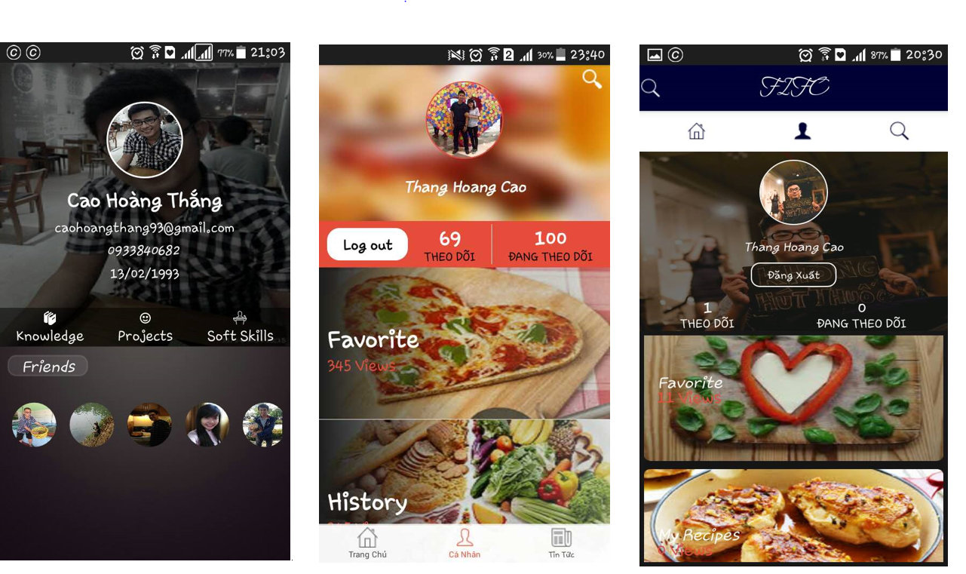 **There are some of my design UI UX mobile applications:**

***https://www.facebook.com/thang.hand.1/media_set?set=a.514361802058239.1073741831.100004532711285&type=3***

|  |  |  |
| --- | --- | --- |
|  | Projects |  |
|  |  |
| **Picture Puzzle – 2013**  **Assignment:** 7 days  **Project Description:** In this app, you can pick one of given pictures or you can take any picture (of yourself) using your own camera and play with it.  **Project Detail:** In this game, you are given many pictures. You can pick one of them and play with it. Moreover, if you are not in given pictures, you can take another picture using your own camera and play with the new one. When you are playing, try your best to minimize the number of steps. The fewer steps you use to finish the puzzle the better you are. The number of steps will be recorded.  Technologies: Android  Team size: 1 (me) | | |

**Image Detail:**

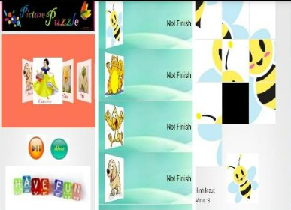

**Upupme – 2014 (Public)**

**Assignment:** 7 months

**Project Description:** This app will provide you some useful information about some nearby fashion shops that you are looking for, e.g. locations, directions, and information of products …

**Project Detail:** This app can help people search some nearby fashion shops. It can also show detailed directions to the shop that you are looking for. Additionally, a list of products with their pictures such as clothes, coats, shoes, wallets, … is provided

**Role(s):** Android developer

**Technologies:**

Mobile: Android, IOS

Database: MySQL

Backend: Using PHP

**Responsibilities:**

Loading data from Web Service to Google Map v2 in application

Deploying UI UX and researched thirdparty libraries. For example: Volley, Retrofit, Picasso and Glide …

**Team size:** 7

**Link google play store:** <https://play.google.com/store/apps/details?id=com.upupme>

**FIFO – 2015 (Startup Project)**

**Assignment:** 5 months

**Project Description:** This app will provide you a lot of food and teach you how to cook easily.

**Project Detail:** This app can enable you looking for food that you want. it might provide a variety of your favorite food. Moreover, you can pin food and create your collections.

**Role(s):** Android developer and Backend developer

**Technologies:**

Languages: Java, C#

Mobile: Android

Database: MySQL

Backend: Using Java and Dropwizard framework

**Responsibilities:**

Designing UI UX for mobile application

Designing structures and pattern for projects

Loading data from API and bind into UI

Deploying backend system

**Team size:** 2

**Image detail:**



**Failed StartUp**

**Ezmart:**

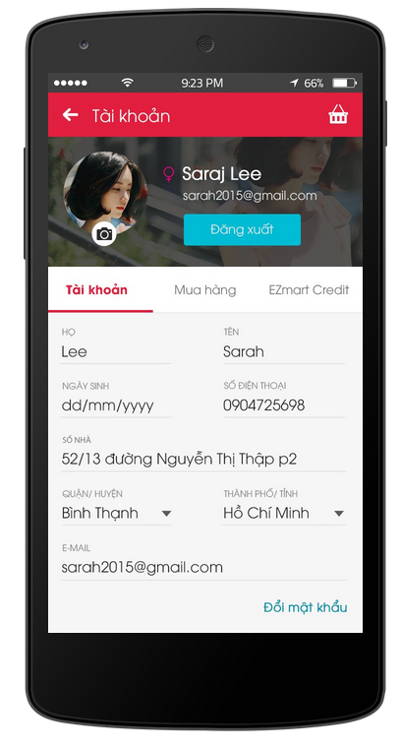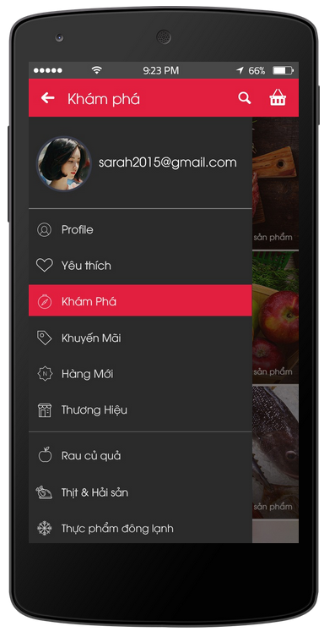 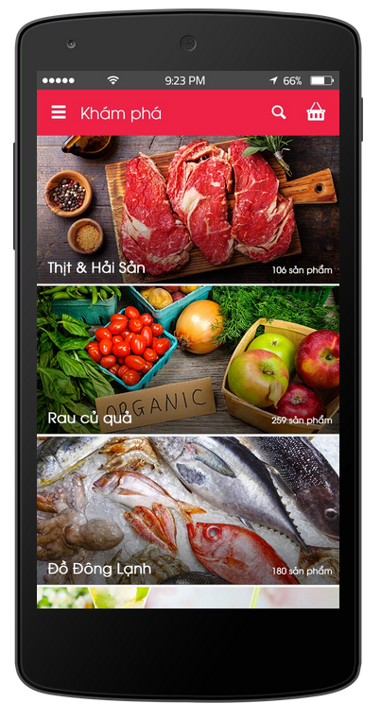 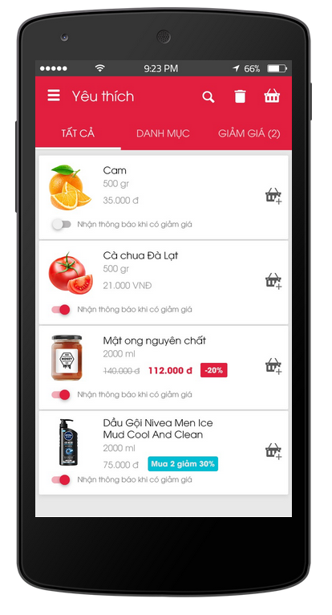

HUNI:

