Korean Food Restaurant

Business Use-Case Specification

Version <1.0>

|  |  |  |  |
| --- | --- | --- | --- |
| **Date** | **Version** | **Description** | **Author** |
| <03/10/2017> | <1.0> | created | Thuy Duong |
|  |  |  | Minh Hien |
|  |  |  | Duc Huy |

Table of Contents

1. Introduction 4

1.1 Purpose 4

1.2 Scope 4

1.3 Overview 4

2. Business Use-Case Name 4

2.1 Brief Description 4

3. Goals 4

4. Performance Goals 4

5. Workflow 4

6. Workflow 4

7. Category 5

8. Risk 5

9. Possibilities 6

10. Process Owner 6

Business Use-Case Specification: <Business Use-Case Name>

# Introduction

The Business Use-Case Specification document will give you an overview of the website uses. This will be background for further uses of the website.

In this document, we will provide you some usecase with flow of process, activity diagram, usecase diagram. By what we show you, you will have a thorough insights of what the website run and how to use it. The flow describes *what* the business does to deliver value to a business actor, not *how* the business solves its problems. This document can be understandable by anyone within the business.

## Purpose

While making this site, we prepare some specification for the uses of the website. However, in order to use the website appropriately, we need to use the site in reality to improve restaurant’s business. This will provide you the basic guidelines for users.

This is a case that we based to develop the basic concept of the website.

## Scope

The use-case is for our consumers, who will be the one use our software. So that, the language we use must be understandable to the majority.

## Overview

The content below will guide you through the case of uses in this software.

# Business Use-Case Name

## Brief Description

Customer is hungry, she or he want to buy a food for eating. In this case, she or he only accesses to website and takes order in there. In the same time, system will receives order and send request to shop clerk. In that time, the system creates bill and update bill for this sales.

And then, while shop clerk push order for chef to cook and delivering for customer in the next step, the system waits until bill status is finished, it updates the bill and sales when.

# Goals

The website will respond to the needs correctly and run as we coded.

# Performance Goals

There will not any errors that occur during the implementation of the website.

# Workflow

|  |  |  |  |  |
| --- | --- | --- | --- | --- |
| **Name of Process:** | Customer’s ordering process | | | |
| **Process Owner:** | Minh Hien, Thuy Duong and Duc Huy | | | |
| **Created By:** | Minh Hien, Thuy Duong and Duc Huy | | **Last Updated By:** | Minh Hien, Thuy Duong and Duc Huy |
| **Date Created:** | 24/9/2017 | | **Last Revision Date:** | 05/10/2017 |
|  | |  | | |
| **Process Purpose:** | | The purpose of the Customer’s ordering process is to show how customer order food through internet. By this way, the restaurant can identify and fill personnel staffing requirements by implementing a standardized organizational process with participation from each division | | |
| **Process Scope:** | | The scope of this process is only to show the process of choosing product to buy by customers | | |
| **Process Input:** | | Customers access into the Korean Food Restaurant website | | |
| **Process Flow:** | | 1. Customers click Menu which contains food and drink’s image and information on navbar. They can easily search and filter by product’s name and type on search box 2. When customer click on product, this product be saved automatically on shopping cart. After that, customer can choose other products they want. 3. When they finish to choose their food, they click on shopping cart on the right side in website. It displays all product they chose and customer can adjust the quantity of product, click on button “order” to go to next step 4. There is a contact form for customer to fill in their information which consist of name, address, phone number and email. Customer must complete this form and agree to terms and conditions of restaurant, 5. They click button “send” that under contact form and receive “thank you” note from restaurant | | |
| **Process Output:** | | Customers receive foods and implement successful transaction | | |

|  |  |  |  |  |
| --- | --- | --- | --- | --- |
| **Name of Process:** | Customer’s managing cart process | | | |
| **Process Owner:** | Minh Hien, Thuy Duong and Duc Huy | | | |
| **Created By:** | Minh Hien, Thuy Duong and Duc Huy | | **Last Updated By:** | Minh Hien, Thuy Duong and Duc Huy |
| **Date Created:** | 24/9/2017 | | **Last Revision Date:** | 05/10/2017 |
|  | |  | | |
| **Process Purpose:** | | The purpose of the Customer’s ordering process is to show how customer to manage cart in this website. By this way, the restaurant can identify and fill personnel staffing requirements by implementing a standardized organizational process with participation from each division | | |
| **Process Scope:** | | The scope of this process is only to show the process of managing cart by customers | | |
| **Process Input:** | | Customers access into the Korean Food Restaurant website | | |
| **Process Flow:** | | 1. Customers click on shopping cart on the right side in website. There is a list of products that customer choose before. 2. Each product has button for customer to delete or edit the quantity. The button with symbol “x” on the left of product box is to delete product. The button “< >” is in turn reduce and increase the quantity of product, 3. When customer finish to manage cart, they can go back to menu to choose other product or click on button “order” under shopping cart form to order the food. | | |
| **Process Output:** | | Customers complete to manage the cart | | |

|  |  |  |  |  |
| --- | --- | --- | --- | --- |
|  | |  | | |
| **Name of Process:** | System Manager’s managing account process | | | |
| **Process Owner:** | Minh Hien, Thuy Duong and Duc Huy | | | |
| **Created By:** | Minh Hien, Thuy Duong and Duc Huy | | **Last Updated By:** | Minh Hien, Thuy Duong and Duc Huy |
| **Date Created:** | 24/9/2017 | | **Last Revision Date:** | 30/9/2017 |
|  | |  | | |
| **Process Purpose:** | | The purpose of Restaurant’s System Manager’s managing account process is to show how Manager manage accounts in server. Then finding the way of handling if the system implements slowly. | | |
| **Process Scope:** | | The scope of process is only to show the process of managing account by system manager | | |
| **Process Input:** | | System manager access into the Korean Food Restaurant admin page | | |
| **Process Flow:** | | 1. System manager login admin page with his account. He must fill in username and password to login admin page. Usernames must be at least 5 characters long and contain any letters **a** to **z** and any numbers from **0** through **9**. Password must be between 6 and 32 characters long and can contain any letters **a** to **z**, any numbers from **0** through **9**, some special characters, including @ (at sign). (period) - (hyphen or dash) _ (underscore). 2. He accesses to manage account page by click on Account Management in navbar 3. It will display the account list on the left side of the page, above account list are 3 buttons: Create (create a new admin account), Register (register a ) and remove( delete a recent admin account) . 4. When he wants to create account, he fills in all box in information account form on the right side of the page. And click on button “create” to finish. 5. When he wants to delete account, he clicks on button “remove”. Symbols “X” in the end of each account appear and when system manager click on button “X”, the account will be gone. | | |
| **Process Output:** | | The account list will update again | | |

|  |  |  |  |  |
| --- | --- | --- | --- | --- |
|  | |  | | |
| **Name of Process:** | System Manager’s managing category process | | | |
| **Process Owner:** | Minh Hien, Thuy Duong and Duc Huy | | | |
| **Created By:** | Minh Hien, Thuy Duong and Duc Huy | | **Last Updated By:** | Minh Hien, Thuy Duong and Duc Huy |
| **Date Created:** | 24/9/2017 | | **Last Revision Date:** | 30/9/2017 |
|  | |  | | |
| **Process Purpose:** | | The purpose of Restaurant’s System Manager’s managing category process is to show how Manager manage category in server. Then finding the way of handling if the system implements slowly. | | |
| **Process Scope:** | | The scope of process is only to show the process of managing category by system manager | | |
| **Process Input:** | | System manager access into the Korean Food Restaurant admin page | | |
| **Process Flow:** | | 1. System manager login admin page with his account. He must fill in username and password to login admin page. Usernames must be at least 5 characters long and contain any letters **a** to **z** and any numbers from **0** through **9**. Password must be between 6 and 32 characters long and can contain any letters **a** to **z**, any numbers from **0** through **9**, some special characters, including @ (at sign), (period) - (hyphen or dash) _ (underscore). 2. He accesses to manage category page by click on Account Management in navbar 3. It will display the account list on the left side of the page, above category list are 3 buttons: Create (create a new category), Register (register a ) and remove( delete a category) . 4. When he wants to create category, he fills in all box in information category form on the right side of the page consist of name and description. And click on button “create” to finish. 5. When he wants to delete account, he clicks on button “remove”. Symbols “X” in the end of each category appear and when system manager click on button “X”, the account will be gone. | | |
| **Process Output:** | | The category list will update again | | |

|  |  |  |  |  |
| --- | --- | --- | --- | --- |
|  | |  | | |
| **Name of Process:** | System Manager’s log process | | | |
| **Process Owner:** | Minh Hien, Thuy Duong and Duc Huy | | | |
| **Created By:** | Minh Hien, Thuy Duong and Duc Huy | | **Last Updated By:** | Minh Hien, Thuy Duong and Duc Huy |
| **Date Created:** | 24/9/2017 | | **Last Revision Date:** | 30/9/2017 |
|  | |  | | |
| **Process Purpose:** | | The purpose of Restaurant’s System Manager’s managing log process is to show how Manager manage log in server. Then finding the way of handling if the system implements slowly. | | |
| **Process Scope:** | | The scope of process is only to show the process of managing log by system manager | | |
| **Process Input:** | | System manager access into the Korean Food Restaurant admin page | | |
| **Process Flow:** | | 1. System manager login admin page with his account. He must fill in username and password to login admin page. Usernames must be at least 5 characters long and contain any letters **a** to **z** and any numbers from **0** through **9**. Password must be between 6 and 32 characters long and can contain any letters **a** to **z**, any numbers from **0** through **9**, some special characters, including @ (at sign), (period) - (hyphen or dash) _ (underscore). 2. He accesses to manage log page by click on log Management in navbar 3. He can search which type of activities that other staffs did and the time when staffs did change by clicking on filter button 4. To display list of log in excel file, admin clicks on button “print excel” in the right above the table of log on this page | | |
| **Process Output:** | | Handle and deliver orders successfully | | |

# Activity Diagram

* Customer’s ordering process

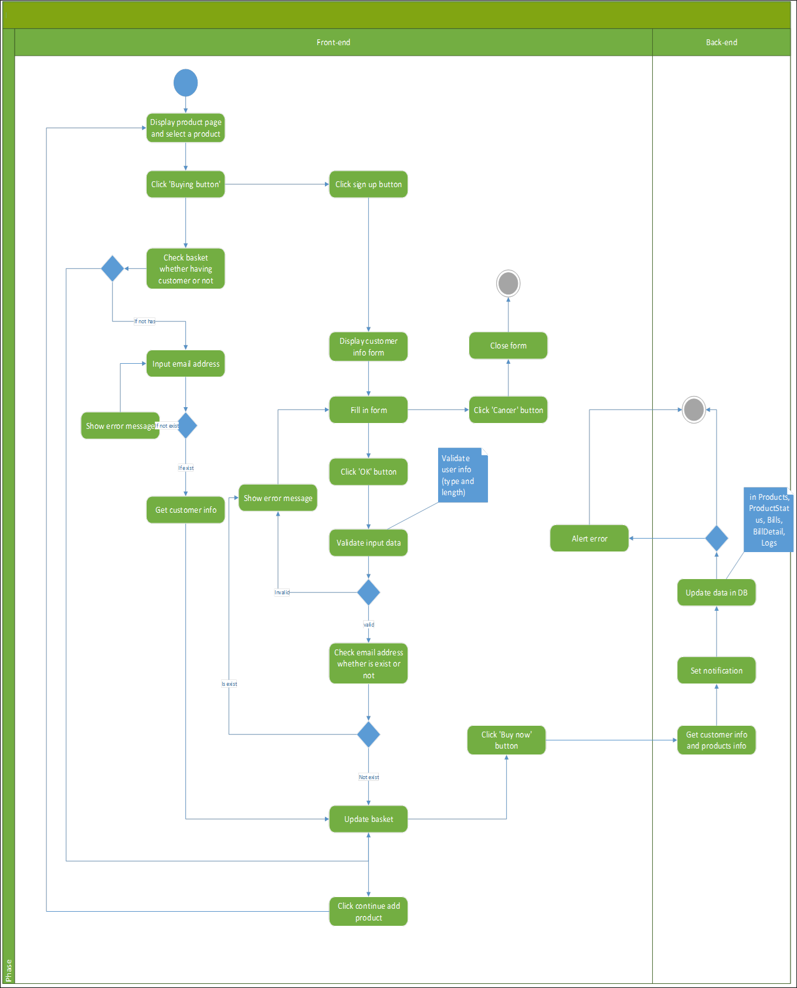

* System Manager’s login process

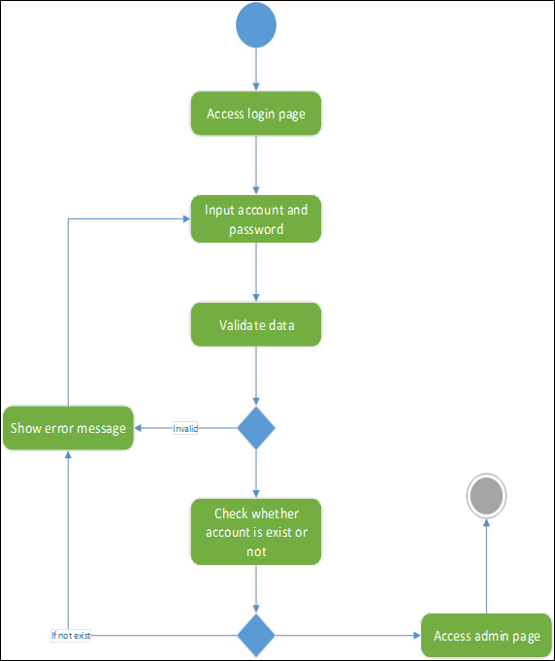

* System Manager’s login process
* 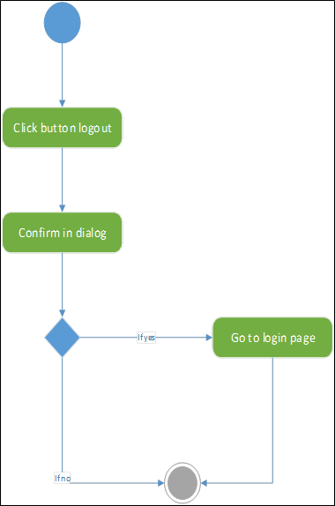
* Account management: Start

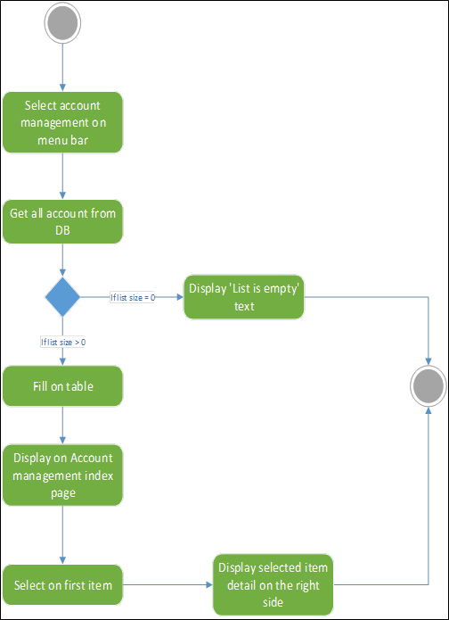

Account management: Create

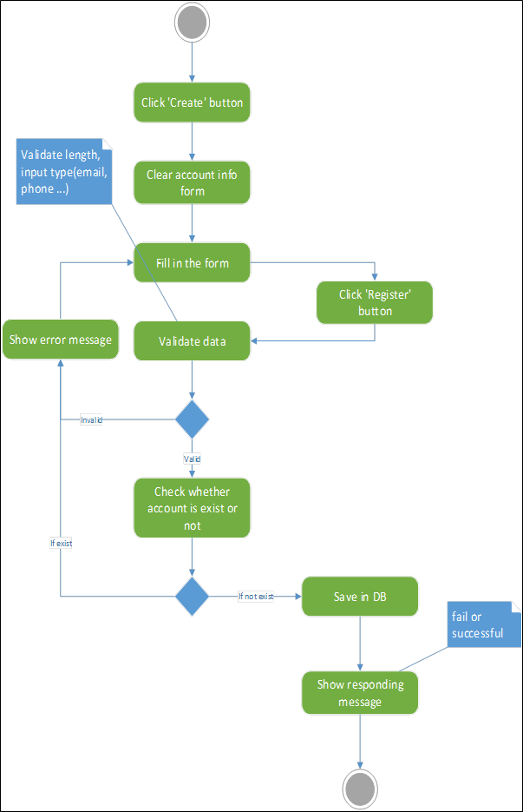

# Category

website Company

# Risk

The website might update correct bill and sale when customer add more or cancel bill.

The shop provide responses to customer during waiting food time

# Possibilities

If the site correctly works as we expected, this will be a chance for further distribute the website outside for larger corporation’s needs.

At this time, we are testing the website internally to gather feedbacks, and finish the first development of the website.

# Process Owner

Restaurant Operations Manager