C++ Code

When building a data processing pipeline and a model, we need to experiment a lot. The python language corresponds to this need thanks to its simple usage. It allows testing different ways of building a model and benefits from good documentation online. That is the reason why we started by experimenting in python.
However, this model has to be processed at the end on the HPC platform, in order to optimize a frequency. The code running in these HPC platforms needs to be in C++ because of the optimization. Thus, it is mandatory to also have our model running in C++ code. The goal is to run a model trained in Python, with the library XGBoost, in a C++ algorithm. There are several ways proposed online to achieve this task.

XGBoost C++ API
The library XGBoost which is used to train our model in Python proposes a C++ API. Even though the python package is very well documented, the part dedicated to the C++ I very poor, if not non-documented at all. We only have access to the list of header files constituting the interface:
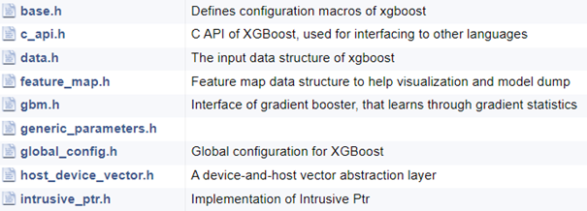
Fortunately, there is a short tutorial on the C API available on the documentation and a few forums talking about this topic.
Tutorial : xgboost.readthedocs.io/en/latest/tutorials/c_api_tutorial.html

FastForest
The FastForest library helps to get a XGBoost model into a C++ production environment as quickly as possible. This library is built to be easy to use, fast, safe and portable, meaning that it doesn’t have other dependencies than C++ standard library.
Indeed, this library shows very easy to use samples of code in their README, with the possibility to easily load a pretrained model from XGBoost.
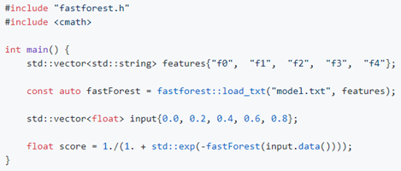
Library: github.com/guitargeek/XGBoost-FastForest

Xgb2cpp
This library allows to transform a pretrained model coming from XGBoost, into a C++ file. It translates the tree model in a program with many “if” and “else”. In order to use this library, it is mandatory to name labels with a strict syntax: “f” + number of the features as {f0, f1, f2, f3, …}.
This library works well but has a limit. When the tree model is too big, the library needs too much memory to translate it. Thus, it is useful when dealing with little trees but too limited when bigger structures are needed.
Library: github.com/popcorn/xgb2cpp

