Practical: Installing Git and Uploading Your MLOps Project to GitHub
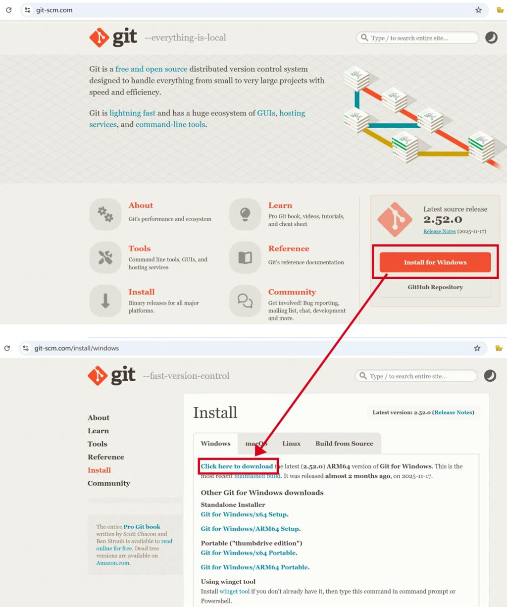
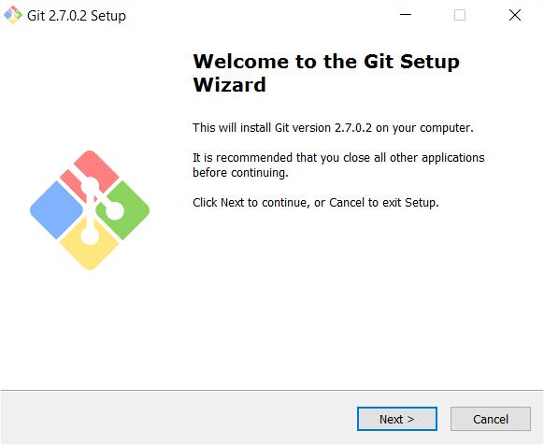
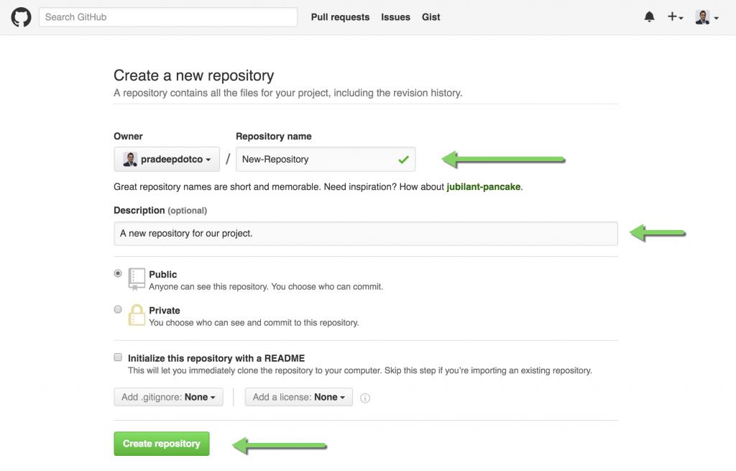

Aim
To install Git on the local system, create a GitHub repository, and upload the MLOps project for version control.

Step 1: Download Git
Open your browser and visit:
Git Downloads
Click Download for Windows.

Step 2: Install Git
- Double-click the downloaded installer.
- Click Next for all installation screens (keep the default settings).
- Click Install.
- Click Finish.

Step 3: Verify Installation
Open Command Prompt.
Type:
git --version
If Git is installed correctly, you will see something similar to:
git version 2.49.0

Step 4: Create a GitHub Account
Go to:
GitHub
Click Sign Up.
Complete:
- Email Address
- Password
- Username
Verify your email.

Step 5: Create a New Repository
After logging in:
- Click the + icon (top-right).
- Select New repository.
Fill in:
Field | Value
Repository Name | Telecom-MLops
Description | MLOps Practical
Visibility | Public (or Private if preferred)
Initialize README | Leave unchecked
Click Create Repository.

Step 6: Open Your Project Folder
Suppose your project is located at:
C:\Users\sarve\Desktop\MLOPS\mlops prac\prac_1
Open Command Prompt.
Navigate to the folder:
cd "C:\Users\sarve\Desktop\MLOPS\mlops prac\prac_1"

Step 7: Initialize Git
Type:
git init
Output:
Initialized empty Git repository
A hidden .git folder is created to track all changes.

Step 8: Configure Git (First Time Only)
Replace with your own name and GitHub email:
git config --global user.name "Your Name"
git config --global user.email "your_email@gmail.com"
Verify:
git config --list

Step 9: Check Project Status
Type:
git status
Output:
Untracked files:

train.py
app.py
tower_telemetry.csv
metrics.json
telecom_tower_model.pkl
These files are not yet being tracked.

Step 10: Add All Files
Type:
git add .
Now check:
git status
You should see:
Changes to be committed

Step 11: Commit Files
Type:
git commit -m "Initial MLOps Project"
Example output:
[master] Initial MLOps Project
5 files changed
Git has now created the first version (commit) of your project.

Step 12: Copy the Repository URL
On your GitHub repository page, click the green Code button.
Copy the HTTPS URL.
Example:
https://github.com/yourusername/Telecom-MLops.git

Step 13: Connect Local Project to GitHub
In Command Prompt:
git remote add origin https://github.com/yourusername/Telecom-MLops.git
Verify:
git remote -v

Step 14: Push Your Project
If your default branch is main:
git branch -M main
Now push:
git push -u origin main
GitHub may ask you to authenticate.
After a successful push, you'll see output similar to:
Branch 'main' set up to track 'origin/main'

Step 15: Refresh GitHub
Open your repository in the browser.
You should now see:
Telecom-MLops

├── app.py
├── train.py
├── tower_telemetry.csv
├── telecom_tower_model.pkl
├── metrics.json
└── README.md (if added later)

Step 16: Make a Change
Open train.py.
Add:
print("Training Started...")
Save the file.

Step 17: Upload the New Version
Run the following commands:
git add train.py
git commit -m "Updated training message"
git push
Refresh GitHub.
The updated version of train.py is now stored in the repository.

Git Workflow
Create Project
│
▼
git init
│
▼
git add .
│
▼
git commit
│
▼
git push
│
▼
GitHub Repository

