7. Project Demonstration
Project Title:
Streamlining IT Procurement: Automating Standard Laptop Orders with Flow Designer
Platform:
ServiceNow
Technology Used:
ServiceNow Flow Designer and Service Catalog
7.1 Introduction
The project demonstration presents the complete working of the automated standard laptop procurement process implemented using ServiceNow Flow Designer. The demonstration shows how a user can place a standard laptop request is processed through the approval workflow. Once the required approval is completed, the configured flow designer flow automatically creates a catalog task and assigns it to the hardware group for laptop configuration.
7.2 Objectives of the Demonstration:
The main objectives of the project demonstration are:
- To demonstrate the standard laptop service catalog item.
- To show how a user places a laptop request.
- To demonstrate the approval process.
- To show the configured flow designer workflow.
- To demonstrate automatic catalog task creation.
- To verify that the task is assigned to the hardware group.
- To verify the configured task description.
- To demonstrate the complete end to end workflow.

7.3 Demonstration Workflow:
User
↓
Service Catalog
↓
Standard Laptop
↓
Order Now
↓
Request Created
↓
Approval
↓
Approved
↓
Flow Designer Trigger
↓
Create Catalog Task
↓
Task Assigned to Hardware
↓
Laptop Configuration

7.4 Demonstration Steps:
Step 1: Open ServiceNow
The demonstration begins by opening the ServiceNow instance.
The ServiceNow platform provides the environment in which the service Catalog and Flow Designer workflow are configured.
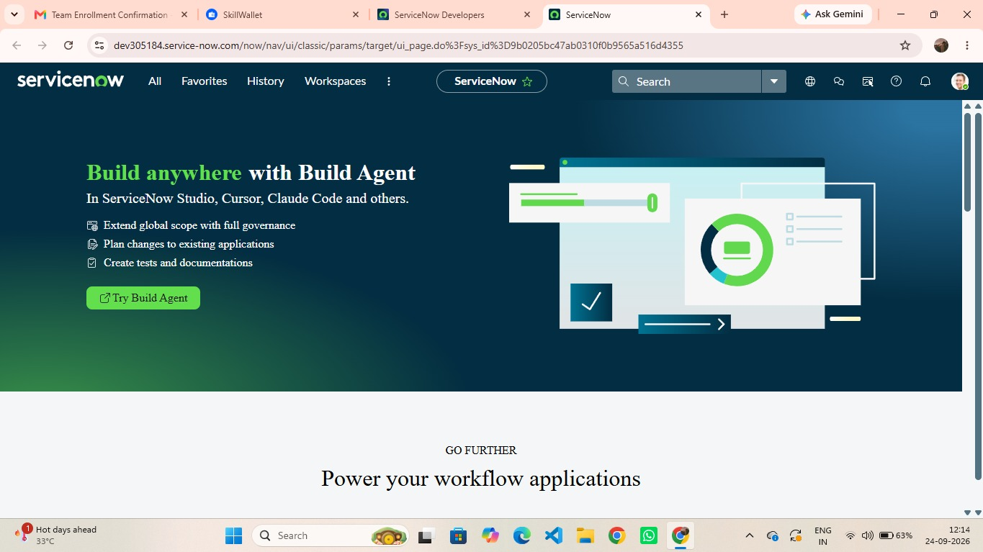
Fig 7.4.1 ServiceNow Platform used for the project
Step 2: Open Flow Designer
Navigate to:
All → Flow Designer
The Flow Designer is opened to display the automation created for the standard laptop request.
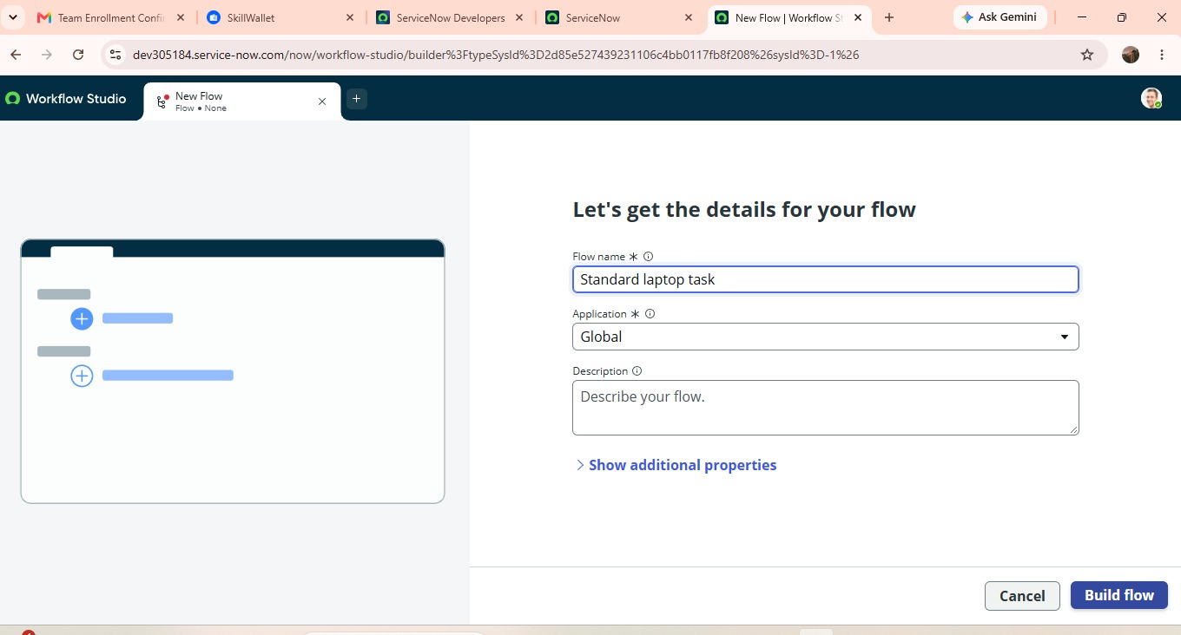
Fig 7.4.2 Flow Designer used to configure the standard Laptop automation.
Step 3: Display the Standard Laptop Task Flow
The Service Catalog trigger is displayed as part of the workflow. The trigger allows the flow to participate in the service catalog request process.
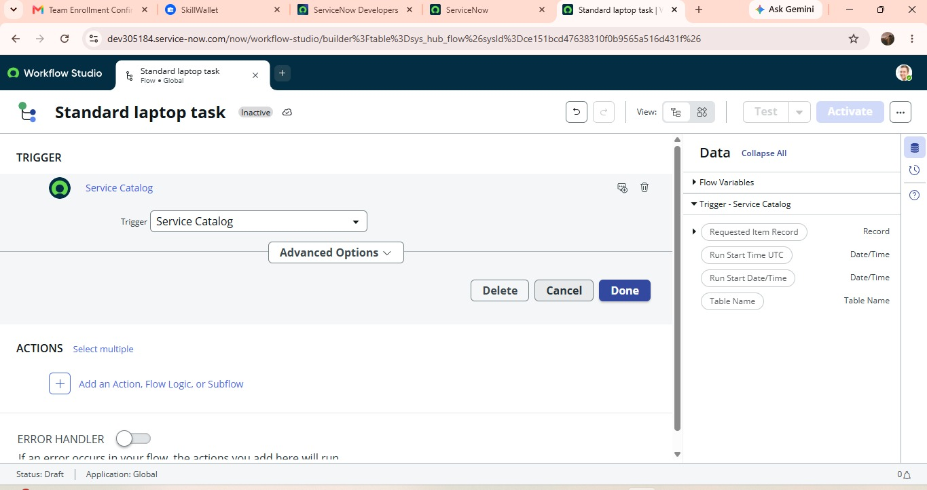
Fig 7.4.3 Service Catalog Trigger Configured for the flow
Step 4: Display the standard Laptop Task Flow
Open the flow named:
Standard Laptop Task
The flow is configured with:
- Application: Global
- Run as: System User
- Trigger: Service Catalog
- Action: Create catalog Task

Fig 7.4.4 Standard Laptop Task Flow Configuration
Step 5: Display the Create Catalog Task Action
The Create Catalog Task action is displayed. The Requested Item Record is used as the Request Item for the Catalog Task.
The task is configured with the following values:
Field | Configured Value
Action | Create Catalog Task
Requested Item | Requested Item Record
Short Description | Laptop need to configured
Description | Laptop need to configured
Assignment Group | Hardware
Approval | Approved

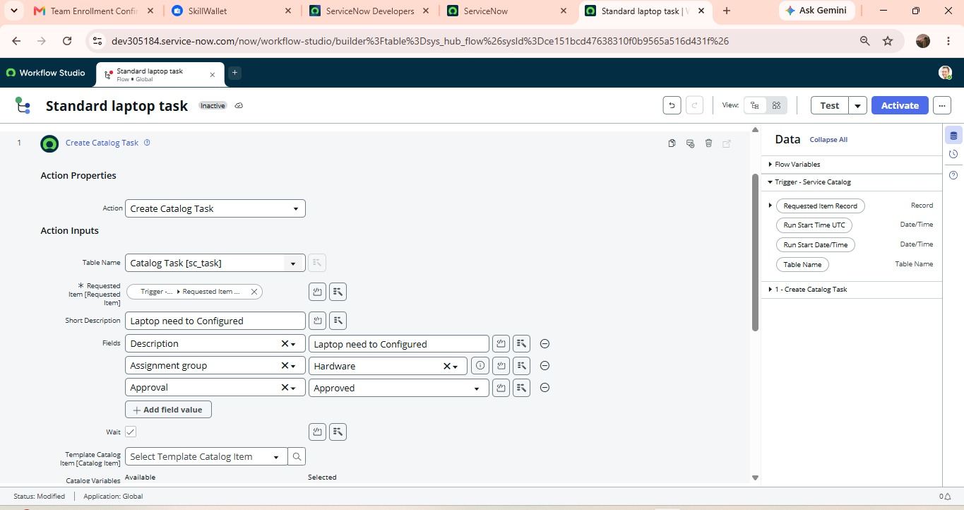
Fig 7.4.5 Create Catalog Task action and configured task fields.
7.5 Demonstration of the Service Catalog
Step 6: Open Service Catalog
Navigate to:
All → Service Catalog → Hardware
The Hardware category contains the available hardware related catalog items.
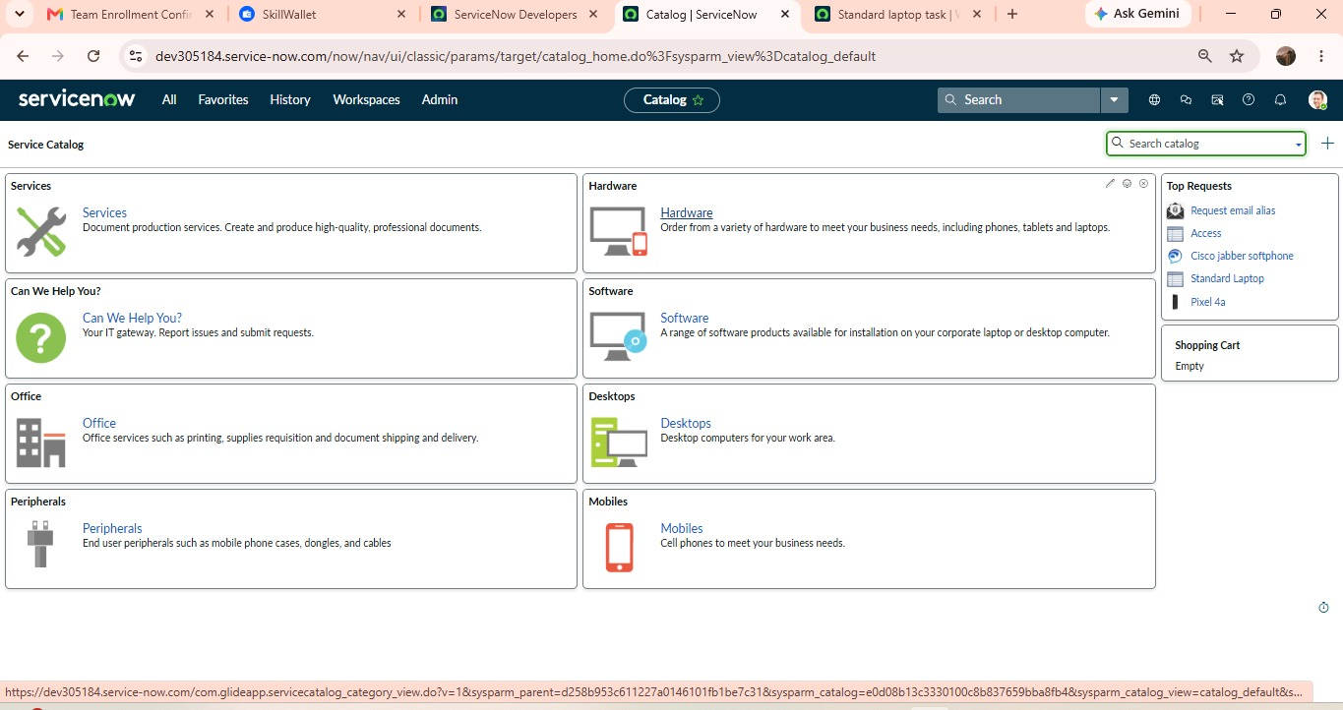
Fig 7.5.1 Hardware category in the Service Catalog

Step 7: Select Standard Laptop
Select the:
Standard Laptop
This is the catalog item used to place the laptop request.
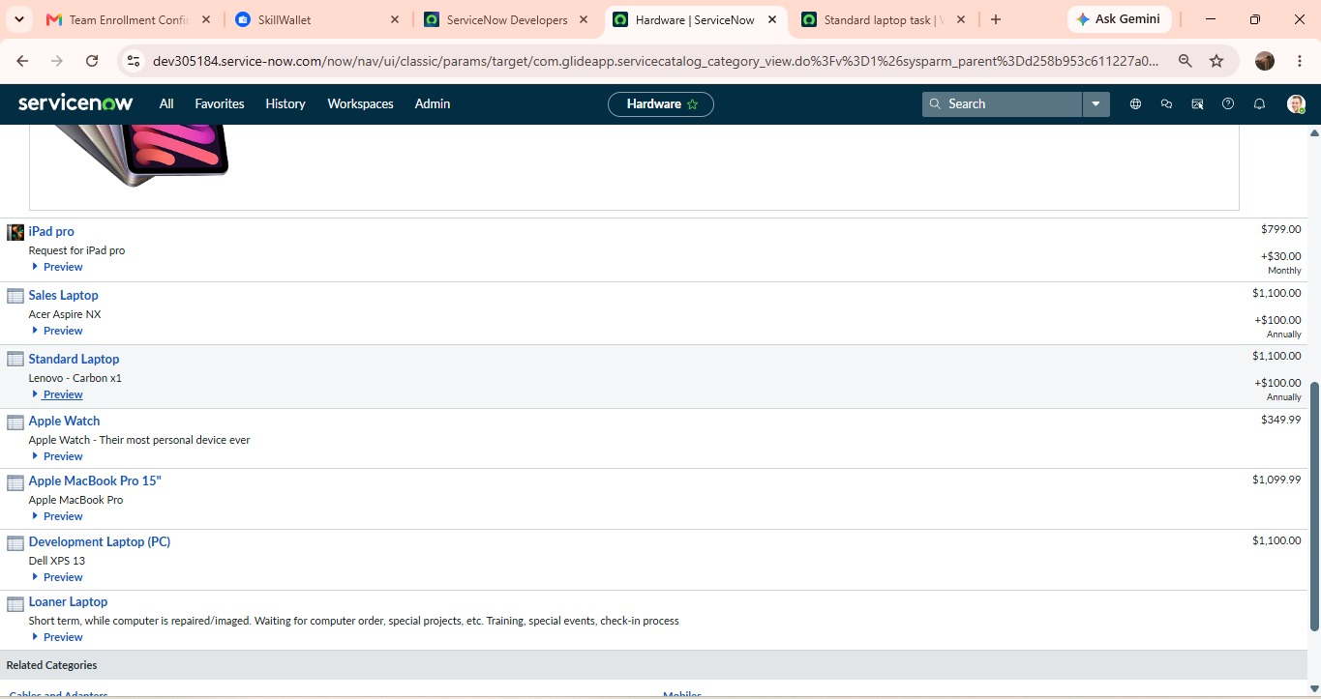
Fig 7.5.2 Standard Laptop Catalog Item
Stem 8: Place the order
Click:
Order Now
A request is generated for the student laptop. The generated request number is recorded for tracking and further processing.
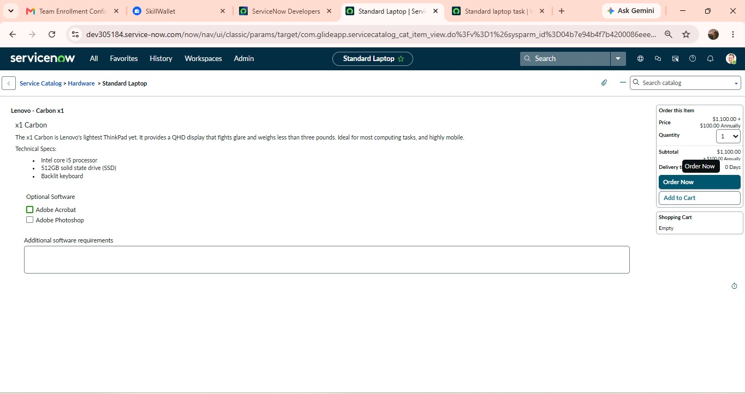
Fig 7.5.3 Standard Laptop request submitted through the Service Catalog
7.6 Demonstration of Approval
Step 9: Open the Request
Open the generated request using the request number. The request record contains information related to the standard laptop request
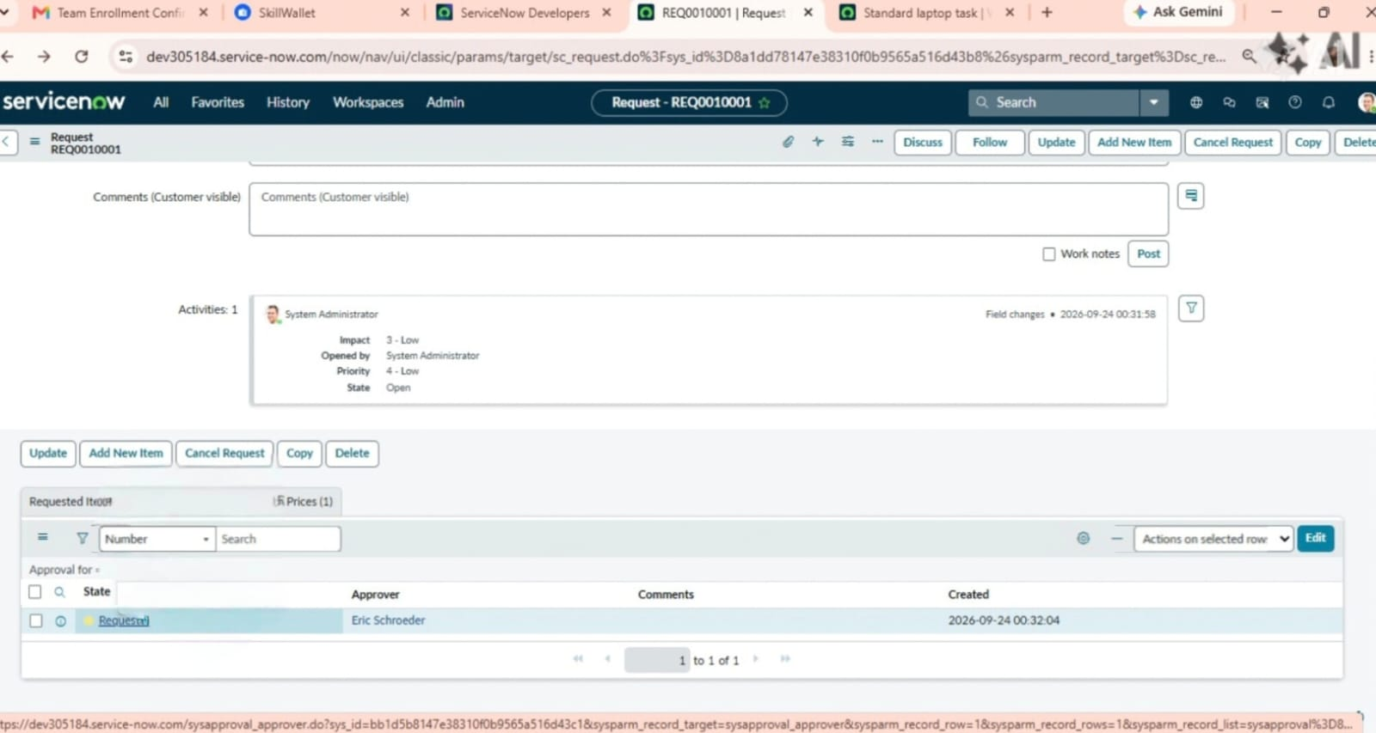
Fig 7.6.1 Generated Standard Laptop Request Record

Step 10: Check the Approval
Navigate to the Approvers section of the request. The approval status is checked before. proceeding with the Catalog Task verification. For the project demonstration, the request is approved according to the configured test process.
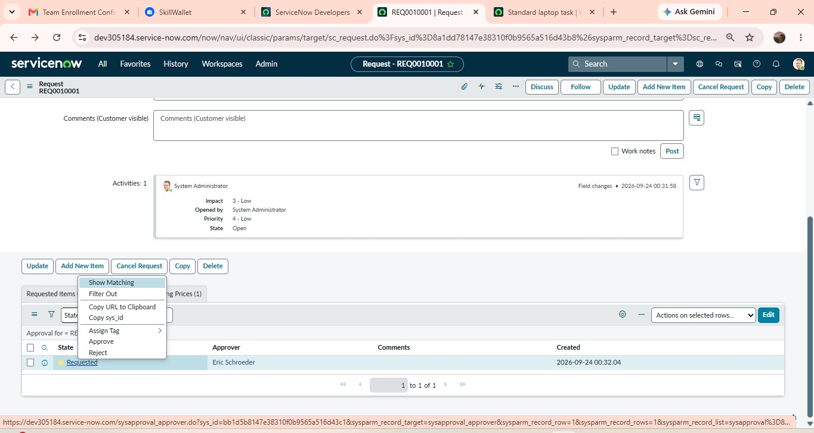
Fig 7.6.2 Approval Information for the Standard Laptop request
7.7 Demonstration of Automatic Task Creation
Step 11: Open the Requested Item
After the request is approved, open the corresponding Requested Item. The requested item contains the catalog Tasks associated with the request.
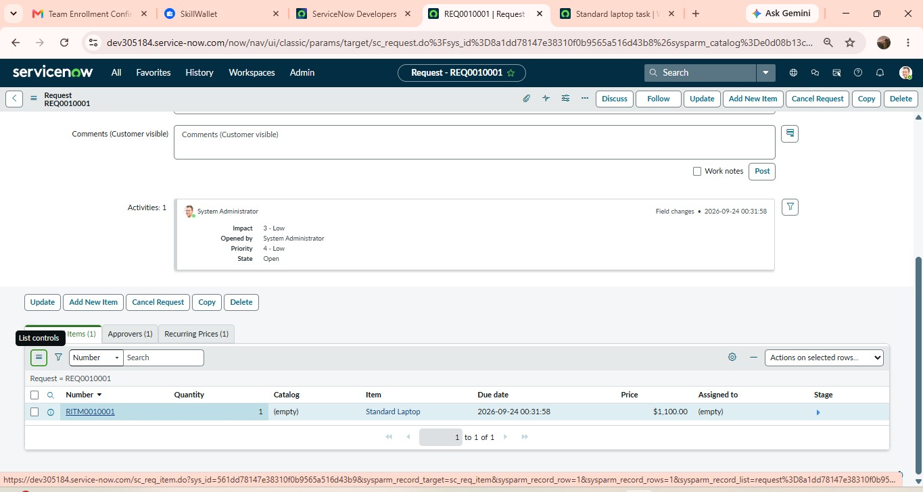
Fig 7.7.1 Requested Item generated for the standard Laptop request
Step 12: Open Catalog Tasks
Scroll to the Catalog Tasks section. The task generated by the flow designer automation is displayed. Open the task to verify its details
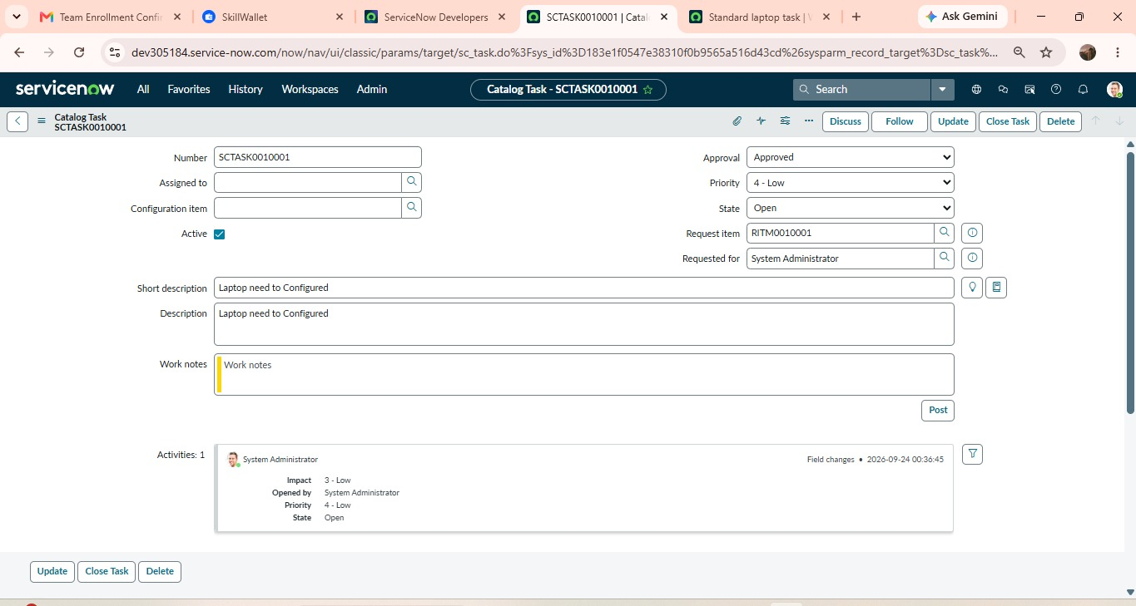
Fig 7.7.2 Automatically generated Catalog Task
Step 13: Verify Task Details
The generated Catalog Task is checked to verify whether the configured values have been applied correctly.
Expected Task Details:
- Short Description: Laptop need to configured
- Description: Laptop need to configured
- Assignment Group: Hardware
- Approval: Approved
7.8 Expected Outcome
The expected outcome of the demonstration is that an approved Standard Laptop request automatically results in the creation of a Catalog Task. The generated task should contain the required laptop configuration description and should be assigned to the Hardware group. This demonstrates that the Flow Designer automation successfully connects the Service Catalog request with the subsequent hardware configuration activity.

