6. Project Documentation
6.1 Project Overview:
The Standard Laptop Procurement Automation project was developed using ServiceNow Flow Designer to automate the creation and assignment of configuration tasks for standard laptop requests.
The project addresses delays and manual intervention in the existing procurement process by automatically creating a catalog task after the required approval.
6.2 Technologies Used:
Technology | Purpose
ServiceNow | IT Service Management platform.
Flow Designer | Workflow automation.
Service Catalog | Laptop request submission.
Catalog Task | Configuration task management.
Process Engine | Associating automation with the catalog item.

6.3 Key Features:
- Automated Catalog Task Creation.
- Automatic Hardware team assignment.
- Standardized task description.
- Approval-based workflow.
- Reduced manual intervention.
- Improved task visibility.
- Faster laptop configuration process.
6.4 Benefits:
The implemented solution provides the following benefits:
Reduced Manual Work:
The IT procurement team does not need to manually create a configuration task for every approved laptop request.
Fast Processing:
The hardware team receives the configuration task automatically.
Improved Resource Allocation:
Tasks are automatically assigned to the appropriate assignment group.

Reduced Errors:
Automation reduces the possibility of forgetting to create or assign a task.
Better User Experience:
Users can receive configured laptops more efficiently because the configuration process starts automatically after approval.
6.5 Testing Result:
The workflow was tested by placing a standard laptop request through the service catalog. The request was approved, and the flow designer workflow automatically created a catalog task.
The resulting task contained:
- Correct short description.
- Correct Description.
- Hardware assignment group.
- Approved status
Therefore, the expected workflow was successfully implemented.
6.6 Outcomes:
Fig 6.6.1: Standard Laptop Procurement Automation Flow:
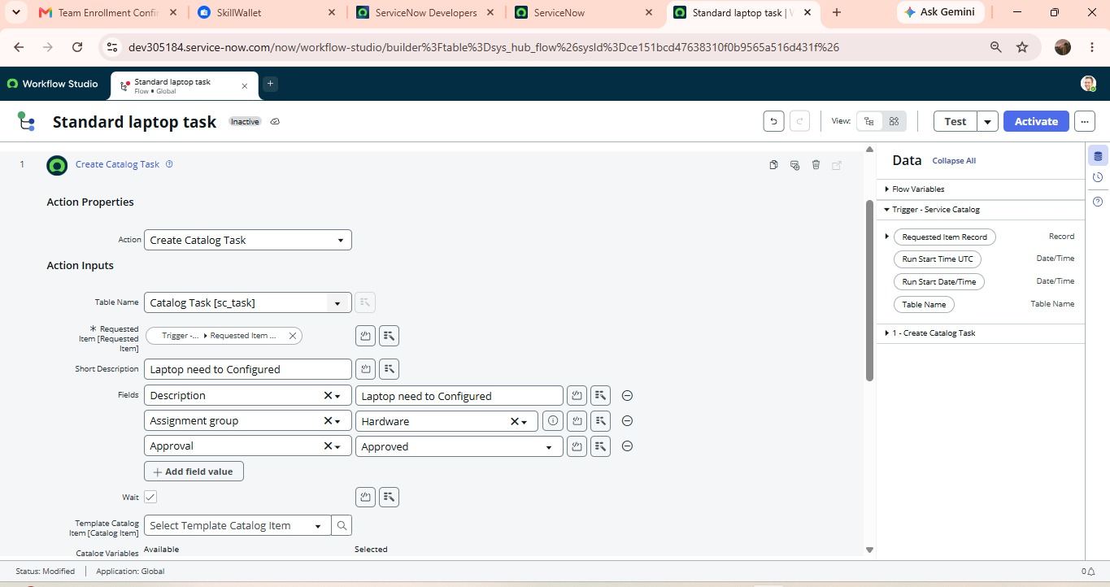

Fig 6.6.2: Standard Laptop Flow Configuration with Process Engine:
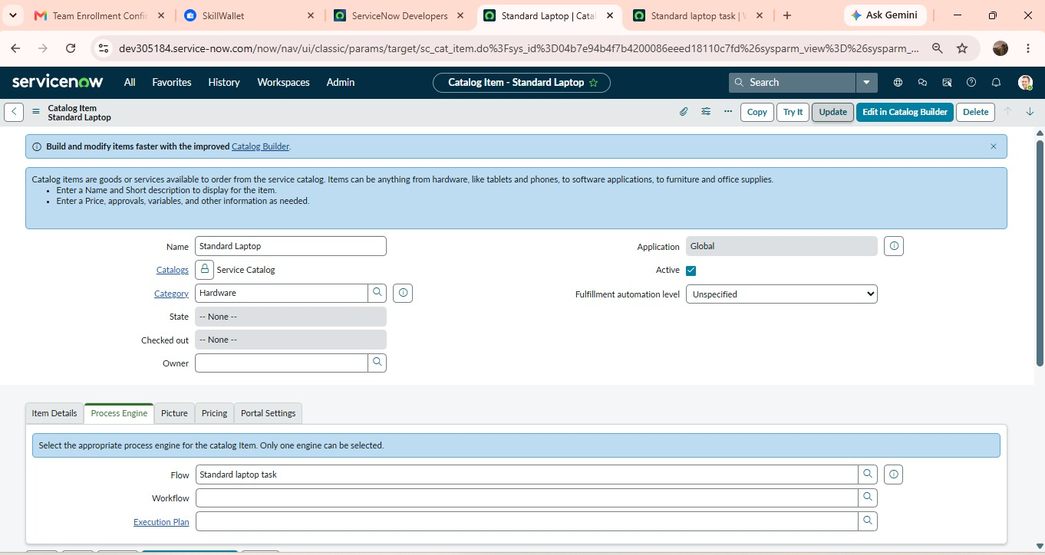

Fig 6.6.3 Final Catalog Task with Hardware Assignment:
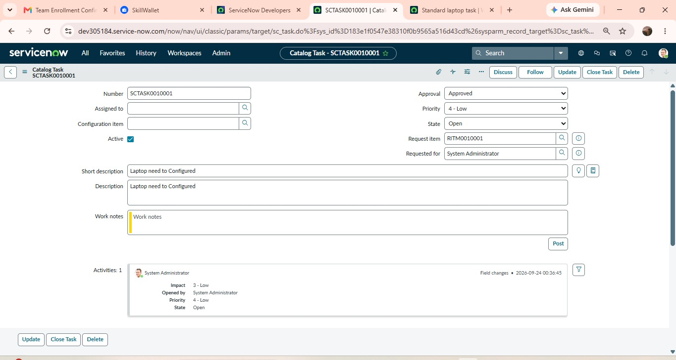

Conclusion:
The Standard Laptop Procurement Automation project successfully implements an automated workflow using ServiceNow Flow Designer. The system automates the creation of a catalog task after the standard laptop request is approved and assigns the task to the Hardware team for configuration. This reduces manual intervention, minimizes delays and errors and improves the efficiency of the laptop procurement process. The implemented workflow provides a structured process from request submission to laptop configuration, resulting in better task management and a smoother experience for both users and IT procurement team.

