PROJECT TESTING DOCUMENT
Automated Standard Laptop Procurement and Configuration
Using ServiceNow Flow Designer

Project Title | Automated Standard Laptop Procurement and Configuration Using ServiceNow Flow Designer
Platform | ServiceNow
Automation Tool | Flow Designer
Main Flow | Standard laptop task
Assignment Group | Hardware

1. Testing Objective
The objective of testing is to verify that the automated Standard Laptop procurement workflow works correctly from request creation through approval and automatic Catalog Task generation. Testing confirms that the Flow Designer flow creates the required task and assigns it to the Hardware team.

2. Testing Scope
- Verify that the Standard Laptop item is available in the Service Catalog.
- Verify that a user can place a Standard Laptop order.
- Verify that the Requested Item is created successfully.
- Verify that the request can be approved.
- Verify that approval triggers the configured Flow Designer workflow.
- Verify that a Catalog Task is created automatically.
- Verify the task short description and description.
- Verify that the task is assigned to the Hardware group.
- Verify that the task appears under the Requested Item Catalog Tasks section.

3. Test Environment
Component | Configuration
Application | ServiceNow
Module | Flow Designer / Service Catalog
Flow Name | Standard laptop task
Trigger | Service Catalog
Action | Create Catalog Task
Run As | System User
Application Scope | Global
Assignment Group | Hardware

4. Test Cases
Test Case ID | Test Scenario | Test Steps | Expected Result | Actual Result | Status
TC01 | Verify Standard Laptop catalog item | Open Service Catalog → Hardware → Standard Laptop. | Standard Laptop item is displayed. | To be filled | Pass / Fail
TC02 | Place Standard Laptop order | Open Standard Laptop and click Order Now. | A request and Requested Item are created. | To be filled | Pass / Fail
TC03 | Verify Requested Item | Open the generated Request Number and Requested Item. | Requested Item record is available. | To be filled | Pass / Fail
TC04 | Approve the request | Open Approvers section and approve the request. | Request status changes to Approved. | To be filled | Pass / Fail
TC05 | Verify Flow execution | After approval, check the configured Standard laptop task flow. | Flow executes for the approved catalog request. | To be filled | Pass / Fail
TC06 | Verify Catalog Task creation | Open Requested Item → Catalog Tasks. | A new Catalog Task is automatically created. | To be filled | Pass / Fail
TC07 | Verify Short Description | Open the generated Catalog Task. | Short Description is “Laptop need to Configured”. | To be filled | Pass / Fail
TC08 | Verify Description | Open the generated Catalog Task and check Description. | Description is “Laptop need to Configured”. | To be filled | Pass / Fail
TC09 | Verify Assignment Group | Check Assignment Group in the Catalog Task. | Assignment Group is Hardware. | To be filled | Pass / Fail
TC10 | Verify Approval field | Check Approval in the Catalog Task. | Approval field is Approved. | To be filled | Pass / Fail

5. Detailed Testing Procedure

Test 1: Service Catalog Verification
Procedure: Navigate to Service Catalog → Hardware and open Standard Laptop. Verify that the item is available and the Order Now option is displayed.
Expected result: Standard Laptop is available for ordering.

Test 2: Request Creation
Procedure: Click Order Now and open the generated request.
Expected result: A request and Requested Item are created successfully.

Test 3: Approval
Procedure: Open the Requested Item, navigate to the Approvers section, and approve the request.
Expected result: The request is approved.

Test 4: Automated Task Creation
Procedure: After approval, check the Requested Item Catalog Tasks section.
Expected result: Flow Designer automatically creates a Catalog Task.

Test 5: Task Configuration
Procedure: Open the generated Catalog Task and verify its fields.
Expected result: Short Description and Description are “Laptop need to Configured”, Assignment Group is Hardware, and Approval is Approved.

6. Screenshot Evidence
Insert screenshots from your actual ServiceNow instance as evidence for the tests below.

Screenshot 1: Standard Laptop Service Catalog item.
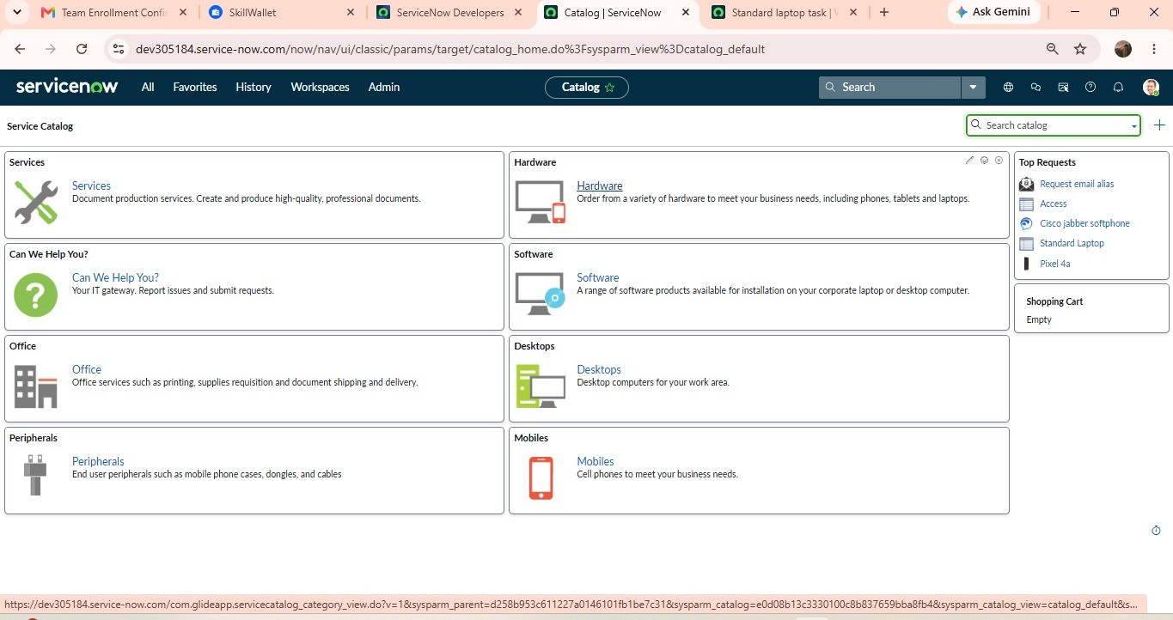
Screenshot 2: Order Now / request creation screen.
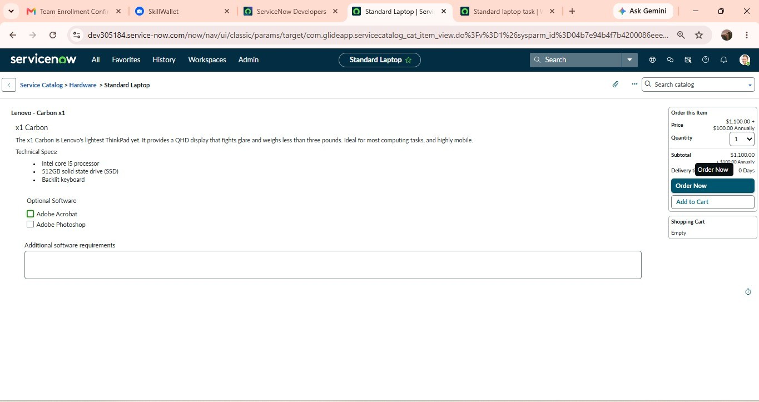

Screenshot 3: Requested Item record.
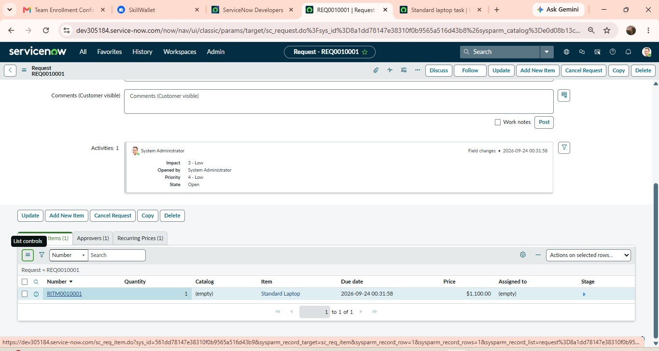
Screenshot 4: Approvers section showing approval.
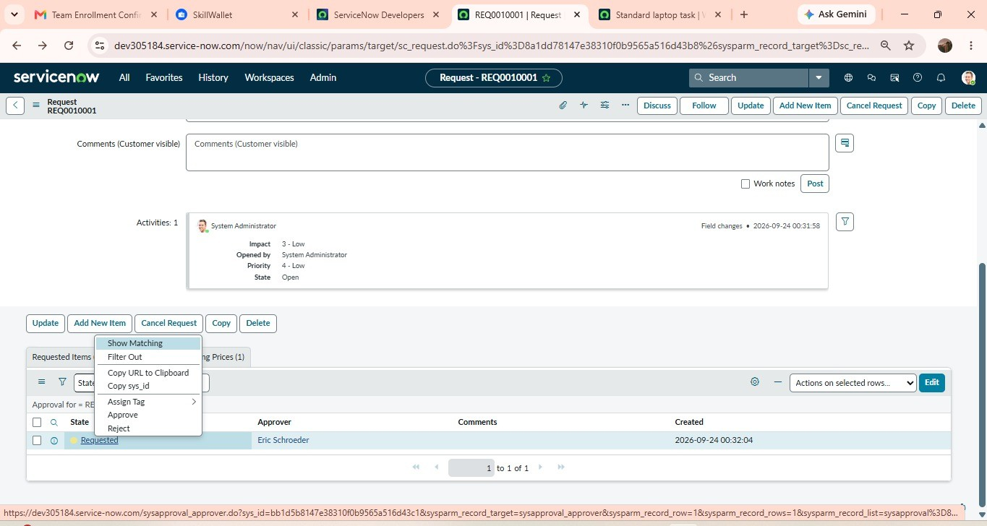

Screenshot 5: Catalog Task showing Short Description and Description.
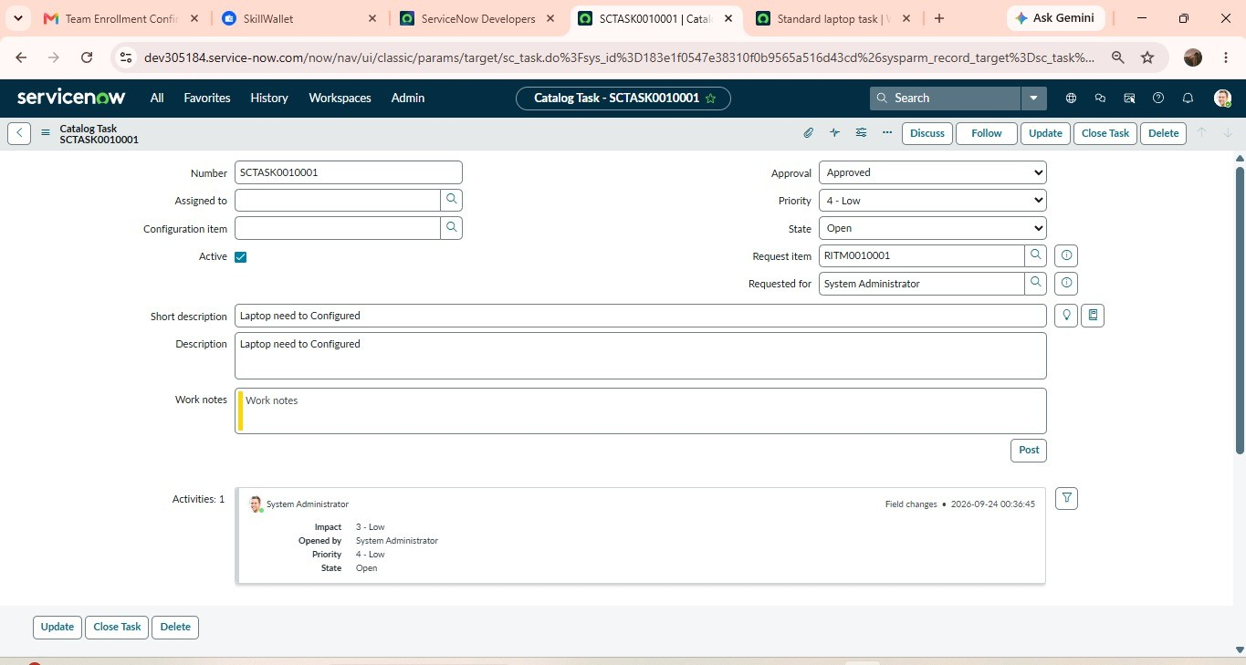
Screenshot 6: Catalog Task showing Assignment Group = Hardware and Approval = Approved.

7. Test Result Summary
The testing verifies the complete automated workflow: a Standard Laptop request is placed, the request is approved, and the configured Flow Designer workflow automatically creates a Catalog Task for the Hardware team.
Category | Expected Outcome | Result
Request | Standard Laptop request is created | To be filled
Approval | Request is approved | To be filled
Automation | Flow runs after approval | To be filled
Catalog Task | Task is created automatically | To be filled
Assignment | Task is assigned to Hardware | To be filled
Task Details | Description and approval fields are correct | To be filled

8. Conclusion
Testing of the ServiceNow Standard Laptop automation workflow is designed to confirm that the procurement process operates correctly with minimal manual intervention. Successful testing demonstrates that an approved Standard Laptop request can trigger automatic Catalog Task creation and assignment to the Hardware team. This supports faster laptop configuration, reduces manual task creation, and improves the efficiency of the IT procurement process.

