A3 testing

Contents
TEST PROJECTS 1
LOCATIONS 2
QR CODES 4
PERFERENCE 4
DEVICES TESTED 4

TEST PROJECTS
(for QR Code, Not Scored and Number of Locations Entered respectively)
{
"id": 19611,
"title": "participant_scoring: Number of Scanned QR Codes",
"description": "Test Number of Scanned QR Codes",
"is_published": true,
"participant_scoring": "Number of Scanned QR Codes",
"username": "s4759487",
"instructions": "Instructions for mapProject",
"initial_clue": "This is the initial clue",
"homescreen_display": "Display initial clue"
},
{
"id": 19610,
"title": "participant_scoring: Not Scored",
"description": "Test Not Scored",
"is_published": false,
"participant_scoring": "Not Scored",
"username": "s4759487",
"instructions": "Instructions for mapProject",
"initial_clue": "This is the initial clue",
"homescreen_display": "Display initial clue"
},
{
"id": 19609,
"title": "participant_scoring: Number of Locations Entered",
"description": "Test Number of Locations Entered",
"is_published": true,
"participant_scoring": "Number of Locations Entered",
"username": "s4759487",
"instructions": "Instructions for mapProject",
"initial_clue": "This is the initial clue",
"homescreen_display": "Display initial clue"
},

LOCATIONS
{
"id": 11109,
"project_id": 19610,
"location_name": "Hawken Engineering Building",
"location_trigger": "Location Entry", // this depends on projects
"location_position": "(-27.499639493479197,153.01342228042296)",
"location_order": 0,
"username": "s4759487",
"location_content": "<p>LOC CONTENT test webview</p>",
"extra": null,
"clue": "no clue",
"score_points": 20
},
{
"id": 11110,
"project_id": 19611,
"location_name": "Hawken Engineering Building",
"location_trigger": "Location Entry", // this depends on projects
"location_position": "(-27.499639493479197,153.01342228042296)",
"location_order": 0,
"username": "s4759487",
"location_content": "<p>LOC CONTENT test webview</p>",
"extra": null,
"clue": "no clue",
"score_points": 20
},
{
"id": 11113,
"project_id": 19610,
"location_name": "UQ Sport Fitness Centre",
"location_trigger": "Location Entry", // this depends on projects
"location_position": "(-27.49575201000884,153.01581444393574)",
"location_order": 0,
"username": "s4759487",
"location_content": "<p>LOC CONTENT test webview</p>",
"extra": null,
"clue": "no clue",
"score_points": 20
},

QR CODES
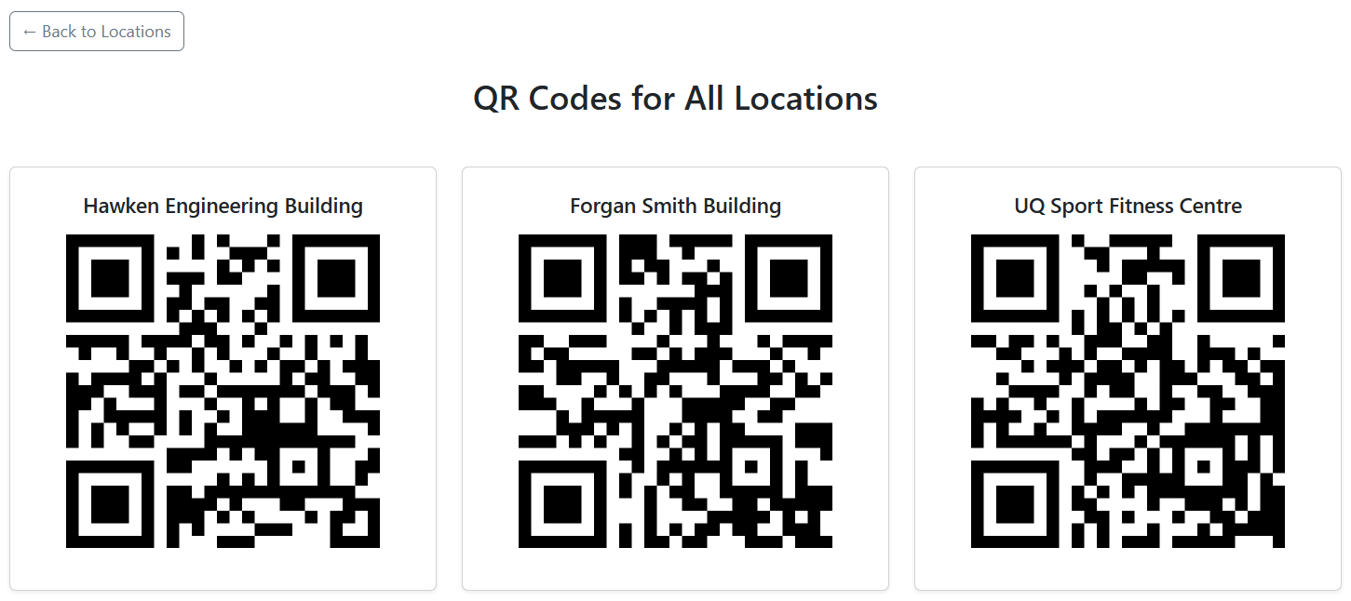

PERFERENCE
I personally prefer QR Code scanning for testing (I used android physical devices – listed in README file)

DEVICES TESTED
This app is tested on 2 Android physical devices, Samsung Galaxy S22 Ultra and Samsung Galaxy S24 Ultra, via [Expo Go](https://expo.dev/go) app downloaded via Play Store.

