Nhóm 8

Bài làm:

# Lab 5: MySQL & PHP

## Configure MySQL Server Instance

## Use MySQL Command Line Client to investigate the mysql database

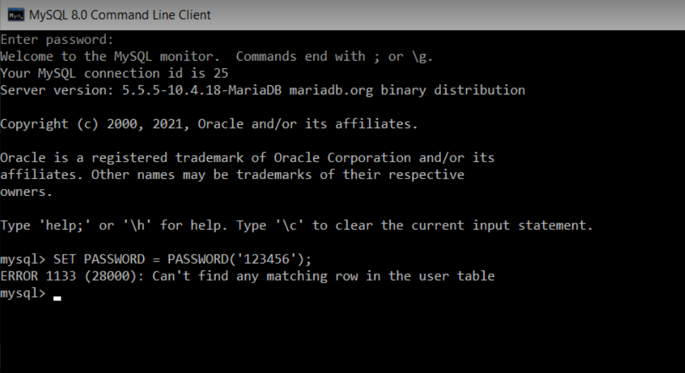

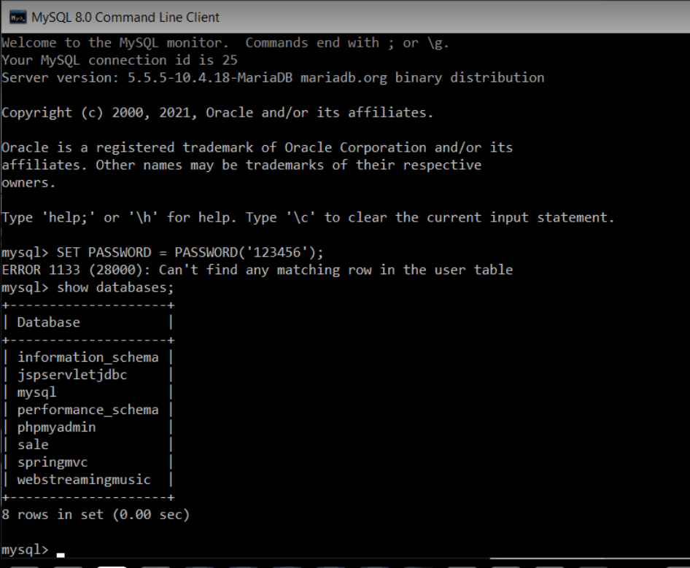

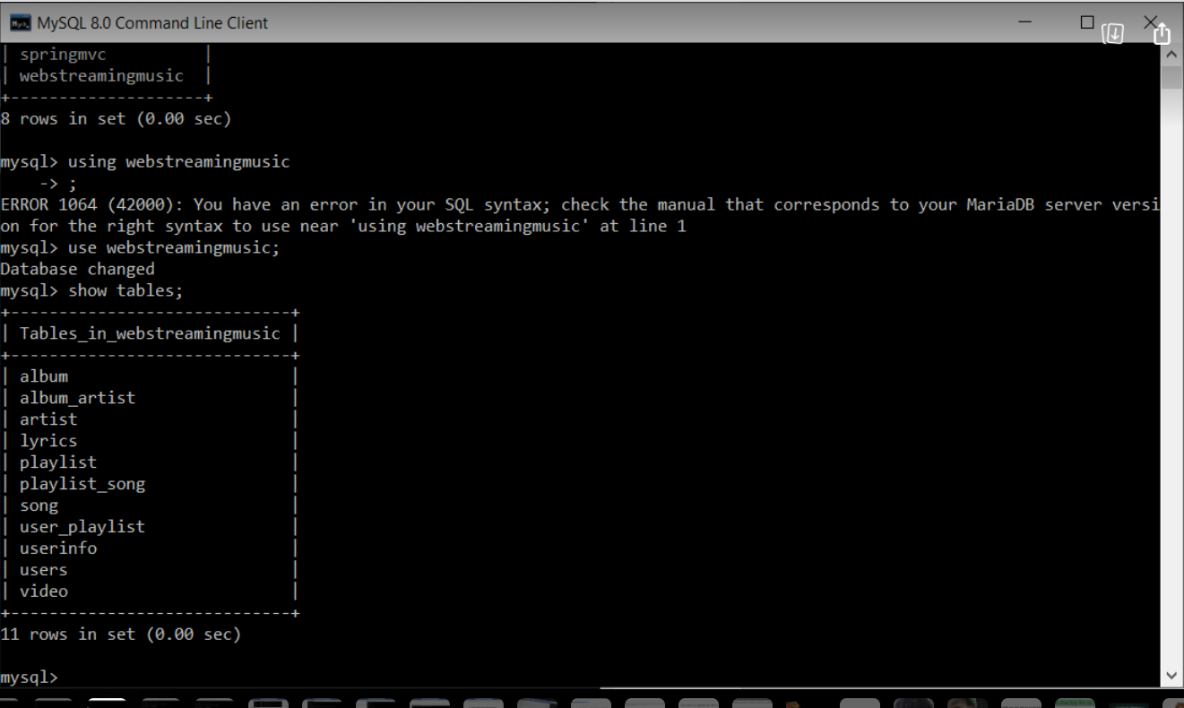

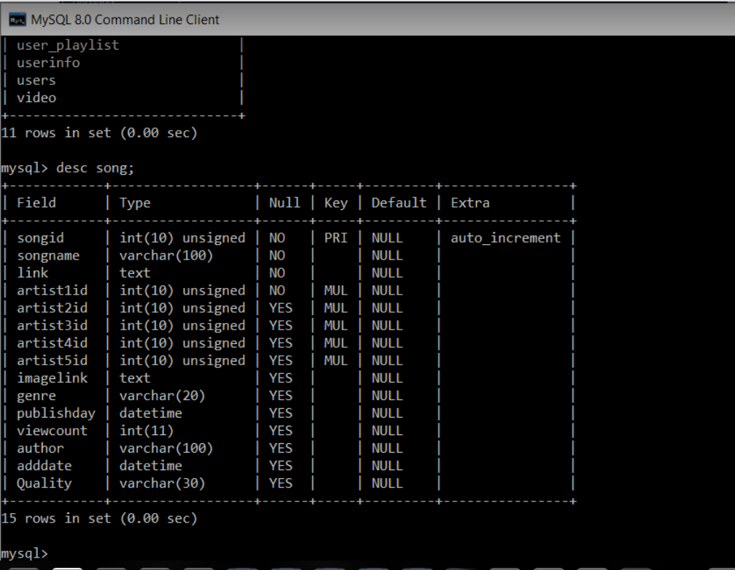

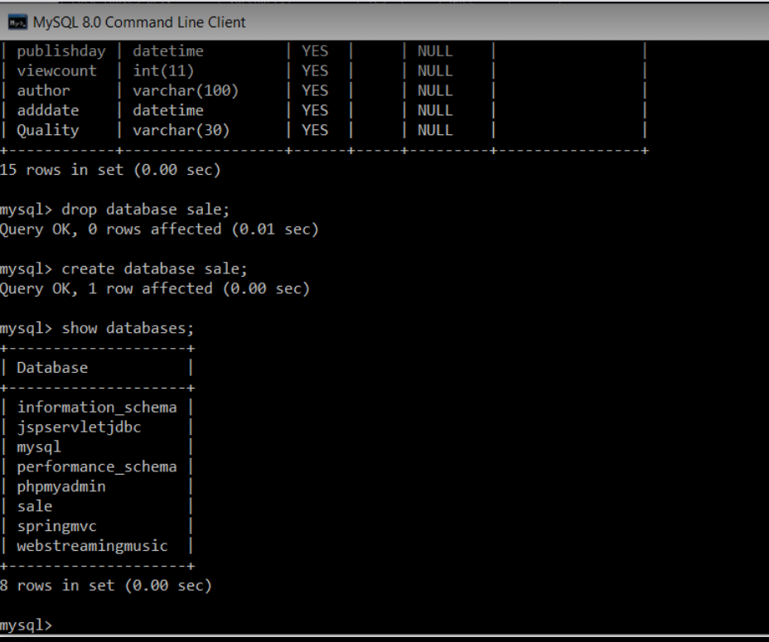

## Run the example in the lecture slides

### Create table Products using PHP scripts

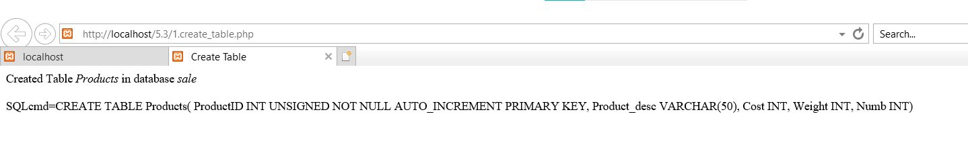

### Insert data to Products

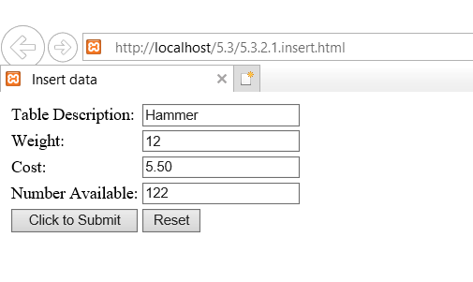

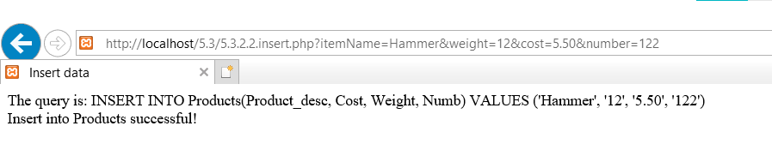

### Display list of products

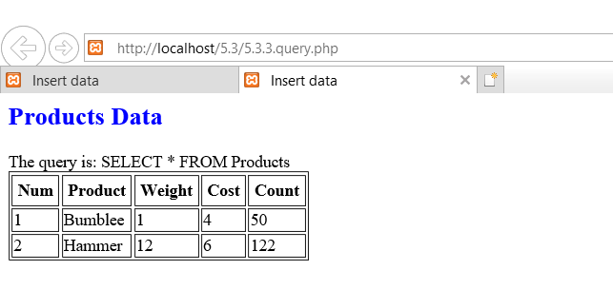

### Search products

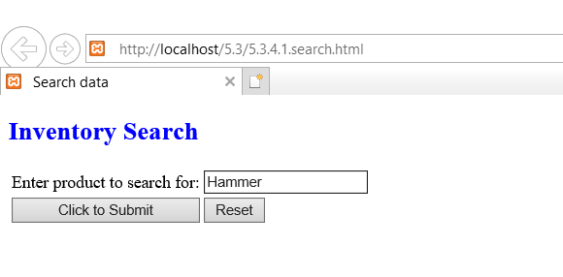

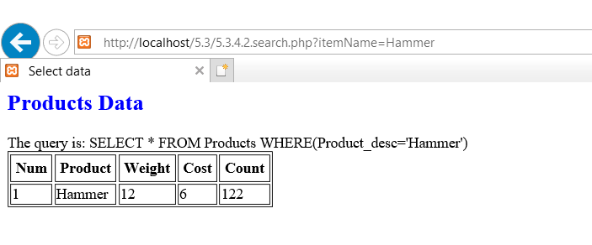

### Update product

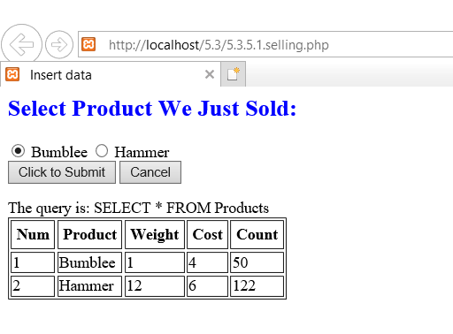

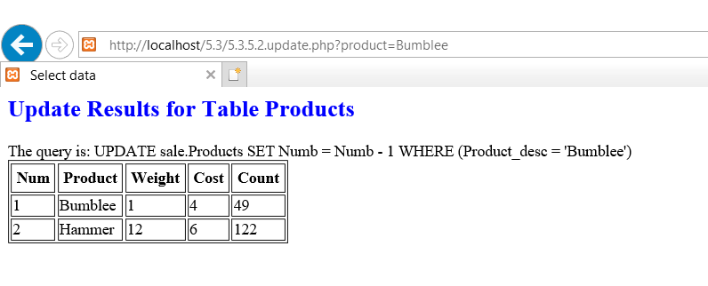

## Open and use phpMyAdmin to create a database and tables

### Open Zend Server Comminity Edition

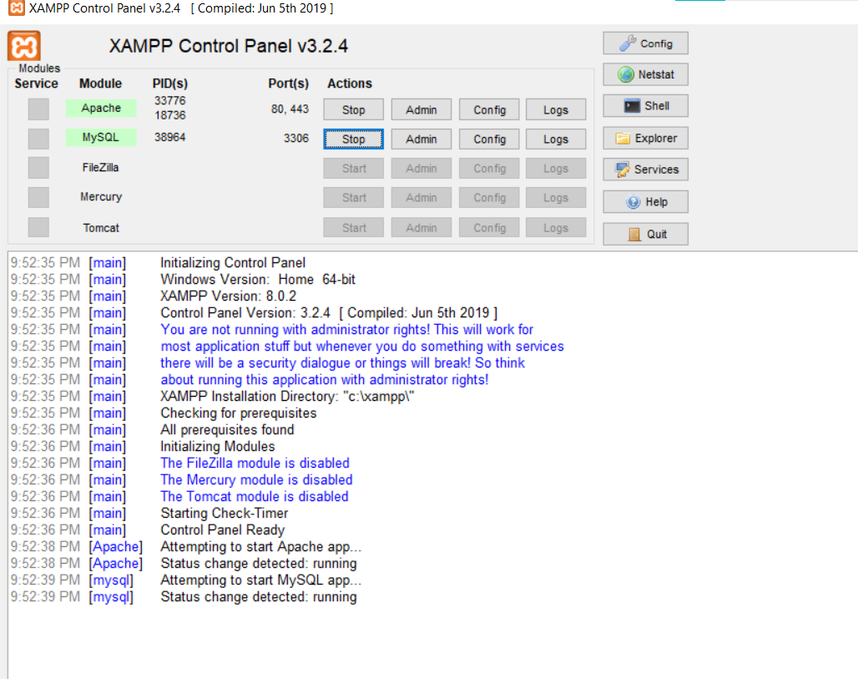

### Open phpMyAdmin

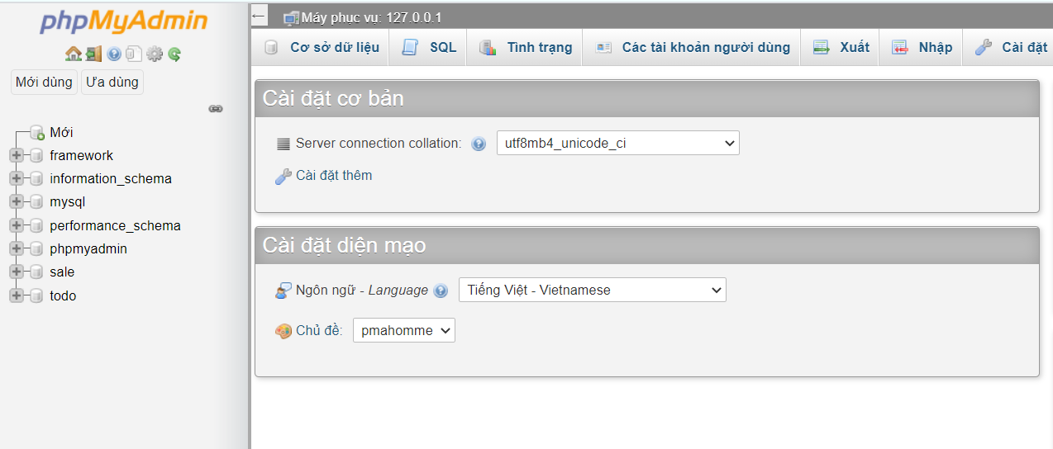

### Create tables and relationships for business listing service

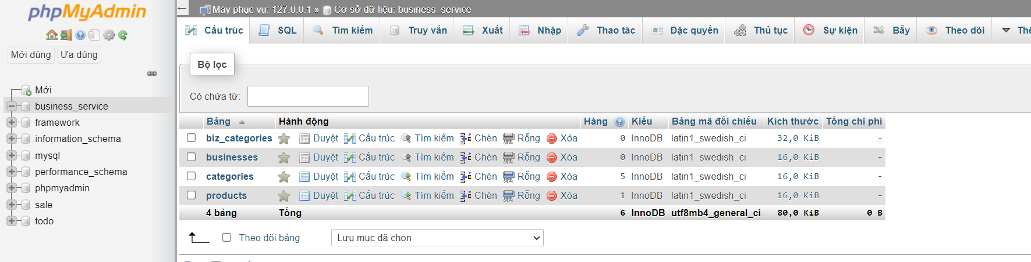

## Category Administration page

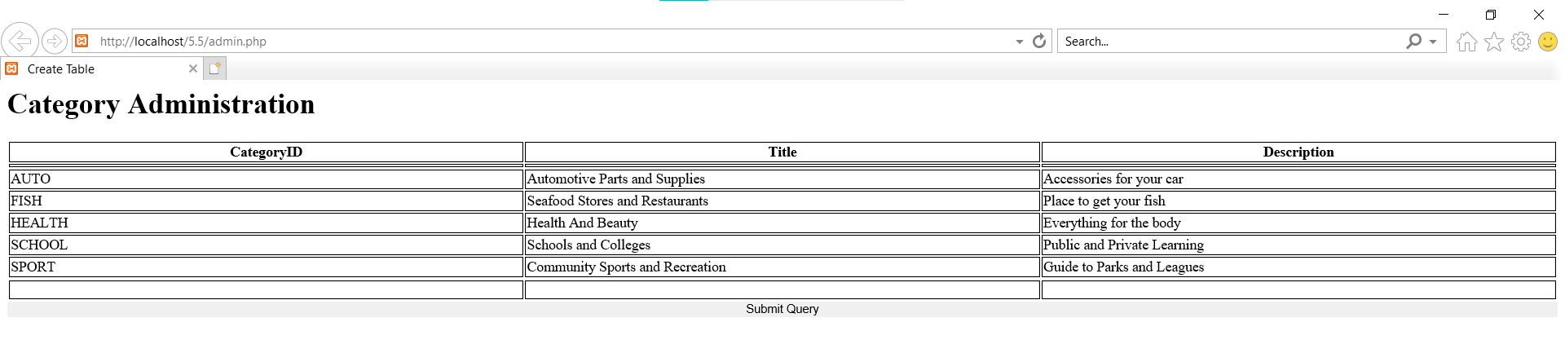

## Business Registration page

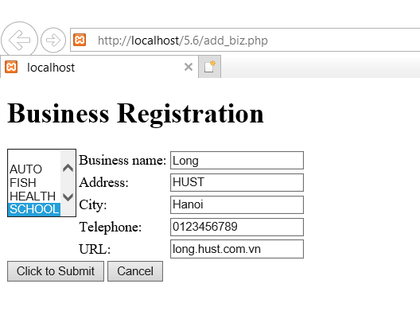

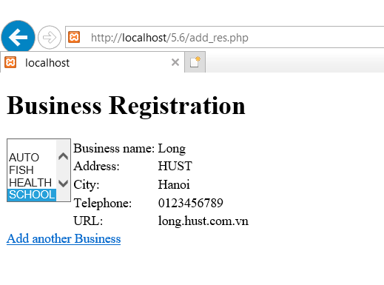

## Business Listing page

