Nhóm 8

Bài làm:

# Lab 6: Styling with CSS

## 6.1 Prepare

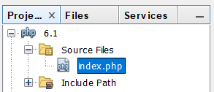

## Embedded style

### Create Fizzics1.html (no style sheet)

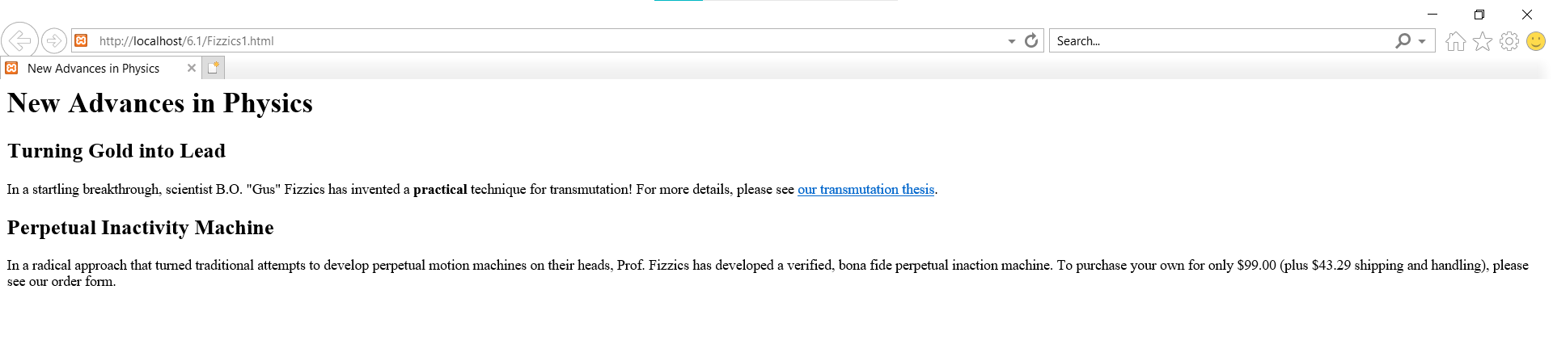

### Save as Fizzics2.html

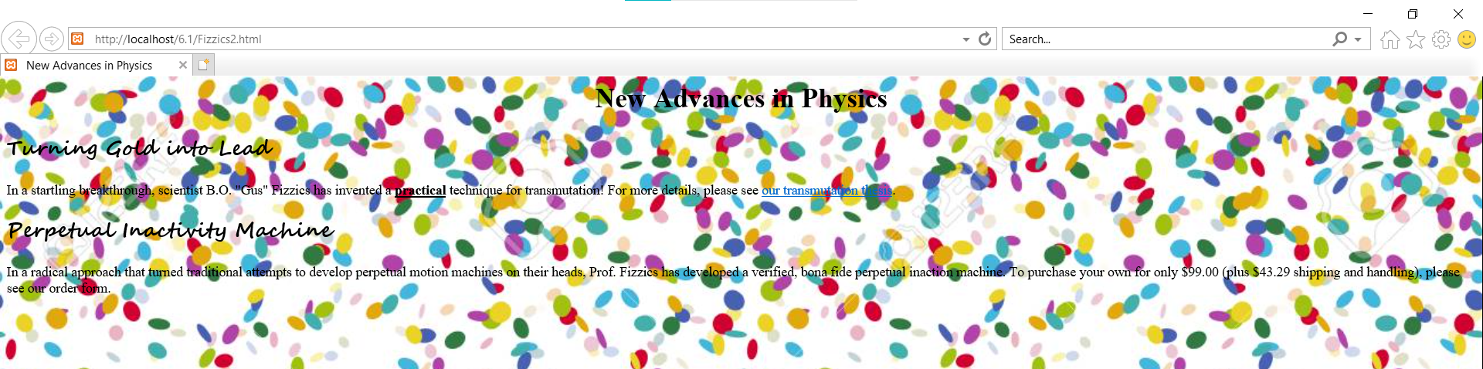

## External style

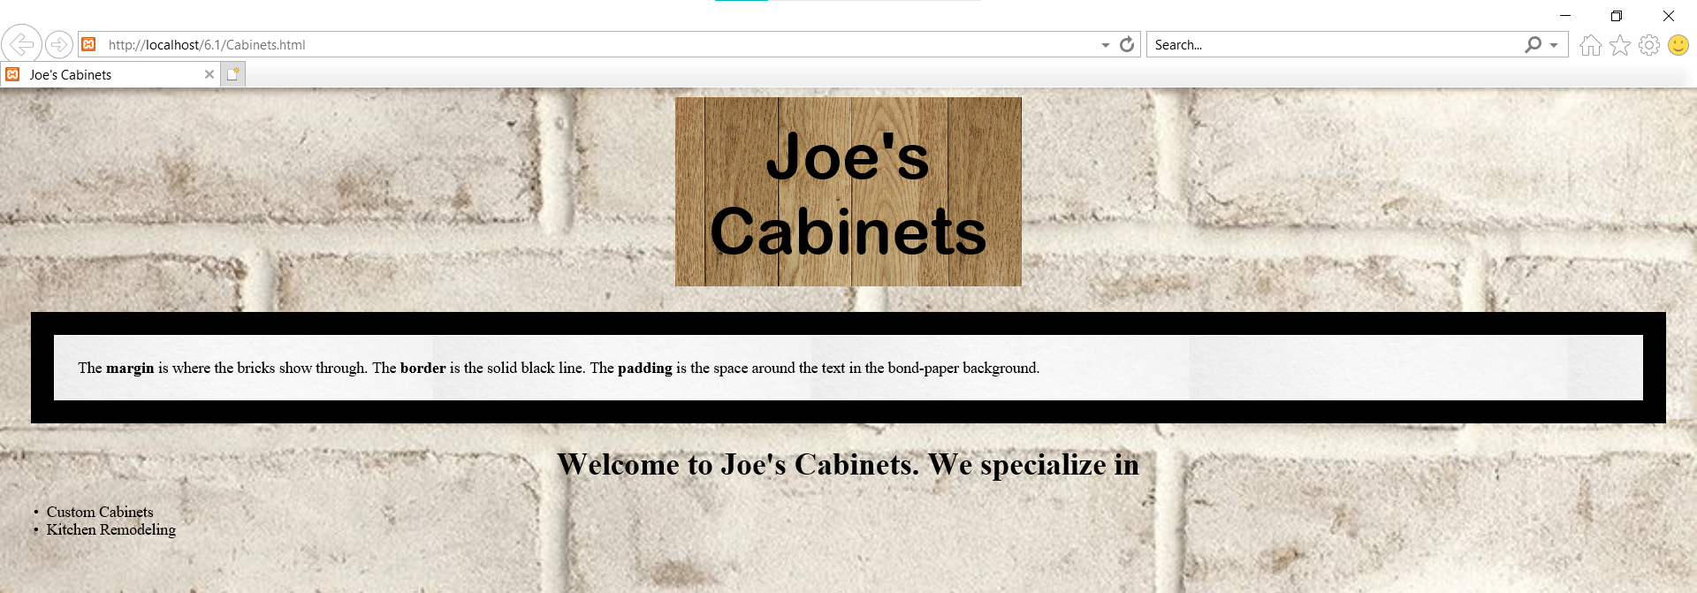

## Text properties

