Nhóm 8

Bài làm:

# Lab 6.2: Layout with CSS

## Prepare

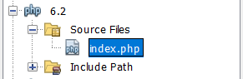

## 6.2 Layout with style

The end results:

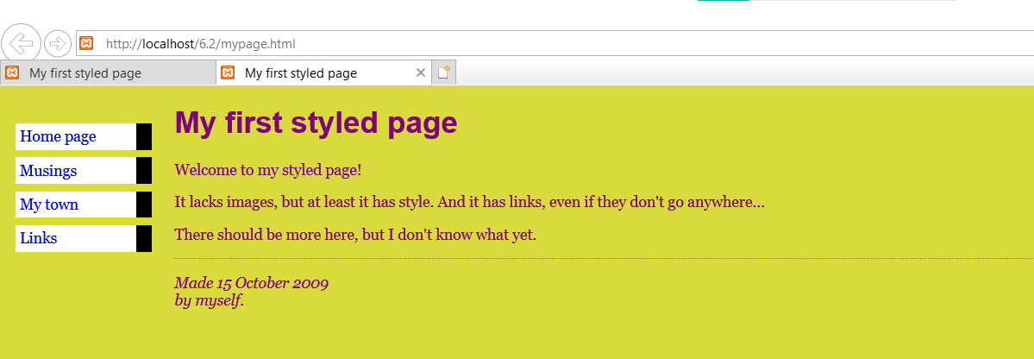

## Layout with DIV tag

### The table-based approach

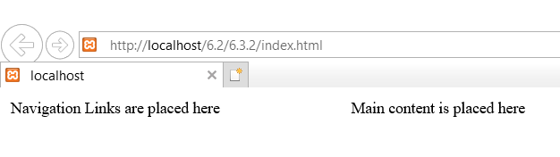

### Fixed layout design with fixed boxes

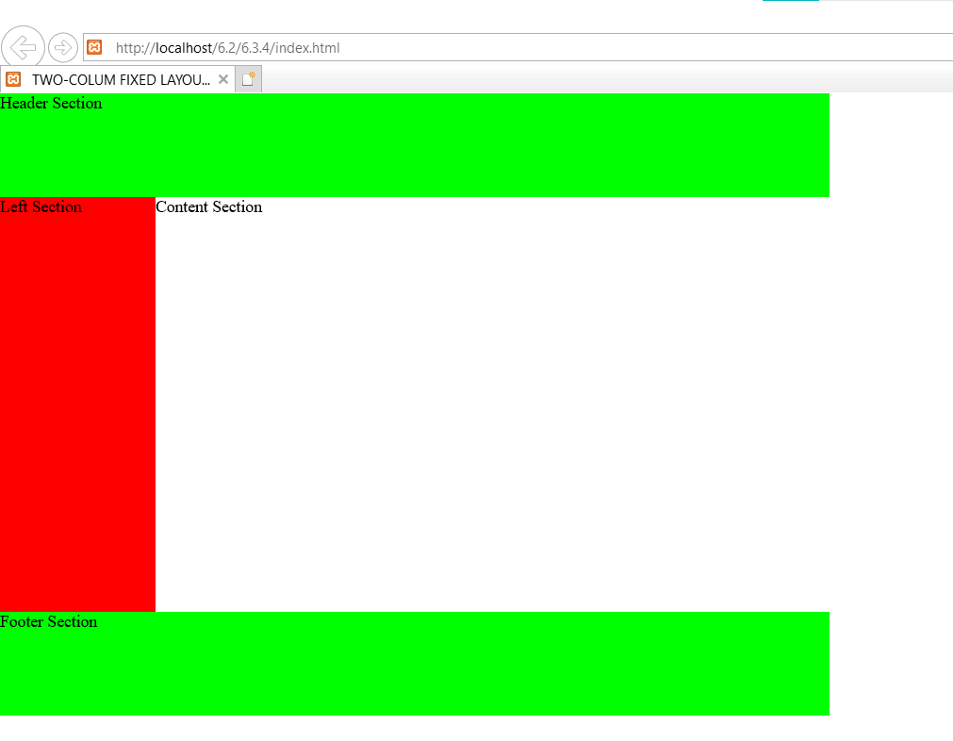

### Three-column fixed layout

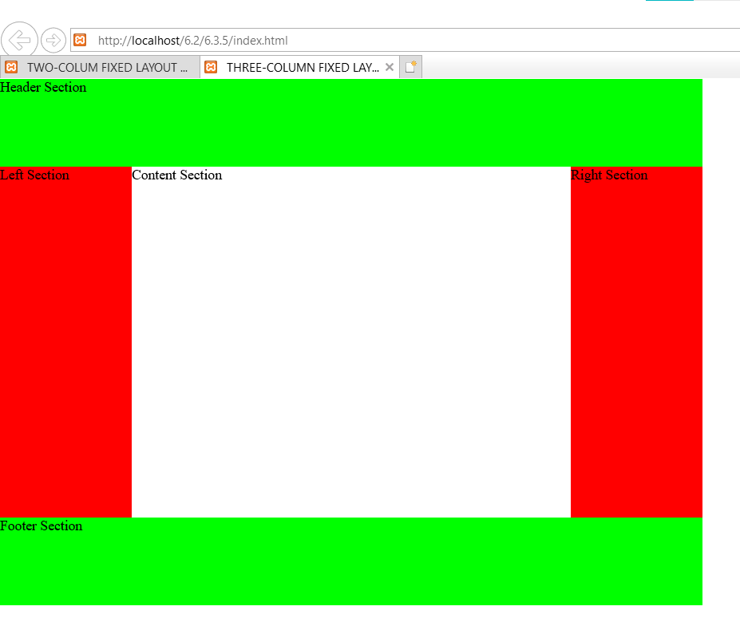

### Fixed layout design with floating boxes

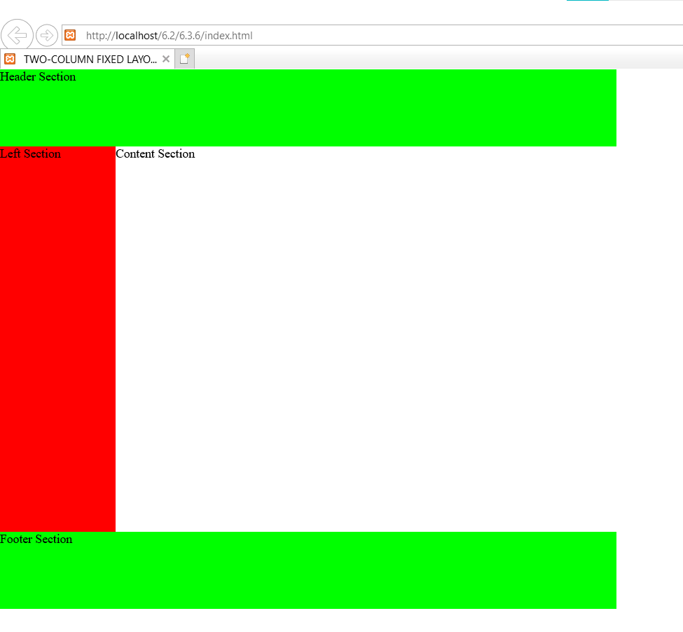

### Adding a right column

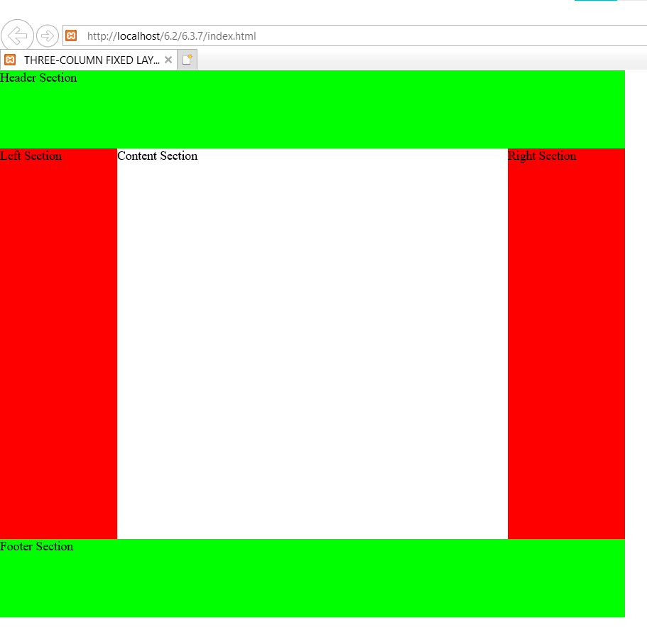

### Liquid design with floating boxes

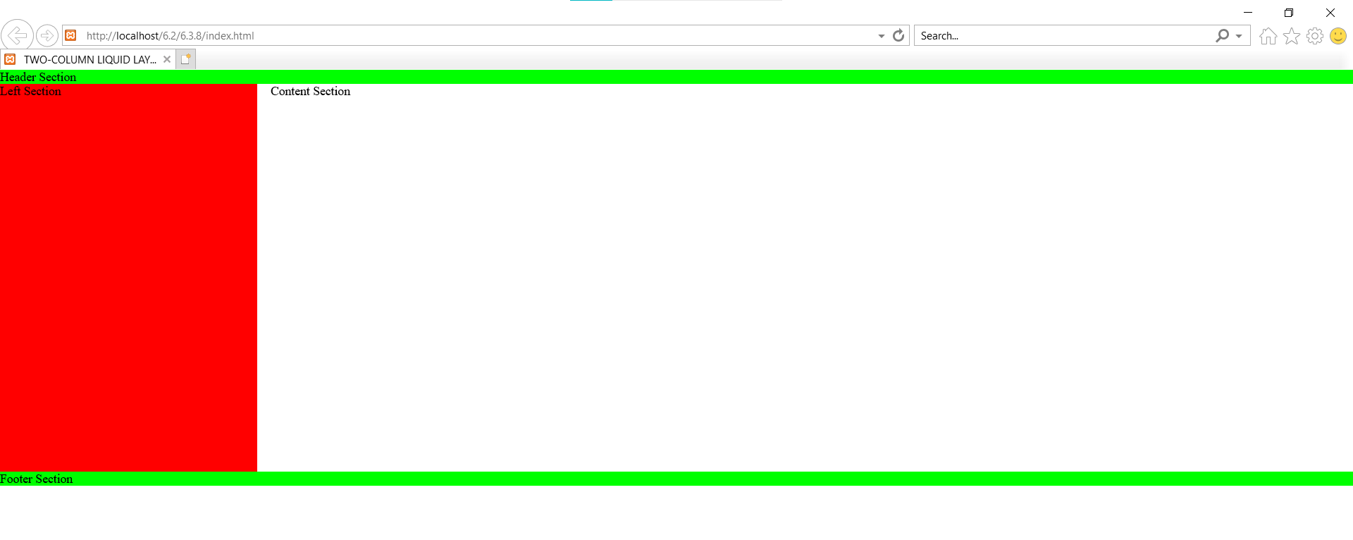

### Three-column liquid layout with floating boxes

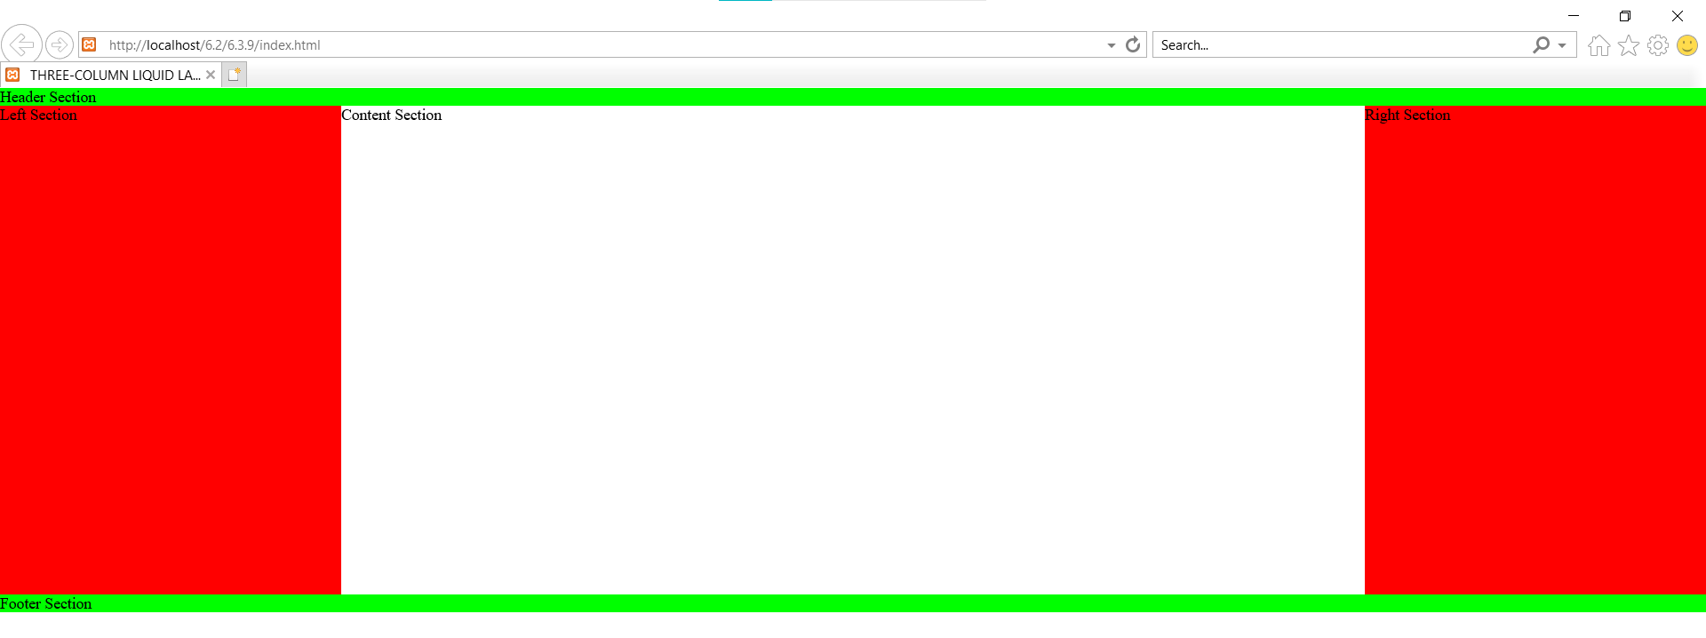

## Exercise 1: Modify 8.1 using DIV tag

Xem code trên github folder 6.4

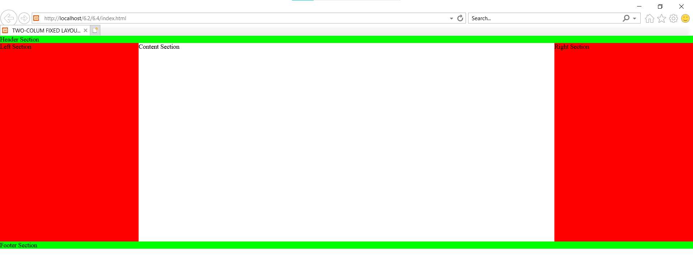

## Exercise 2: CSS Box Model

Layout and style:

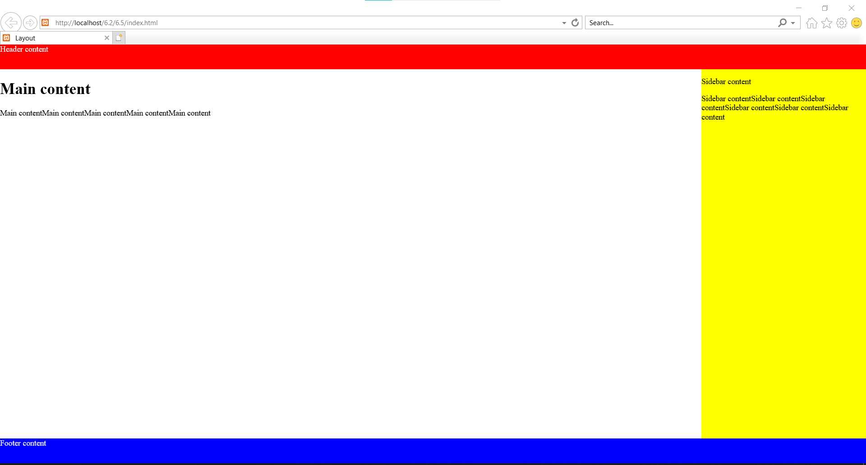

Web phim:

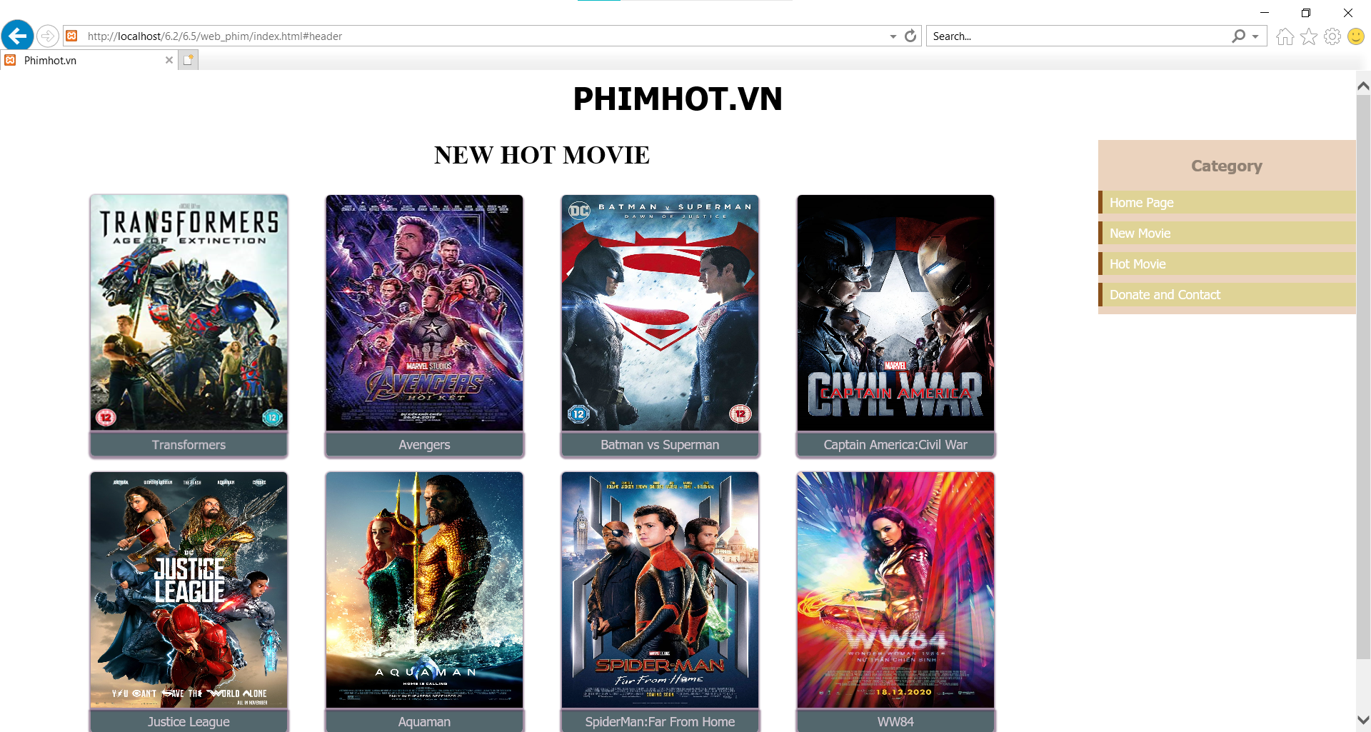

Web nhạc:

