Nhóm 8

Bài làm:

# Lab 7: XML and XHTML

## XML document Practice

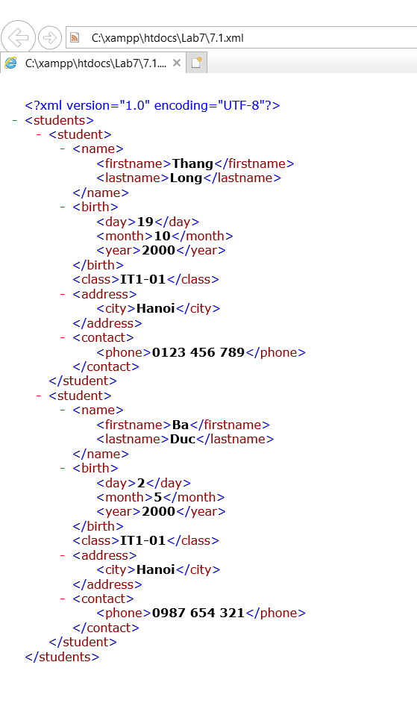

## MathML Practice

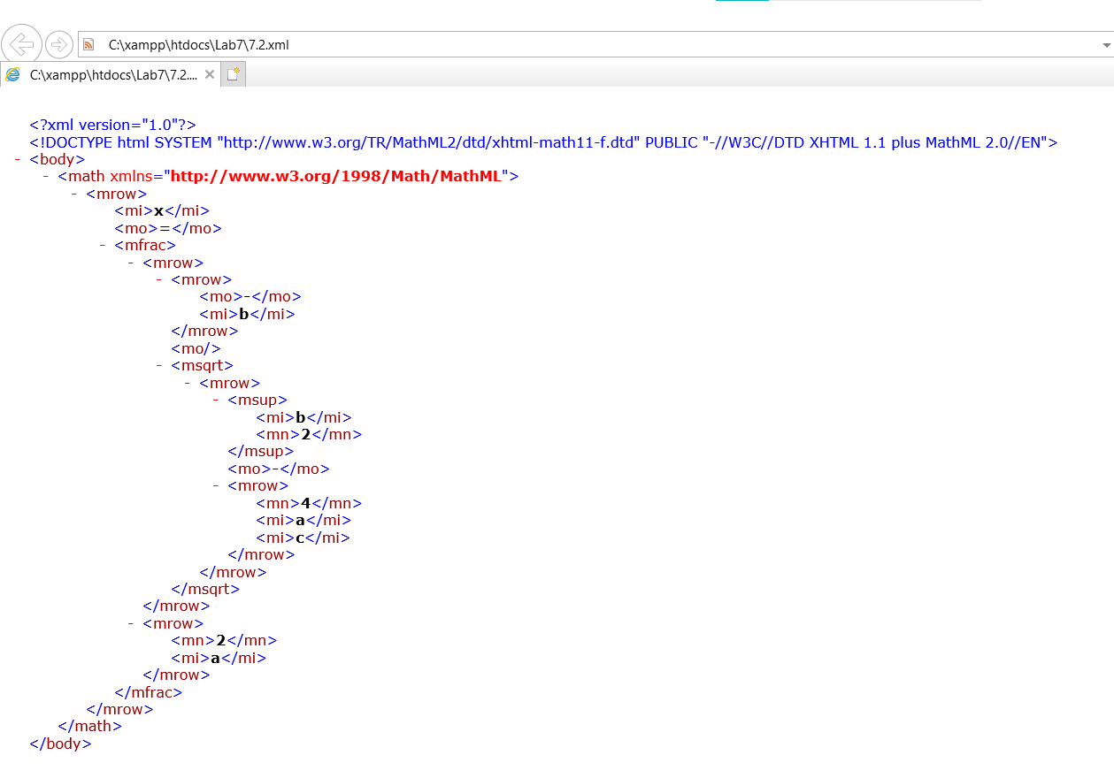

## KML Practice

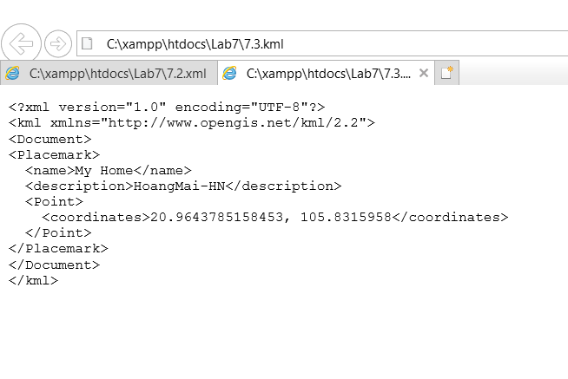

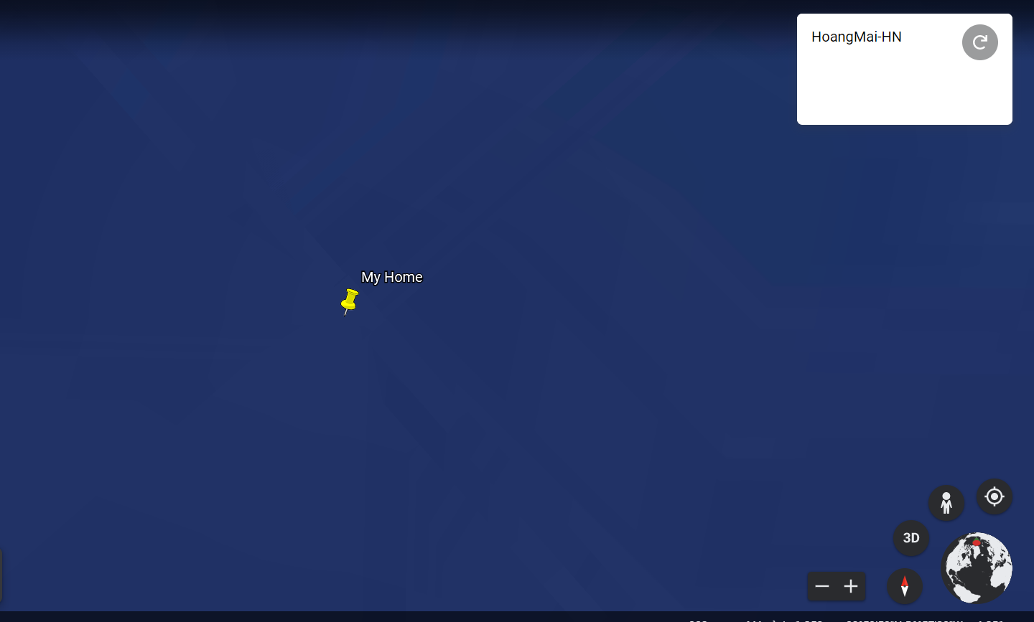

## SVG Practice

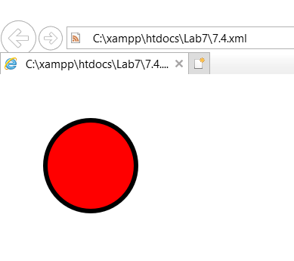

## Exercise 1: HTML, XHTML & XML

### HTML 4.01 Strict

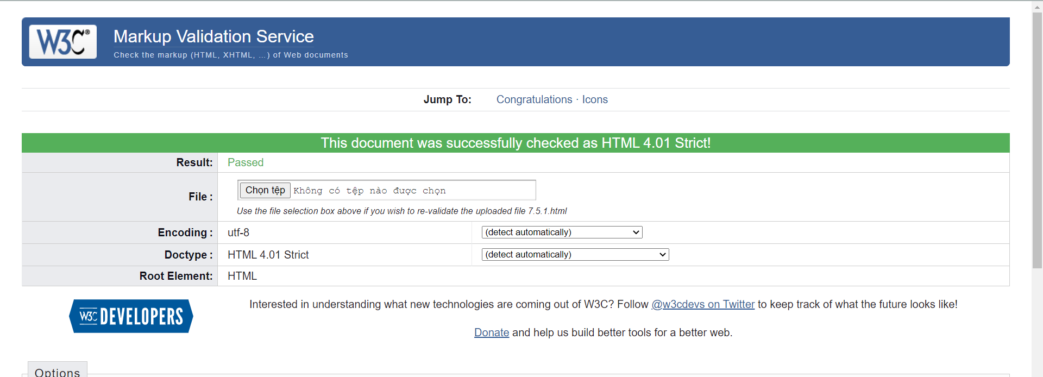

### XHTML 1.0 Strict

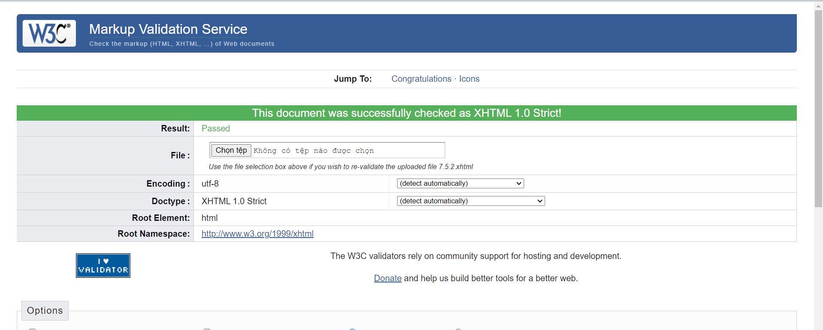

### Well-formed XML

https://www.xml.com/pub/a/2001/12/12/schemacompare.html

### SVG

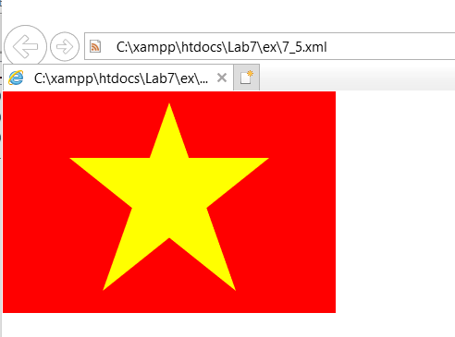

## Exercise 2: XML Programming

### Petting Zoo

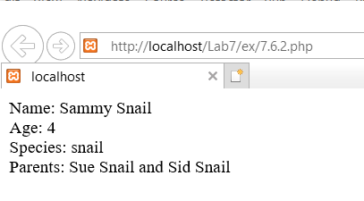

### Sin City

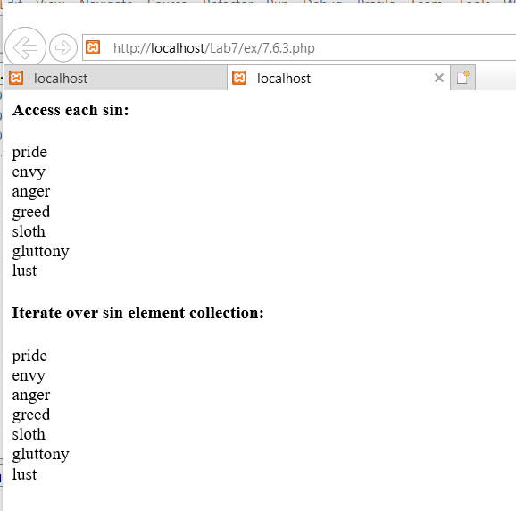

### The Shape of Things to Come

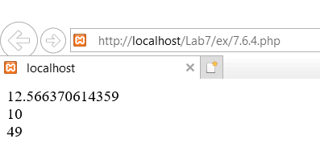

### X Marks The Spot

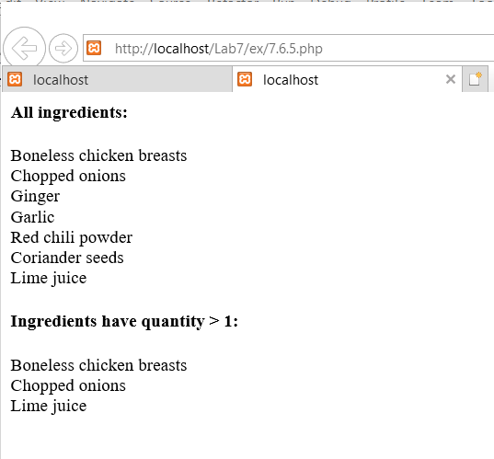

### An Evening At The Moulin Rouge

