**Topic 12: Newspaper Management System**

# **Group 18**

# **Members**:

* **Nguyễn Đức Thắng BI10-160**
* **Lê Đức Mạnh BI10-110**
* **Trần Dũng BI9-074**
* **Đàm Thận Long BA9-040**

**Tables of content**

1. **What the program does?**
2. **Why you need to use our program?**
3. **How I created it?**
4. **Code & reference**

# **What the program does?**

* The program helps to manage Newspaper such as VnExpress, Zing.vn…
* It can easily add, delete and view the content, title and author of every news and advertisement on the page.

# **Why you need to use our program?**

* You should use the program if you want to manage the newspaper in a quick and easy way.
* You can easily add, delete and view any newspaper and advertisement very easily with simple and appealing interface.
* It helps you save a lot of time because it needs only few clicks to add a new news or advertisements on your page.
* By using the program, you will save many time of your time to do other things in your life. And you will be very satisfied because of the simple interface.

# **How we created it?**

Firstly we discussed and decided that it’s will be simple program that focus on News and Advertisments, and the program can add, delete and view the data. After trying to build the program by using OOP and it can’t work properly like we want ( We realize that teleworking and communicating via facebook have many limitations), we decided to build program by using POP (The most obvious benefit is being able to reuse a lot of code in each module and making it easier for each member to understand the code of others).

Then we create basic ER diagram:

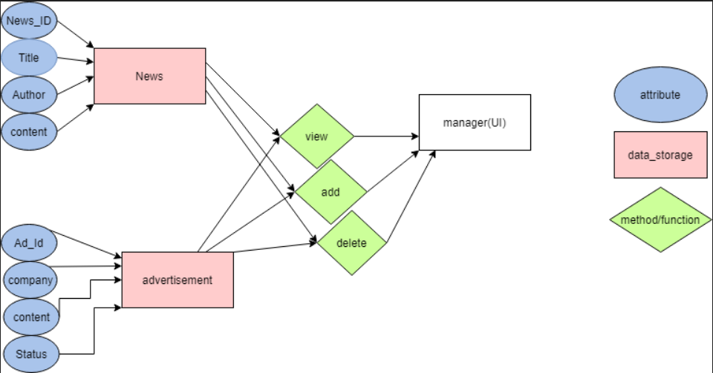

Then, we create database schema:

-

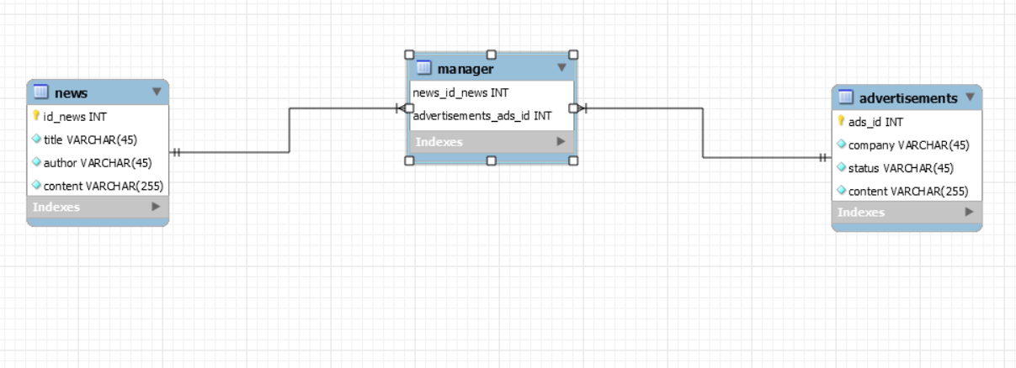

Then we creat main function:

* Using 3 packages Tkinter, PyMySQL and PIL (install them easily via Pycharm's pip install)
* Create database by using MySQL Workbench 8.0 (The code and instructions are on github)
* Find an image to use as background for the main menu

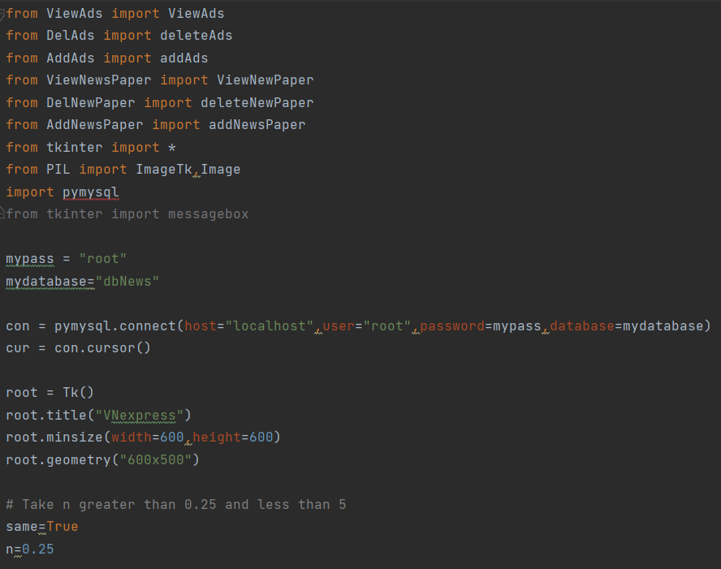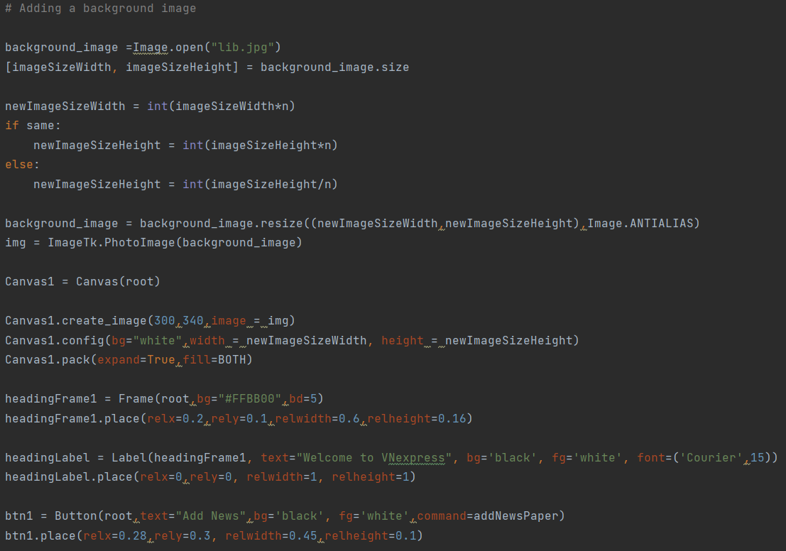

* Set 6 button on main menu interface

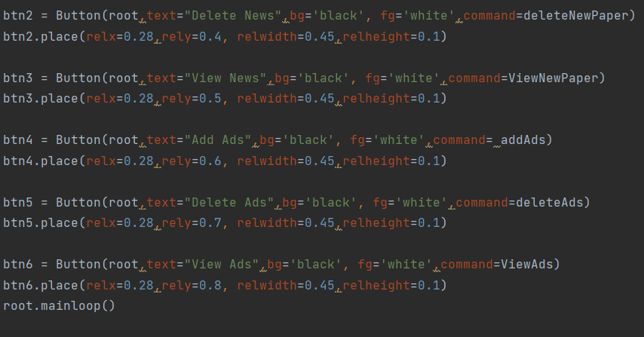

Then we create modules: (as you can see we can re-use many code from each modules)

Add_news:

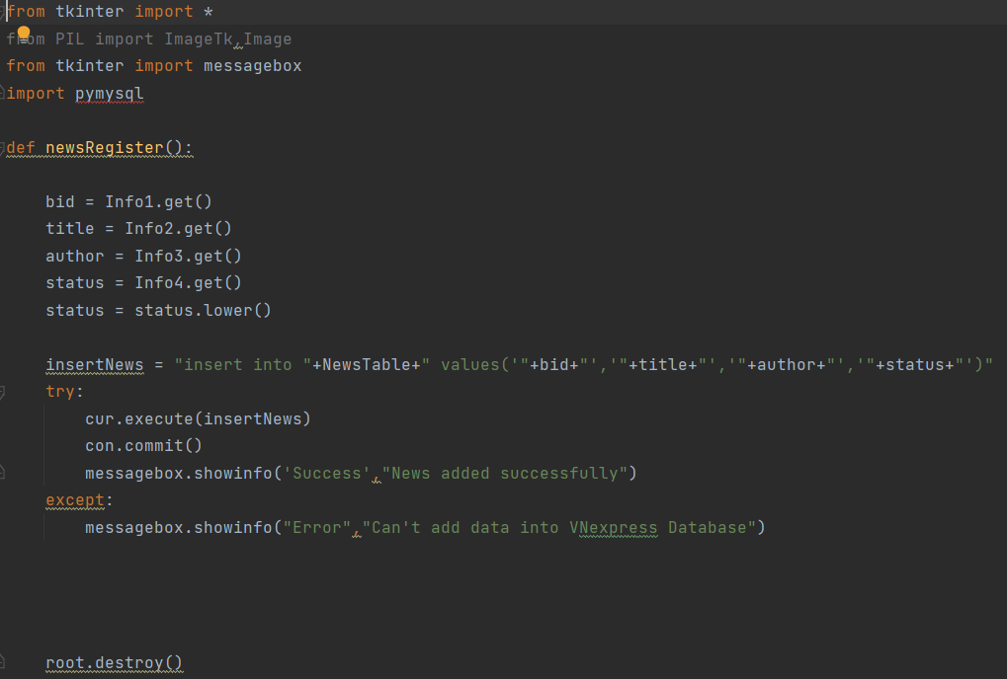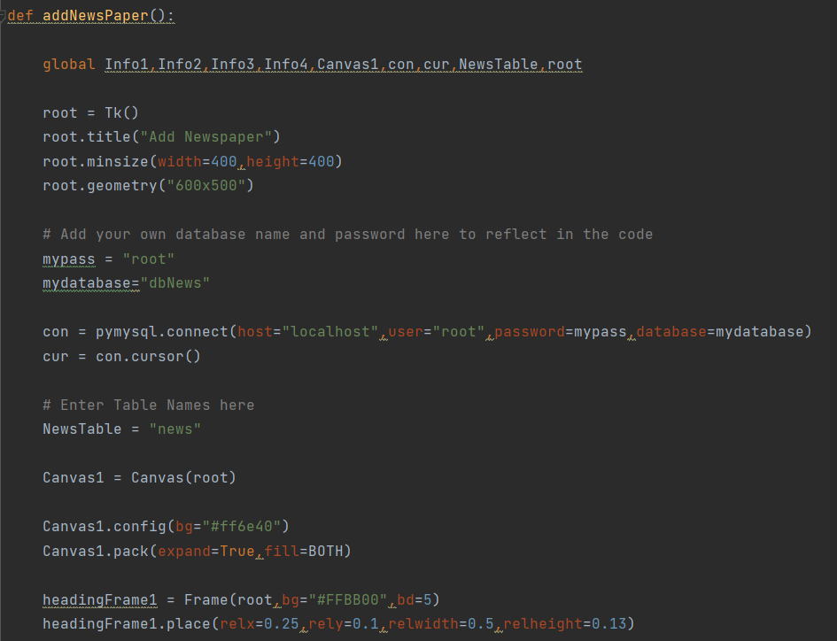

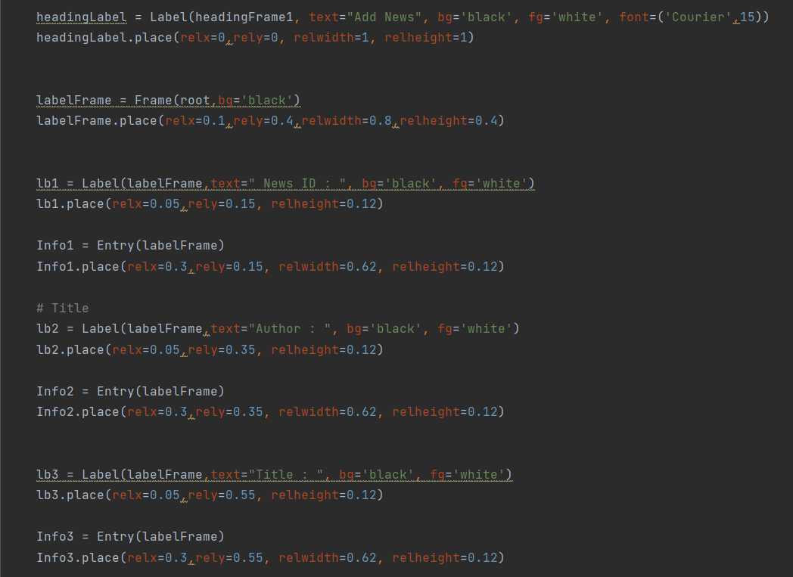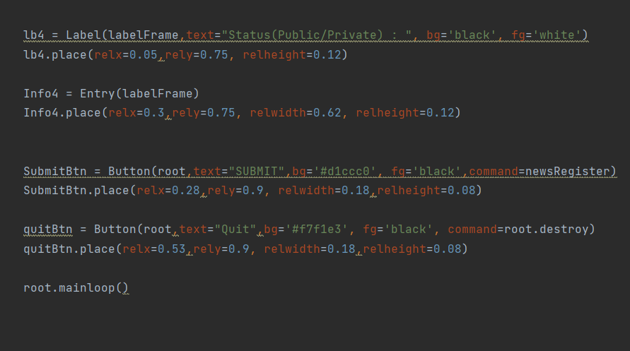

Add_ads:

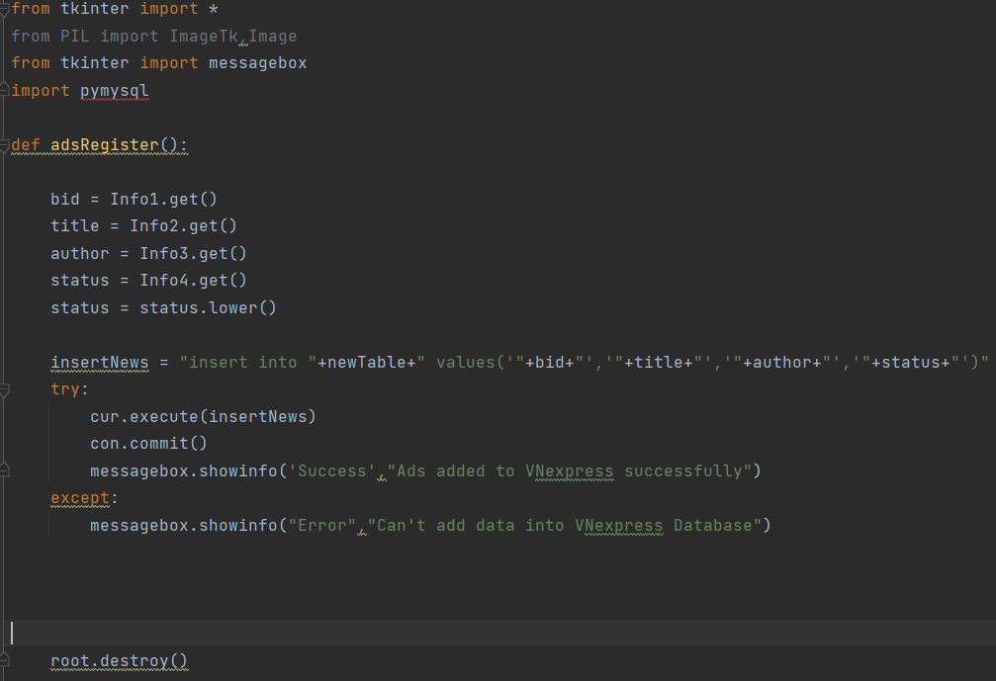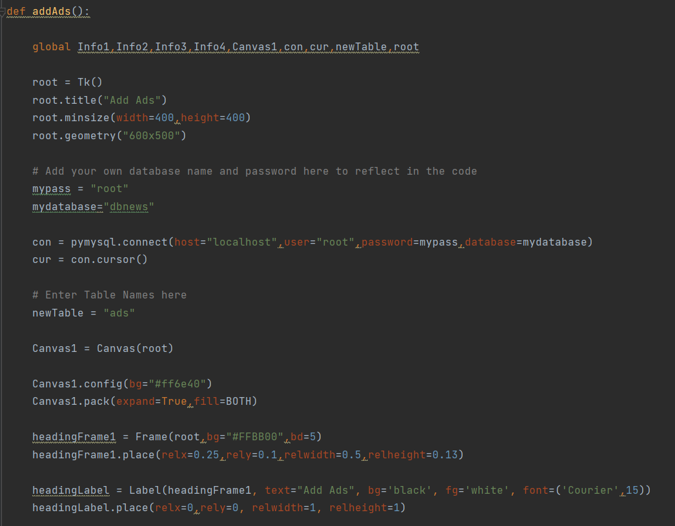

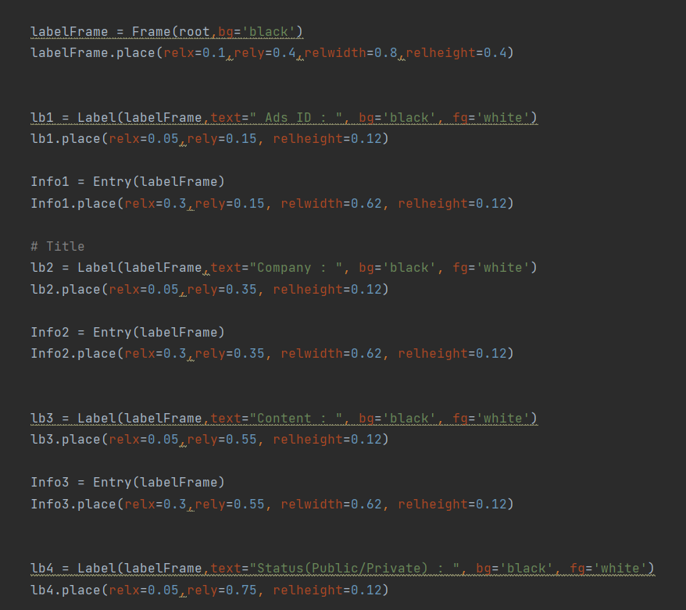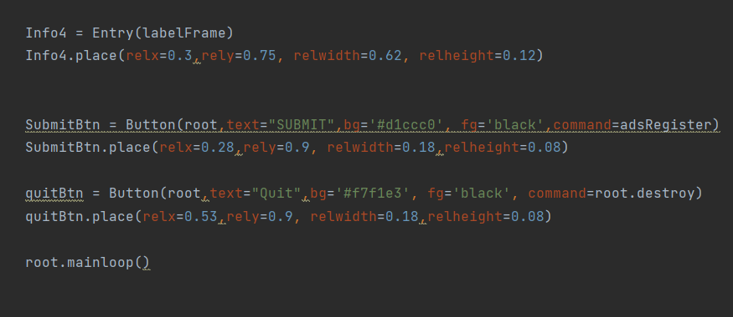

View_news:

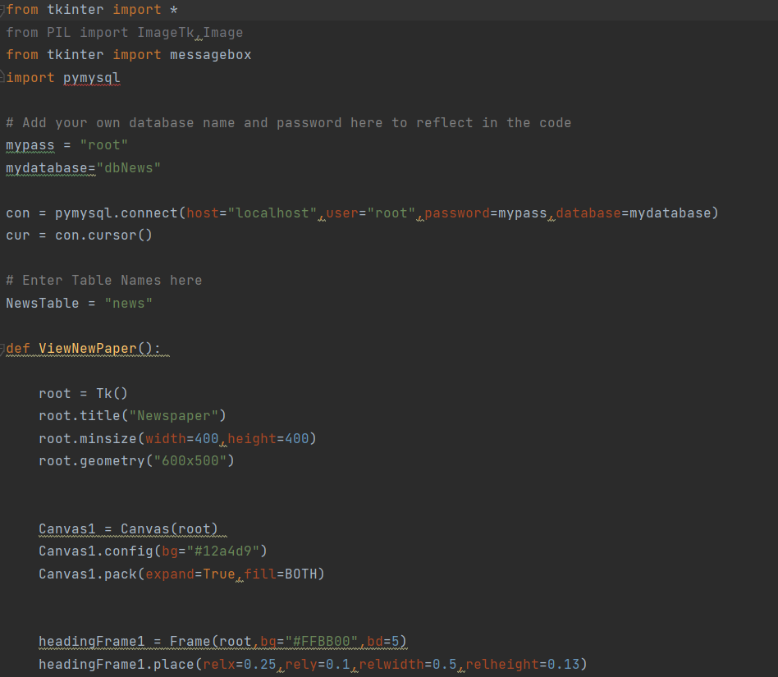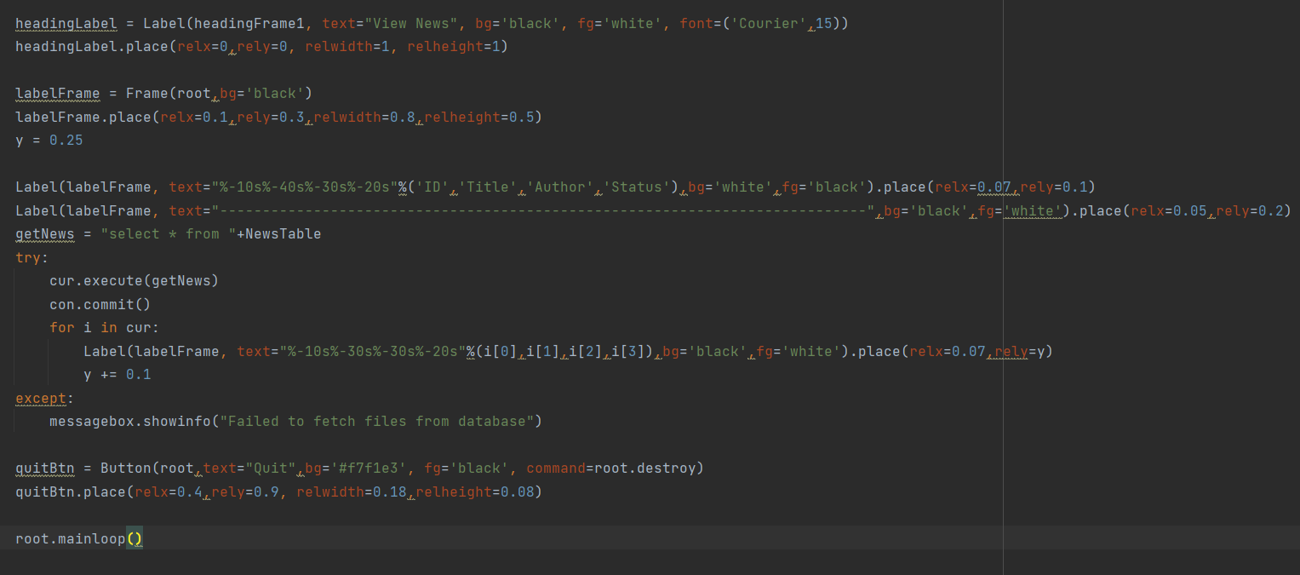

View_ads:

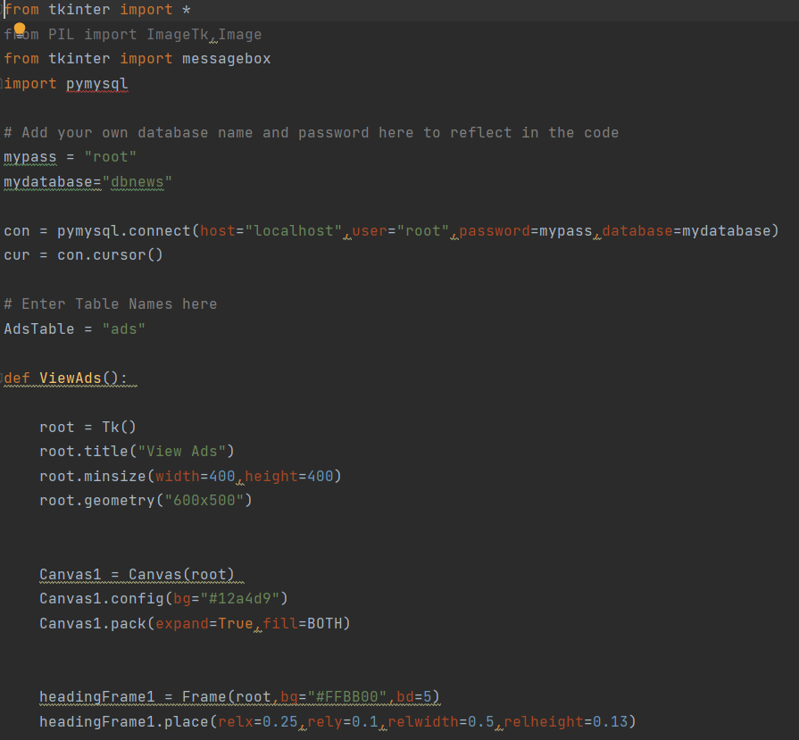

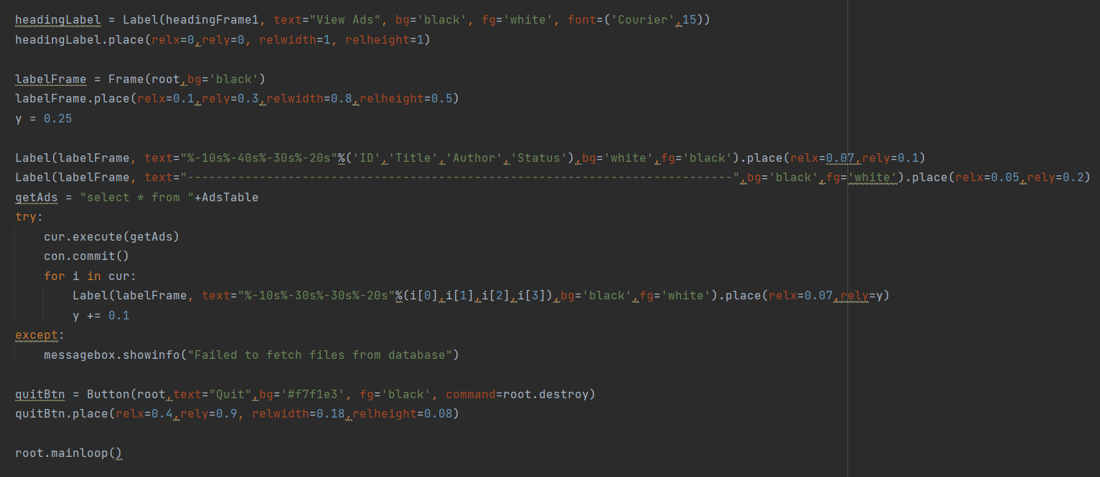

Delete_News:

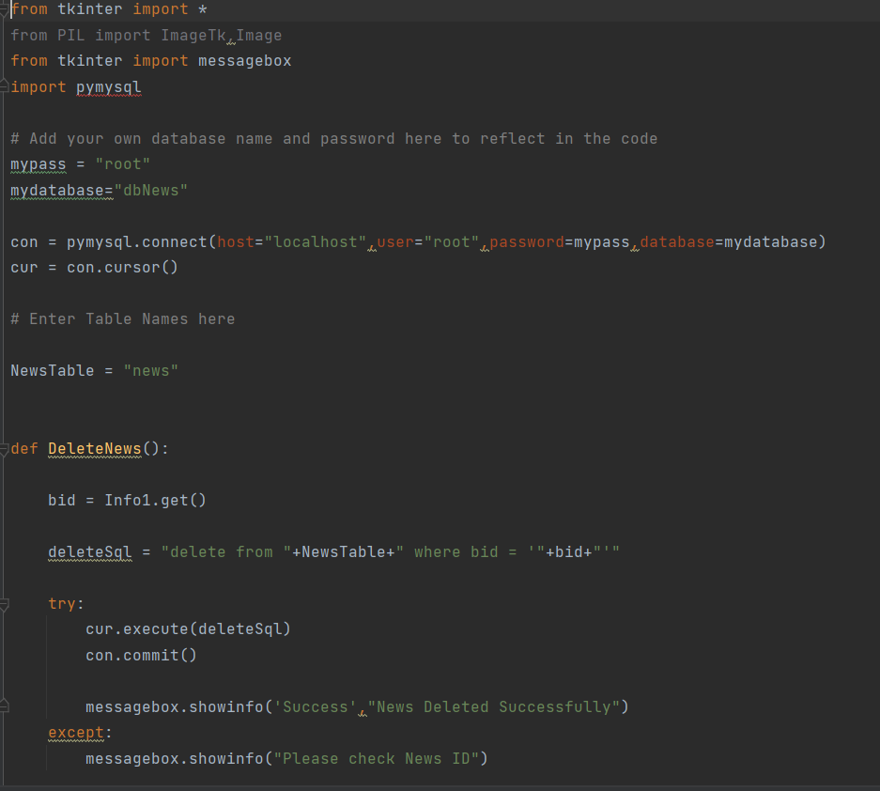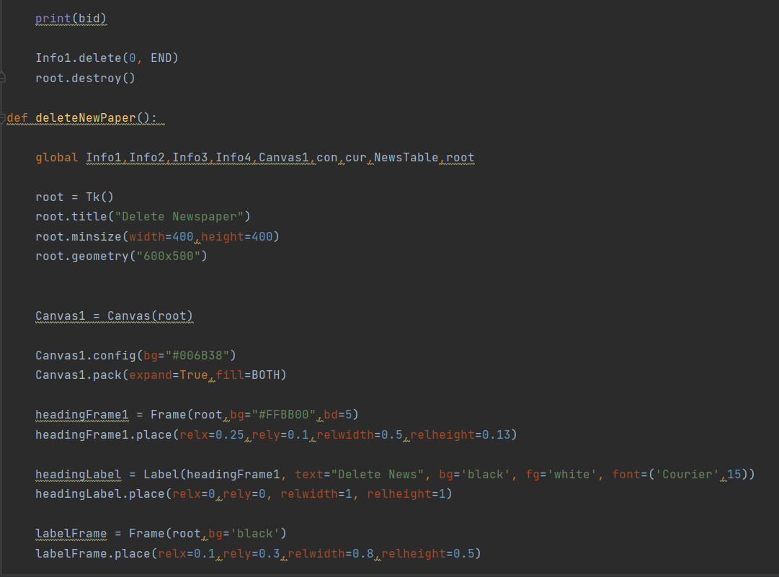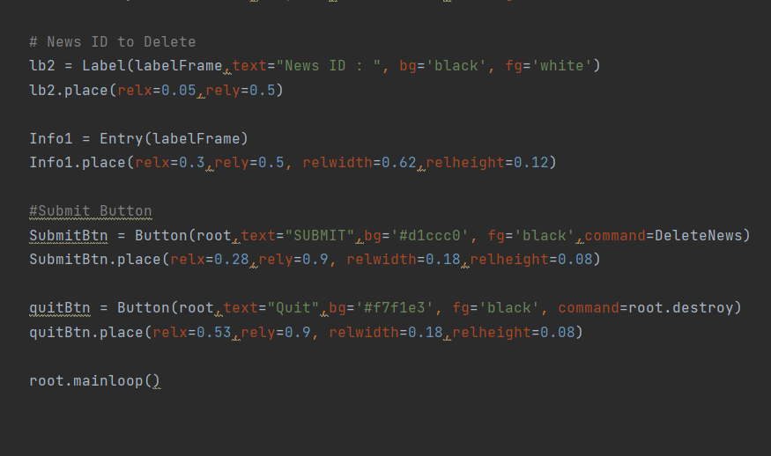

Del_ads: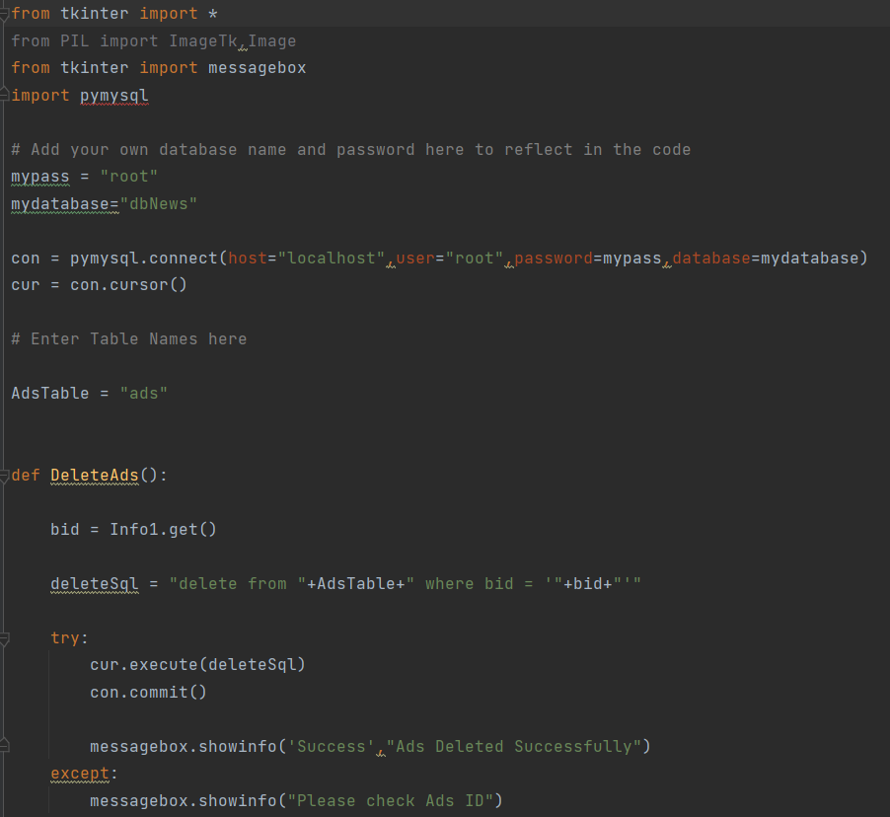

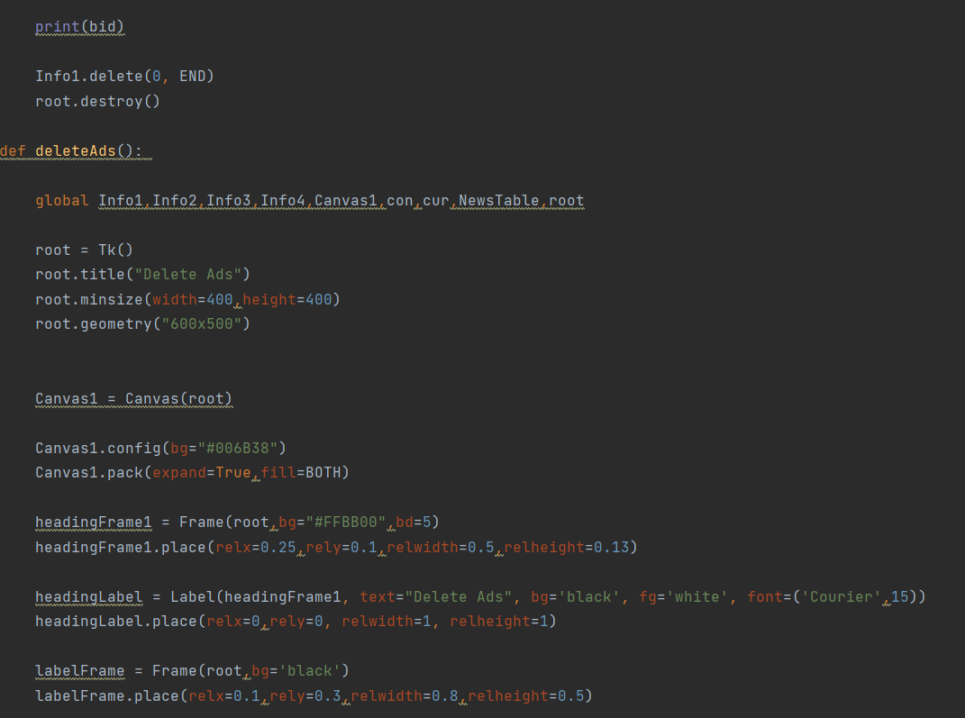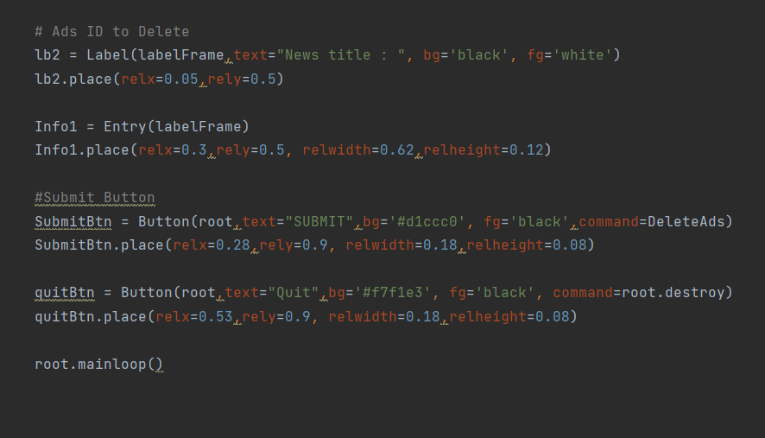

The input of the program would be:

* Add_news:
  + New_id
  + Author
  + Title
  + Content
* Add_ads:
  + Ads_id
  + Company
  + Content
  + State(Public/Private)
* Delete_news:
  + New_id
* Delete_ads:
  + Ads_id

The output of the program would be:

* View_news
  + Id
  + Tile
  + Author
  + Content
* View_ads
  + Id
  + Title
  + Author
  + Status

The user interface would be like this:

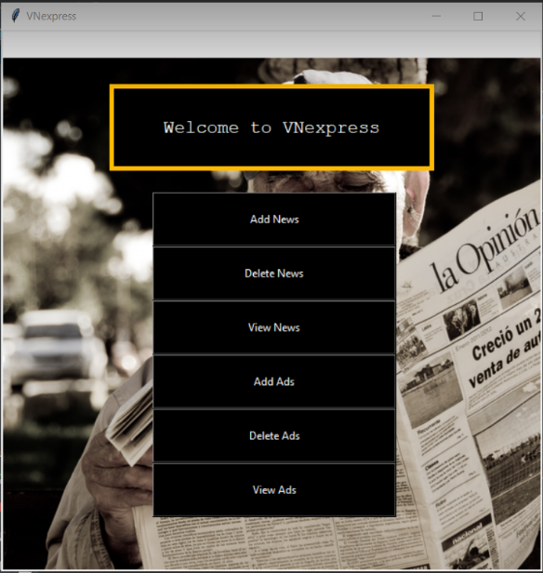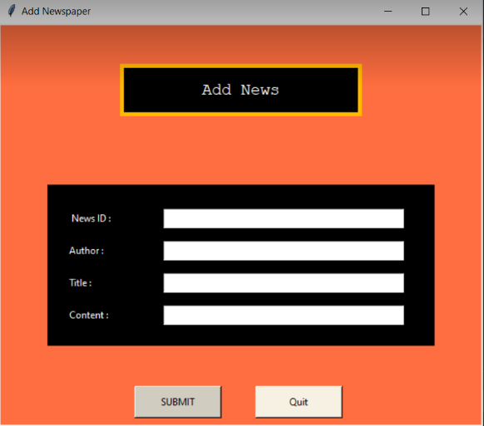

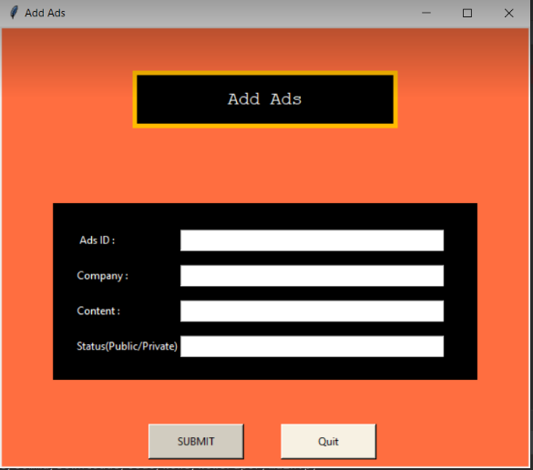 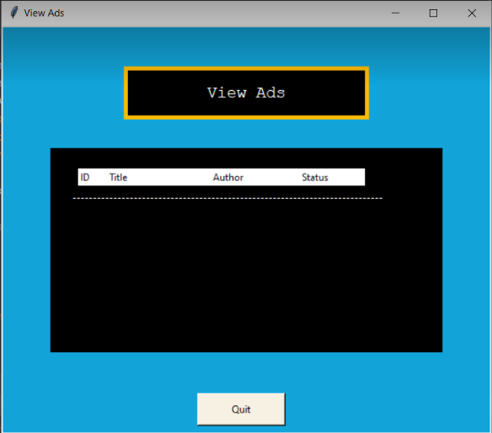 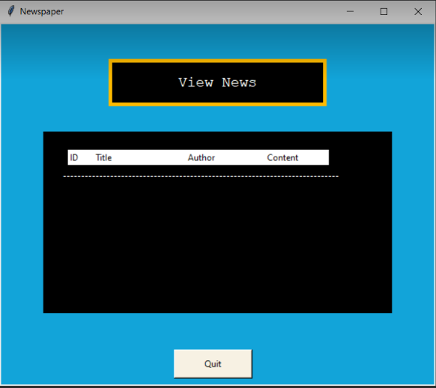 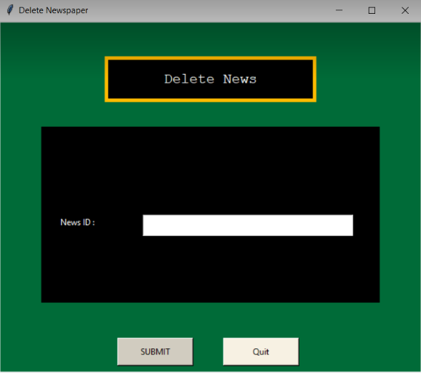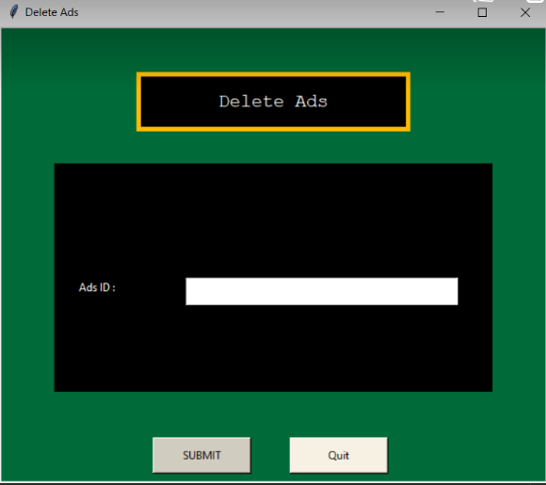

# **4. Code & reference**

**1. Basic ER diagram**

<https://drive.google.com/file/d/16WU5l3zvjtzulAt4F5B7ipjFbzJlGPUR/view?usp=sharing>

**2. Database & diagram**



**3. Code**

https://github.com/thangnd-10160/Final-Python