

Báo Cáo Thực Hành

Môn: Thực Hành Kiến Trúc Máy Tính

**Assignment 1:**

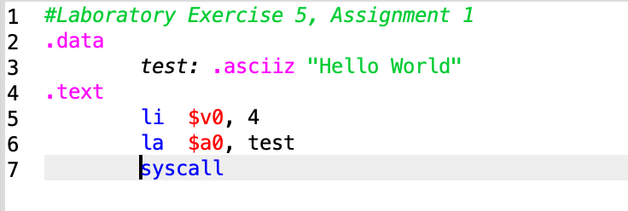

Kết quả:

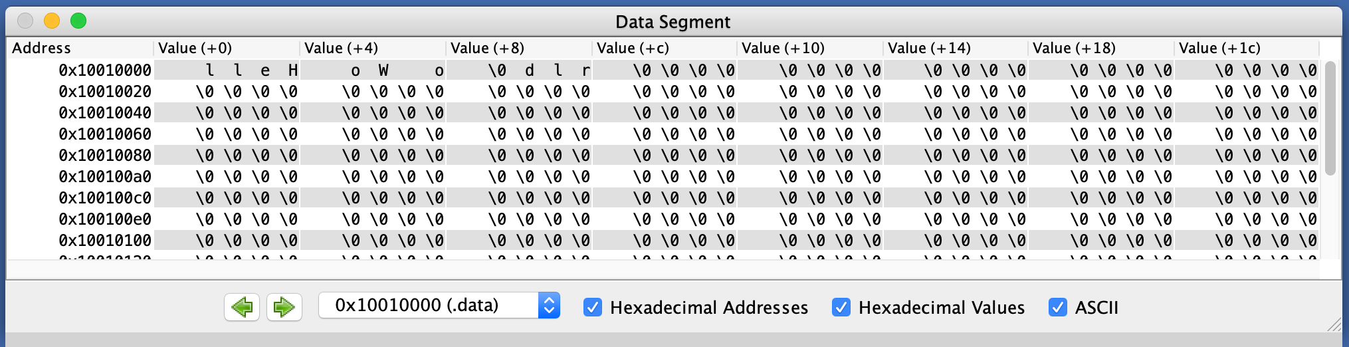

**Assignment 2:**

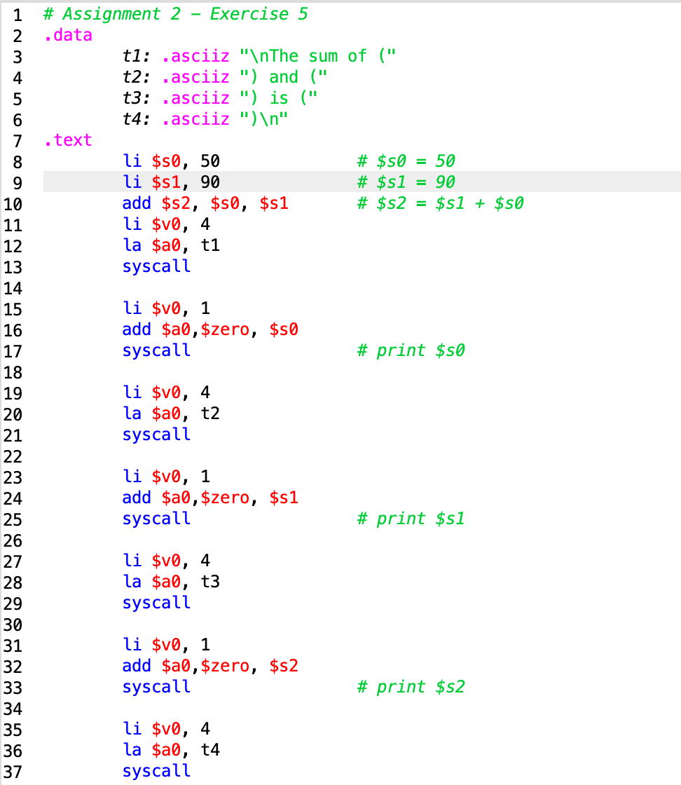

Kết quả:

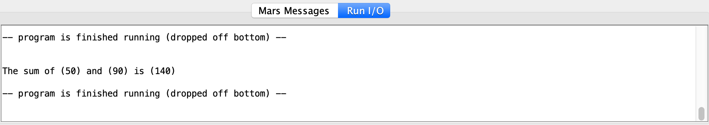

**Assignment 3:**

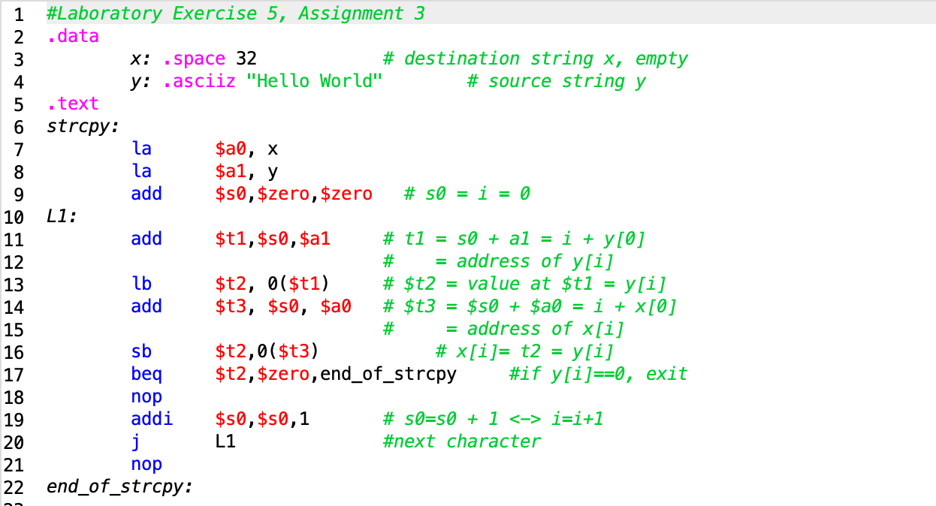

Kết quả:

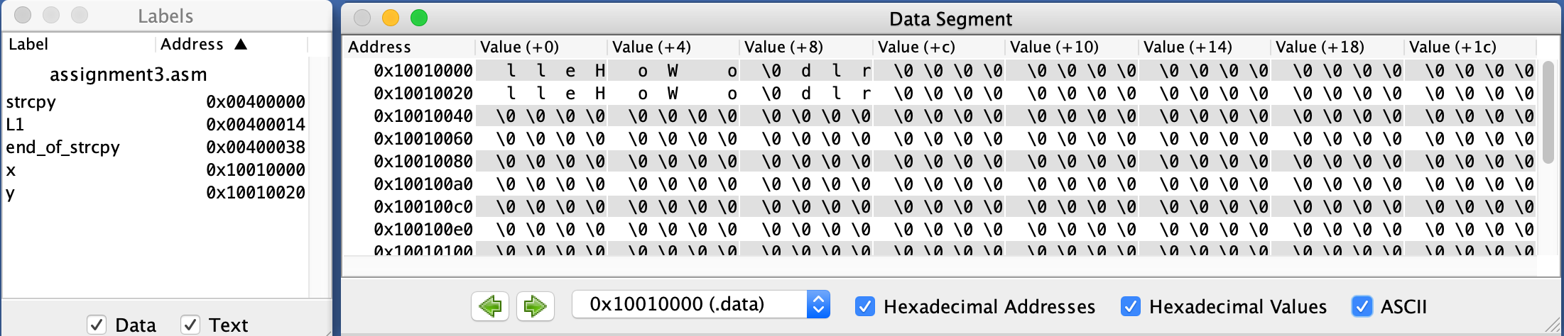

**Assignment 4:**

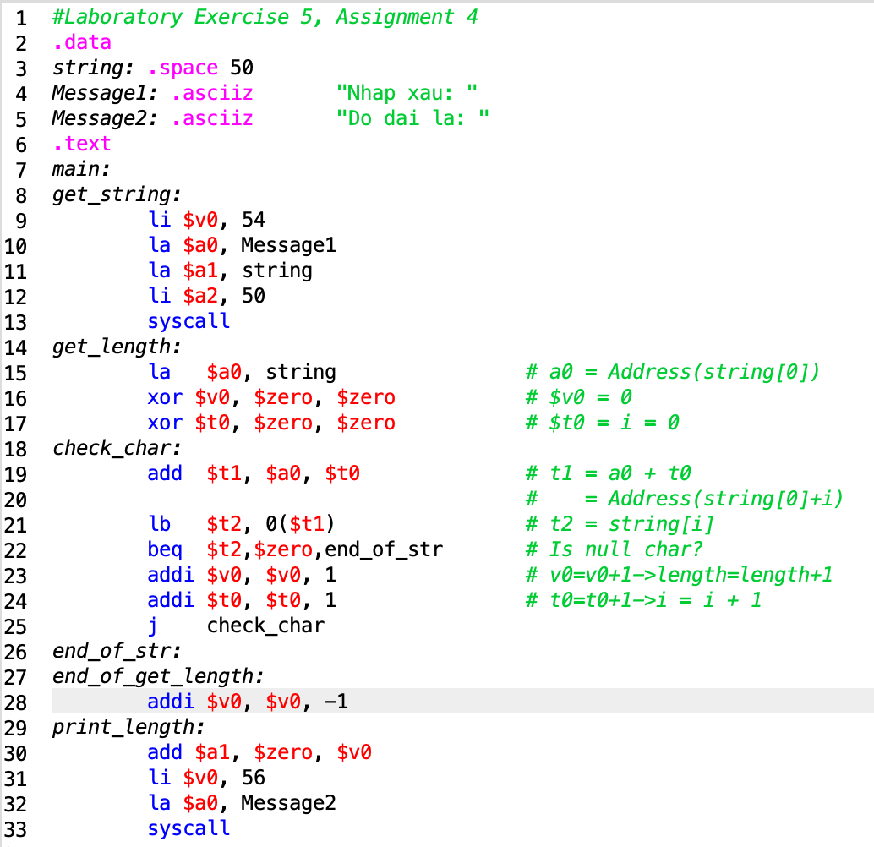

Kết quả:

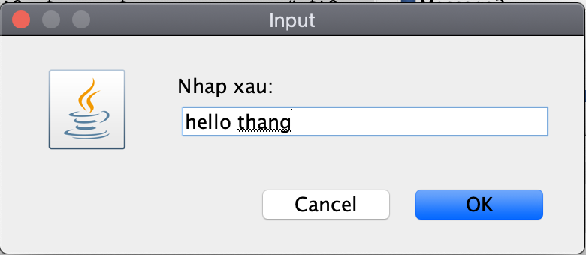 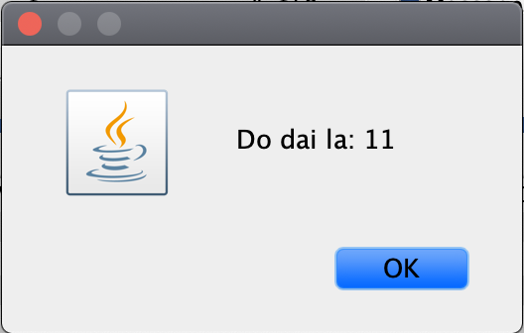

**Assignment 5:**

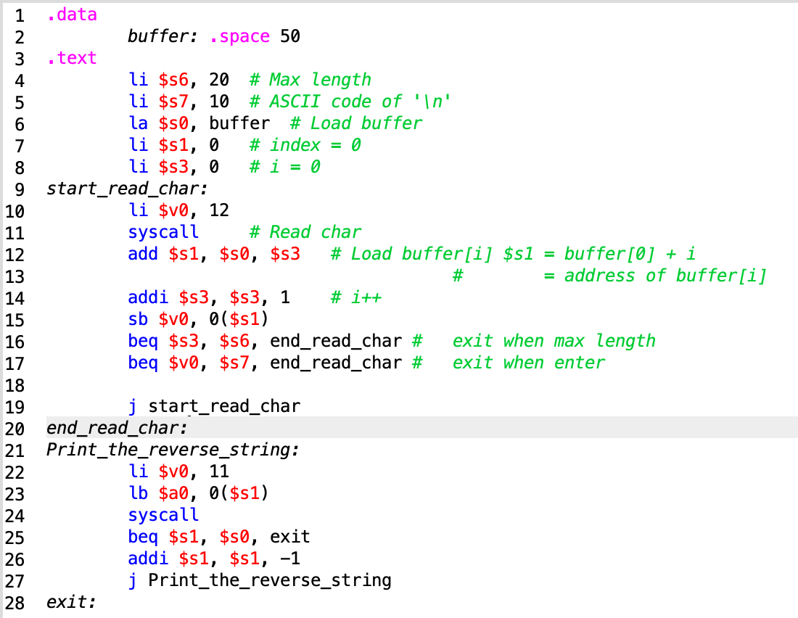

Kết quả:

Trường hợp khi ấn enter:



Trường hợp khi đủ max length = 20 ký tự:

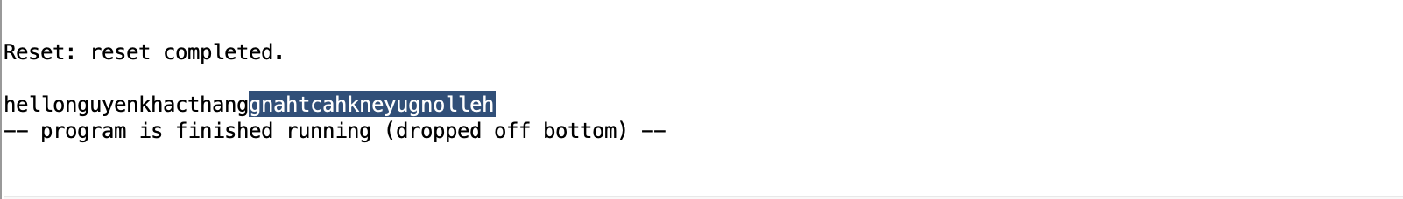

Conclusions: Before you pass the laboratory exercise, think about the questions below:

1. *What the difference between the string in C and Java?*

* String in C is Array terminated with a NUL (\0) character. But, in Java strings are instances (objects) of the *java.lang.String* class, you can not use them as array.

1. *In C, with 8 bytes, how many characters that we can store?*

* Chars in C are typically (not always) 8-bit

1. *In Java, with 8 bytes, how many characters that we can store?*

* Java chars are 16-bits (always).