**ASSIGNMENT 2 FRONT SHEET**

|  |  |  |  |
| --- | --- | --- | --- |
| **Qualification** | **BTEC Level 5 HND Diploma in Computing** | | |
| **Unit number and title** | Unit 9: Cloud Computing | | |
| **Submission date** |  | **Date Received 1st submission** |  |
| **Re-submission Date** |  | **Date Received 2nd submission** |  |
| **Student Name** | Nguyễn Ngọc Thắng | **Student ID** | gch18753 |
| **Class** | gch0719 | **Assessor name** | Đỗ Quốc Bình |
| **Student declaration**  I certify that the assignment submission is entirely my own work and I fully understand the consequences of plagiarism. I understand that making a false declaration is a form of malpractice. | | | |
|  |  | **Student’s signature** |  |

**Grading grid**

|  |  |  |  |  |  |  |  |
| --- | --- | --- | --- | --- | --- | --- | --- |
| P5 | P6 | P7 | P8 | M3 | M4 | D2 | D3 |
|  |  |  |  |  |  |  |  |

|  |  |  |
| --- | --- | --- |
| **❒ Summative Feedback: ❒ Resubmission Feedback:** | | |
| **Grade:** | **Assessor Signature:** | **Date:** |
| **Internal Verifier’s Comments:** | | |
| **Signature & Date:** | | |

Contents

I. Configuring and deploying the web application. 4

1. Steps in configuring and deploying the web application 4

2. Connecting to database. 4

II. GitHub. 10

III. Heroku. 11

IV. The Produce Page. 13

1. Insert product. 13

2. Delete product. 14

3. Edit product. 15

V. The most common problems which arise in a Cloud Computing platform. 17

VI. The most common security issues in cloud cloud environments. 19

VII. Biography. 20

# Configuring and deploying the web application.

## Steps in configuring and deploying the web application

4 steps to implementing my website:

**Step 1:** code execution and programming.

**Step 2:** push the code to GitHub (GitHub makes it possible for us to get code from anywhere to help people do it effectively and especially GitHub will help us return to old code when new code encounters bugs and cannot repairable).

**Step 3:** connect to the mongo DB database.

**Step 4:** push the app so Heroku.

Here I will go step-by-step and carefully analyze each of my processes as I build my website.

## Connecting to database.

I decided to use mongo dB because it made it easy for me to connect to the database. Mogodu’s features like add, delete, and repair are also superior to the rest of the servers. To use MongoDB I need to know how to use 2 types: MongoDB Atlas, MongoDB Compass. Upon creation, MongoDB Atlas will provide me with a URL so I can connect to the database online.

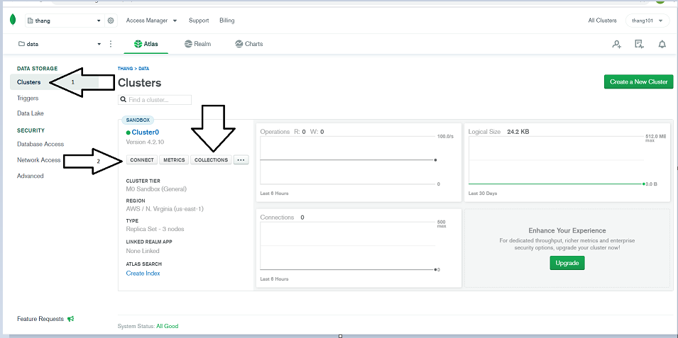

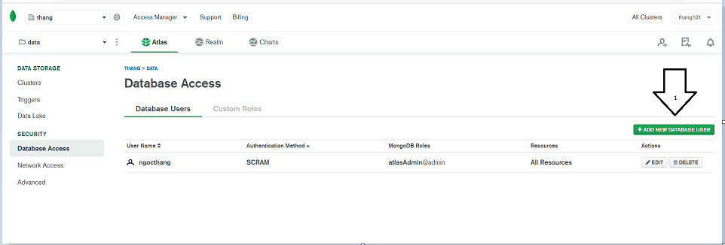

- At the marker named "Database Access" in accessing Database Access. We can control who has access to this database.

- number 2 represents "connect" first you have to select the clusters on the toolbar then click "connect" and select the last line "Connect using MongoDB Compass", then it will appear for you a URL code you copy that code to have a connection to the Database.

-In number 3 is "Collection", you can manage your database here. In addition, you can also manage the database through MongoDB Compass or through Atlas.



-If you already have "database user", please select the last line as shown below to get the URL code connecting to the database. If there is no "database user", please press and "add database user" to add an account, password and then do as shown in the instructions.

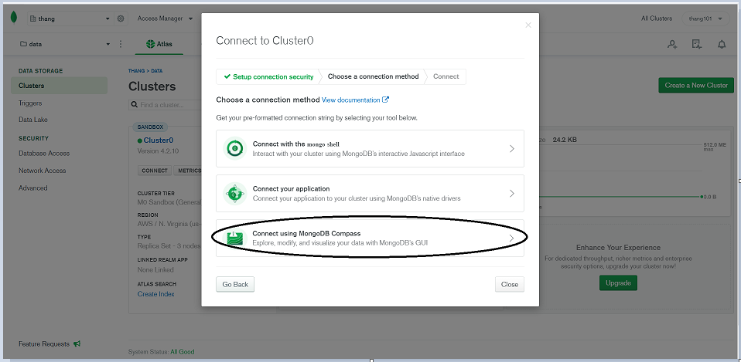

- the next, click "I have mongo DB compass" then click "copy".

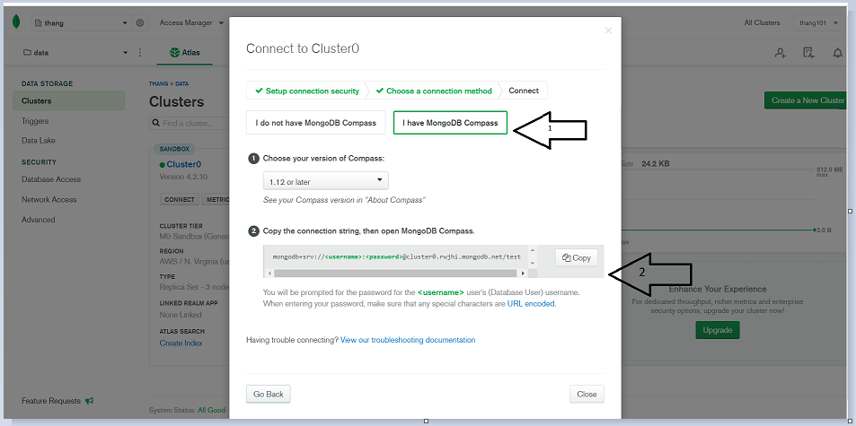

* Next, we will open the Mongo dB compass to follow the instructions. First we paste the URL code we just copied and then press "connect".

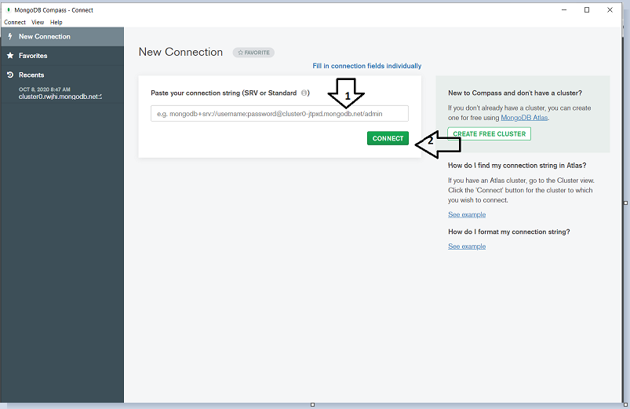

When you are successfully connected the screen will appear as follows:

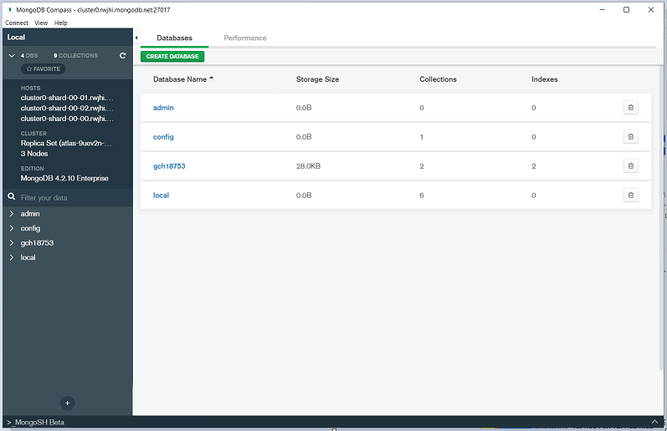

-Enter as shown in the picture to be able to create new data

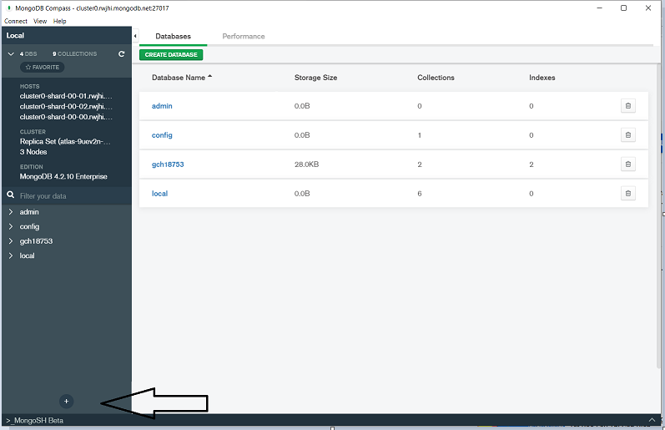

* enter information to be able to create new data.

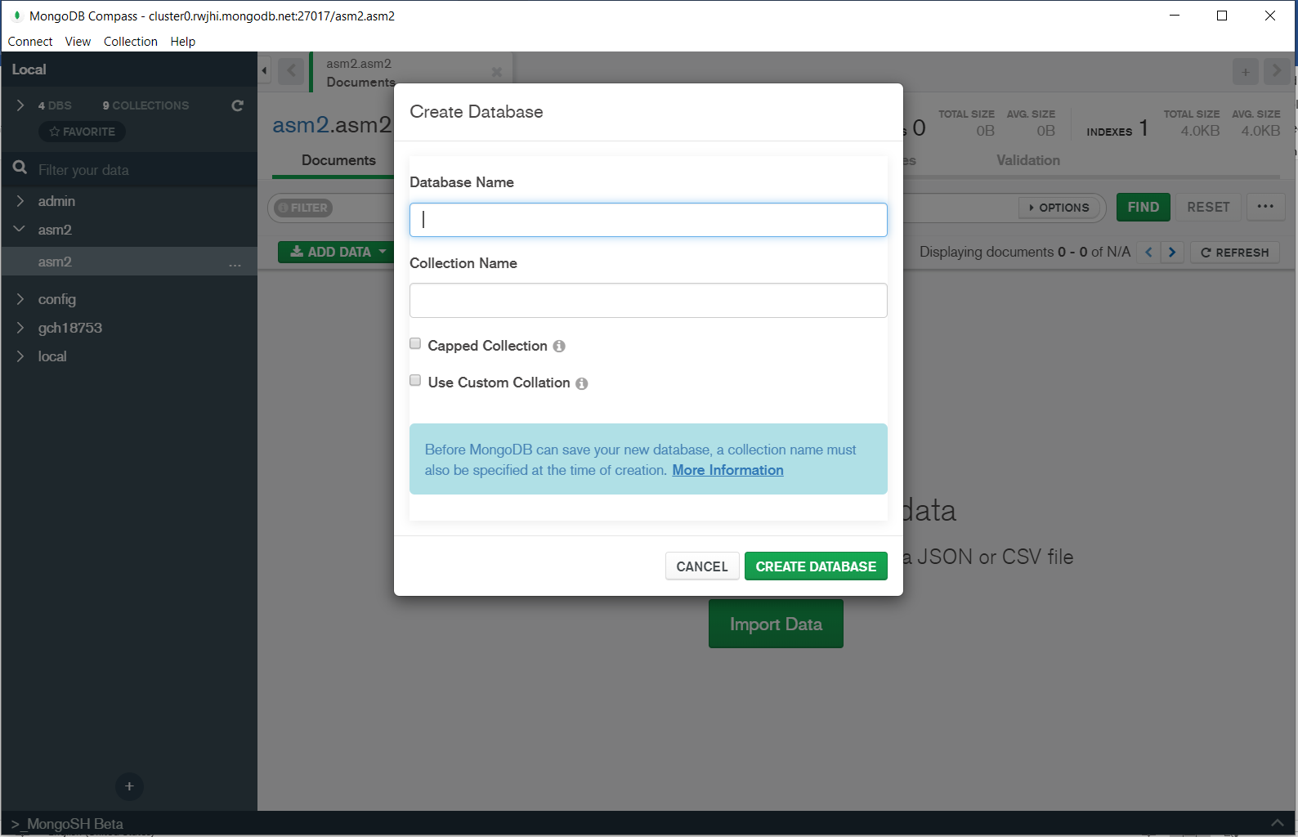

After creating the data you will have 2 options to import the data as shown:

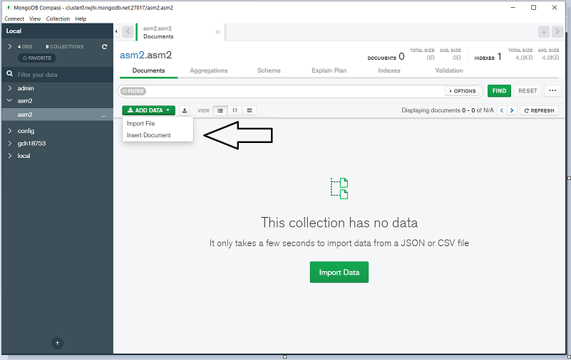

-after you successfully added data

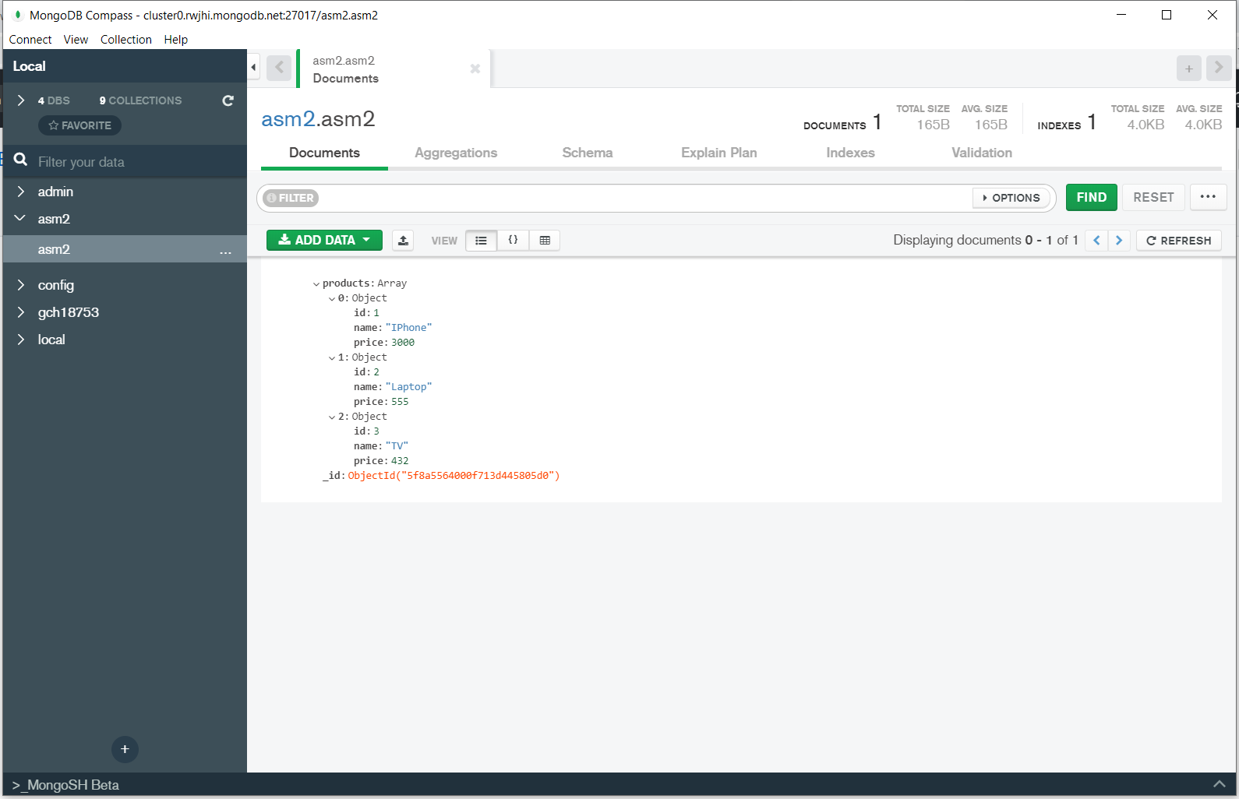

# GitHub.

After completing the code we need to push them to GitHub here I have created a database named "ATNweb". It is important that if we want to implement our code on Heroku we must be able to push the code to GitHub. GitHub also helps us: if our code on a computer is changed, we can also easily change the code online easily through the 3 steps I mention below:

Here if your code is linked with 3 link number 2 as shown within the picture, it means you have got successfully connected the database. "Package.json". At "scripts", I add the command "start" to create sure that "node myserver.js" runs the program as shown in figure 1.

next i need to deploy my website on Heroku just like GitHub first i need to create my own account and log in to account. Then I will create a new app like this:

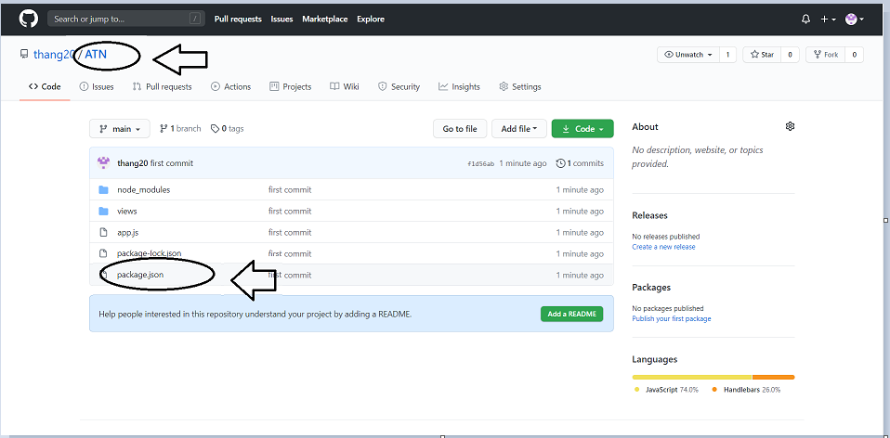

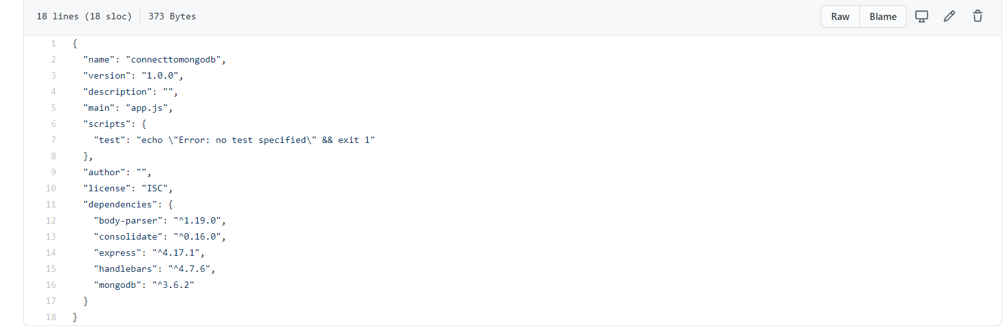

Here if your code is linked with 3 link number 2 as shown within the picture, it means you have got successfully connected the database. "Package.json". At "scripts", I add the command "start" to create sure that "node myserver.js" runs the program as shown in figure .

# Heroku.

next I need to deploy my website on Heroku just like GitHub first i need to create my own account and log in to account. Then I will create a new app like this:

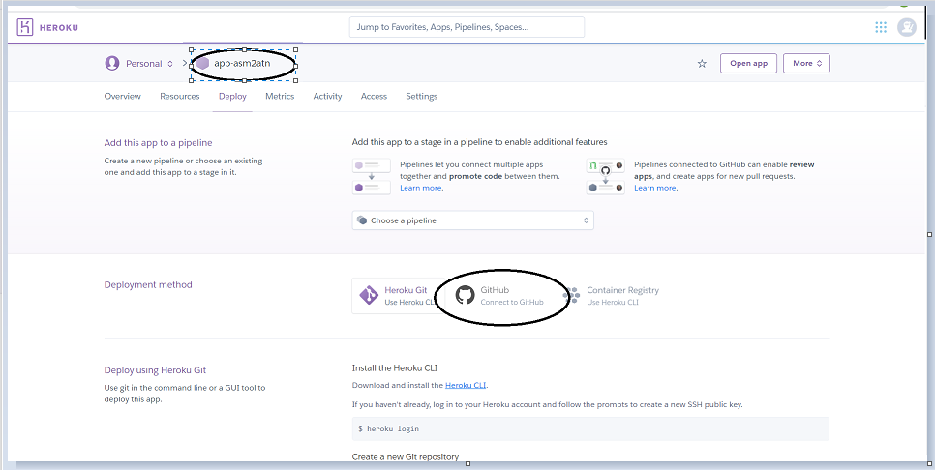

-In "asm2atn", you can choose GitHub to connect, Heroku will choose the source code in GitHub.

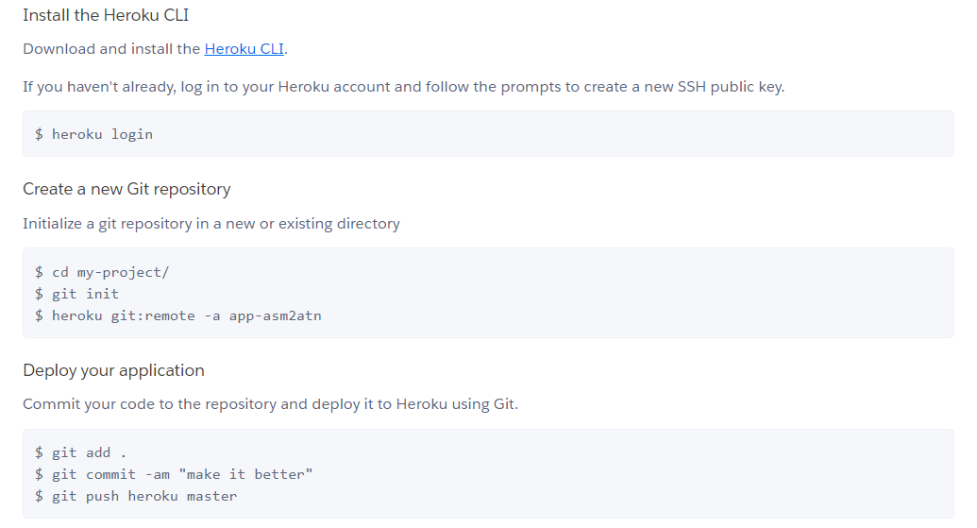

* Use all of the above codes to push your app onto Heroku.

# The Produce Page.

Our website can add, edit, and delete products for users. All product information will be saved on the database.

## Insert product.

You need to enter information such as name, price, type to be able to add products:

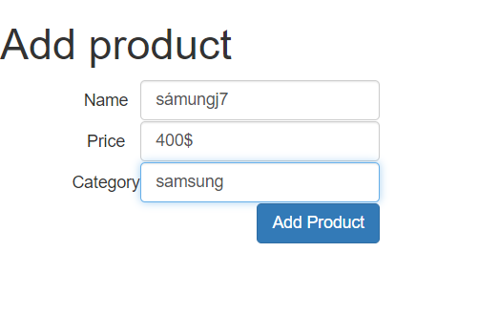

after successfully adding the product :

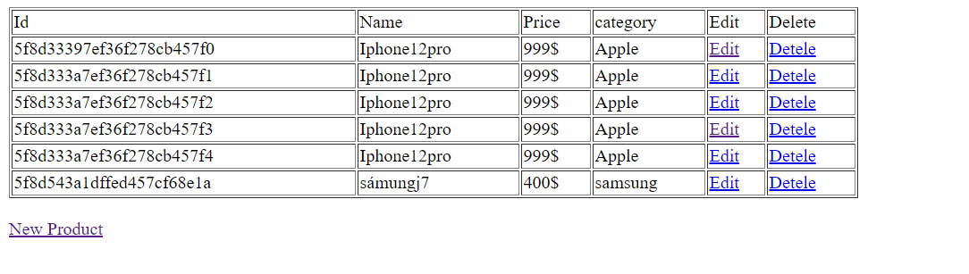

Code :

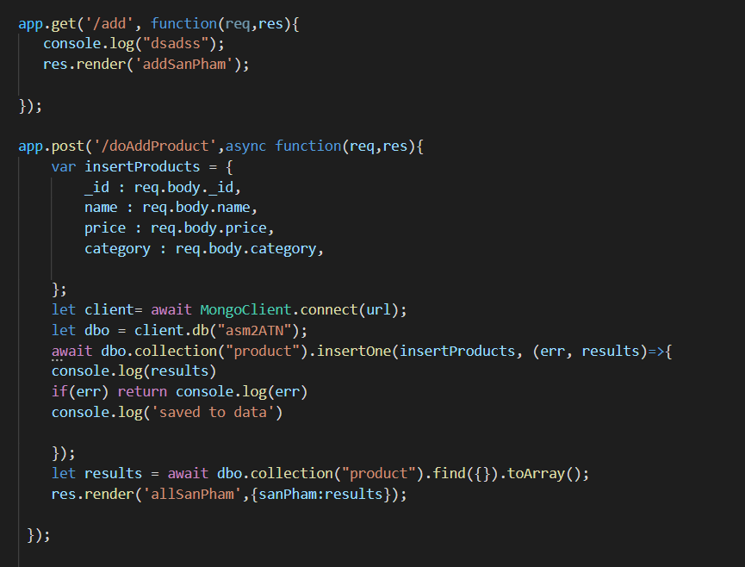

## Delete product.



After delete product :

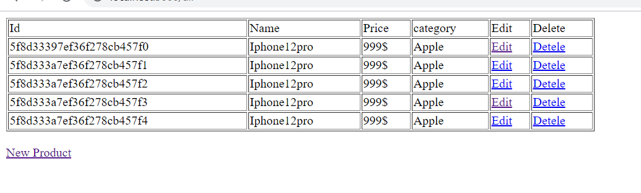

Code :

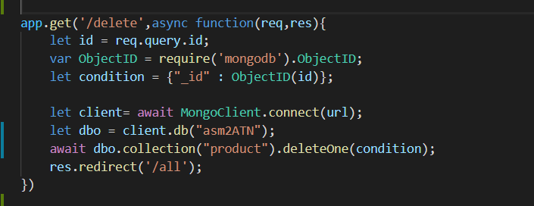

## Edit product.



You need to enter information such as name, price, type to be able to edit products:

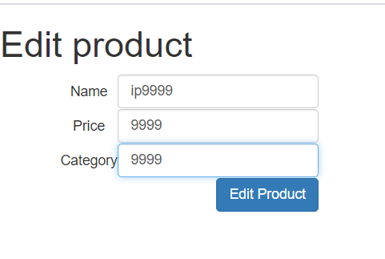

After edit product :

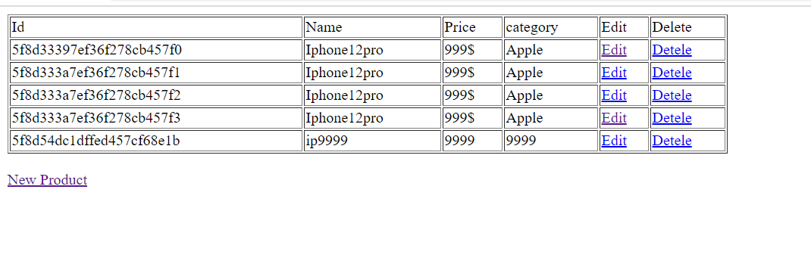

Code :

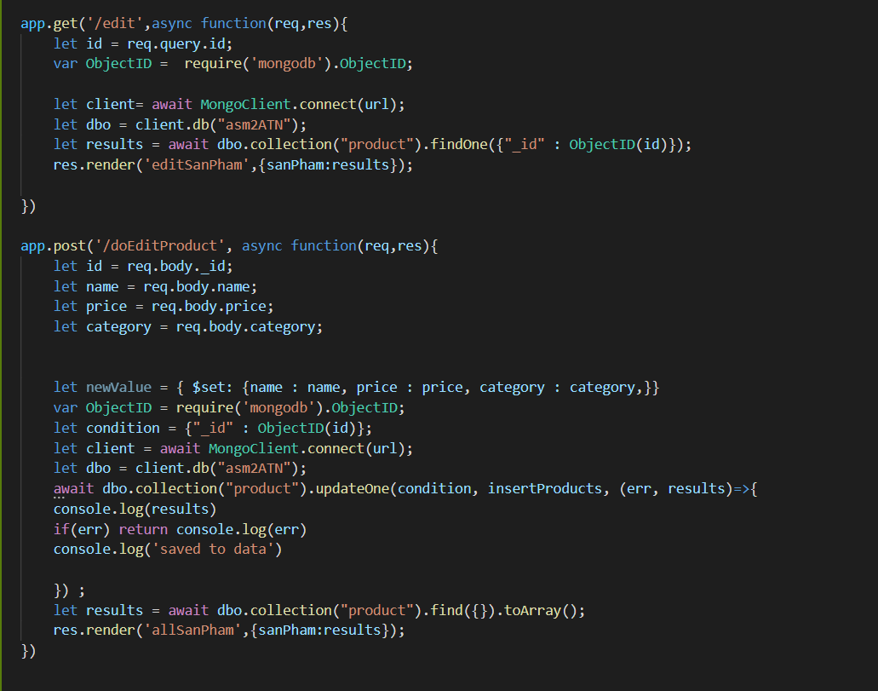

# The most common problems which arise in a Cloud Computing platform.

**a, Backup:**

The backup takes place in the event that Ransomware "locks" corporate data information in encrypted files, and then allows. they can only access the information if the ransom is paid. Backing up the data is an important issue to be addressed (Sabir, 2018).

There are several solutions for the company such as:

✓ Cloud sellers should be interested in choosing to save part or all of the data on their computer: like Dropbox, OneDrive…, and should find out mentioned in the SLA that in this case what are the problems and give remedy.

✓ It is advisable to register the packages which are secured in case of a service failure for better recovery.

**b) Server downtime:**

Server downtime: Downtime is the time the cloud system's system begins to respond to the following client. Many times with errors, causing these limitations may not be a major obstacle for many individuals and businesses (Sabir, 2018)

Solution:

✓ Downtime should be minimized and backup power reserve should be established to maintain downtime. This is an important solution.

✓ Program should be upgraded, and upgraded from 3rd party in case of shutdown.

**c) Multi-tenancy:**

A community of mutual resources may be the cloud. Whilst offering a multi-tenant environment, data security must be taken seriously. Threats can cause clients with cloud storage services during this scenario, and threats targeting one client can also affect other clients. Different cloud providers have various data protection mechanisms, resulting in problems with integration (Sabir, 2018)

Solution:

✓ The best solution for this case is that the company should change the password regularly for all customers, authenticating by many different forms.

# The most common security issues in cloud cloud environments.

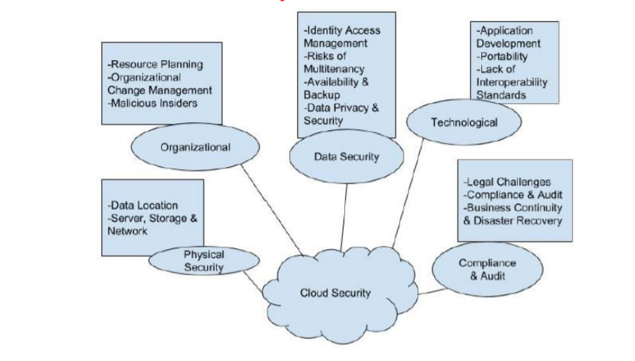

**In Physical Security Risks :**

The physical location of the central cloud databases must be secured by the CSP, in order to prevent on-premises unauthorized access to CSC data. mean when the project works then CSP is responsible for physical infrastructure. In it they must implement and operate appropriate infrastructure controls including activities such as specialized staff training, physical location security, network firewalls (Worlany, 2015).

The CSP must protect the physical location of the cloud data center in order to avoid unauthorized data centers. CSC data on-site access Even firewalls and encryption are unable to protect against physical theft of CSC data About information.

**Compliance and Audit Risks :**

These are risks directly related to the law. Risk is related to lack of information about authority,

jurisdictional changes, illegal contractual terms and ongoing legal disputes. (Worlany,

2015).

There are continuing threats related to the lack of details on jurisdiction, change of jurisdiction, unconstitutional contractual clauses and legal disputes. This sector deals primarily with legal concerns and, in nature, both CSP and CSC must consider their legal and regulatory obligations and ensure that CSP must also ensure that its discoverability does not compromise the protection and privacy of information of any performance contracts that satisfy those obligations. (Worlany, 2015).

**Technological Security Risks :**

There is a wide variety of knowledge security risks that we would like to ask to be considered. In terms of technology security risks, there are Four Key properties that we need to confirm and understand closely are data privacy, integrity, confidentiality and availability (Worlany, 2015).

* Privacy is one of the most critical problems for cloud and network security in general to pander to. Privacy guarantees that a CSC's private data and identity are not exposed to unauthorized users. This is also important until confidential data is dealt with.
* Data privacy is said to be confidential and this is also the property that guarantees that certain unauthorized parties do not leak the details belonging to a CSC.

# Biography.

Worlany 2015. searchdatacenter.[Online]

Available at: http: //searchdatacenter.techtarget.

[Accessed 28 May 2015].

Sabir, 2018. NIST. [Online]

Available at: <https://NIST-con.com>

[Accessed 7 May 2018].