EV Charging Platform
Solution Design Decisions
Principal AI Engineer — Solution Design Challenge

1. Purpose & Approach
This document captures the architecture, entity model, and engineering trade-offs behind the backend service built for this exercise. Per the brief, the goal is not full completeness but demonstrated judgement: what was built, what was simplified, what was deferred, and why.
The document is structured in three layers. First, the platform vision: the high-level, target-scale architecture this domain naturally grows into. Second, the exercise design: what was actually built, scoped deliberately to the available timeline. Third, the adaptation path: an explicit mapping showing how the exercise design evolves into the vision architecture as real demand justifies it. Section 16 closes the loop with a line-by-line traceability matrix checking every requirement in the original brief against where it's covered. Section 2, immediately below, grounds all of this in why the platform exists before any architecture is discussed.

2. Business Context & Use Cases
Before any architecture: who is this platform for, and what do they actually come to it to do. This section uses a C4-style System Context diagram (C4 model, level 1) to fix the platform's boundary and its relationships to the people and external systems around it, then lists the primary business use cases those relationships produce.

2.1 System Context (C4 Level 1)
At this level, the platform is a single box. The diagram deliberately does not show internal architecture (that's Section 3 onward) — only who and what sits outside the boundary and why they interact with it.
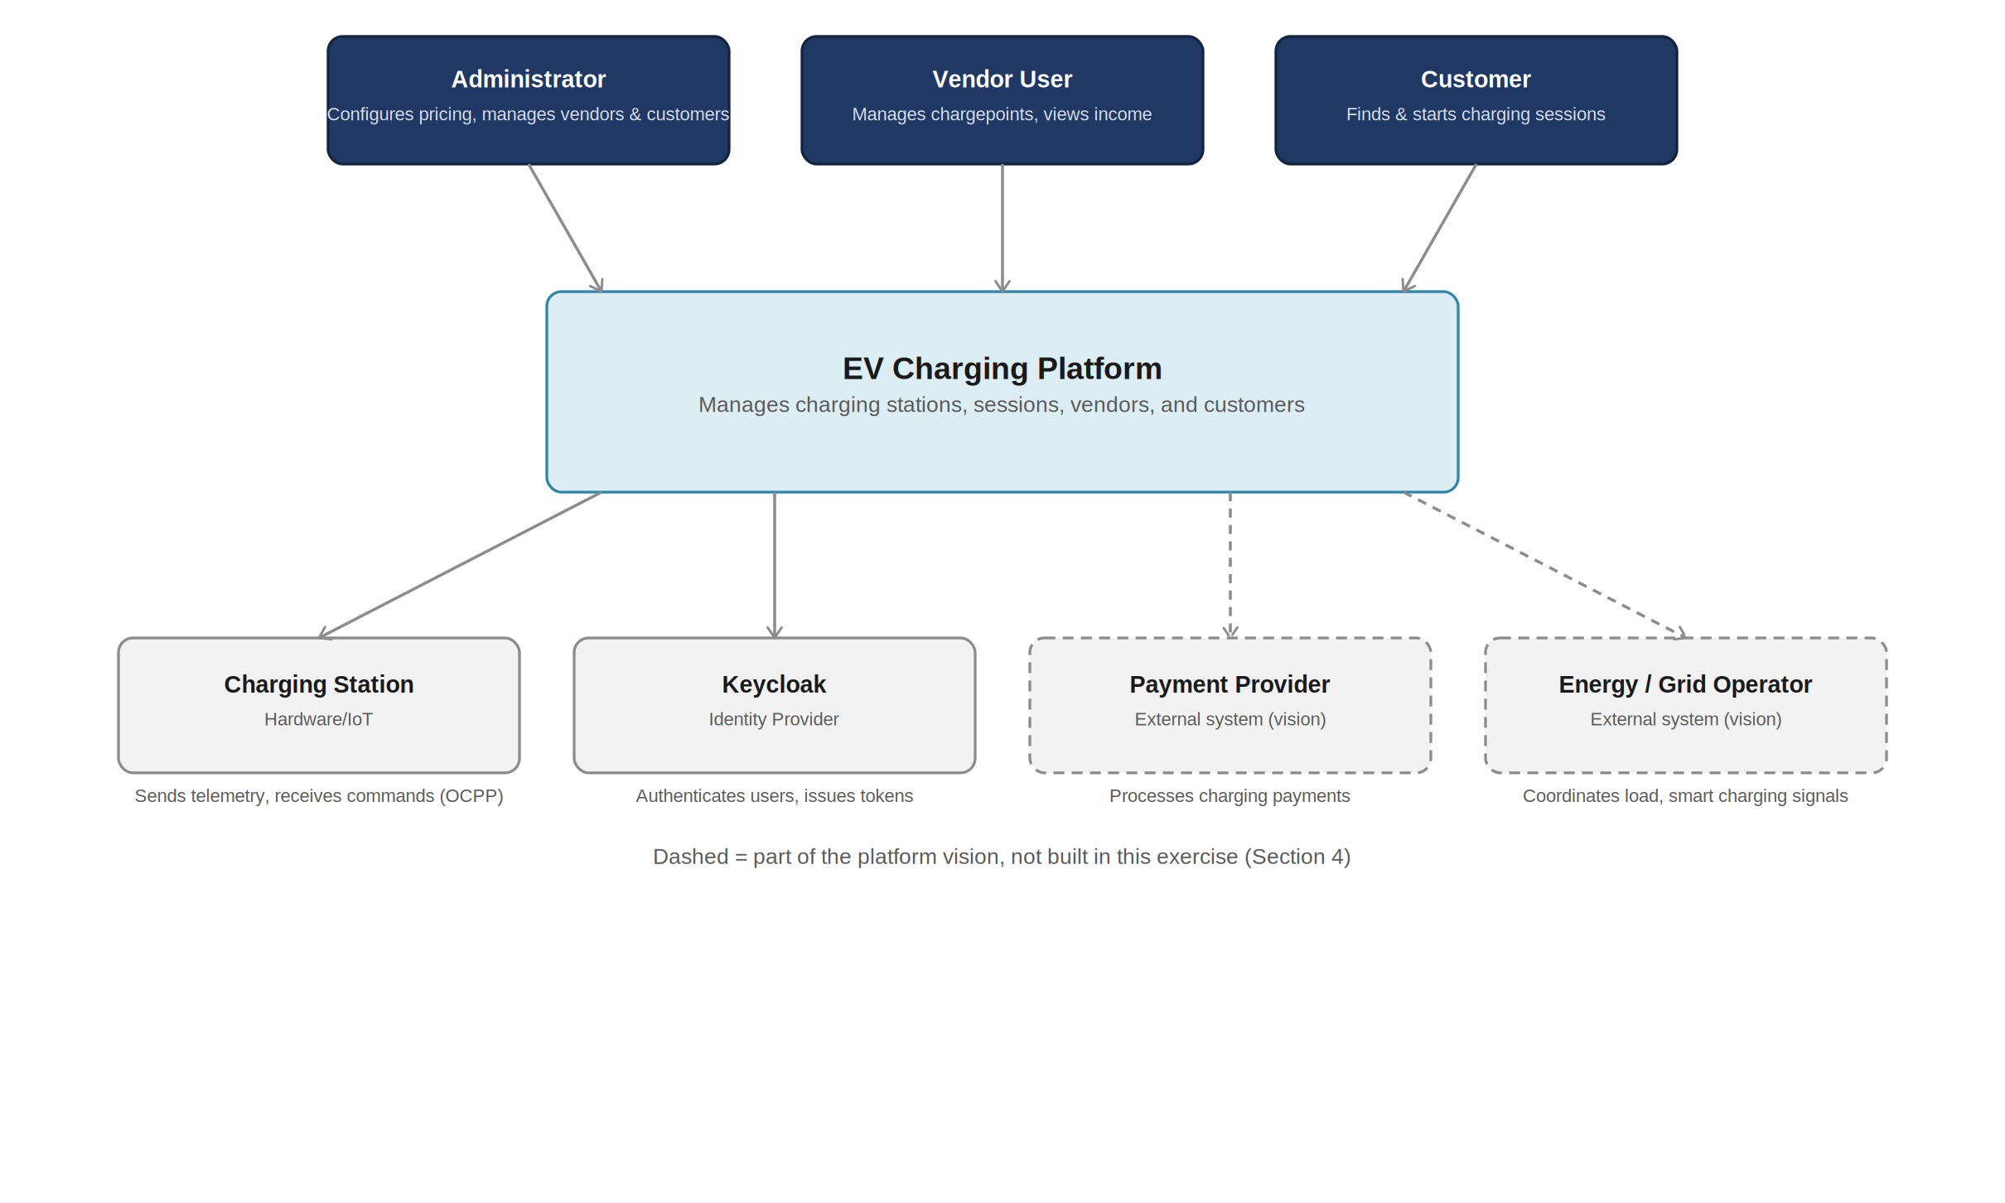
Figure 1 — C4 System Context: three actor types drive the platform from above; four external systems sit below it, two already relevant to this exercise (Charging Station hardware, Keycloak) and two that belong to the fuller platform vision (Payment Provider, Energy/Grid Operator).
Three things worth calling out about this boundary:
- The platform sits between two very different worlds: people using REST APIs on one side, and physical hardware speaking OCPP on the other. That asymmetry is the reason the internal architecture (Section 3) splits into an API Gateway path and a Device Gateway path rather than treating all traffic uniformly.
- Keycloak is drawn as an external system rather than inside the platform boundary on purpose — it's a dependency the platform trusts for identity, not a component the platform owns (Section 3.2).
- Payment Provider and Energy/Grid Operator are real relationships in the platform's target end-state, not in this exercise. They're included here so the business context is honest about where the platform is ultimately headed, with the exercise's actual boundary made explicit in Section 4.

2.2 Primary Business Use Cases
Every relationship in Figure 1 resolves into concrete use cases. These map directly onto the entity model's capability bullets (Section 5) and the traceability matrix (Section 16) — this table is the business-level summary; those sections are where each one is actually designed and verified:
Use Case | Primary Actor | Where It's Designed
Locate an available charging station and its price | Customer | Section 5 (Chargepoint), Section 7 (API)
Start a charging session, identified by RFID, plate, or manual selection | Customer | Section 5.5, Section 3.4.2
Monitor charging progress and stop a session | Customer / Platform | Section 5 (ChargingSession), Section 7
View charging session history and monthly totals, including the current partial month | Customer | Section 7 (GET /customers/{id}/sessions?month=)
Register and de-list vehicles | Customer | Section 5.1, Section 7
Add, update, and remove chargepoints | Vendor | Section 7 (chargepoint CRUD)
View income and charging activity, including current-month and per-chargepoint breakdowns | Vendor | Section 7 (GET /vendors/{id}/chargepoints/{cpId}/income)
Generate a session report for a chargepoint on a given date | Vendor | Section 7 (GET /chargepoints/{id}/sessions/report)
Manage vendor-owned resources according to assigned permissions | Vendor User | Section 5.4, Section 6
Sign up a new vendor and invite its first vendor user | Administrator | Section 7 (POST /vendors)
Set the markup added to a vendor's unit price | Administrator | Section 3.1 (Pricing & Billing), Section 10.3
View income over a period, optionally filtered by vendor | Administrator | Section 7 (GET /admin/income)
Reset credentials for a user where appropriate | Administrator | Section 7 (POST /users/{id}/reset-credentials)
Search sessions, customers, and vehicles with partial-match terms | Administrator | Section 9 (full-text search)
These fourteen use cases are exhaustive against the brief (Section 16 confirms this bullet by bullet) and map cleanly onto three of the four actor types in Figure 1. The fourth — the charging station itself — doesn't drive a “use case” in the traditional sense; it's the source of the telemetry events described in Section 3.4.3, which is why it's modelled as an external system rather than a person in the C4 diagram.

3. Platform Vision: High-Level Architecture (C4 Level 2: Container Diagram)
Where Section 2.1 showed the platform as a single box (C4 Level 1: System Context), this section opens it up one level. Every box below is a container in the C4 sense — an independently runnable or deployable unit with its own technology choice — and the same actors and external systems from Section 2.1 (Administrator, Vendor User, Customer, Charging Station, Keycloak, Payment Provider) reappear here, now shown crossing into or out of an explicit system boundary rather than connecting to one opaque box.
The same domain naturally extends into a multi-sided EV charging network platform in the style of ChargePoint, Tesla Supercharger, or Shell Recharge — connecting operators, vendors, customers, vehicles, payments, energy providers, and IoT devices. The diagram below is the target end-state architecture this platform grows toward, not what was built for this exercise.
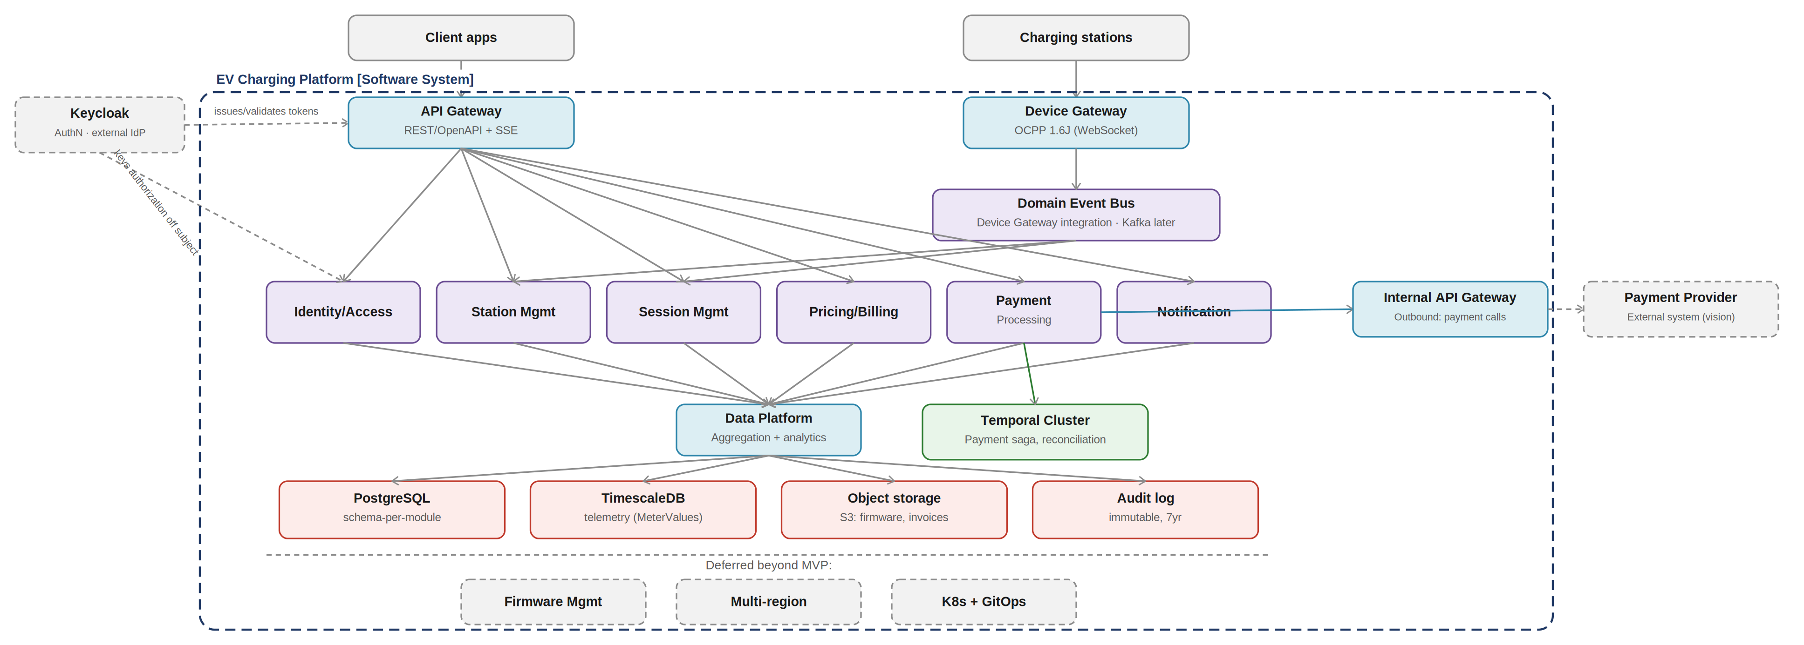
Figure 2 — C4 Level 2 Container Diagram: the dashed boundary marks everything that belongs to the EV Charging Platform as a software system. The API Gateway calls each internal service directly for synchronous client requests; the Domain Event Bus is a separate, narrower integration layer carrying charger telemetry from the Device Gateway to the two services that consume it. Keycloak and Payment Provider are external systems whose connectors cross the boundary; a Temporal Cluster inside the boundary orchestrates the payment/reconciliation workflow.
The diagram deliberately shows two distinct integration paths rather than one shared bus, because they solve different problems:
- API Gateway → services (direct, synchronous) — client requests (mobile app, admin dashboard, vendor portal) are request/response by nature: “create this vendor,” “show me this session.” The gateway calls the relevant service directly over REST; there is no reason to route a synchronous read or write through an event bus, and doing so would only add latency and an unnecessary point of failure.
- Device Gateway → Domain Event Bus → Station Mgmt, Session Mgmt (asynchronous) — charger telemetry (Heartbeat, StatusNotification, MeterValues, Start/StopTransaction) is fundamentally event-shaped and one-to-many in effect: a single OCPP message needs to update station health and progress an active session, without the charger itself waiting on either. The event bus is scoped specifically to this integration, not used as a general-purpose message bus for every service.

3.1 Target Service Decomposition
Domain-driven decomposition gives each bounded context clear ownership of its own data. Client-facing services are reached directly through the API Gateway; Station Mgmt and Session Mgmt additionally consume device events from the Domain Event Bus:
Service | Core Responsibility | Key Entities
Identity & Access | Authorization: RBAC, fine-grained permissions, role-to-resource mapping. Authentication itself is delegated to an external IdP (see Section 3.2) | Roles, Permissions, UserProfile (linked to IdP subject)
Station Mgmt | Station registry, connectors, health, firmware metadata | Stations, Connectors, Vendors, Firmware
Session Mgmt | Charging session lifecycle, metering, state machine | Sessions, Transactions, MeterValues
Pricing & Billing | Tariff rules, cost calculation, invoicing | Tariffs, PriceRules, Invoices
Payment Processing | Payment orchestration, provider integration, PCI scope | Payments, Refunds, PaymentMethods
Notification | Multi-channel delivery, templates, preferences | Notifications, Templates, Channels
Device Gateway | OCPP protocol handling, message routing, device auth | DeviceConnections, MessageQueue
This decomposition is deliberately close to the module boundaries already used inside the exercise's monolith (Section 5 onward) — the intent is that today's internal module split is tomorrow's service split, not a different shape entirely.

3.2 Authentication vs. Authorization: Where the Boundary Sits
Keycloak (or an equivalent OIDC provider) owns authentication — verifying credentials, MFA, social/enterprise login, and issuing the token. Identity & Access owns authorization — interpreting that token's identity against this platform's own roles and permissions to decide what the caller may do. This split is deliberate rather than incidental: authentication is a solved, standardised problem that a generic IdP handles well precisely because it knows nothing about this domain, while authorization here is domain-specific and changes whenever the business rules do (a new vendor-permission type, a new admin capability). Keeping them separate means adding a permission never touches IdP configuration, and rotating or replacing the IdP never touches authorization logic.
Concretely: Keycloak issues a token carrying a stable subject identifier and, at most, a coarse account type (admin, vendor user, customer). Identity & Access holds the fine-grained permission model — the vendor-user permission set from Section 5.4, tenant scoping from Section 6 — keyed off that subject identifier, not duplicated into the IdP. The API Gateway's Resource Server role (Section 8) is the seam between the two: it validates the token came from a trusted issuer, then passes the validated identity through for Identity & Access and each service's own authorization checks to interpret.

3.3 Component Descriptions
Every box in Figure 2 has a distinct, single-sentence job. Grouped by layer, each with the technology it's actually built (or planned to be built) in:

Entry Points, Gateways & Integration
Component | Responsibility | Technology | Talks To
Client apps | Mobile app, vendor portal, and admin dashboard — anything a person uses to interact with the platform. Not built in this exercise (no UI required). | External (not built) | Keycloak (login), API Gateway (everything else)
Charging stations | Physical AC/DC/ultra-fast chargers in the field. Speak OCPP, not REST — they are hardware, not API clients. | External (hardware) | Device Gateway (OCPP over WebSocket)
Keycloak | Owns authentication: credential verification, MFA, social/enterprise login, and JWT issuance. Knows nothing about this platform's domain — deliberately (Section 3.2). | External (OIDC provider) | Client apps (login flow), API Gateway (token trust)
API Gateway | Single entry point for synchronous client traffic. Terminates TLS, validates JWTs as an OAuth2 Resource Server, and routes each request directly to the owning service. Carries no business logic. | Spring Cloud Gateway | Keycloak (token validation), all six domain services directly
Device Gateway | The protocol boundary for physical hardware. Handles OCPP connection lifecycle (BootNotification, Heartbeat, Authorize) and translates raw OCPP frames into normalised domain events, so no other service has to speak OCPP. | Spring Boot + WebSocket | Charging stations (OCPP), Domain Event Bus (publishes events)
Domain Event Bus | A narrow, purpose-built integration layer — not a general message bus for the whole platform. Carries charger telemetry from the Device Gateway to exactly the two services that need it. In-process today; Kafka if device volume later demands durable, replayable delivery. | In-process → Kafka later | Device Gateway (consumes from), Station Mgmt + Session Mgmt (publishes to)

Domain Services
Component | Responsibility | Technology | Talks To
Identity & Access | Authorization only (Section 3.2): RBAC, fine-grained permissions, tenant/vendor scoping, keyed off Keycloak's subject identifier. | Spring Boot | API Gateway (direct); consulted by every other service for authorization decisions
Station Mgmt | Station and chargepoint registry: ownership, connectors, unit price, availability, firmware metadata. Updates health/status from device telemetry. | Spring Boot | API Gateway (direct); Domain Event Bus (StatusNotification, Heartbeat)
Session Mgmt | Charging session lifecycle: start, stop, metering, state. Owns the transactional record of what happened during a charge. | Spring Boot | API Gateway (direct); Domain Event Bus (StartTransaction, MeterValues, StopTransaction)
Pricing & Billing | Tariff rules, markup/rate calculation, invoice generation. In the exercise, only the rate-calculation half of this is built (Section 15.1). | Spring Boot | API Gateway (direct); called by Session Mgmt for the effective rate
Payment Processing | Payment orchestration and provider integration (e.g. Stripe, Adyen), kept out of PCI scope for the rest of the platform via tokenisation. | Spring Boot | API Gateway (direct); triggered by session-completed / invoice-generated events; Internal API Gateway (outbound); Temporal Cluster (orchestration)
Notification | Multi-channel delivery (push, SMS, email) driven by domain events — session complete, payment failed, station offline. | Spring Boot | API Gateway (direct, for preferences); triggered by events from other services

Outbound Integration & Workflow Orchestration
Two components exist purely to serve Payment Processing's external-facing responsibilities, and neither is a domain service in its own right:
Component | Responsibility | Technology | Talks To
Internal API Gateway | Egress point for calls out to external providers — isolates services from third-party API specifics (retries, circuit breaking, credential rotation) behind a stable internal interface. The inverse of the (inbound) API Gateway: this one exists so services never hold a direct dependency on a vendor's SDK. | Spring Cloud Gateway | Payment Processing (outbound); Payment Provider (external)
Payment Provider | Third-party payment processor (e.g. Stripe, Adyen) that actually moves money. External system (Section 2.1), not owned by this platform — the same box shown in the C4 context diagram. | External (Stripe/Adyen) | Internal API Gateway
Temporal Cluster | Durable workflow orchestration engine for the payment and reconciliation process — gives each step of the session-completion chain (Section 3.4.4) automatic retry, durable state that survives a crash, and visibility into exactly where a stuck workflow is stuck. Only justified once a workflow spans multiple services with real failure modes to recover from (Section 14). | Temporal | Payment Processing (primary); coordinates with Pricing & Billing and Notification for the same workflow

Data Layer
Component | Responsibility | Technology | Talks To
Data Platform | Aggregates data out of all six domain services into read models for reporting, analytics, and search — so operational services stay lean and don't carry reporting-query load. | Spring Boot (batch/stream) | All six domain services (consumes from)
PostgreSQL | System of record, one logical schema per module (Section 10.1). Source of truth for every domain service's own data. | PostgreSQL | Every domain service (its own schema only)
TimescaleDB | High-volume, time-series telemetry — MeterValues readings arrive far more often than session or station records change, and benefit from time-partitioned storage. | TimescaleDB | Data Platform (ingest and query)
Object storage (S3) | Large or binary artefacts that don't belong in a relational row: firmware images, generated invoice PDFs. | AWS S3 (or equiv.) | Station Mgmt (firmware), Pricing & Billing (invoices)
Audit log | Immutable, append-only record of business-significant mutations, retained for compliance (7 years). Written to, never queried by, the business logic. | Append-only table | Every domain service (write-only)

3.4 Architecture Flows
Four flows explain how the components in Figure 2 actually cooperate. The first two are the platform's everyday paths; the third and fourth show why the event bus and a decoupled billing step exist at all.

3.4.1 Authentication Flow
- A client app authenticates directly against Keycloak (username/password, MFA, or social/enterprise login — entirely outside this platform's own code).
- Keycloak issues a JWT carrying a stable subject identifier and a coarse account type (admin, vendor user, customer).
- The client attaches that token as a Bearer credential to every subsequent API Gateway request.
- The API Gateway, acting as an OAuth2 Resource Server, validates the token's signature, expiry, and issuer against Keycloak's public keys — it never contacts Keycloak synchronously per request.
- The validated identity is passed downstream; Identity & Access and each service's own authorization logic interpret it against this platform's permission model (Section 3.2), not against anything Keycloak knows.

3.4.2 Synchronous Client Request Flow
Example: a vendor requesting their chargepoint income breakdown.
- Client app calls GET on the API Gateway with its Bearer token.
- The gateway validates the token (Flow 2.4.1) and routes the request directly to Station Mgmt (or whichever service owns that endpoint) — no event bus involved, because this is a request/response read, not a telemetry event.
- Station Mgmt checks the caller's permissions (vendor-scoped access to this specific vendor's data) before querying its own PostgreSQL schema.
- For aggregate or historical views, Station Mgmt may instead query the Data Platform's read models rather than recomputing from source tables on every request.
- The response returns through the gateway to the client.

3.4.3 Charger Telemetry Flow (Event-Driven)
Example: a charging station reporting a MeterValues reading mid-session.
- The physical charger sends an OCPP MeterValues message over its WebSocket connection to the Device Gateway.
- The Device Gateway translates this OCPP-specific payload into a normalised domain event and publishes it to the Domain Event Bus — downstream services never see raw OCPP.
- Session Mgmt consumes the event to update the in-progress session's energy total; Station Mgmt separately consumes StatusNotification/Heartbeat events to keep chargepoint health current.
- Each service persists to its own schema independently — there is no synchronous call from the charger all the way through to a database write, so a slow or unreliable charger connection never blocks business logic.
- The Data Platform later aggregates from both services for reporting; the raw telemetry itself lands in TimescaleDB.

3.4.4 Session Completion & Billing Flow
This flow is deliberately decoupled rather than a single synchronous chain, echoing the reasoning already captured in Section 14's decision log (cross-module transactions, payment settlement).
- Session Mgmt marks a session complete (charger sent StopTransaction, or the customer ended it via the app) and emits a session-completed event.
- Pricing & Billing consumes that event, calculates the final cost, and generates an invoice.
- Payment Processing consumes the invoice event and attempts to charge the customer's stored payment method — asynchronously, with retry, so a slow or failed charge never blocks the charger from disconnecting or the customer from driving away. This call goes out through the Internal API Gateway, never directly to the payment provider's SDK.
- Notification consumes events from both Pricing & Billing and Payment Processing to send the customer a receipt, or an operator an alert if payment ultimately fails after retries.
- Every step here is a separate service reacting to an event, not a single request holding a connection open across four services — exactly the kind of chain the vision's saga-style, event-driven design (Section 14) is built to avoid doing synchronously.
At this scale, steps 1–4 are realised as a single Temporal workflow rather than four independent event handlers. The distinction matters once things fail partway through: a plain event handler that crashes after charging the customer but before sending the receipt leaves no record that the receipt is owed, while a Temporal workflow persists its progress durably and resumes exactly where it left off. The same engine also runs the platform's reconciliation jobs — periodically checking for sessions whose payment never completed and retrying or escalating them — which is a poor fit for one-shot event handlers but a natural fit for a workflow engine designed around long-running, resumable state.

4. Scope of This Exercise (Timeline-Driven)
Given the exercise's timeline, the design deliberately does not build the vision architecture above. Instead, it implements a modular monolith covering the domains that are explicit, testable requirements in the brief — station, vendor, customer, and session management, with authentication and full-text search — while structuring the code so each domain remains a clean, extractable module.
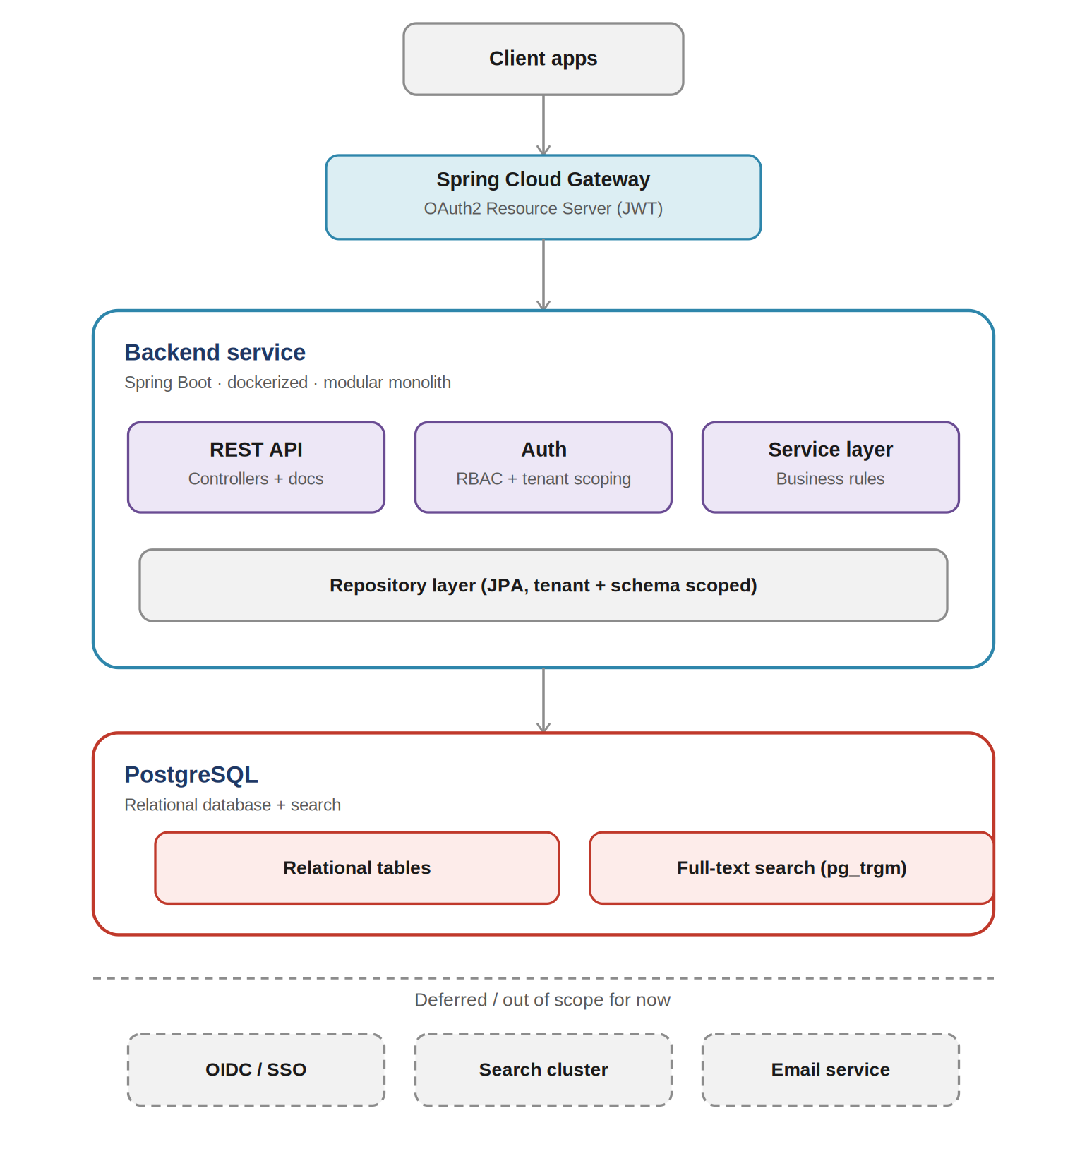
Figure 3 — What was actually built: a Spring Cloud Gateway (OAuth2 Resource Server) fronting a single dockerized Spring Boot service over one PostgreSQL instance, with the deferred vision components shown for contrast.
Four architectural decisions define this scope. Each is deliberate, not a default, and each is explained below on its own terms rather than left implicit.

4.1 Why a Modular Monolith, Not Microservices
The vision architecture (Section 3) decomposes into seven services. Building that here would be over-engineering relative to both the timeline and the actual scale: there is one team, one deployable, and no requirement anywhere in the brief that implies independent scaling or independent release cycles for, say, Station Mgmt versus Session Mgmt. Microservices trade in-process simplicity for distributed-systems cost — network calls in place of function calls, eventual consistency in place of a single transaction, service-to-service auth, and separate deployment pipelines — and that cost only pays for itself once something actually needs to scale, deploy, or fail independently. Nothing here does yet.
The modular monolith is not a rejection of the vision, it's the same module boundaries (Section 3.1) built as one deployable instead of seven. Each module's package structure, schema, and interface (Section 10) are already shaped the way they'd need to be to split later (Section 15) — the decision is about deployment topology today, not about the domain model, which is identical either way.

4.2 Why Spring Cloud Gateway as an OAuth2 Resource Server
Authentication is fronted by a Spring Cloud Gateway configured as an OAuth2 Resource Server, sitting in front of the backend service rather than JWT validation being hand-rolled inside the application itself. The gateway validates tokens (signature, expiry, issuer) at the edge; the backend service then only has to handle role-based authorization and tenant scoping (Section 6), not token mechanics. This is a deliberate, small piece of extra structure that pays for itself immediately: swapping in an external identity provider later (Keycloak, Azure AD, or similar) is a gateway configuration change — pointing it at a different issuer/JWKS endpoint — not a rewrite of authentication logic scattered across controllers. It also gives a single, obvious place to add rate limiting or request logging later, without touching business code.

4.3 Inter-Module Communication
Within the monolith, modules call each other directly, in-process, through plain Java interfaces — not REST calls to itself, and not a message broker between modules that live in the same deployable. This is the opposite decision from the vision's Domain Event Bus, and deliberately so: an event bus earns its place when the producer and consumer are decoupled in time, volume, or reliability (exactly the Device Gateway's situation, Section 3.4.3) — a charger's telemetry arrives whether or not Session Mgmt is ready for it, at a volume and reliability the charger doesn't control. Two modules inside the same running process, sharing the same deployment and the same failure domain, have none of that asymmetry: adding a network hop or a broker between them would add latency and a new failure mode for zero isolation benefit, since they already start, stop, and crash together.
The isolation that actually matters here — one module's code not reaching into another module's tables or internals — is enforced where it belongs: at compile time, via package boundaries and the ports/adapters discipline in Section 10.2, not at runtime via a network boundary. This is exactly what makes the modules extractable later without redesigning them: swapping an in-process call for an HTTP or gRPC client (Section 15.4) is a change to the adapter, not to the module's own logic.

4.4 Cross-Module Orchestration Workflow
The one place this exercise coordinates across modules is session completion: Session Mgmt calls the Pricing module synchronously to get the effective rate, then persists the session with that rate snapshotted (Section 5.2, Section 5.3). This is deliberately the simplest possible orchestration — a single method call inside a single database transaction, not a saga, not a workflow engine, and not explicit compensating actions. That simplicity is earned, not accidental: with exactly one downstream call, in the same process, writing to schemas in the same database, an ordinary transaction already gives atomicity for free — if the rate lookup fails, the transaction simply rolls back, and there is no partial state to compensate for.
This is intentionally a smaller answer than the vision-scale reasoning in Section 14's decision log, which recommends a lightweight workflow orchestrator with explicit compensation once a flow spans multiple services (Section 3.4.4's session-completion-to-billing chain touches four, and is realised there by a Temporal Cluster). That machinery solves a problem this exercise doesn't have: nothing here calls out to something slow, unreliable, or external. The moment Payment Processing enters the picture — a call that can be slow, can fail independently, and must not block the charger or the customer — synchronous orchestration stops being sufficient and the vision's durable, workflow-engine-backed approach becomes the right one. Built correctly now, extending the module boundary (Section 4.1) is what makes that transition additive later rather than a rewrite.
Sections 5 through 13 describe this scoped design in detail. Section 14 reconciles a set of vision-scale architectural decisions against this baseline, and Section 15 maps the exercise's modules onto the target service decomposition.

5. Entity Model & Relationships
The core entities and their relationships, along with the non-obvious modelling decisions each one required:
Entity | Key Properties | Relationships | Notable Decision
AdminUser | name, email | Global scope | Not tenant-scoped; can act across all vendors
Vendor | name, account number | 1—N VendorUser; 1—N Chargepoint | Markup is configured per vendor by an admin, not per chargepoint
VendorUser | name, email, vendor | Belongs to exactly one vendor | “Assigned permissions” modelled as a dedicated permission set, not a single role flag
Chargepoint | unique identifier, group label, unit price, availability, vendor | Owned by one vendor | unit price is the vendor's base rate; customer price = base + vendor's markup
CustomerUser | name, email, account number, phone | 1—N Vehicle; 1—N ChargingSession | Billing is explicitly out of scope
Vehicle | registration plate, RFID, customer | Owned by one customer; can be de-listed / re-listed | Plate is not a durable unique key — the same plate can be re-registered under a new customer after resale
ChargingSession | start, end, vehicle, chargepoint, marked-up unit rate, error code, total energy, total charged | Belongs to one vehicle and one chargepoint | Snapshots the rate at session start rather than referencing a live price, to preserve historical accuracy

5.1 Vehicle Identity Over Time
Because a registration plate can be reassigned to a new owner after a vehicle changes hands, the plate cannot be the primary key. The Vehicle entity uses a synthetic identifier (UUID), with the plate stored as a non-unique, indexed attribute. De-listing is modelled as a soft-delete / status change so that historical charging sessions remain attributable, rather than a hard delete that would orphan session history.

5.2 Monetary Precision
Unit prices are specified in tenths of a cent, which rules out floating-point types for anything money-related. All monetary fields use integer minor-units (or BigDecimal with an explicit fixed scale) end-to-end — storage, calculation, and API payloads — to avoid rounding drift in markup and total-charged calculations.

5.3 Session Month Bucketing
Charging sessions belong to the month in which they start. Rather than computing this with a date-extraction expression on every aggregate query, a derived period column (e.g. year_month) is stored alongside the session so monthly income and usage rollups can be indexed and queried efficiently at scale.

5.4 Vendor User Permissions
The brief's phrase “according to their assigned permissions” implies more than a single role. The design introduces a small, explicit permission set (for example: manage chargepoints, view income, manage vendor users) attached to a VendorUser via a join table, rather than a single hard-coded role enum. This keeps the model extensible without requiring a schema change for each new permission.

5.5 Vehicle Identification at Session Start
A charging session needs to resolve which vehicle it belongs to before it can be created, and the brief specifies three identification paths: automatic RFID match, automatic plate detection, or manual customer selection — with an optional side effect where a manually-selected session that also has an RFID present associates that RFID with the vehicle for next time. This is modelled as part of the session-start request rather than as a separate identification service:
- RFID match — the request carries an RFID number; if it matches a vehicle already associated with one, that vehicle is used directly.
- Plate detection — the request carries a recognised registration plate; resolved against the customer's active vehicles by plate (Section 5.1 covers why plate alone isn't a durable identity across ownership changes).
- Manual selection — the customer (or client app) supplies a vehicleId directly; if an RFID is also present on the request and the vehicle doesn't already have one, it is stored against the vehicle for future automatic identification.
The actual RFID reader / plate-recognition hardware integration is out of scope for this exercise — there is no live device feed (Section 4) — but the data model and API contract for accepting any of the three identification methods, and for the RFID-association side effect, are built and testable against seed data.

6. Roles & Authorization Model
Authorization is enforced at two layers: role-based access (what an actor type may do) and tenant/row-level scoping (which specific records an actor may act on). This second layer is the more consequential design decision, since role checks alone do not prevent a vendor user from acting on another vendor's data.
- Admin — global read/write; cross-vendor income views; markup configuration; credential resets for any user.
- Vendor user — scoped strictly to their own vendor's chargepoints and sessions; specific actions gated further by assigned permissions.
- Customer — scoped strictly to their own vehicles, sessions, and account history.
Enforcement combines method-level authorization (e.g. Spring Security @PreAuthorize) with repository-level tenant filtering, so that scoping is not solely reliant on the API layer — a defence against IDOR-style access attempts on directly-guessed resource IDs.

7. API Surface
Beyond standard per-entity CRUD, the requirements imply a set of business-capability endpoints. These were prioritised over generic CRUD completeness, in line with the brief's guidance to favour judgement over exhaustive coverage:
- POST /vendors — admin onboards a vendor and invites the original vendor user
- POST /vendors/{id}/users — invite additional vendor users
- POST/PUT/DELETE /vendors/{id}/chargepoints — add, update, and remove a vendor's chargepoints
- PUT /vendors/{id}/markup — set the markup applied to a vendor's unit price
- POST /users/{id}/reset-credentials — admin credential reset
- GET /admin/income?vendorId=&from=&to= — income view, optionally filtered by vendor
- GET /vendors/{id}/chargepoints/{cpId}/income?breakdown=day|week|month — chargepoint-level activity, including the current month
- GET /chargepoints/{id}/sessions/report?date= — session report for a chargepoint on a given date
- POST /chargepoints/{id}/sessions — start a charging session; the vehicle is identified by RFID, by registration plate, or by manual customer/vehicle selection, and a newly-supplied RFID is associated with the vehicle when given during a manual selection (see Section 5.5)
- PATCH /sessions/{id}/stop — stop a charging session, recording end time, total energy, total charged, and an error code if the session was partially or fully unsuccessful
- GET /customers/{id}/sessions?month= — session history and totals, including the current partial month
- POST/DELETE /customers/{id}/vehicles — vehicle registration and de-listing
- GET /admin/search?q= — full-text search across sessions, customers, and vehicles
Client-application needs were considered even though no UI was required: list endpoints support pagination and filtering, and monetary/date fields use unambiguous, timezone-explicit representations to avoid client-side misinterpretation.

8. Authentication Approach
Chosen approach: a Spring Cloud Gateway configured as a stateless OAuth2 Resource Server sits in front of the backend service and validates every incoming JWT (signature, expiry, issuer) before a request reaches application code. Behind the gateway, the backend service carries a dedicated user table with a role (ADMIN, VENDOR_USER, CUSTOMER) and Argon2/BCrypt password hashing, and is responsible only for role-based authorization and tenant scoping (Section 6) — not for token validation itself. Token issuance is handled by the application for this exercise, but the validation path is written against the standard OAuth2/OIDC resource-server contract rather than a bespoke JWT filter.
Rationale: separating “is this token valid” (the gateway's job) from “what is this caller allowed to do” (the backend's job) is a cheap architectural seam that pays for itself immediately. The exercise is backend-only with no mandated identity provider integration, and no external client ecosystem to federate against yet, so building or running a full IdP isn't justified — but putting the resource-server boundary at the gateway rather than scattering JWT parsing across controllers means swapping in an external identity provider later is a gateway configuration change (pointing it at a different issuer/JWKS endpoint), not a rewrite of authentication logic throughout the application.
Deferred alternative: a managed identity provider (e.g. Keycloak) fronting the platform over OIDC, with the gateway simply pointed at it instead of the application's own token issuer. This is the right long-term choice once there are real first- and third-party client applications, mobile SDKs, or a need for social/enterprise login and centralised credential/MFA management — but running and operating an IdP is infrastructure overhead disproportionate to this exercise's scope. Documented here explicitly as a scale-driven, not correctness-driven, deferral, and one the gateway seam is specifically designed to make cheap when it happens. Note that this deferral only concerns authentication: the role-based authorization and tenant-scoping logic in Section 6 already lives entirely in the backend service and is unaffected either way, exactly matching the AuthN/AuthZ boundary described for the vision architecture in Section 3.2.

9. Full-Text Search Design
The requirement's own example — a search for “AUD” matching plates “AUD186” and “AUD994” — is a substring/prefix matching problem, not a tokenized full-text search problem. A conventional tokenizer would treat each plate as a single token and fail to match partial fragments.
Chosen approach: PostgreSQL's pg_trgm extension with a GIN trigram index over plate, account number, and error code fields, exposed through a single search endpoint. This gives indexed, reasonably fast partial-match search at the scale implied by the exercise without adding a separate search infrastructure component.
Alternatives considered and rejected for now:
- Plain SQL LIKE '%term%' — functionally adequate and simpler to stand up, but does not use an index and degrades badly as data volume grows; noted as an acceptable fallback if the trigram extension is unavailable in a given environment.
- Elasticsearch / OpenSearch — the natural next step once search volume, relevance ranking, or cross-entity search complexity grows beyond what pg_trgm comfortably handles, but disproportionate infrastructure for the exercise's current scale.

10. Data Architecture & Module Boundaries
Even inside a single deployable monolith, how modules share data determines whether the system stays extractable or quietly becomes a distributed monolith later. Two decisions matter here.

10.1 Schema-per-Module in a Single PostgreSQL Instance
Rather than one flat schema, tables are grouped into logical schemas aligned to the module boundaries in Section 3.1 (for example, station, pricing, session, and shared reference data). Modules access only their own schema; cross-module reads go through the owning module's service interface rather than a direct join. This costs nothing operationally today — it is still one database, one connection pool, one set of backups — but it means extracting a module into its own service later is a matter of moving its schema to its own database, not untangling shared tables.

10.2 Module Boundary Enforcement
Package structure mirrors the module boundaries, and boundaries are enforced at build time (for example, with ArchUnit rules forbidding one module's package from importing another module's internals directly). Cross-module interaction happens only through explicit service interfaces or an in-process domain event publisher, never direct field/entity access. This is the same discipline a hexagonal/ports-and-adapters style enforces: a module's core logic depends only on its own ports, and the adapter wiring is what would change if a module were later called over REST/gRPC instead of in-process.

10.3 Concrete Modules in This Exercise
To keep the exercise's baseline honest against the vision decomposition in Section 3.1, the monolith is organised into five concrete modules rather than a generic layered structure. This is a deliberate, confirmed choice for the exercise: the deployment unit is a single modular monolith, not separate services, but each module below is named, scoped, and kept separate to match a vision service one-for-one wherever a corresponding vision service exists — including keeping pricing and billing logic out of the session module entirely.
Module | Owns | Vision Service Alignment
Identity & Access | Users, roles, permissions, credential management — an interim consolidation of both authentication and authorization, since this exercise has no external IdP (Section 3.2) | Matches Identity & Access's authorization responsibility directly; also stands in for Keycloak's authentication role until an external IdP is introduced
Station Mgmt | Vendor, VendorUser, Chargepoint (including the vendor's base unit price) | Matches Station Mgmt directly
Pricing | Admin-configured markup, and the calculation that combines a vendor's base price with the markup into an effective rate. Invoicing and billing statements are not built (Section 12.3) | Covers the pricing half of Pricing & Billing; kept as its own module rather than folded into Session Mgmt
Session Mgmt | CustomerUser, Vehicle, ChargingSession; calls Pricing for the effective rate and snapshots the result onto the session at start time | Matches Session Mgmt directly
Reporting & Search | Income views, chargepoint/session reports, pg_trgm search | Corresponds to Data Platform / Analytics, implemented as a capability over the other modules' data rather than a separate module
Payment Processing, Notification, and Device Gateway have no corresponding module in this exercise at all — not simplified, not embedded, simply not built, for the reasons given in Section 12.3. Pricing, by contrast, is fully built as its own module covering rate and markup calculation — it does not cover invoicing or billing statements, which stay out of scope. Session Mgmt only owns session lifecycle data and calls into Pricing through a service interface to get the rate to snapshot, rather than calculating it itself. This keeps the two responsibilities — “what did this session cost” and “what is a vehicle doing right now” — independently testable and independently extractable.

11. Build Order
- Scaffold the Spring Boot project (Web, JPA, Security, Postgres) with schema migrations and seed data, using logical per-module schemas from the start.
- Implement the authentication foundation — user/role model, OAuth2 resource-server JWT validation, security configuration — before any business endpoints.
- Build core CRUD for vendors, vendor users, chargepoints, customers, and vehicles, with tenant-scoping designed in from the start rather than retrofitted.
- Implement charging sessions, including rate snapshotting, month bucketing, and monetary calculations.
- Build the reporting endpoints — income breakdowns and chargepoint session reports.
- Add full-text search via pg_trgm and a GIN index.
- Add API documentation (OpenAPI/Swagger), Dockerfile and docker-compose, and automated tests for the pricing and tenancy logic.
- Write up this design-decisions document alongside the code.

12. What Was Built, Simplified, and Deferred
Consistent with the brief's preference for well-reasoned trade-offs over completeness, this section makes explicit what was fully implemented, what was implemented in a deliberately narrower form, and what was left out entirely with a stated production path.

12.1 Built (fully implemented)
Area | What | Why it made the cut
Core entity model | AdminUser, Vendor, VendorUser, Chargepoint, CustomerUser, Vehicle, ChargingSession with correct relationships and constraints | Foundation everything else depends on
Multi-tenant CRUD | Full CRUD for vendors, chargepoints, customers, vehicles, with tenant-scoped repository queries | Demonstrates the core architectural judgement call (row-level isolation)
Charging session recording | Session creation with vehicle identification (RFID, plate, or manual selection), rate-snapshotting, month bucketing, energy/total calculations | Transactional heart of the domain — has to be correct
Authentication | Spring Cloud Gateway as OAuth2 Resource Server (JWT validation at the edge), role model (ADMIN / VENDOR_USER / CUSTOMER), password hashing | Explicit deliverable — REST API with authentication
Full-text search endpoint | pg_trgm + GIN index search across plate, account number, error code, with partial-match support | Explicit, testable requirement with a concrete worked example
API documentation | Swagger / OpenAPI | Explicit deliverable
Dockerised solution + seed data | Docker Compose (app + Postgres), SQL seed script on startup | Explicit deliverable
Core automated tests | Unit tests for pricing/markup math and tenant-scoping logic; integration tests on the trickiest endpoints | Highest-risk areas for silent breakage

12.2 Simplified (built, but deliberately narrower than a full production version)
Area | What was simplified | Why
Vendor user permissions | A small fixed permission set (e.g. manage chargepoints, view income, manage vendor users) rather than a configurable permission-builder | Proves the extensible data-model pattern without building unrequested admin tooling
Reporting breakdowns | Day/week/month income views implemented; custom date ranges and YoY comparisons left out | Covers what's explicitly requested; open-ended reporting has no fixed spec
Search | Trigram substring search across the three named fields only, not a general-purpose search-everything endpoint | Matches the exact requirement given; broader scope wasn't asked for
Validation & error handling | Solid validation where correctness risk is highest (money, session data); lighter elsewhere | Time-boxing judgement — depth where it matters most

12.3 Deferred (explicitly not built, with a stated production path)
Area | Deferred to | Why deferred
Billing / invoicing | Out of scope entirely | Brief explicitly states billing is handled elsewhere
Managed identity provider (OIDC) | Documented as the production path (e.g. Keycloak) | No external client ecosystem yet to justify the infrastructure; resource-server JWT validation is proportionate now
Elasticsearch / OpenSearch | Documented as the natural next step if search volume/relevance needs grow | pg_trgm fully satisfies the stated requirement at this scale
Email delivery (invites, credential resets) | Endpoint stubbed / logged; real delivery via SES/SendGrid noted | Delivery integration is an ops/vendor decision, not an architecture decision
Rate limiting / API gateway | Noted as a platform-layer concern | Belongs at the infrastructure/gateway level in production
Full audit logging | Noted as required for production | Valuable but orthogonal to proving the core design; would duplicate effort across every write endpoint
CI/CD pipeline | Noted as next step | Not part of the stated deliverables

12.4 The Underlying Logic
Everything in Built either directly satisfies an explicit deliverable or is foundational to correctness (money, tenancy, auth). Everything in Simplified proves the right pattern at a scope that matches what was actually asked, rather than gold-plating unrequested flexibility. Everything in Deferred is a genuine infrastructure/scale decision — each becomes more right as the platform grows, but would be premature optimisation today. This premature-versus-proportionate framing is the throughline behind every trade-off in this document.

13. Non-Functional & Productionisation Considerations
- Multi-tenant data isolation as a first-class security concern — enforced at both the authorization and repository/query layer, not just at the API boundary.
- Monetary precision — integer minor-units or fixed-scale BigDecimal throughout, with an explicit, documented rounding policy for markup calculations.
- Timezone handling — an explicit policy (e.g. UTC storage, vendor-local display) for “month” boundaries and the “current partial month” view, since this is otherwise a silent source of off-by-one-day bugs.
- Idempotency — charging session creation should tolerate retries from an unreliable chargepoint connection without creating duplicate sessions.
- Observability — lightweight, standards-based instrumentation (structured logs with correlation IDs, health checks, basic metrics) from day one; full OpenTelemetry-backed tracing/metrics/log stack (e.g. Grafana Loki/Tempo/Mimir) deferred until operational scale justifies it. The cheap part (correlation IDs, consistent structured logging) is worth doing immediately; the expensive part (running an observability platform) is not.
- Backup & recovery — for this exercise, managed PostgreSQL backups plus an append-only audit trail for key business events are sufficient. Full point-in-time recovery, tiered retention, and cross-region replication are noted as production requirements once real transactional and payment data exist.
- Rate limiting — basic protection would sit at the API gateway layer in production; not implemented here, but the design keeps an extension point (a single ingress point per client type) rather than scattering ad-hoc limits through business logic.
- Migration strategy — Flyway/Liquibase-managed schema migrations in production, in place of the SQL-at-startup approach used for this exercise's test data.

14. Architecture Decision Log: Reconciling Vision-Scale Decisions
A separate design-review session worked through twenty vision-scale architectural questions for this domain — protocol choice, service decomposition, data architecture, transactions, auth, observability, deployment, and more. None of those decisions required changing the exercise's scope or direction; if anything, they independently converged on the same modular-monolith-first approach taken here. This table reconciles each decision against this document's baseline so the alignment is explicit rather than assumed.
Decision Area | Vision-Scale / MVP Recommendation | Status vs. This Baseline
Device communication protocol | OCPP 1.6J over WebSocket, behind a protocol abstraction layer; migrate to 2.0.1 later | New scope — not built; this exercise has no live device gateway (Section 4)
Service decomposition | DDD boundaries: Identity, Station, Session, Pricing & Billing, Payment, Notification, Device Gateway | Aligned — mirrors this document's module split (Sections 3.1, 15)
Deployment shape for v1 | Modular monolith with enforced module boundaries, not microservices | Aligned — this is the exercise's core architectural choice (Section 4, 10.2)
Data ownership | Single PostgreSQL, schema-per-module, no cross-schema joins | Adopted as refinement — formalised in Section 10.1
Inter-module communication | Hexagonal ports/adapters; in-process now, swappable to REST/gRPC later | Adopted as refinement — formalised in Section 10.2
Cross-module transactions | Lightweight workflow orchestrator with explicit compensation; Temporal later if needed | New scope — this exercise has a single-service transaction (session create + price calc); no multi-step saga exists yet
External API contract | REST + OpenAPI for commands/queries; SSE for real-time updates | Partially aligned — REST + OpenAPI built (Section 7); SSE deferred, no real-time push requirement in this exercise
Authentication | OAuth2/OIDC resource-server pattern; avoid standing up an IdP until justified | Aligned — matches this document's authentication decision exactly (Section 8)
Device Gateway isolation | Dedicated module, isolated from Station Mgmt, simple stack for v1 | New scope — no device gateway in this exercise; noted as a future module (Section 15)
Billing & payment | Separate Billing and Payment modules; tokenised payment methods; settlement decoupled from session lifecycle | Directionally aligned — billing/payment explicitly deferred here (Section 12.3) for the same reason: keep it out of the core transaction path
Observability | OTel-style instrumentation from day one; defer the full backend stack | Aligned — matches Section 13's observability stance exactly
Deployment infrastructure | Containerise from day one; defer Kubernetes/GitOps until scale justifies it | Aligned — this exercise ships Docker Compose, not Kubernetes
Firmware management | Metadata-only in Station Mgmt for v1; defer staged rollout entirely | New scope — firmware is outside this exercise's entity model; noted for future extension
Multi-vendor isolation | Vendor-scoped data with logical isolation, not physical multi-tenancy | Aligned — this is exactly this document's tenancy model (Section 6)
Session lifecycle modelling | Simplified lifecycle for v1; protocol state and business state kept separate | Partially aligned — this exercise models session data, not a full protocol-vs-business state machine (no live device feed to drive one)
Rate limiting | Basic protection at the gateway layer for v1; defer granular per-domain limits | Aligned — matches Section 13's rate-limiting stance
Testing strategy | Strong unit + integration tests; defer formal contract testing until modules are extracted | Aligned — matches this document's testing scope (Section 12.1)
Backup & disaster recovery | Managed backups + immutable audit log for v1; defer full PITR and DR drills | Aligned — matches Section 13's backup stance exactly
Multi-region deployment | Single region, multi-AZ for v1; multi-region only when latency/compliance demands it | Out of scope — not applicable at this exercise's scale; no change needed
CI/CD | Simple build/test/scan/deploy pipeline; defer GitOps and progressive delivery | New scope — CI/CD noted as future work (Section 12.3), consistent with this recommendation
Two genuinely new pieces of scope came out of this reconciliation and are worth calling out explicitly: schema-per-module data ownership (Section 10.1) and explicit module-boundary enforcement (Section 10.2). Both were folded into the baseline design above because they cost nothing at this scale and materially improve the platform's evolution path — exactly the kind of refinement this reconciliation process is meant to surface.

15. Adapting the Exercise Design to the Platform Vision
This section makes the evolution path concrete: which of the exercise's five modules (Section 10.3) map directly onto the target service decomposition, and which vision services are net-new builds triggered only by real demand.
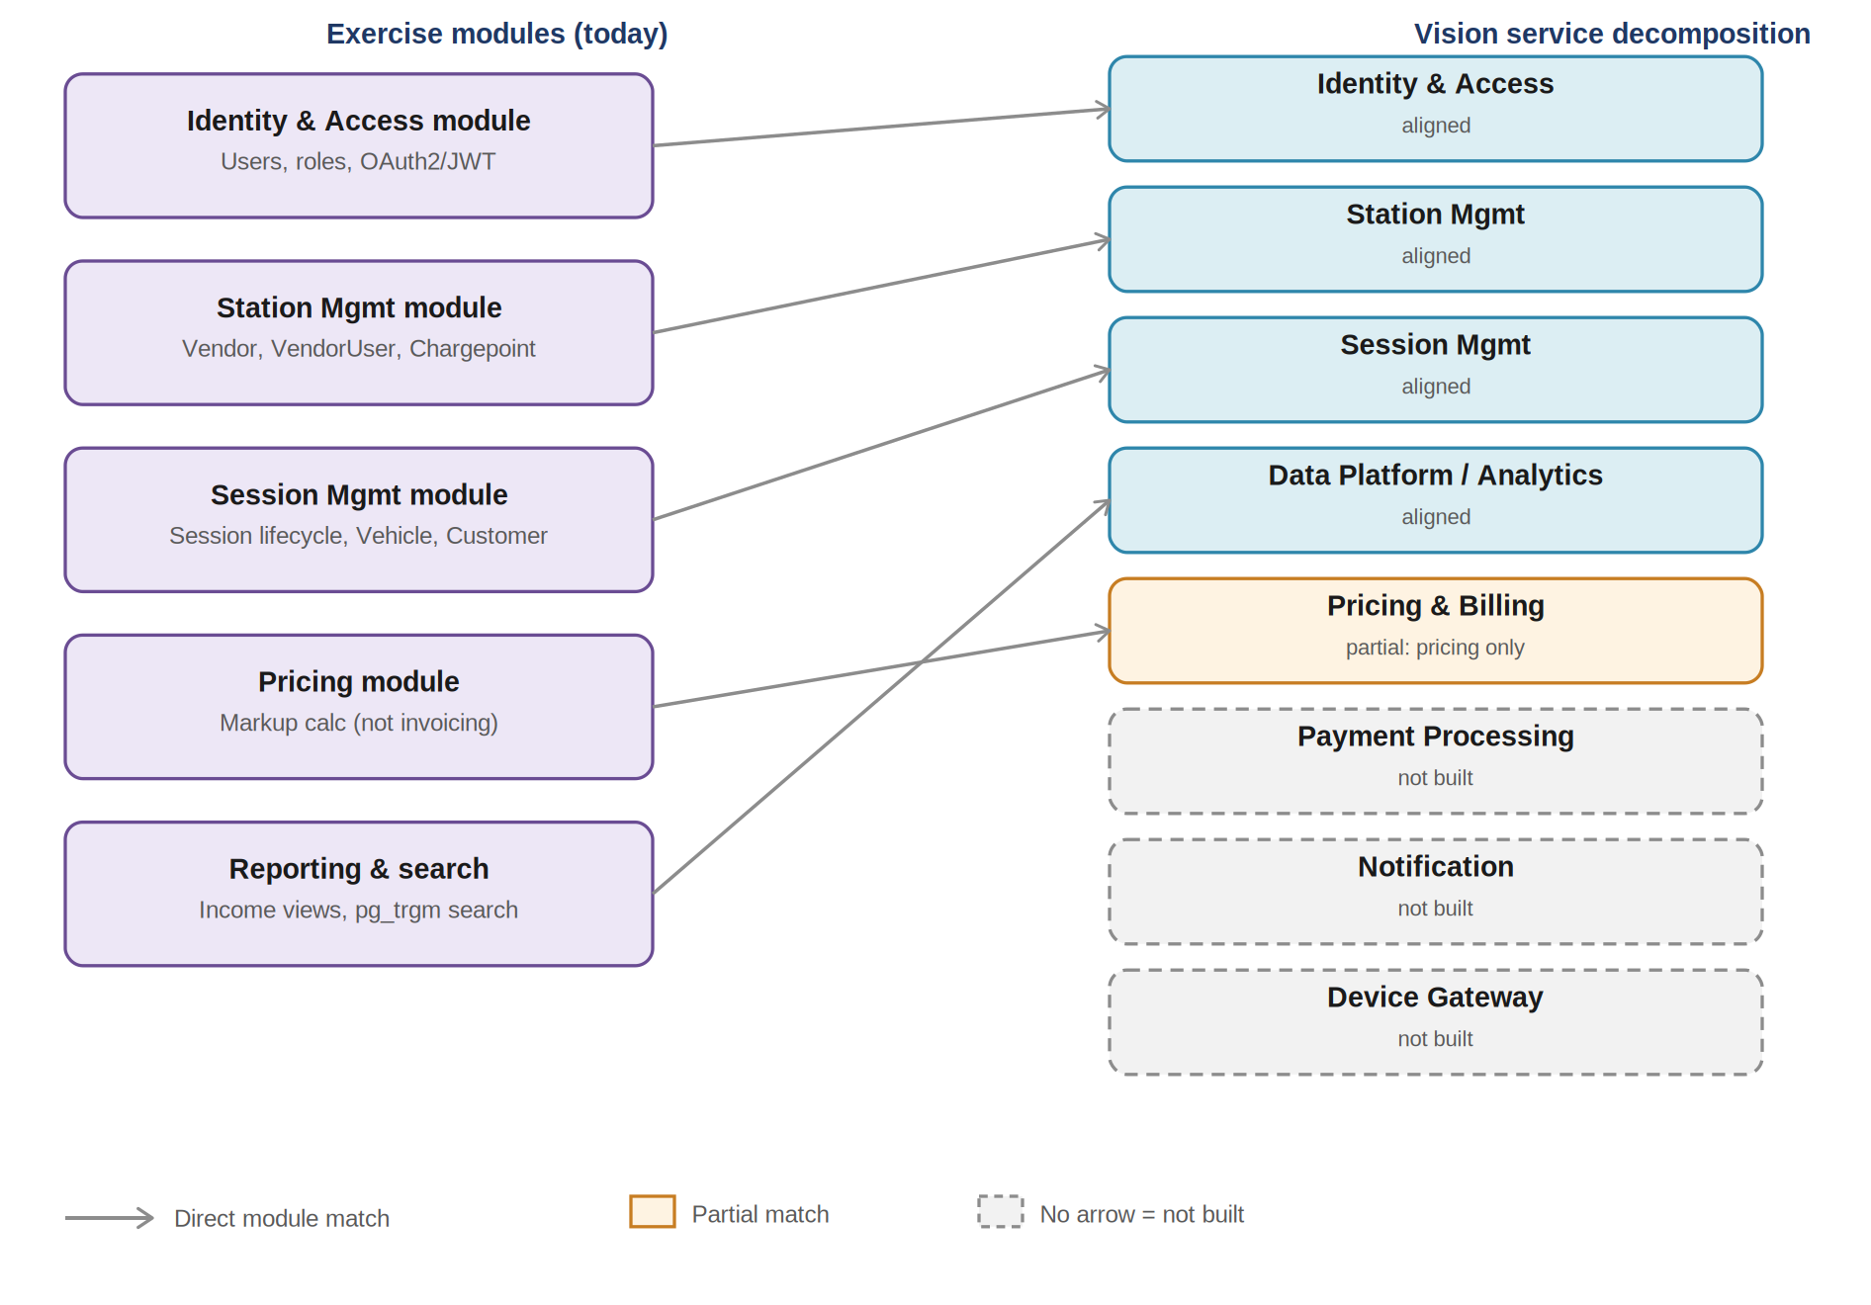
Figure 4 — Exercise modules mapped onto the target service decomposition. Every built module maps one-to-one onto its vision service; boxes with no arrow have no equivalent in the exercise at all.

15.1 Module → Vision Service Mapping
Exercise Module | Vision Service | Match | Note
Identity & Access module | Identity & Access | Direct | One-to-one; same responsibility, same data
Station Mgmt module | Station Mgmt | Direct | One-to-one; same responsibility, same data
Pricing module | Pricing & Billing | Partial (pricing only) | Rate/markup calculation is built and kept separate from Session Mgmt; invoicing and billing statements are not built, per Section 12.3
Session Mgmt module | Session Mgmt | Direct | One-to-one for session lifecycle and recording; calls the Pricing module rather than calculating rates itself
Reporting & Search | Data Platform / Analytics | Direct (as a capability, not a module) | Implemented as read/reporting logic over the other modules' data rather than a sixth standalone module
— none — | Payment Processing | Not built | Explicitly out of scope; billing is handled elsewhere per the brief
— none — | Notification | Not built | No client application in this exercise to notify
— none — | Device Gateway | Not built | No live OCPP/device feed; chargepoints are managed via CRUD and seed data only
Every module that exists in this exercise maps onto its vision service — directly for Identity & Access, Station Mgmt, and Session Mgmt, and partially for Pricing, which covers rate and markup calculation but not invoicing or billing statements. Pricing is deliberately kept as its own module rather than folded into Session Mgmt, so that pricing rules can grow in complexity (tiered rates, promotions, time-of-use pricing) without touching session-lifecycle code, and so that extending it to cover full billing later is additive rather than a rewrite. The remaining gap is Payment Processing, Notification, and Device Gateway, which simply do not exist in this exercise: this remains, and must remain, a single modular monolith of five modules — the right shape for its scope, not a precursor to prematurely splitting services.

15.2 Actor Mapping
Vision Actor | Maps To | Status
Administrator / network operator | AdminUser | Built
Charging station vendor | Vendor + VendorUser | Built
Individual driver | CustomerUser + Vehicle | Built
Business / fleet operator | CustomerUser with multiple vehicles | Data model supports it; no fleet-specific tooling built
Charging device (IoT) | Chargepoint | Modelled; no live OCPP/MQTT feed — data arrives via seeded/simulated sessions
Vehicle | Vehicle | Modelled; no live telematics API integration

15.3 Domain Scope: Built vs. Vision
Domain | Status Now | What Would Trigger Building It
IAM / RBAC | Built | —
Station management | Built | —
Charging session recording | Built | —
Basic reporting / income views | Built | —
Real OCPP / Device Gateway | Not built — brief asks only for a data model plus seed data | A real hardware fleet needing live BootNotification / Heartbeat / MeterValues ingestion
Pricing (rate/markup calculation) | Built | —
Payment Processing | Not built — brief states billing is handled elsewhere | A real payments-provider integration decision, outside this service's boundary
Dynamic / demand pricing | Not built | Brief specifies only a flat unit price plus vendor markup
Notification service | Not built — no UI required | A product decision once a client app exists
Fleet optimisation, predictive maintenance, smart-grid balancing, AI features | Vision only | Real scale and real IoT telemetry volume, realistically well beyond this exercise's horizon

15.4 How This Connects to the Extraction Path
This vision does not change the recommendation to keep the current solution as a modular monolith. It does, however, sharpen the future microservice boundaries already identified: a Device Gateway becomes the clearest long-term candidate for extraction once real OCPP traffic exists, since it has a fundamentally different throughput and consistency profile from the customer- and vendor-facing paths. Because Pricing already exists as its own module rather than being embedded in Session Mgmt, extending it to full invoicing and billing — and eventually Payment Processing — is additive work on a clean boundary, not an untangling exercise. Payment Processing, full billing/invoicing, and fleet optimisation are still best treated as entirely separate systems integrated behind clean interfaces, rather than features bolted onto this service, precisely because each carries its own compliance, scaling, and data-ownership concerns.
Because the exercise's modules already follow the schema-per-module and ports/adapters discipline described in Section 10, this extraction is expected to be a matter of moving a module's schema and swapping its in-process adapter for a network client — not a rewrite. The platform vision is useful as a shared mental model for where the domain can go, and the decision log in Section 14 shows that model was independently validated rather than invented for this document — not as a justification for building any of it ahead of real demand.

16. Requirements Traceability Matrix
Sections 5 through 9 describe the design; this section checks that design directly against every bullet in the original brief, bullet by bullet, so coverage is verifiable rather than assumed. “Built” means implemented and testable against seed data; “Assumption” means the brief left the point underspecified and a sensible default was made explicit elsewhere in this document; “Out of scope” means the brief itself excludes it.

16.1 Setup
Requirement | Status | Covered In
Spring Initializr project; manage entities in a relational database; access via REST APIs with authentication | Built | Sections 4, 7, 8

16.2 Admin Users
Requirement | Status | Covered In
Properties: name, email | Built | Section 5
Sign up vendors, including inviting the original vendor user | Built | Section 7 (POST /vendors)
View income over a period, optionally filtered by vendor | Built | Section 7 (GET /admin/income)
Set the markup added to the vendor's unit price | Built | Section 7 (PUT /vendors/{id}/markup); Section 10.3 (Pricing module)
Reset credentials for users where appropriate | Built | Section 7 (POST /users/{id}/reset-credentials)

16.3 Vendors
Requirement | Status | Covered In
Properties: name, account number | Built | Section 5
Have one or more users who manage vendor-owned resources per assigned permissions | Built | Sections 5.4, 6
Own chargepoints and can add, update, and remove them | Built | Section 7 (chargepoint CRUD)
Insights into income and charging activity, including the current month and breakdowns by chargepoint over days/weeks/months | Built | Section 7 (GET /vendors/{id}/chargepoints/{cpId}/income?breakdown=)
Can generate reports of charging sessions for a chargepoint on a given date | Built | Section 7 (GET /chargepoints/{id}/sessions/report?date=)

16.4 Vendor Users
Requirement | Status | Covered In
Properties: name, email, vendor | Built | Section 5
Belong to exactly one vendor | Built | Section 5
Can manage vendor-owned resources according to their assigned permissions | Built | Sections 5.4, 6

16.5 Chargepoints
Requirement | Status | Covered In
Properties: unique identifier, group label, unit price, availability, vendor | Built | Section 5
Owned by a vendor | Built | Section 5
Unique identifier displayed on the physical chargepoint for support purposes | Built | Section 5
May have a group label to identify multiple chargepoints belonging together | Built | Section 5
Unit price in tenths of cents | Built | Section 5.2 (monetary precision)
May be temporarily unavailable | Built | Section 5 (availability field)

16.6 Customer Users
Requirement | Status | Covered In
Properties: name, email, account number, phone number | Built | Section 5
Register with the platform | Built | Standard CRUD, Section 7 intro
Perform charging sessions using the marked-up unit price | Built | Section 5.5; Section 10.3 (Pricing module)
View charging session history and totals by month, including the current partial month | Built | Section 7 (GET /customers/{id}/sessions?month=)
Billing is handled elsewhere | Out of scope (by design) | Section 12.3
Own one or more vehicles and maintain them themselves | Built | Section 5; Section 7 (vehicle CRUD)
Can de-list vehicles (e.g. following disposal or sale) | Built | Section 7 (DELETE /customers/{id}/vehicles); Section 5.1 (soft delete)
If a vehicle is later owned by another customer, it may be registered again with the same plate | Built (assumption documented) | Section 5.1 (vehicle identity over time)

16.7 Vehicles
Requirement | Status | Covered In
Properties: registration plate, RFID number, customer | Built | Section 5
Owned by a customer | Built | Section 5
Can be identified automatically by RFID or plate detection | Built (API + data model); detection hardware itself out of scope | Section 5.5
Can also be selected manually by the customer | Built | Section 5.5
If an RFID is available during a manual selection, it may be associated with the vehicle for future identification | Built | Section 5.5

16.8 Charging Sessions
Requirement | Status | Covered In
Properties: start, end, vehicle, chargepoint, marked-up unit rate, error code, total energy, total charged | Built | Section 5
Belong to the month in which they start | Built | Section 5.3 (month bucketing)
Use the unit price applicable at the session start time | Built | Section 5 (rate snapshot decision)
Record an error code if partially or fully unsuccessful; otherwise empty | Built | Section 5; Section 7 (PATCH /sessions/{id}/stop)
Record the total energy delivered (kWh) | Built | Section 5
Record the total amount charged to the customer | Built | Section 5

16.9 REST API
Requirement | Status | Covered In
REST API with authentication and API documentation (Swagger or equivalent) | Built | Sections 7, 8, 12.1
API designed for the entity model's capabilities, considering client-application needs | Built | Section 7
Authentication approach selected and explained | Built | Section 8

16.10 Full-Text Search
Requirement | Status | Covered In
Endpoint for administrators to search sessions using session, customer, or vehicle information | Built | Section 9
Search supports partial matches (e.g. “AUD” matches “AUD186” and “AUD994”) | Built | Section 9 (pg_trgm + GIN index)
Net result: every capability bullet in the brief is built, with two explicit, brief-sanctioned exclusions (billing/invoicing itself, and physical RFID/plate-detection hardware, since there is no live device feed to detect from) and one documented assumption (vehicle re-registration after resale). No requirement was silently dropped — the two gaps this audit surfaced against an earlier draft (session start/stop endpoints and vehicle identification handling) have been folded into Sections 5.5 and 7 above rather than left implicit.

