

cAKE sHOP

* **Faculty: Ho Hoan Kiem**
* **Batch:**
* **Team Member:**
  + - * **Nguyễn Toàn Thắng**
      * **Nguyễn Tiến Thiên**

**Ho Chi Minh City, 11/11/2018**

1. Introduce

* **Problem Definition..…………………………………………………………………………………01**
* **Customer Request Specification……………………………………………………………… 02**

1. *Diagram*

* ***Use Case Diagram* 04**
* ***Class Diagram* 15**
* ***Sequence Diagram* 16**
* ***ERD* 18**
* ***Entity Description* 19**
* ***Table Relationship Diagram* 26**

Problem Definition

1. **The Object Of The Project**

This project will aim at creation of a online shoping system. Customer who have a valid User Id and Password will order cake on this system. Admin can maintain and manage product and customer. This system provides the following facilities:

* View order history
* Buy cake in their hosue
* View statictis every 3 month, every year.
* Save data of old product.

Customer Request   
 Specification

1. **Functional Requirements**

Following is a list of functionalities of the system.

* Customer must have a valid User Id and password to login to the system .
* After the valid user logs customer will buy cake.
* After add cake to cart. Cutomer will input information of receiver.
* Customer can cancel order which is not been accepted..

# Hardware/ Software Requirements

By adding new technologies such as ASP.NET 3.5, AJAX, Web Service and 3-tier architecture, the web site becomes more interactive with users, security and easily updated.

1. **System Requirement**

* **For Users**
  + **Hardware**
    - CPU: Pentium IV 2.0 GHz or higher
    - RAM: 512 MB or higher
  + **Software**
    - OS: Windows 7/XP Professional/Server 2003…
    - Browser: Internet Explorer 8.0 or higher
* **For Software Developers**
  + **Hardware**
    - CPU: Pentium IV 2.0 GHz or higher
    - RAM: 512 MB or higher
  + **Software**
    - OS: Windows XP Professional/Server 2003…
    - Environment: Microsoft .NET Framework 3.5
    - Database Management System: Microsoft SQL Server 2014
    - IDE: Microsoft Visual Studio 2010
    - Web Server: Internet Information Services (IIS) JSP / Servlets Dev. Kit

|  |  |  |
| --- | --- | --- |
| **Date: Sep 10, 2012** | **Prepared by Project Group 4**  **Team Leader:** | **Approved by**  **Mr Ho Hoan Kiem** |
| **Signature** |  |  |

**USE CASE DIAGRAM**

**Customer :**

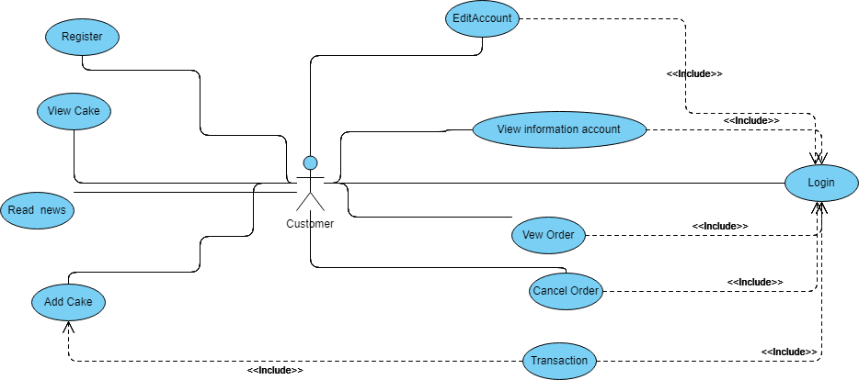

**Administrators :**

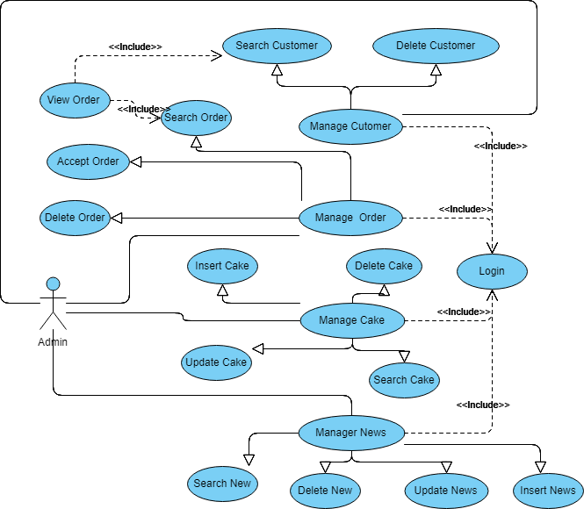

**USE CASE DESCRIPTION**

1. **Actor:**

* **Customers :** include all visitors that use this website. They are guests and members. ***Guest*** is the person that uses this website but doesn’t register. ***Member*** is the person that uses this website and register to become a member of us.
* **Admin :** The person(s) that manage and maintain this web site.

1. **Usecase:**

|  |  |
| --- | --- |
| **Usecase** | Register |
| **Short Description** | 1.Register account to become a member of the shop |
| **Pre-Conditions** |  |
| **Post-Conditions** |  |
| **Main flow** | * Guest must provide mandatory information : * Username. * Password. * Confirm Password. * Email. * PhoneNumber. * Guest provides supplementary information : FirstName, LastName, Address. * Guest clicks on Register button. * System checks the information which guest provided * System create new account for guest that registers to this website. * Guest becomes a member of this website. |
| **Alternative flow(s)** | * If guest clicks on the Reset button, all the field will be reset. * If the mandatory information that guest provided, is missed or not exactly, system notifys the error. All cases are : * Username has existed in Database. * Password is less than 6 characters or more than 30 characters. * Confirm Password and Password are not the same. * Email is invalid or has existed in database. * Any fields are blank. * If the suplementary information that guest provided, is invalid form, system nofitfys the error. All cases are : * PhoneNumber has any character is not a digit. * If server notifys any error when it’s processing, system must be write report into Log file. |

|  |  |
| --- | --- |
| **Usecase** | Login |
| **Short Description** | Log in from to Admin Dashboard. |
| **Pre-Conditions** |  |
| **Post-Conditions** |  |
| **Main flow** | * Admin inputs the login information : * Username * Password * Admin clicks on the Login button. * System check the Username and Password. * If Username and Password are valid, system will move Admin to Dashboard. |
| **Alternative flow(s)** | * If Admin clicks on “Clear” button, the Username field and Password field are blank. * If Username field or Password field is invalid form or blank when Admin clicks on the “Login” button, system will notify the error. * If server notifies any error when it’s processing, system must be write report into Log file. |

|  |  |
| --- | --- |
| **Usecase** | Insert Cake |
| **Short Description** | Create new Cake . |
| **Pre-Conditions** |  |
| **Post-Conditions** |  |
| **Main flow** | * Admin inputs the information of cake : * Cake Id * Name * Price * Quantity * Category * 1-3 Image of cake * Admin clicks on the Insert button. * System check Information of cake. * If Informations are valid, New Cake will be created.. |
| **Alternative flow(s)** | * If Admin clicks on “Clear” button, the Cake Id field , Name field,Price,Quantity will blank. * If the infomations are invalid, System will show error.All case : * Cake Id is not exist in database. * Price is a number * Quantity is a integer and > 0. * Least one image are imported. * All field are not blank. * If server notifies any error when it’s processing, system must be write report into Log file. |

|  |  |
| --- | --- |
| **Usecase** | Delete Cake |
| **Short Description** | Delete cake which be not bought. |
| **Pre-Conditions** |  |
| **Post-Conditions** |  |
| **Main flow** | * Admin choose Cake * Admin clicks on the Delete button. * System show form “Do You want to Delete this cake ?” * If Admin click Yes .System check Cake is exist or not. * If Delete successful. System will show popup “Delete Successfull”. |
| **Alternative flow(s)** | * If Admin clicks on “No” button, The Cake will not be deleted, * If server notifies any error when it’s processing, system must be write report into Log file. |

|  |  |
| --- | --- |
| **Usecase** | Update Cake |
| **Short Description** | Update information of cake |
| **Pre-Conditions** |  |
| **Post-Conditions** |  |
| **Main flow** | * Admin choose Cake * Information of old Cake will be show in fields. * Admin Change information of Cake: * Name * Price * Quantity * Category * 1-3 Image of cake * Admin clicks on the Update button. * System check Information of cake. * If Informations are valid ,system will show popup “Do You Want Update this Cake ?” * If Admin click “Yes” Buton ,Information of Cake will be Updated.. |
| **Alternative flow(s)** | * If Admin clicks on “No” button, The Cake will not be Updated, * If the infomations are invalid, System will show error.All case : * Price is a number * Quantity is a integer and > 0. * Least one image are imported. * All field are not blank * If server notifies any error when it’s processing, system must be write report into Log file. |

|  |  |
| --- | --- |
| **Usecase** | Search Cake |
| **Short Description** | Search information of cake |
| **Pre-Conditions** |  |
| **Post-Conditions** |  |
| **Main flow** | * Admin Input name of Cake to Search field/ * Admin clicks on the Search button. * System check Name of cake. * Information of cake will be shown in the table. |
| **Alternative flow(s)** | * If no cake have name like this name , the popup will be show  “Do not Cake like this name ”. * If server notifies any error when it’s processing, system must be write report into Log file. |

|  |  |
| --- | --- |
| **Usecase** | Search News |
| **Short Description** | Search News By Title |
| **Pre-Conditions** |  |
| **Post-Conditions** |  |
| **Main flow** | * Admin Input Title of News to Search field. * Admin clicks on the Search button. * System check Title of News. * Information of News will be shown in the table: * Title * Date |
| **Alternative flow(s)** | * If no News with name like this name , the popup will be show  “Do not News like this name ”. * If server notifies any error when it’s processing, system must be write report into Log file. |

|  |  |
| --- | --- |
| **Usecase** | Update News |
| **Short Description** | Update information of News |
| **Pre-Conditions** |  |
| **Post-Conditions** |  |
| **Main flow** | * Admin choose News in the table/ * Information of old News will be show in fields. * Admin Change information of News: * Title * Paragraph-Image * Admin clicks on the Update button. * System check Information of News. * If Informations are valid ,system will show popup “Do You Want Update this News ?” * If Admin click “Yes” Buton ,Information of News will be Updated.. |
| **Alternative flow(s)** | * If Admin clicks on “No” button, The News will not be Updated, * If the infomations are invalid, System will show error.All case : * One paragraph have least 1 image . * 1 image must have 1 paragraph. * All field are not blank * If server notifies any error when it’s processing, system must be write report into Log file. |

|  |  |
| --- | --- |
| **Usecase** | Insert News |
| **Short Description** | Insert News |
| **Pre-Conditions** |  |
| **Post-Conditions** |  |
| **Main flow** | * Admin inputs the information of News : * Title * Paragraph-image * Admin clicks on the Insert button. * System check Information of News. * If Informations are valid, New News will be created.. |
| **Alternative flow(s)** | * If the infomations are invalid, System will show error.All case : * One paragraph have least 1 image . * 1 image must have 1 paragraph. * All field are not blank * If server notifies any error when it’s processing, system must be write report into Log file. |

|  |  |
| --- | --- |
| **Usecase** | Delete News |
| **Short Description** | Delete News is not valid. |
| **Pre-Conditions** |  |
| **Post-Conditions** |  |
| **Main flow** | * Admin choose News * Admin clicks on the Delete button. * System show form “Do You want to Delete this News?” * If Admin click Yes .System check News is exist or not. * If Delete successful. System will show popup “Delete Successfull”. |
| **Alternative flow(s)** | * If Admin clicks on “No” button, The News will not be deleted, * If server notifies any error when it’s processing, system must be write report into Log file. |

|  |  |
| --- | --- |
| **Usecase** | Login |
| **Short Description** | Log in from to Home Page. |
| **Pre-Conditions** |  |
| **Post-Conditions** |  |
| **Main flow** | * Customer inputs the login information : * Username * Password * Customer clicks on the Login button. * System check the Username and Password. * If Username and Password are valid, system will move Customer to Home Page . |
| **Alternative flow(s)** | * If Username field or Password field is invalid form or blank when Admin clicks on the “Login” button, system will notify the error. * If server notifies any error when it’s processing, system must be write report into Log file. |

|  |  |
| --- | --- |
| **Usecase** | Edit Account |
| **Short Description** | Change Information of Customer |
| **Pre-Conditions** |  |
| **Post-Conditions** |  |
| **Main flow** | * Customer inputs information : * Password * New Password * Comfirm New Password * First Name * Last Name * Address * Emai * Phone Number * Customer clicks on the Save button. * System check the Information. * System checks the information which Customer provided * System Update information of Customer |
| **Alternative flow(s)** | * If the information that Customer provided, is missed or not exactly, system notifys the error. All cases are : * New Password is less than 6 characters or more than 30 characters. * Password is match with password of customer. * Confirm New apssword must match with New password. * Email is invalid or has existed in database. * Any fields are blank. * PhoneNumber has any character is not a digit. * If server notifys any error when it’s processing, system must be write report into Log file. |

|  |  |
| --- | --- |
| **Usecase** | View Account |
| **Short Description** | View to Information of Customer |
| **Pre-Conditions** |  |
| **Post-Conditions** |  |
| **Main flow** | * Customer move to the icon of account * Customer click “Edit profile” * System check the account is alive. * System show Account Page. |
| **Alternative flow(s)** | * If Account is not alive. System will move to home page. |

|  |  |
| --- | --- |
| **Usecase** | View Order |
| **Short Description** | View to Order of Customer |
| **Pre-Conditions** |  |
| **Post-Conditions** |  |
| **Main flow** | * Customer move to the icon of account * Customer click “Edit profile” * System check the account is alive. * System show Order Page. |
| **Alternative flow(s)** | * If Account is not alive. System will move to home page. |

|  |  |
| --- | --- |
| **Usecase** | Cancel Order |
| **Short Description** | Cancek Orded which have status “New” |
| **Pre-Conditions** |  |
| **Post-Conditions** |  |
| **Main flow** | * Customer Click Tab order is new. * Customer click “Cancel” bution with every order. * System check the Order is New or is accepted.. * System show New Order Page. |
| **Alternative flow(s)** | * If Order is acceptted. System will Update Order Page.. |

|  |  |
| --- | --- |
| **Usecase** | Trancation |
| **Short Description** | Customer choose address to recieve |
| **Pre-Conditions** |  |
| **Post-Conditions** |  |
| **Main flow** | * Customer Click “Order” buton * Customer input information of reciever: * Name. * Address. * Phone Number. * System check the Information . * System create new Order. |
| **Alternative flow(s)** | * If infomstion of reciever is not valid.System will show error.All case: * All filed is blank * Phone Number have character |

|  |  |
| --- | --- |
| **Usecase** | Manage Customers |
| **Short Description** | Manage all information about customer. |
| **Pre-Conditions** | Logged in as Admin |
| **Post-Conditions** |  |
| **Main flow** | Manage all information of customer. |
| **Alternative flow(s)** | If server notifies any error when it’s processing, system must be write report into Log file. |

|  |  |
| --- | --- |
| **Usecase** | View Customer’s Information |
| **Short Description** | Administrator view customer’s information. |
| **Pre-Conditions** | Logged in as Admin |
| **Post-Conditions** |  |
| **Main flow** | Administrator choose the customer that administrator wants to see information.  Administrator clicks on the “View Information” button.  System shows the customer’s information to the administrator. |
| **Alternative flow(s)** | If server notifies any error when it’s processing, system must be write report into Log file. |

|  |  |
| --- | --- |
| **Usecase** | Delete Customer’s Information |
| **Short Description** | Administrator view customer’s information. |
| **Pre-Conditions** | Logged in as Admin |
| **Post-Conditions** |  |
| **Main flow** | Administrator choose the customer that administrator wants to delete.  Administrator clicks on the “Delete” button.  System shows the result success or not to the administrator. |
| **Alternative flow(s)** | If server notifies any error when it’s processing, system must be write report into Log file. |

|  |  |
| --- | --- |
| **Usecase** | Search Customer |
| **Short Description** | Administrator view customer’s information. |
| **Pre-Conditions** | Logged in as Admin |
| **Post-Conditions** |  |
| **Main flow** | Administrator input the text field the customer Id  Administrator clicks on the “Search” button.  System shows the search like customer Id result to the administrator. |
| **Alternative flow(s)** | If server notifies any error when it’s processing, system must be write report into Log file. |

|  |  |
| --- | --- |
| **Usecase** | Search Order |
| **Short Description** | Administrator view Orders information. |
| **Pre-Conditions** | Logged in as Admin |
| **Post-Conditions** |  |
| **Main flow** | Administrator input the text field the order Id  Administrator clicks on the “Search” button.  System shows the search like order Id result to the administrator. |
| **Alternative flow(s)** | If server notifies any error when it’s processing, system must be write report into Log file. |

|  |  |
| --- | --- |
| **Usecase** | View Order |
| **Short Description** | Administrator view order |
| **Pre-Conditions** | Logged in as Admin |
| **Post-Conditions** |  |
| **Main flow** | Administrator choose the order that administrator wants to see information.  Administrator clicks on the “View order” button.  System shows the order’s information to the administrator. |
| **Alternative flow(s)** | If server notifies any error when it’s processing, system must be write report into Log file. |

|  |  |
| --- | --- |
| **Usecase** | Accept Order |
| **Short Description** | Administrator accept order |
| **Pre-Conditions** | Logged in as Admin |
| **Post-Conditions** |  |
| **Main flow** | Administrator choose the order that administrator wants to accept.  Administrator clicks on the “Accept order” button.  System shows the result success or not to the administrator. |
| **Alternative flow(s)** | If server notifies any error when it’s processing, system must be write report into Log file. |

|  |  |
| --- | --- |
| **Usecase** | Delete Order |
| **Short Description** | Administrator delete order |
| **Pre-Conditions** | Logged in as Admin |
| **Post-Conditions** |  |
| **Main flow** | Administrator choose the order that administrator wants to delete.  Administrator clicks on the “Delete order” button.  System shows the result success or not to the administrator. |
| **Alternative flow(s)** | If server notifies any error when it’s processing, system must be write report into Log file. |

Customer

|  |  |
| --- | --- |
| **Usecase** | View Cake |
| **Short Description** | Customer or guest view order |
| **Pre-Conditions** |  |
| **Post-Conditions** |  |
| **Main flow** | Guest choose the cake that wants to see information.  Guest clicks on the “View cake” button.  System shows the order’s information to the administrator. |
| **Alternative flow(s)** | If server notifies any error when it’s processing, system must be write report into Log file. |

|  |  |
| --- | --- |
| **Usecase** | Search Cake |
| **Short Description** | Customer or guest search list of cake |
| **Pre-Conditions** |  |
| **Post-Conditions** |  |
| **Main flow** | guest input the text field the cake name  guest clicks on the “Search” button.  System shows the search like cake name result to the guest. |
| **Alternative flow(s)** | If server notifies any error when it’s processing, system must be write report into Log file. |

|  |  |
| --- | --- |
| **Usecase** | Read news |
| **Short Description** | Show news |
| **Pre-Conditions** |  |
| **Post-Conditions** |  |
| **Main flow** | Access website  guest clicks on the “News” button.  System shows news short by upload time to the guest. |
| **Alternative flow(s)** | If server notifies any error when it’s processing, system must be write report into Log file. |

|  |  |
| --- | --- |
| **Usecase** | Register |
| **Short Description** | Register account to become a member of the web site. |
| **Pre-Conditions** |  |
| **Post-Conditions** |  |
| **Main flow** | _Guest must provide mandatory information :   * LoginID. * Password. * Confirm Password. * Email. * Identity card.   _Guest provides supplementary information : Full name, PhoneNumber, Address  _Guest clicks on Register button.  _System checks the information which guest provided  _System create new account for guest that registers to this website.  _Guest becomes a member of this website. |
| **Alternative flow(s)** | _If guest clicks on the Reset button, all the field will be reset.  _If the mandatory information that guest provided, is missed or not exactly, system notifys the error. All cases are :   * LoginID has existed in Database. * Password is less than 6 characters or more than 30 characters. * Confirm Password and Password are not the same. * Email is invalid or has existed in database. * Identity card has any is digit not a character. * Any fields are blank.   _If the suplementary information that guest provided, is invalid form, system nofitfys the error. All cases are :   * PhoneNumber has any character is not a digit. * Birthday is not along with format “dd/MM/yyyy”.   _System must be insert the date that guest register to become member.  _If server notifys any error when it’s processing, system must be write report into Log file. |

|  |  |
| --- | --- |
| **Usecase** | Add Cake |
| **Short Description** | Customer or guest view order |
| **Pre-Conditions** |  |
| **Post-Conditions** |  |
| **Main flow** | Guest choose the cake that wants to Add to cart.  Guest clicks on the “add cake” button.  System shows the add cake for guest. |
| **Alternative flow(s)** | If server notifies any error when it’s processing, system must be write report into Log file. |

**CLASS DIAGRAM**

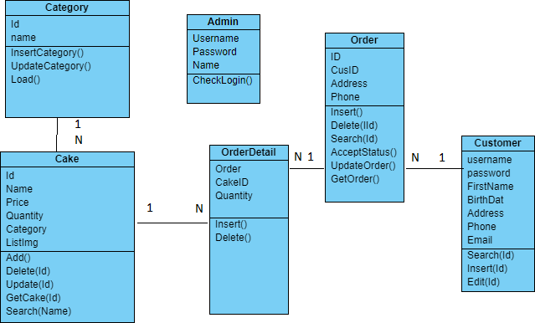

**ENTITY RELATIONSHIP DIAGRAM (ERD)  
  
  
  
  
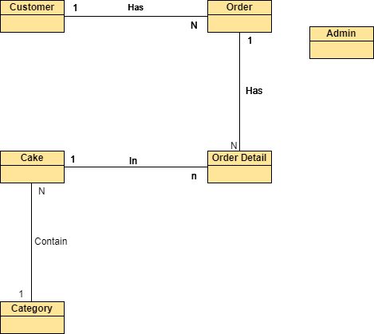  
  
  
  
NOTE  
  
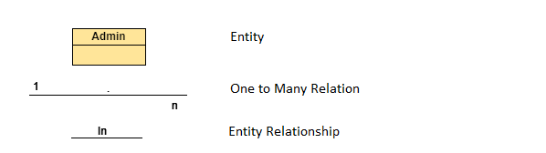  
  
  
  
ENTITY DESCRIPTION**

**1.Account Customer :**

**Admin**

**2. Customer Information :  
3. Category :**

**Customer**

**4. Order :  
  
5. OrderDetail :**

**Order**

**Category**

**OrderDetail**

**6.Cake**

**Cake**

**TABLE DESIGN**

1. **Admin :**

|  |  |  |  |  |  |
| --- | --- | --- | --- | --- | --- |
| **No** | **Column Name** | **Data Type** | **Size** | **Check** | **Description** |
| 1 | **🗝**Username | Varchar | 50 | Not Null | Admin ID |
| 2 | Passwords | Varchar | 50 | Not Null | Admin’s password |
| 3 | name | Varchar | 50 | Not Null | Admin’s name |

1. **Customer Information :**

|  |  |  |  |  |  |
| --- | --- | --- | --- | --- | --- |
| **No** | **Column Name** | **Data Type** | **Size** | **Check** | **Description** |
| 1 | **🗝**CustID | Varchar | 50 | Not Null | ID |
| 2 | Fullname | Varchar | 50 | Null | Fullname Customer |
| 3 | Password | Varchar | 50 | Null | Name Customer |
| 4 | Birthday | Varchar | 50 | Null | Birthday Customer |
| 5 | Address | Varchar | 50 | Null | Address Customer |
| 6 | Emait | Varchar | 50 | Null | Emait Customer |
| 7 | Phone | Varchar | 50 | Null | Phone Customer |

1. **OrderDetail :**

|  |  |  |  |  |  |
| --- | --- | --- | --- | --- | --- |
| **No** | **Column Name** | **Data Type** | **Size** | **Check** | **Description** |
| 1 | **🗝**OrderId | Varchar | 50 | Not Null | Id of Order |
| 2 | **🗝**CakeId | Varchar | 50 | Not Null | Id of Cake |
| 3 | Quantity | Int |  | Notnull | Number of cake |

1. **Order:**

|  |  |  |  |  |  |
| --- | --- | --- | --- | --- | --- |
| **No** | **Column Name** | **Data Type** | **Size** | **Check** | **Description** |
| 1 | **🗝**Order ID | Varchar | 5 | Not Null | Style Card ID |
| 2 | CusID | Varchar | 10 | Not Null | Name Style Card |
| 3 | Address | Varchar | 50 | Not Null | Address of recieier |
| 4 | Phone | Varchar | 50 | Not null | Phone of reciever |
| 5 | Status | Varchar | 50 | Not null | Status of Order |

1. **Cake:**

|  |  |  |  |  |  |
| --- | --- | --- | --- | --- | --- |
| **No** | **Column Name** | **Data Type** | **Size** | **Check** | **Description** |
| 1 | **🗝**Cake ID | Varhchar | 50 | Not Null | Id of Cake |
| 2 | Name | Varchar | 50 | Not Null | Name of cake |
| 3 | Price | Float |  | Not Null | Price of Cake |
| 4 | Quantity | Int |  | Not Null | Quantity of cake |
| 5 | CategoryID | Varchar | 50 | Not Null | Id of category |
| 6 | Img1 | Varchar | 50 |  | Link Image of cake |
| 7 | Img2 | Varchar | 50 |  | Link Image of cake |
| 8 | Img3 | Varchar | 50 |  | Link Image of cake |

**Note**

**🗝** Primary key

✓ Unique constraint

**TABLE RELATIONSHIP DIAGRAM**

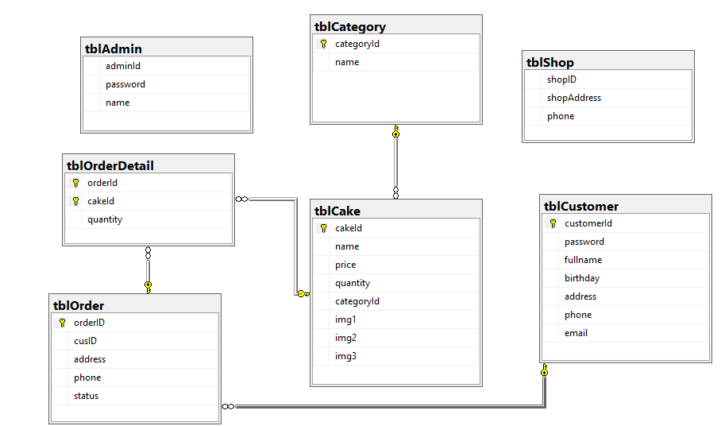

**SEQUENCE DIAGRAM**

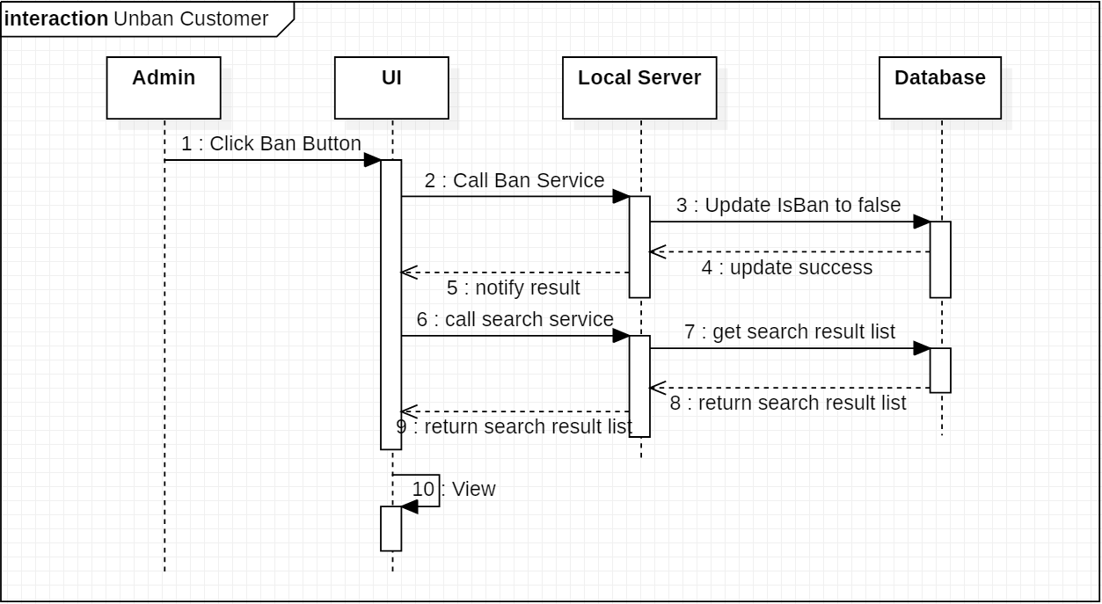

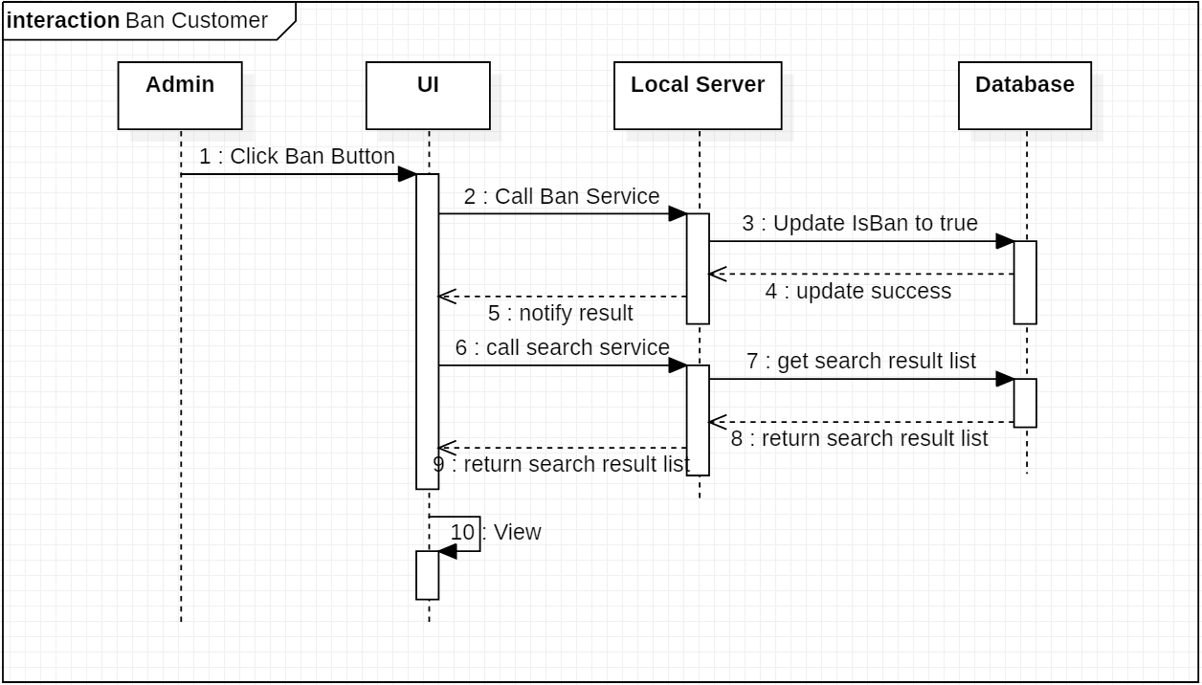

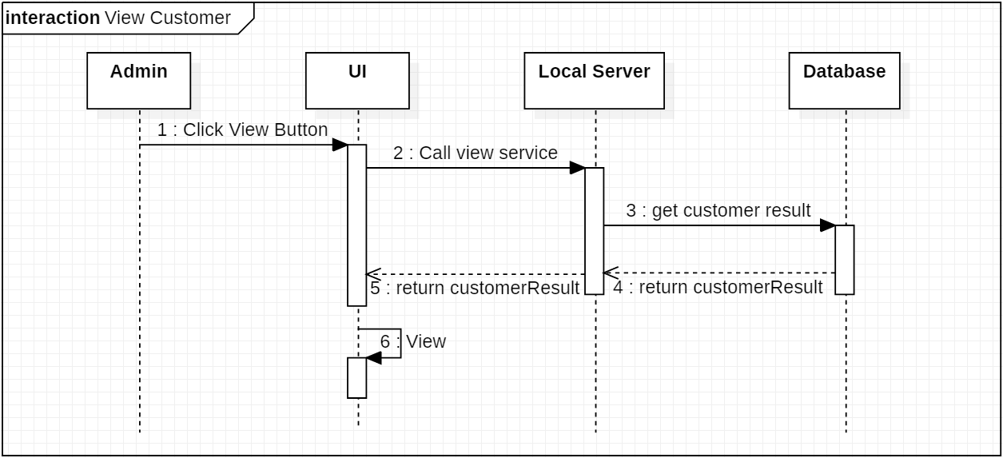

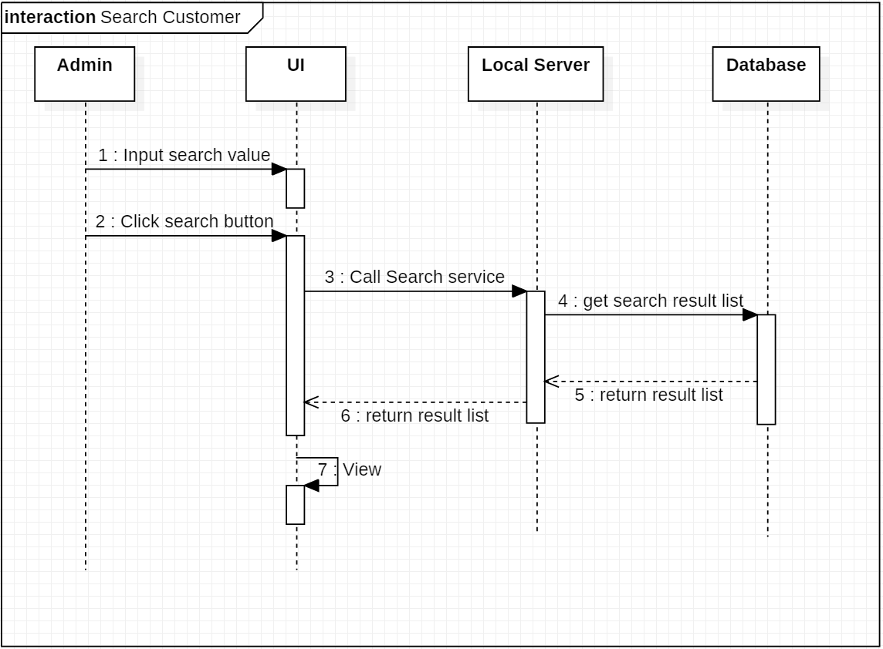

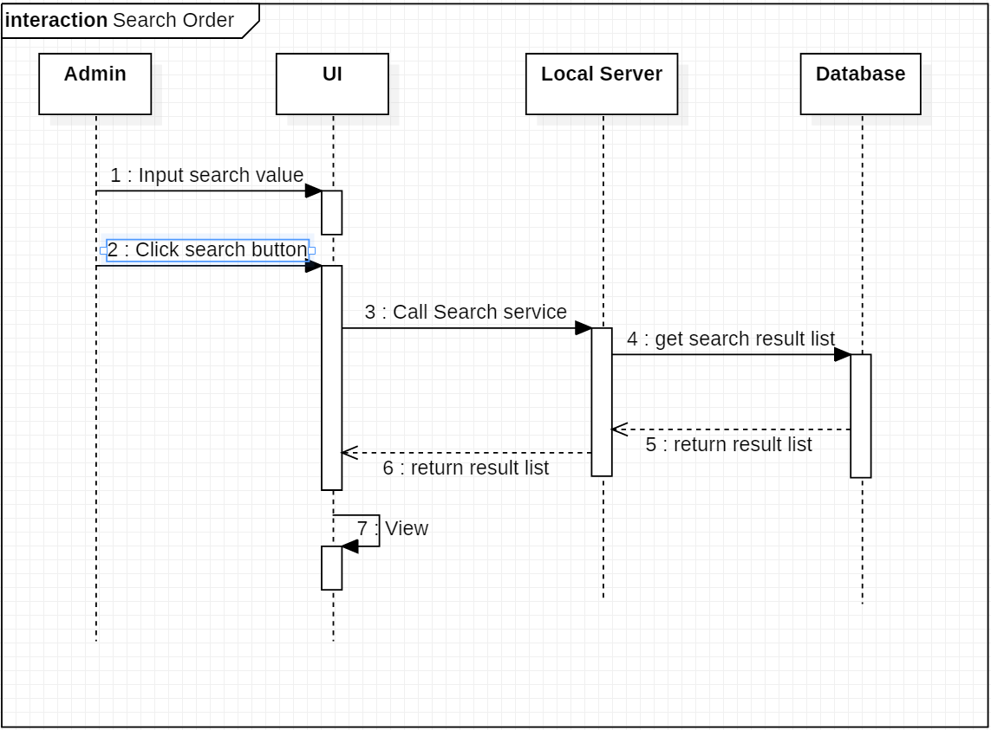

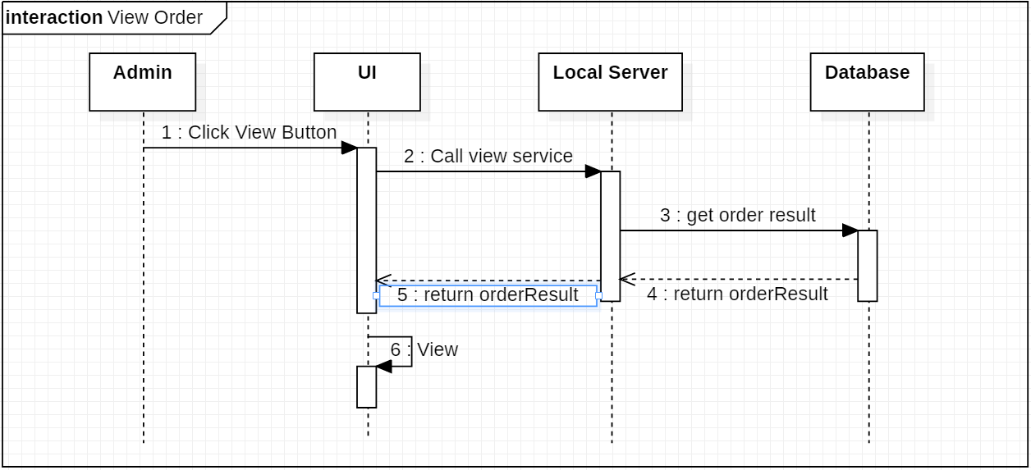

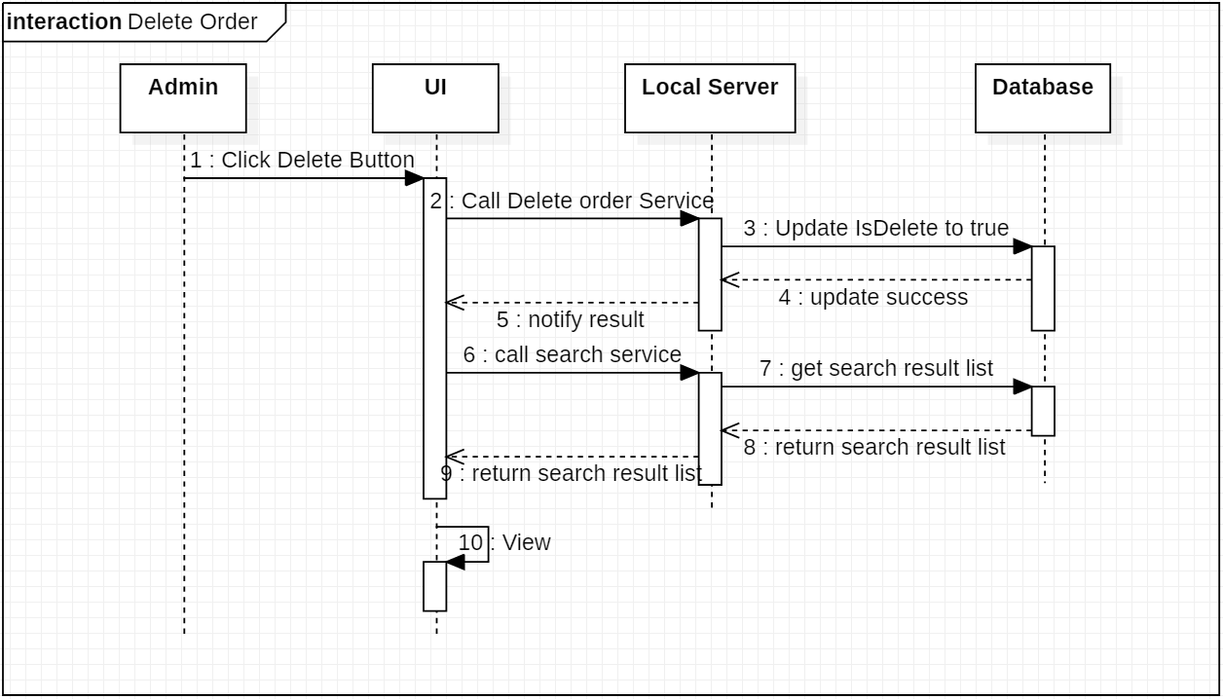

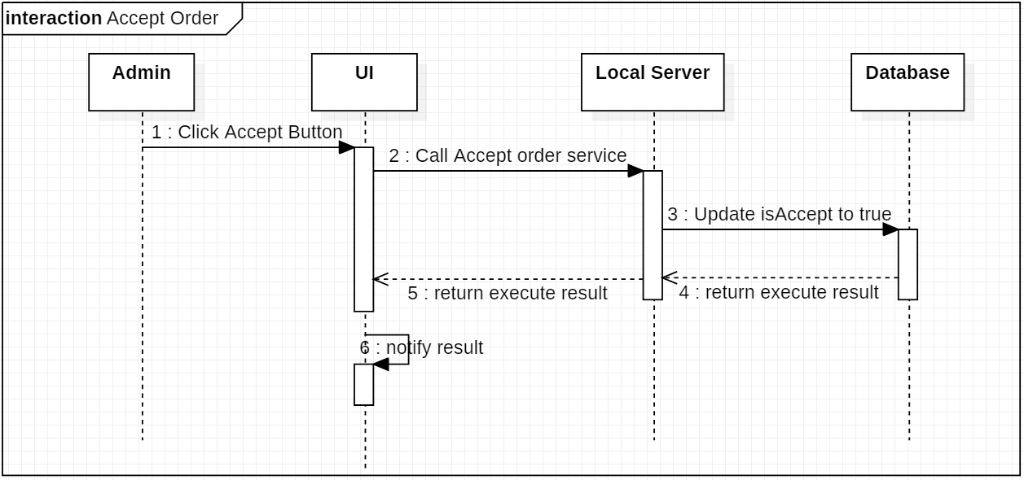

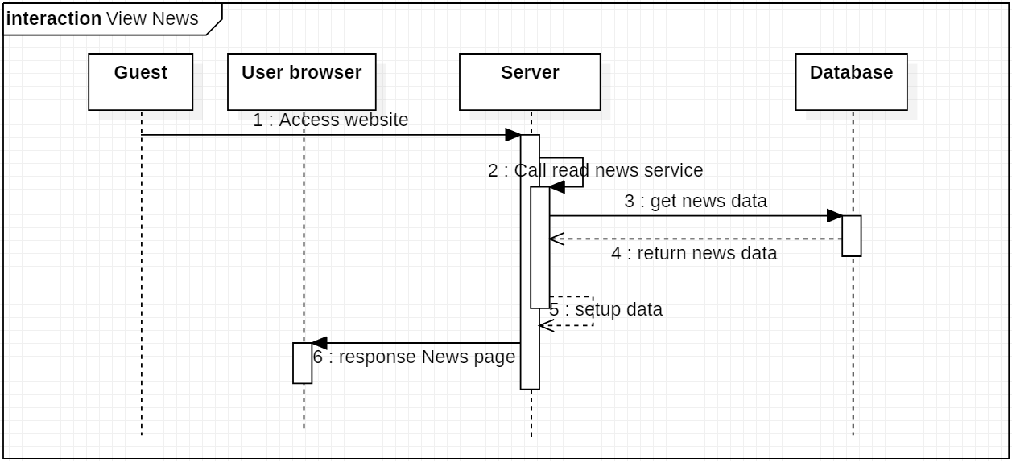

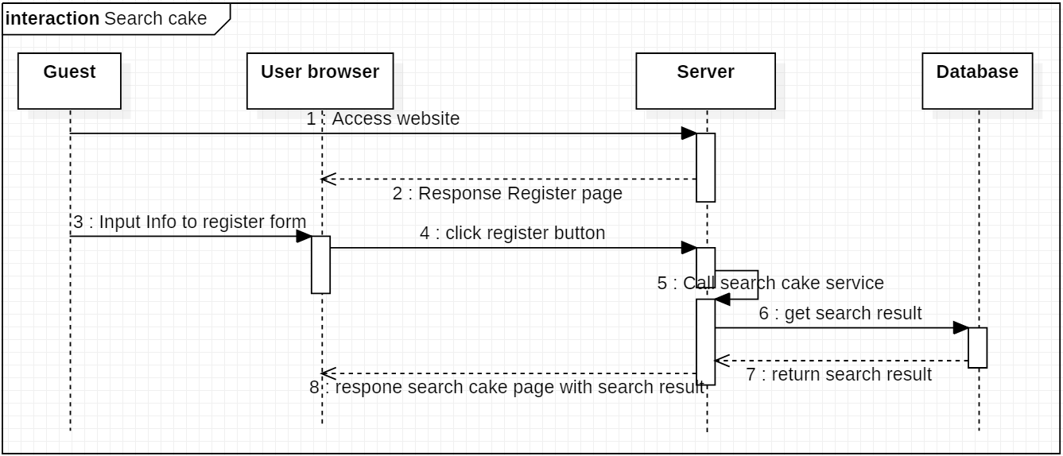

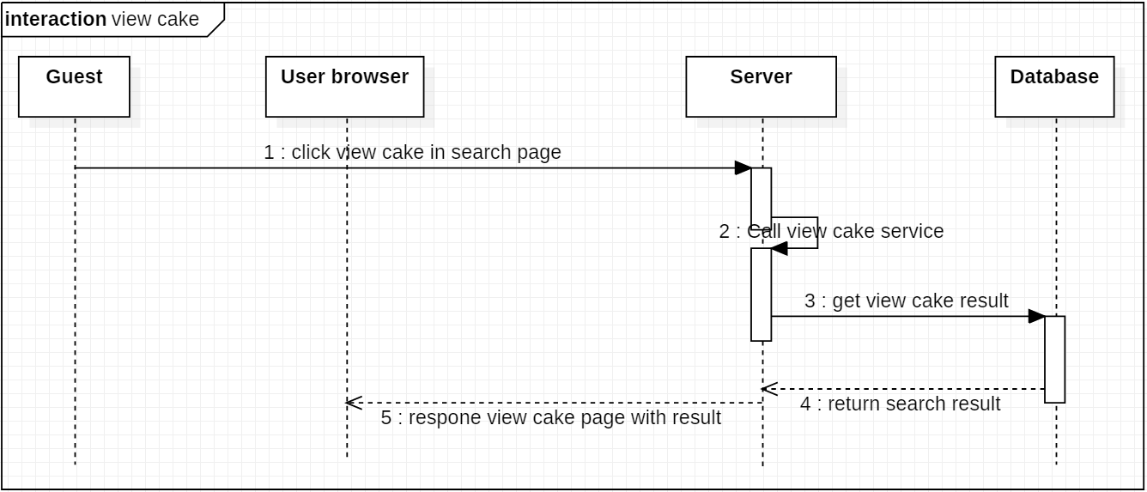

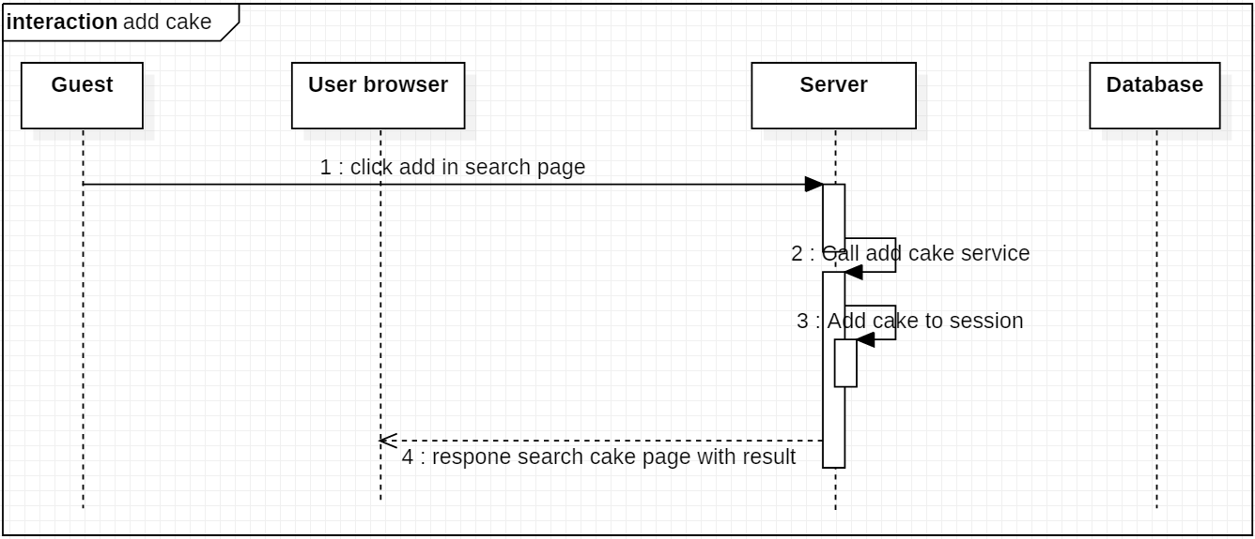

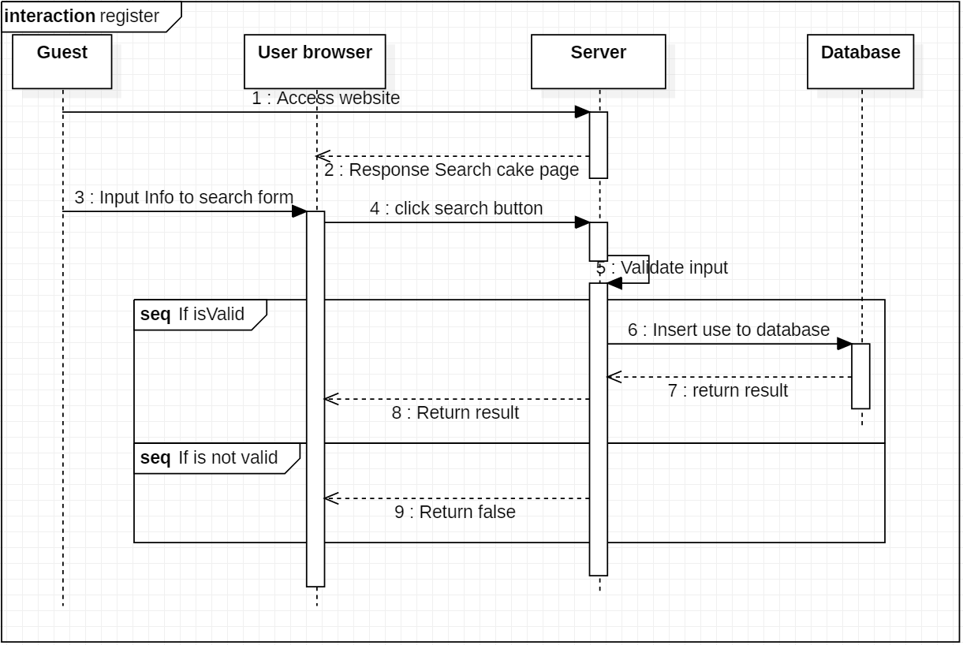

**INTERFACE DESIGN**

* 1. **Home Page**

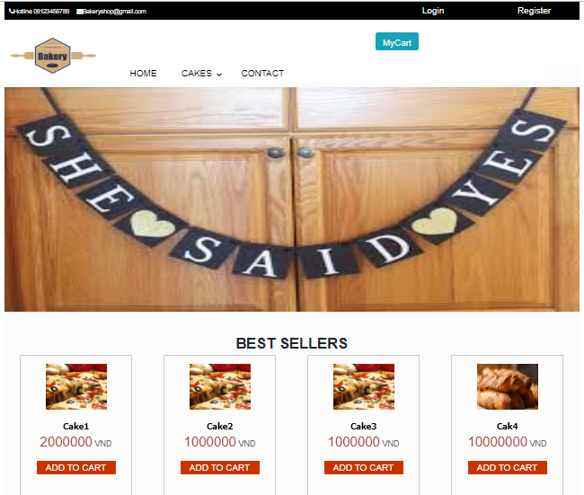

* 1. **Login Form for Customer**

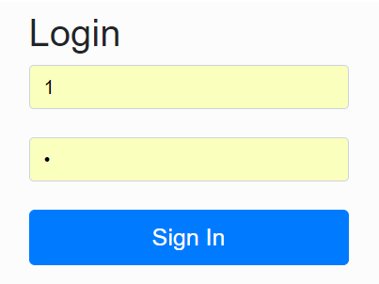

* 1. **Show all Cake**

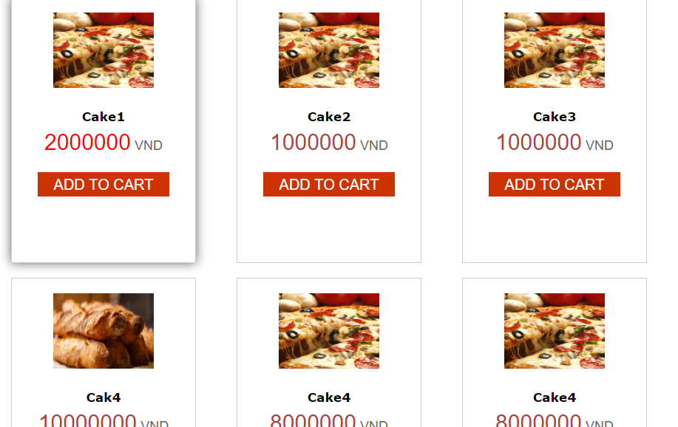

* 1. **CART**

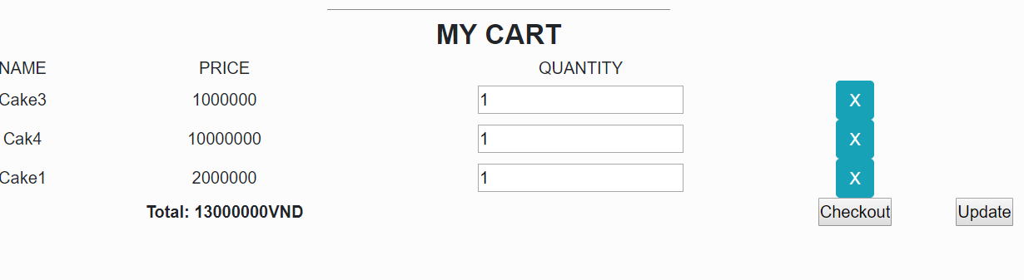

* 1. **LoginEmployee**

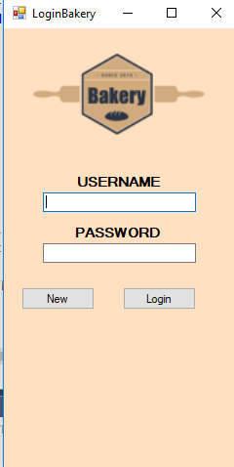

**6.SellForm**

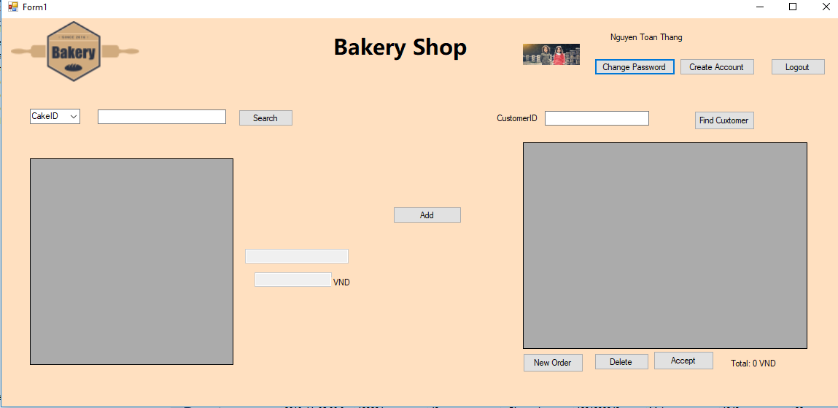

* 1. Change passwor form

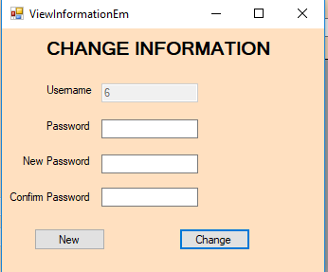

* 1. Create Account

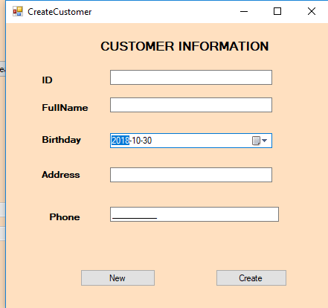

* 1. ManagerCake

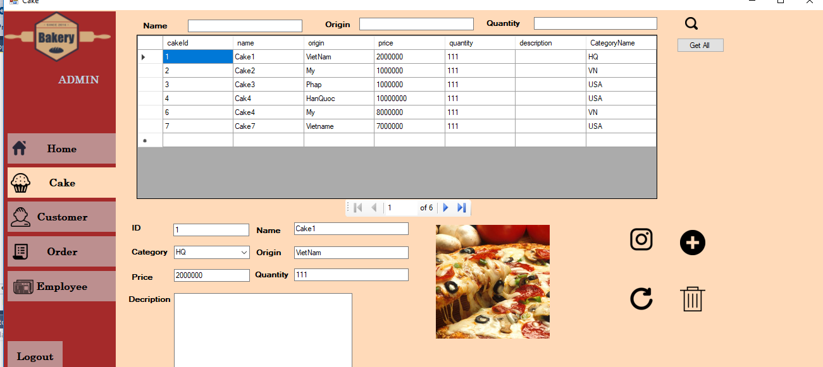

* 1. ManageEmployee

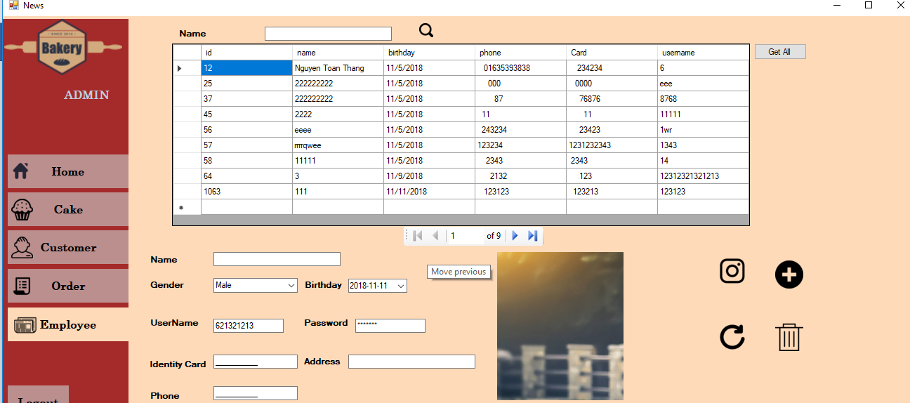

* 1. OrderManaageer

