Database For Donut Shop
Team Members: Thang Pham, Steven Nicholson

Business Description:
This Donut Shop is a small, locally-owned donut shop that specializes in homemade donuts, coffee, and other beverages. The shop operates both walk-in and pre-order services, and also offers catering for local events. The business aims to provide high-quality with a focus on customer experience, inventory freshness, and efficient order management

Business Goals:
- Increase customer retention through personalized service and loyalty programs
- Optimize inventory management to reduce waste and ensure product freshness
- Streamline order processing for both in-store and online pre-orders
- Support business growth through data-driven decisions about popular products and peak times

Basic Operations:
- Customers place orders in-store, online, or via phone
- Employees manage donut production, sales, and inventory
- The shop tracks daily sales, ingredient usage, and customer preferences
- Seasonal and custom donut offerings are introduced periodically

Purpose of the Database:
The database will centralize all business operations into a single, organized system. It will replace current manual tracking methods (spreadsheets, paper logs) and enable efficient data management, reporting, and business analysis

Business Problems Solved
- Inefficient Order Tracking
- Poor Inventory Management
- Limited Customer Insights
- Lack of Sales Reporting

Data to be Tracked
- Customer Information (name, contact, loyalty points)
- Product details (donut types, prices, ingredients)
- Inventory (flour, sugar, toppings, etc)
- Order transaction (date, items, total, payment method)
- Employee schedule and roles

How the Database will Help
- Automate order entry and reduce human error
- Provide real-time inventory updates to minimize waste
- Enable customer loyalty tracking and personalized marketing
- Generate sales and performance reports to guide business decisions
- Improve scheduling and staff management

Themes (Tables)
Customers
Products
Ingredients
Orders
Employees
OrderDetails
Business Rules
- A customer can have many orders
- An order can have many products
- A product can be a part of many orders
- A customer must have at least one order to be stored’
Entities
- Customers
- Orders
- Products
- Product-Orders (linking table)
Cardinalities
- Customers -> Orders
    - One customer can place many orders
    - One order belongs to one customer
    - 1 : M
    - Mandatory
    - A customer must have one order to be logged
  - Orders -> Product-Order
    - One order can have many order items
    - 1 : M
    - Optional
    - An order must have at least one product to exist
  - Product -> Product-Order
    - One product can have many product-orders
    - 1:M
    - Optional
Screenshot of Diagram
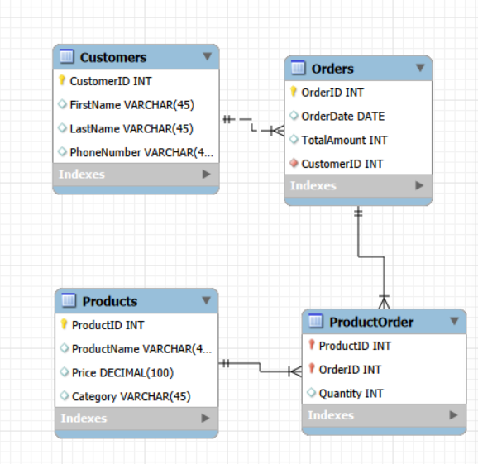

Relational forms
- CUSTOMERS(CustomerID, FirstName, LastName, PhoneNumber)
- Orders(OrderID, OrderDate, TotalAmount, CustomerID)
- Products(ProductID, ProductName, Price, Category)
- ProductOrder(ProductID, OrderID, Quantity)

Implementation
We implemented the database by using forward engineering on the ER model. I then ran the SQL to create the database. 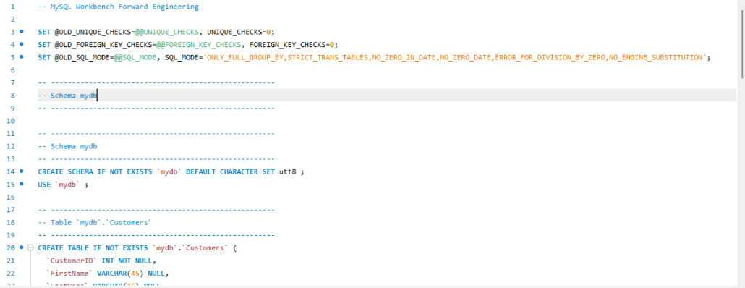
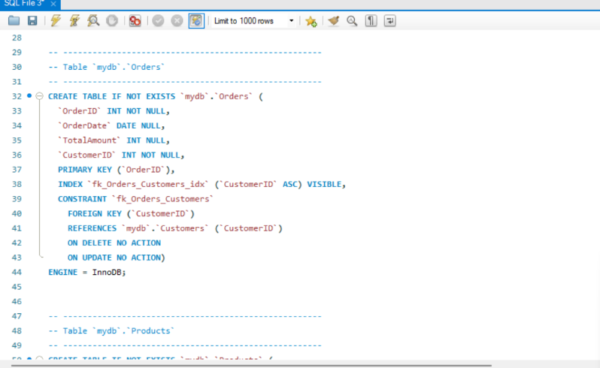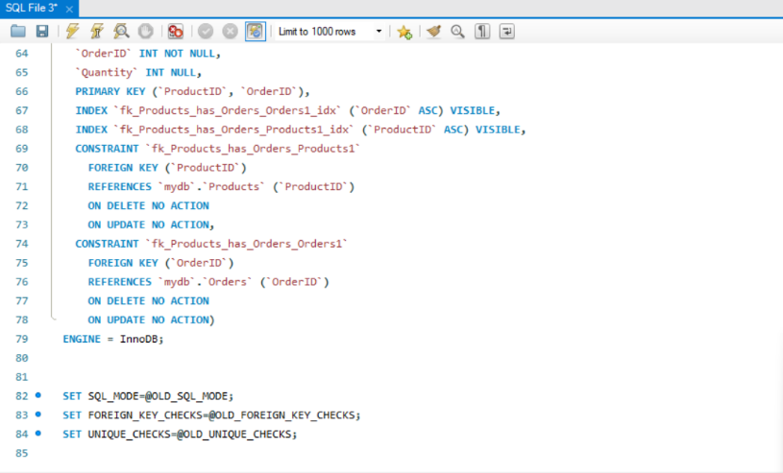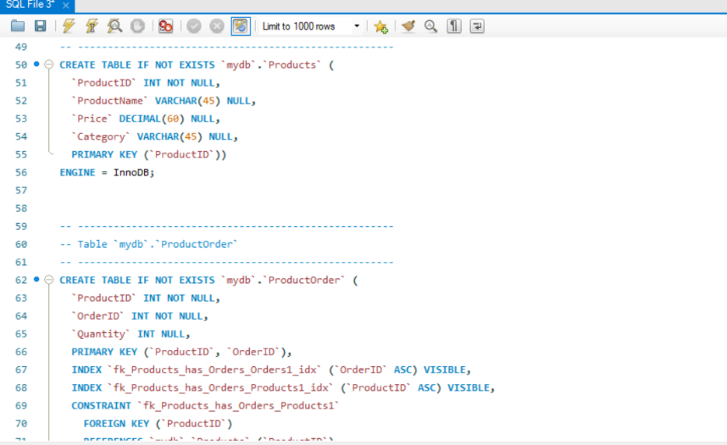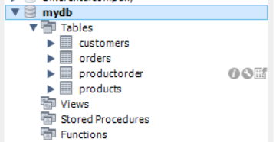
Screenshots of Database Schema and Tables

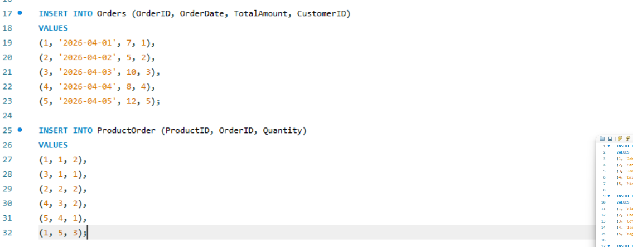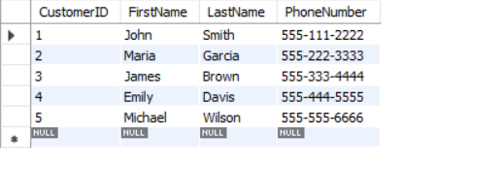
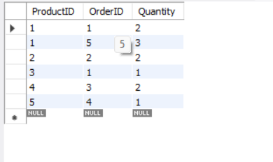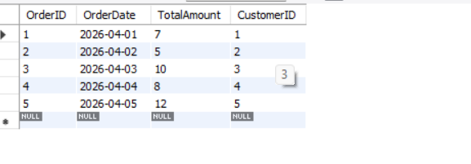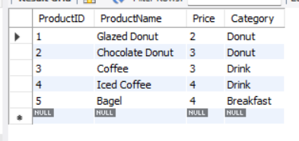
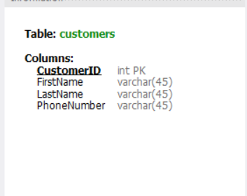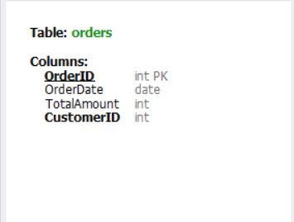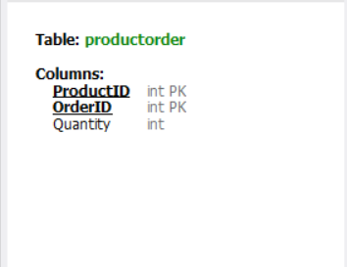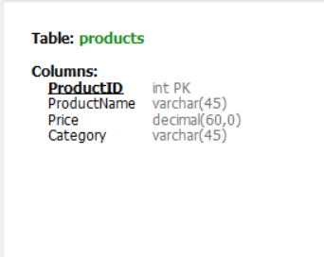

Queries:
Query 1:
Description:
This query returns orders where the total amount is greater than 7 dollars and the order date is April 3, 2026 or later.
Business Use:
Helps the business identify larger, more recent purchases, which can be useful for monitoring revenue trends or identifying high-value orders.
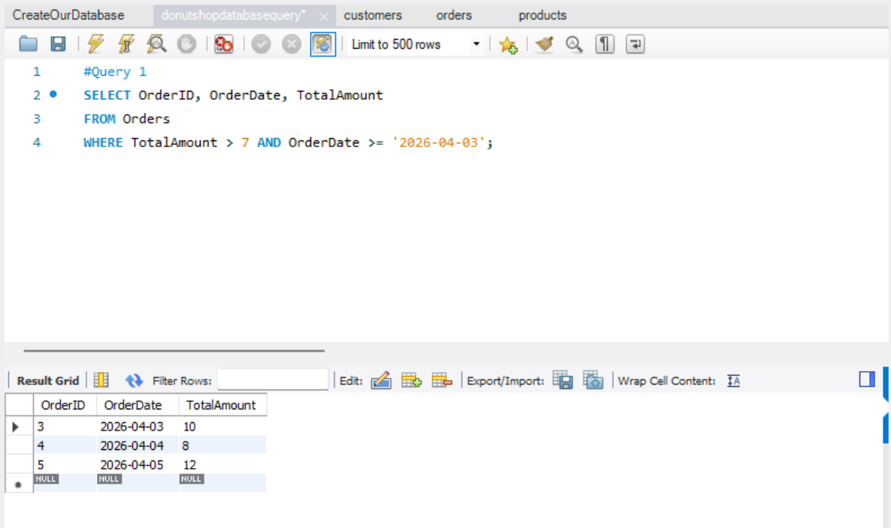

Query 2:
Description:
This query counts the total number of customers in the database.
Business Use:
Allows the business to quickly see how many customers they currently have, which is useful for customer growth tracking.
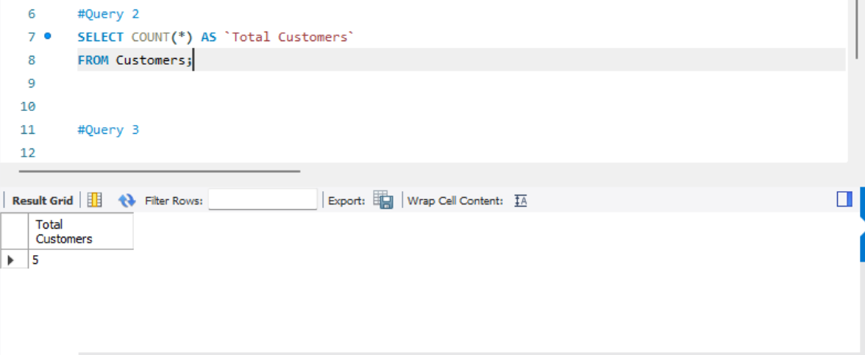
Query 3:
Description:
This query groups products by category and shows only categories where the average price is greater than $3.
Business Use:
Helps the business identify higher‑priced product categories, which may contribute more to profit.
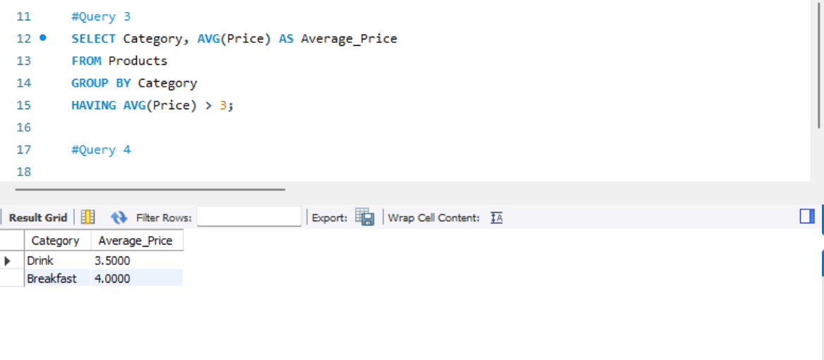

Query 4:
Description:
This query returns products that are priced above the average product price.
Business Use:
Allows the business to identify premium products, which may need special marketing or pricing strategies.
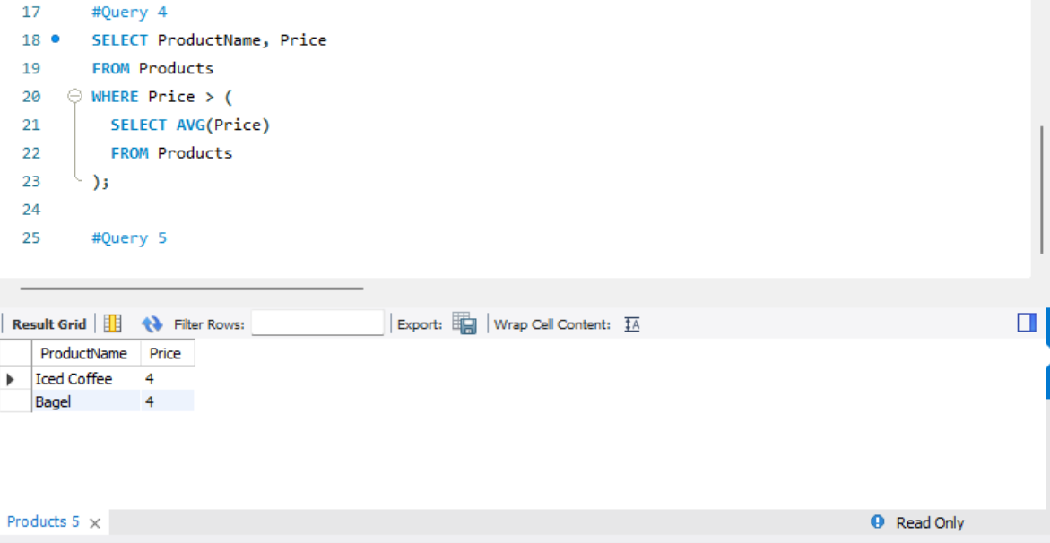

Query 5:
Description:
This query joins the Customers and Orders tables to show which customers placed which orders.
Business Use:
Helps the business link customer information to purchase behavior, useful for customer service and sales analysis.
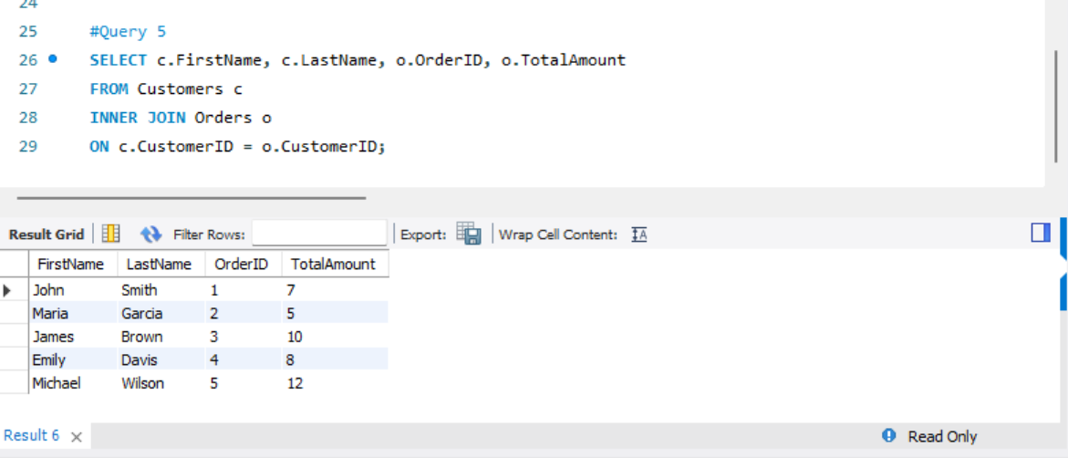

Conclusion
This project showed how a database can improve the daily operations of a donut shop. By organizing data like customers, orders, and products into one system, the business can work more efficiently and reduce errors from manual tracking. The database also helps the shop understand sales patterns and customer behavior, which supports better decisions. Overall, the system makes it easier to manage orders, track inventory, and support business growth.
Lessons Learned
From this project, we learned the importance of planning a clear database structure before building it. Creating tables, setting relationships, and following business rules helped keep the data organized and accurate. We also learned how useful queries can be for solving real business problems, such as tracking sales and identifying popular products. In addition, this project helped us understand how databases can be applied in real-world situations to improve efficiency and decision making.

Contributions and team work
Thang Pham | Steven Nicholson
- Description of database  - Queries  - Conclusion | - ER model description  - Relational form representation of normalized database entities  - Database implementation

Communication
Discord Calls: Weekly call to discuss progress and divide tasks
Discord Chat: Occasional communication for quick questions and updates
Shared Google Drive: Used for drafting documents

