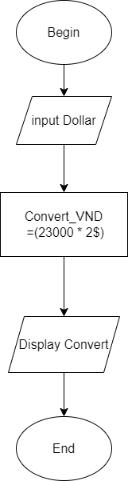

Begin

Input Dollar: 2$:

Convert_VND =(23000 * 2);

Display Convert

End