Electronic Signature Management Use Case Specifications
The following specifications cover the List, Create, View, and Update Signature screens. Each flow follows the supplied use case diagrams, mockups, and current implementation. Mockup fields that are not available in the current API are identified in a source alignment note.

UC-14 List Electronic Signature
Primary Actors | Registered User, External Partner, Employee, Administrative Staff, Accountant Staff, HOD, CEO | Secondary Actors | None
Description | As a registered user, I want to view and search my electronic signatures so that I can select a signature to inspect or manage.
Preconditions | • The user is authenticated.  • The user can access Signature Management.
Postconditions | • The signatures belonging to the current user are displayed.  • No signature data is changed.
Normal Sequence/Flow | 1. The user opens Signature Management and selects List Signature.  2. The screen requests the electronic signature list from the backend.  3. The system identifies the authenticated user and retrieves that user’s signatures.  4. The screen displays signature names, types, statuses, image previews, and available actions.  5. The user may search, apply type or status filters, and move between result pages.  6. The user may select New Signature or open a signature action to continue to another use case.
Alternative Sequences/Flows | • A1. No signatures  • 1. The system returns an empty list.  • 2. The screen displays an empty state and keeps New Signature available.  • A2. List request fails  • 1. The backend request fails.  • 2. The screen does not display stale results and provides an error or empty state.
Source alignment note | The mockup shows Used In and Updated At columns. The current list API returns neither a usage category nor updatedAt; its response contains uploadAt from the creation date. The frontend filter currently reads field names that differ from the list response DTO.

UC-16 Create Electronic Signature
Primary Actors | Registered User, External Partner, Employee, Administrative Staff, Accountant Staff, HOD, CEO | Secondary Actors | None
Description | As a registered user, I want to create a personal electronic signature so that I can use it for contracts, approvals, and internal documents.
Preconditions | • The user is authenticated.  • The user can access the Create Signature screen.  • A signature image is available before submission.
Postconditions | • A new electronic signature is stored for the current user.  • The signature image and public-key record are saved.  • The browser may retain an encrypted private-key backup according to the create flow.
Normal Sequence/Flow | 1. The user selects Create Signature or New Signature.  2. The user enters a signature name and selects a type, status, and default setting.  3. The user enters and confirms a PIN, then requests RSA key generation.  4. The system generates a key pair and certificate; the browser encrypts the private key and offers a backup download.  5. The user draws, uploads, or types a signature image and previews it.  6. The user selects Save Signature.  7. The screen sends multipart form data containing the image, signature fields, public key, key code, and certificate.  8. The system identifies the user, saves the public-key record, uploads the image, and saves the electronic signature.  9. The system returns HTTP 201 and the screen shows creation success.
Alternative Sequences/Flows | • A1. Required information is missing  • 1. The user omits a required name or signature image.  • 2. The screen or backend rejects the submission and asks the user to complete the required data.  • A2. PIN or key generation fails  • 1. PIN validation fails or the key-generation request fails.  • 2. The screen shows an error and does not submit the signature.  • A3. Image upload or save fails  • 1. The image upload or database save fails.  • 2. The screen shows an error instead of creation success.
Source alignment note | Used In, Access Scope, Description, Last Modified, and Document Automation Preview appear in the mockup. The current CreateElectronicSignatureRequest does not define fields to persist Used In, Access Scope, or Description.

UC-15 View Electronic Signature
Primary Actors | Registered User, External Partner, Employee, Administrative Staff, Accountant Staff, HOD, CEO | Secondary Actors | None
Description | As a registered user, I want to view my electronic signature details so that I can verify its information and appearance before using or editing it.
Preconditions | • The user is authenticated.  • The selected electronic signature has an identifier.
Postconditions | • The signature details and image are displayed when the signature belongs to the user.  • No signature data is changed.
Normal Sequence/Flow | 1. The user selects a signature from the list or opens View Signature.  2. The screen requests detail using the selected signature ID.  3. The system identifies the authenticated user and queries the signature by user ID and signature ID.  4. The system returns the signature name, type, status, default flag, creation date, and image URL.  5. The screen displays the signature information and image.  6. The user may select Edit Signature to open the update screen.
Alternative Sequences/Flows | • A1. Signature is unavailable  • 1. No signature matches the user ID and signature ID.  • 2. The screen displays a signature-not-found state.  • A2. Detail request fails  • 1. The detail request fails.  • 2. The screen displays an error or unavailable state.
Source alignment note | Used In, Description, Access Scope, Last Updated, and Usage Summary appear in the mockup. The current detail response does not contain those values. The service currently returns a null projection directly when no owned signature is found.

UC-17 Update Electronic Signature
Primary Actors | Registered User, External Partner, Employee, Administrative Staff, Accountant Staff, HOD, CEO | Secondary Actors | None
Description | As a registered user, I want to update my electronic signature information or image so that future use reflects my changes.
Preconditions | • The user is authenticated.  • The signature exists and belongs to the current user.  • The user has opened the Update Signature screen.
Postconditions | • The changed name, type, status, default flag, and optional replacement image are saved.  • The signature updatedAt date is set.  • The existing public-key record is not replaced by the current update implementation.
Normal Sequence/Flow | 1. The user opens Update Signature for a selected signature.  2. The screen retrieves existing detail by signature ID and pre-fills the form.  3. The user changes the name, type, status, or default flag and may choose a new image.  4. The user previews the image and selects Save Changes.  5. The screen validates the name and sends the updated fields and optional multipart image.  6. The system identifies the user, finds the signature, and verifies ownership.  7. If a new image is provided, the system uploads it and links the resulting file record.  8. The system updates the signature fields and updatedAt date, then saves the entity.  9. The system returns HTTP 200 and the screen shows update success.
Alternative Sequences/Flows | • A1. Signature not found  • 1. The repository cannot find the signature ID.  • 2. The system rejects the update and the screen displays an error.  • A2. User does not own the signature  • 1. The signature owner differs from the current user.  • 2. The system denies the update and the screen displays an error.  • A3. Invalid name  • 1. The name is blank.  • 2. The screen asks the user to enter a signature name.  • A4. Image upload or save fails  • 1. The optional image upload or database save fails.  • 2. The screen shows an error instead of update success.
Source alignment note | Used In, Access Scope, Description, and Document Automation Preview appear in the mockup but are not persisted by the current update request. The update sequence diagram includes public-key validation and key replacement branches that are not implemented in the current service.

Signature Management Screen and Field Specifications
These screens correspond to the four electronic signature use cases above. Field descriptions identify mockup-only fields that are not present in the current API.

3.1.1.1 List Signature Screen
UI layout
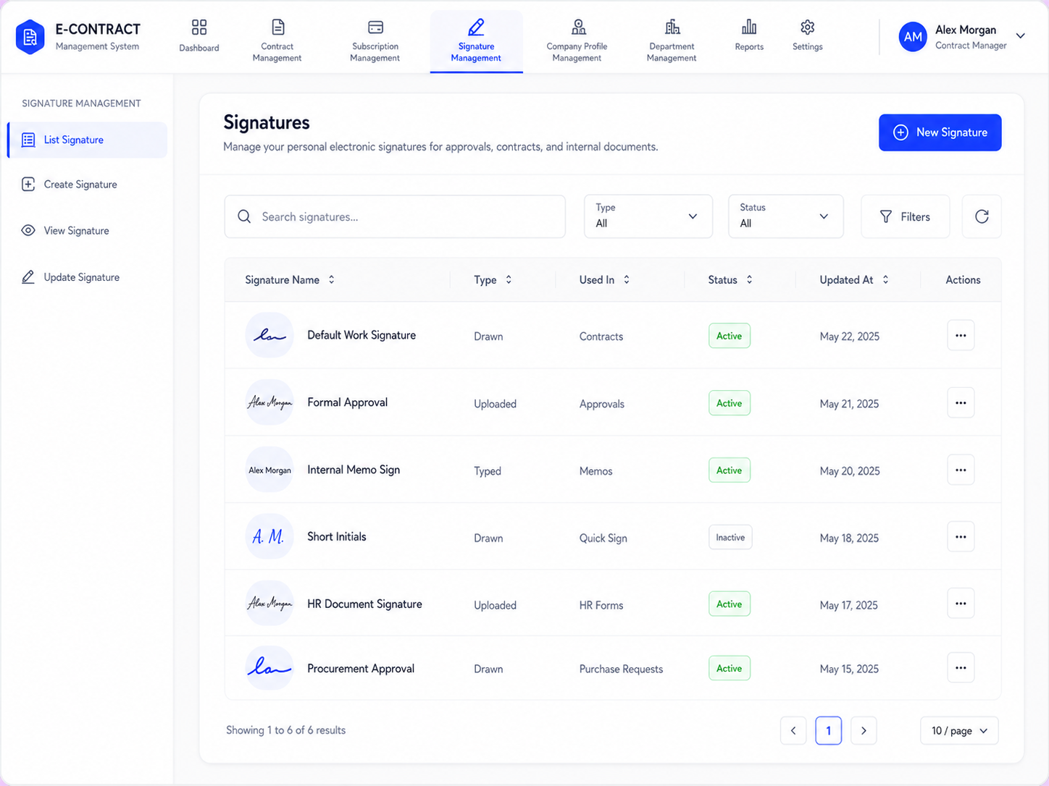
Function and related use case
Displays the current user’s electronic signatures. The user can search, filter, paginate, open a signature, or start creation. Related use case: UC-14 List Electronic Signature.
Screen components and fields
Field Name | Description
Search and filters
Search signatures | Text input; searches names in the loaded list. No maximum length is defined in the current frontend.
Type | Dropdown; filters by electronic signature type. Initial value: All.
Status | Dropdown; filters by signature status. Initial value: All.
Filters | Button shown in the mockup for filter controls; the current page uses direct type and status filters.
Refresh | Reloads the signature list from the backend.
Signature table
Signature Name | Text and image preview for each signature. The API projection uses signatureName and fileUrl.
Type | ElectronicSignatureType value for each signature.
Used In | Usage category shown in the mockup; not returned by the current list API.
Status | ElectronicStatus value for each signature.
Updated At | Date shown in the mockup; the current list API returns uploadAt from createdAt, not updatedAt.
Actions | Opens actions for a selected signature, including viewing its details.
Pagination | Moves between pages of the client-side filtered list.
Page size | Selects the number of rows shown per page; the current default is 10.
New Signature | Opens the Create Signature screen.

3.1.1.2 Create Signature Screen
UI layout
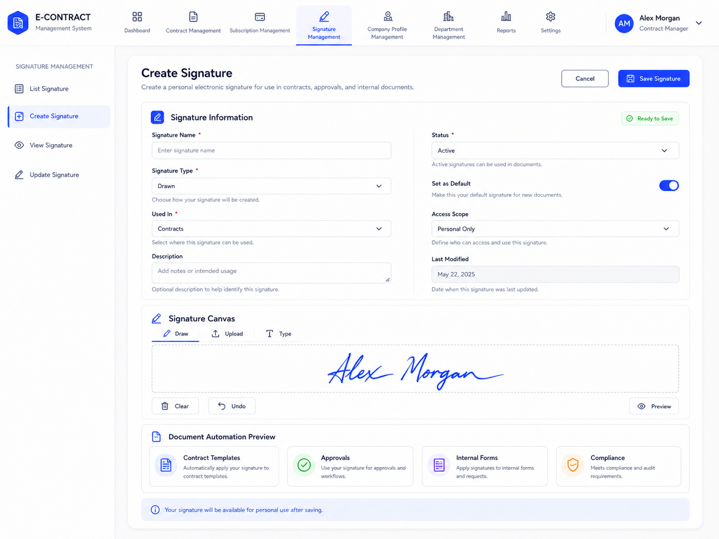
Function and related use case
Collects signature details and an image, generates an RSA key pair, and submits a new signature for the current user. Related use case: UC-16 Create Electronic Signature.
Screen components and fields
Field Name | Description
Signature Information
Signature Name | Required text input; stored as electronicSignatureName. The current request defines no maximum length.
Signature Type | Required dropdown; stored as ElectronicSignatureType. The mockup offers Drawn, Uploaded, and Typed modes.
Used In | Required dropdown in the mockup; not defined in the current create request or signature entity.
Description | Optional text area in the mockup; not defined in the current create request or signature entity.
Status | Required dropdown; stored as ElectronicStatus. Initial mockup value: Active.
Set as Default | Boolean toggle; stored as isDefault. Initial mockup value: enabled.
Access Scope | Dropdown in the mockup; not defined in the current create request or signature entity.
Last Modified | Read-only date displayed in the mockup; not entered by the user during creation.
Signature Canvas and key
Draw / Upload / Type | Modes for producing a signature image; the submitted request must contain multipartFile.
PIN and Confirm PIN | Browser-side values used to protect the generated private key; not saved in the signature request.
Generate Key | Requests RSA public/private key information and a certificate.
Clear / Undo | Canvas controls shown in the mockup for editing the drawn image.
Preview | Shows the image before submission.
Save Signature | Submits name, type, status, default flag, public key, key code, certificate, and image.
Cancel | Leaves the create screen without submitting.

3.1.1.3 View Signature Screen
UI layout
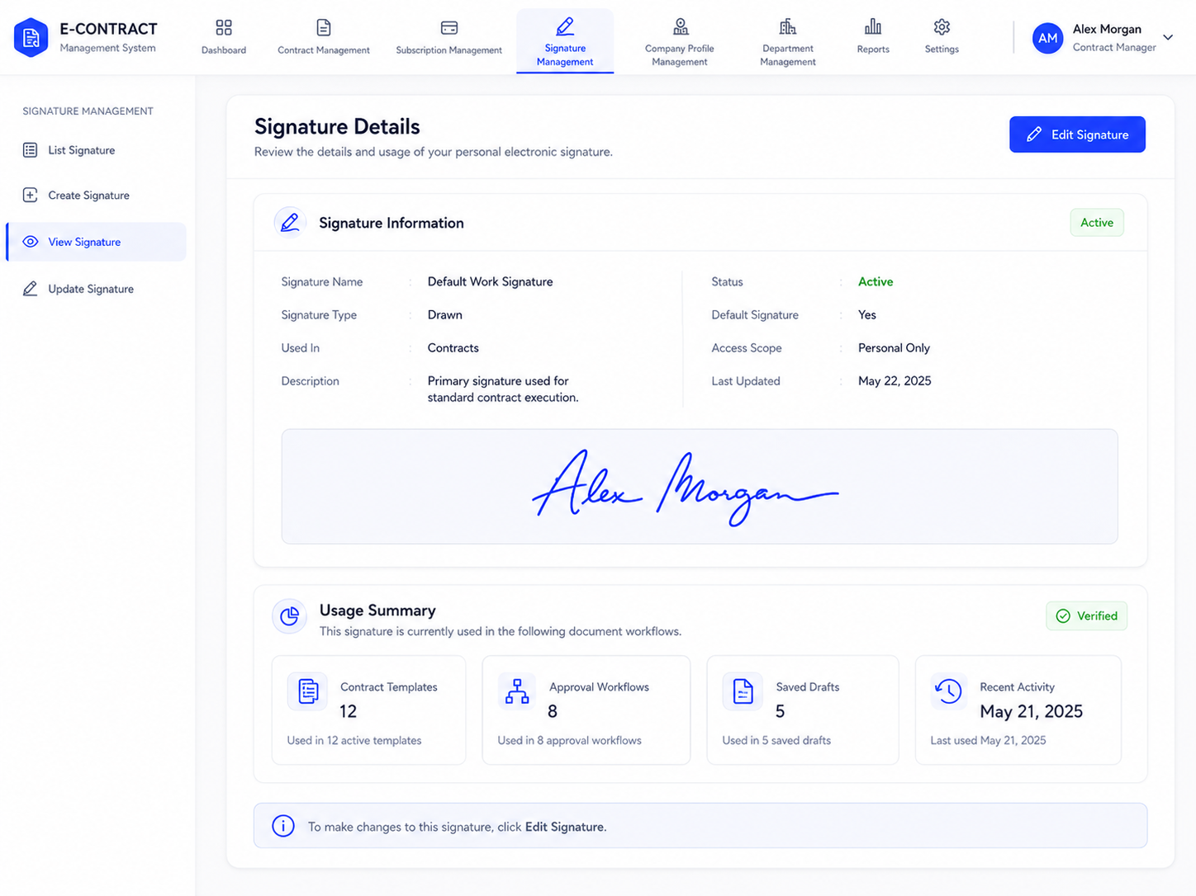
Function and related use case
Displays the selected user-owned electronic signature and offers navigation to editing. Related use case: UC-15 View Electronic Signature.
Screen components and fields
Field Name | Description
Signature Information
Signature Name | Read-only String returned as electronicSignatureName.
Signature Type | Read-only ElectronicSignatureType value.
Used In | Read-only usage category shown in the mockup; not returned by the current detail API.
Description | Read-only text shown in the mockup; not returned by the current detail API.
Status | Read-only ElectronicStatus returned as electronicSignatureStatus.
Default Signature | Read-only Boolean returned as isDefault.
Access Scope | Read-only access setting shown in the mockup; not returned by the current detail API.
Last Updated | Read-only date shown in the mockup; the current detail API returns createAt instead.
Signature Image | Displays the image from signatureUrl.
Usage Summary
Contract Templates / Approval Workflows / Saved Drafts / Recent Activity | Mockup usage metrics; not returned by the current signature detail API.
Edit Signature | Opens the Update Signature screen for the selected ID.

3.1.1.4 Update Signature Screen
UI layout
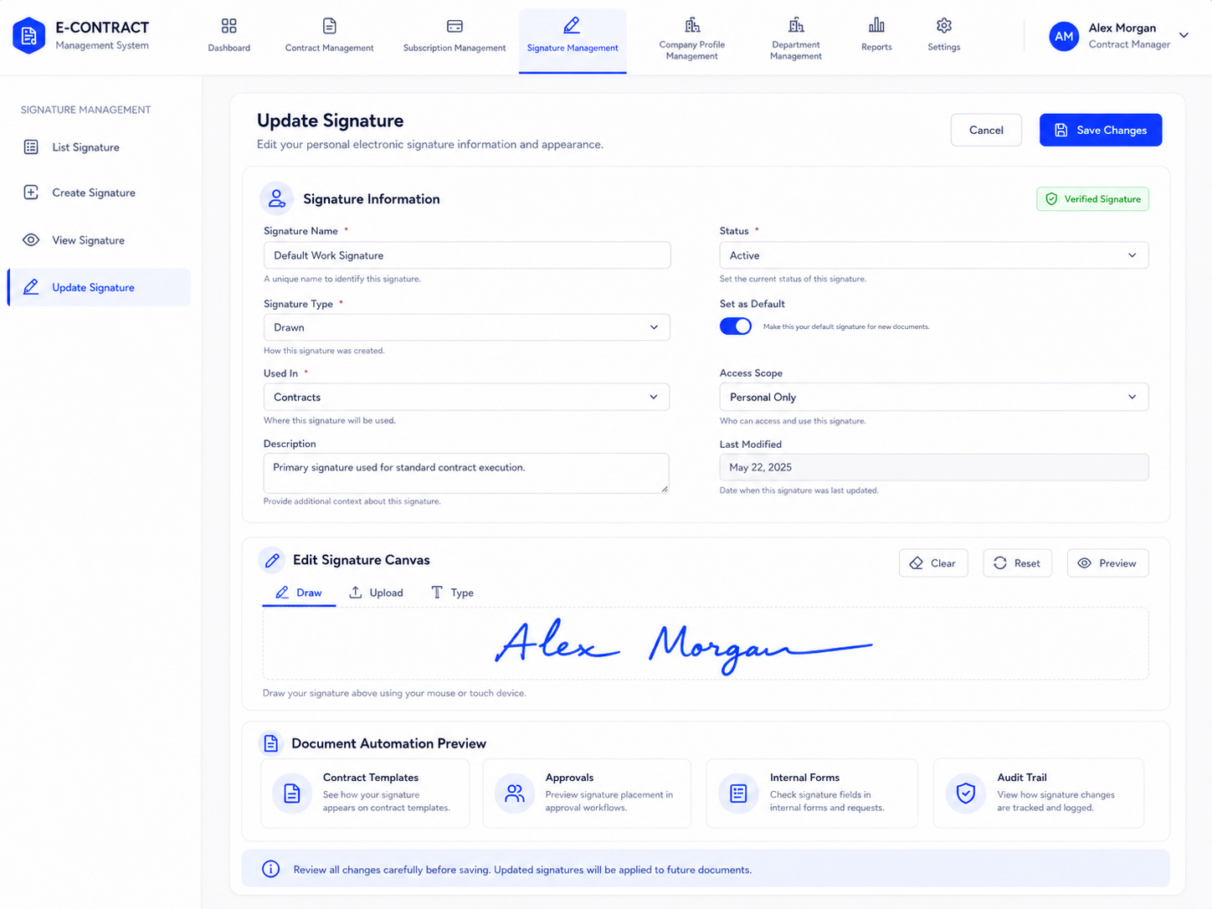
Function and related use case
Loads an existing signature, lets its owner edit supported fields or replace the image, and saves the changes. Related use case: UC-17 Update Electronic Signature.
Screen components and fields
Field Name | Description
Signature Information
Signature Name | Required text input; updates electronicSignatureName. Blank names are rejected by the frontend.
Signature Type | Dropdown; updates electronicSignatureType.
Used In | Dropdown shown in the mockup; not defined in UpdateElectronicSignatureRequest.
Description | Text area shown in the mockup; not defined in UpdateElectronicSignatureRequest.
Status | Dropdown; updates electronicStatus.
Set as Default | Boolean toggle; updates isDefault.
Access Scope | Dropdown shown in the mockup; not defined in UpdateElectronicSignatureRequest.
Last Modified | Read-only date shown in the mockup; updatedAt is set by the backend when saving.
Edit Signature Canvas
Draw / Upload / Type | Modes shown for replacing the image; a new multipartFile is optional in the update API.
Clear / Reset / Preview | Controls shown in the mockup for editing and checking the image before saving.
Save Changes | Submits the edited fields and optional image; the backend checks signature ownership.
Cancel | Leaves the update screen without saving.

